What is a Kareez / Kariz / Karez (Qanat)?
A kareez (کاریز) (also spelt karez / kariz and later called qanat in Arabic) is a combination below and above ground channel system used to bring water to a settlement or fields from a natural source, say an aquifer, mountain spring or lake. Many of the kareez / qanats are ancient and their history is intertwined with the history of Aryan lands. Importantly, the system was sustainable and did not exhaust underground aquifers.
[A jube (also spelt jub), is an above ground gutter (drain, ditch, or rain sewer). Frequently, communities that construct and use the kareez, also employ the jube as part of an urban water collection and management system. Jubes collect rain water in those areas with a significant enough amount of precipitation to cause a run-off. Water collected in this manner, while probably not suitable as drinking water is useful as irrigation water. In Persian, a spring is called sarab meaning the head or start of water or stream or cheshmeh.]

Need for a Kareez / Kariz / Karez (Qanat)
The kareez are difficult, laborious and time consuming to build and maintain. However, without them normal life in the more arid regions of the Aryan lands and the later Persian empire, including Egypt, would have been untenable. In these lands, as well as the Aryan's Turkic neighbours in Kazakhstan and the Tarim river basin in what is today the far western Chinese Uygur province of Xinjiang - the kareez was, and in many cases still is, the principal method of water supply and distribution. After the Arab conquests of the Aryan lands, the Arabs called the system a 'qanat'. However, the system continued to be called kareez in the eastern Aryan lands including the neighbouring eastern Turkic lands.
By bringing water down from the mountains where it was stored as snow or collected as rain, the kareez enabled otherwise desolate land to be transformed into an oasis in the desert. But the kareez enabled life in these otherwise desolate areas to rise above mere survival. Indeed, where there was sufficient water brought down for sustenance, the water was also used to create Persian gardens or chahar baghs. The 16th century Tajik writer Makhmud Zainaddin Wasifi, wrote in his book Amazing Events, that in the Central Asian oasis town of Sauran (today in southern Kazakhstan), two kareez lines made possible a chahar-bagh whose beauty had never been "seen neither on land neither on sea."
Ancient Persian Achaemenian kings provided an incentive for the construction of kareez by issuing a decree granting land use for five generations to anyone who constructed a kareez.

Kareez / Kariz / Karez (Qanat) Construction
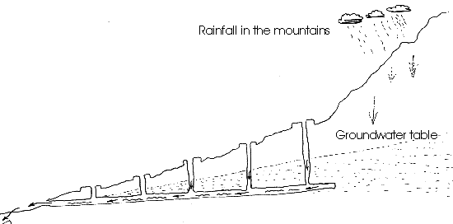
Schematic diagram showing the kareez (qanat) concept
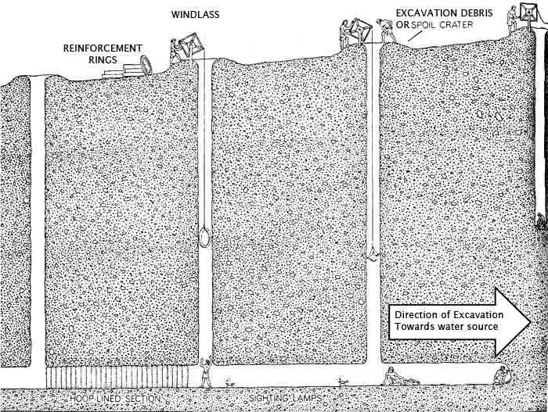
Schematic diagram showing the construction of the underground section of a kareez (qanat)
The construction of a kareez / qanat may start with a construction of a reservoir or even a system of stepped reservoirs which contain the spring snow run-off and provide a year round supply of water. Alternatively, a kareez they may tap into aquifers or underground streams that begin at the base of mountains. A kareez may even tap in water from a system of interconnected wells. Other sources of water are wells where the water is raised from the water table to the kareez using the principle of differential pressure.
Constructing the kareez as an underground water channel rather than an above ground canal, helps to prevent evaporation. When the kareez enter an agricultural area, they often become above ground channels or streams.
The underground sections are evidenced by excavation craters at the top of shafts that go down to the tunnel. It is not unusual to find several underground kareez running parallel to one another, or to find a freshly constructed kareez constructed close to an older disused one.
Establishing the size and gradient of the kareez requires experience and knowledge of surveying, geology and hydrology. The kareez cannot be too steep because the erosion by swift water can cause irreparable damage. Kareez tunnels can have a 0.5 to 0.1% slope gradient. A tunnel needs to be of a size sufficient enough to accommodate the water flow as well as a person working and maintaining the tunnel.
Determining the course of the kareez also needs an understanding of the geology of the area. Kareez construction became a very well-paid profession, knowledge of which was passed down from father to son, the professional being known as muqannis.
Using modern technology, the construction of a kareez may not be especially noteworthy. However, in ancient times, in the absence of surveying or mechanical equipment, the development of kareez construction techniques and the construction of a network thousands of kilometres in length was an incredible feat.
A typical shallow medium length kareez is constructed by a team of 3-4 muqannis. First the team members dig a source well to locate the source of water. Next, they work on the underground tunnel section starting at the destination end where the tunnel emerges above ground and work toward the source well. In this phase they may divide the work as follows: one muqannis to dig the horizontal shaft, one to raise the excavated earth from the shaft, and one to distribute the excavated earth at the top.
Every 20 to 35 metres, the muqannis sink vertical shafts. The distance between the shafts is determined by the excavation effort required to create a shaft, the excavation effort required to carry the tunnel debris back to the shaft and the amount of air needed to sustain a worker. Muqannis carry castor-oil lamps to test the ventilation underground. If the air does not keep the flame alight another shaft is sunk. Future maintenance is also a consideration. Closely spaced shafts make future maintenance easier. Since deeper tunnels require deeper shafts, it stands to reason that deeper kareez may have shafts spaced as far apart as practical.
Deeper and longer kareez may have several muqannis teams working in cooperation from both ends at once. However, they may complete the work substantially before the final section is excavated allowing water to start flowing.
H. E. Wulff in his article The Qanats of Iran states in his April 1968 article in Scientific American that "A qanat about six miles long (cost) between $13,500 and $34,000 to build, the cost varying with the nature of the terrain. For a qanat 10 to 15 miles long the cost runs to about $90,000."

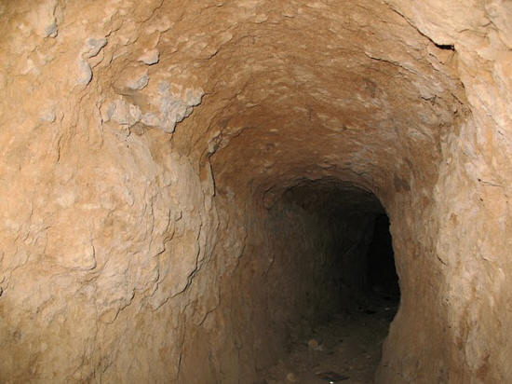
Kareez in Yazd

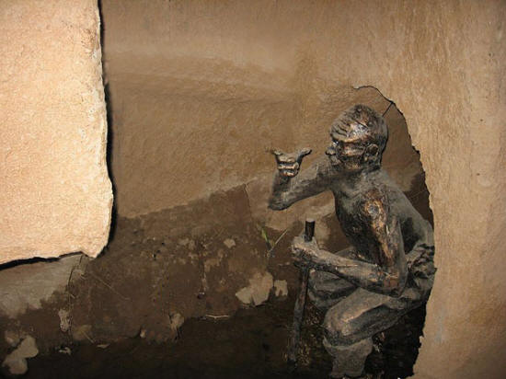
Model of the digging of a kareez tunnel

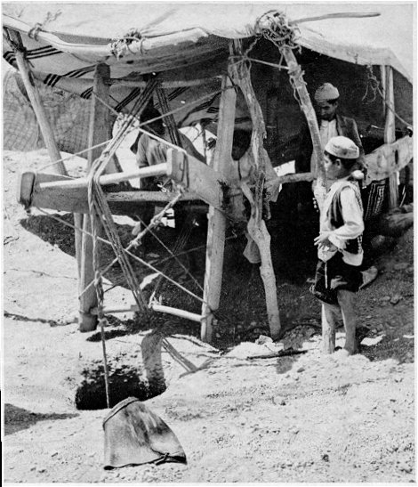
Archive photograph of a windlass in operation during construction

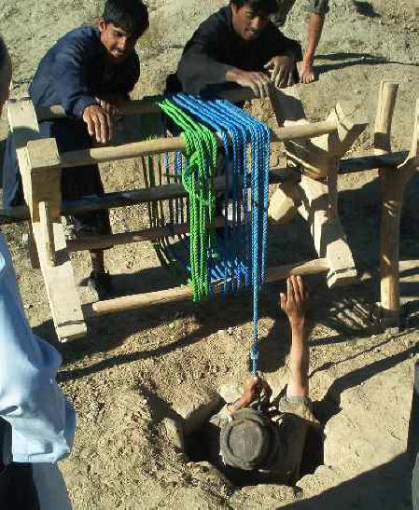
Recent photograph of a windlass in operation during construction

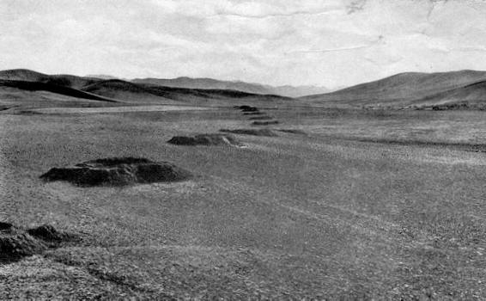
Excavation (spoil) crater at the top of the shaft from the surface to the kareez tunnel

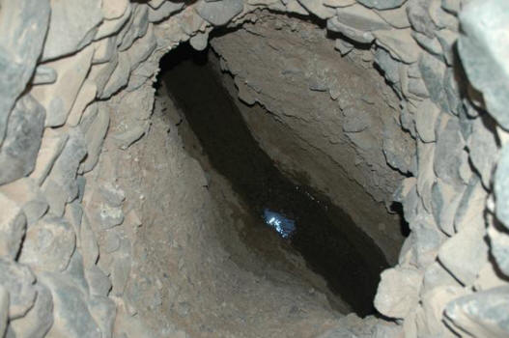
A look down the shaft to the water flowing through the kareez tunnel

A satellite image of the spoil craters (the lines of dots) created by the excavation & ventilation shafts when constructing a kareez (qanat) near Mastung, Baluchistan, presently in Pakistan (note that there are several parallel kareez):
View Larger Map

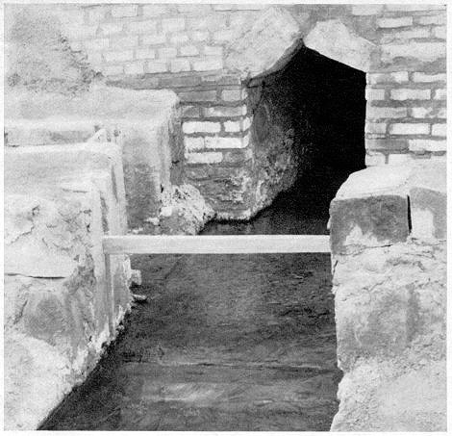
Stream from the underground kareez emerging above ground

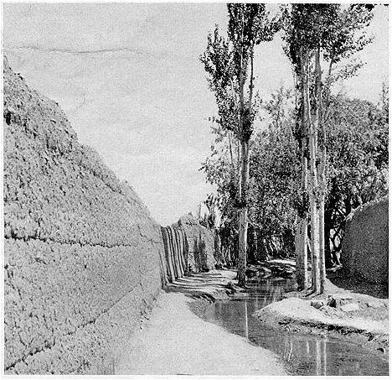
Stream from the kareez flowing as an above ground stream

History of Kareez
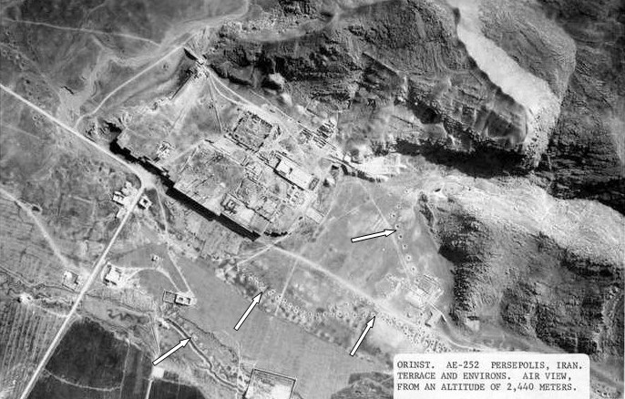
Archival aerial photograph of Persepolis.
Note the line od dots formed by the debris craters around the kareez shafts
Image credit: Oriental Institute of the University of Chicago
Some of the earliest known kareez have been found in north-eastern Iran and ancient Persia. By the middle of the twentieth century, it is estimated that approximately 50,000 kareez were in use in Iran. With the advent of modern technology and the ability to dig deep wells, the number declined to 22,000 by the turn of the century. These surviving kareez are some 274,000 kilometres in length - all dug out by hand.
There is considerable evidence of an ancient above ground water irrigation system in Central Asia. Author Henry Gubler believes that the transition to the use of an underground channel system may have taken place around 800 BCE when coal miners in north eastern Iran / Central Asia, used underground tunnels in order to extract the water from the coal mines. It is quite plausible that the method of excavating the tunnels started as mining technology. With the observation that the water being drained from the mines, water that was a precious resource in arid regions, could be utilized for other purposes, the technology was probably adopted by farmers to bring water from the hilly regions beside the settlements. The technology would have spread throughout the Aryan lands.
The oldest and largest known operating kareez is the Kaikhusrau Kareez that supplies water to the north-eastern Iranian city of Gonabad (also known as Gulnabad and Juymand), Razavi Khorasan province, and it still provides drinking and agricultural water to nearly 40,000 people at a rate of some 150 litres per second. The age of the Gonabad kareez is estimated at over 2,500 years old and has been declared a UNESCO world heritage site. It has has one of the deepest main kareez wells - one that reaches down to a depth of more than 350 metres, and its length runs more than 45 kilometres with some reports placing the chain as 70 km. in length.
During the formative years of the Persian kingdoms, King Sargon II (reign c. 722-705 BCE) of Assyria reports the existence of a kareez-like water distribution system during his raids on lands south of Lake Urmia. Sargon's son, King Sennacherib, used the technology for a construction of a irrigation system around Nineveh, and for the construction of a kareez system to supply water for the city of Arbela.
An aerial photograph taken about the University of Chicago reveals the presence of kareez craters at Persepolis (see image to the right. While some of the Persepolis kareez may be relatively modern, others may be as old of the capital itself and we await a more definitive dating.
A recent 2008 discovery of a 500 hectare settlement about twelve kilometres from Yazd and nearby a kareez-like system may indicate the use of kareez that predate the establishment the Achaemenian dynasty and we await further the publication of further research on the subject.
It is during Achaemenian rule and the establishment of the Persian empire, that we see the most consistent use and reports of a kareez-like water collection and distribution system. King Cyrus used a kareez-like water distribution system in Pasargadae and the palace complex at Persepolis incorporated an underground channel system that was six metres deep in places. A cistern whose walls and bottom were made from stone blocks, was part of the water storage and distribution system in Persepolis. The tank was 23.5 metres square and two metres deep. Achaemenian water collection and distribution technology made possible their legendary gardens mentioned by Lysander to Greek writer Xenophon, and that gave rise to the word 'paradise'.
With the Persian conquests of lands to the south and west of traditional Aryan lands, the kareez system reached the region that is today part of Oman and Saudi Arabia by about 525 BCE, and modern Africa (present day Egypt) around 500 BCE. In addition, during Achaemenian era, kareez technology spread all along the Aryan trade roads. Near the city of Bam in the southern province of Kerman, we find evidence of full-fledged Achaemenian era kareez system that supplied water to an urban settlement. The kareez of Mashhad is also believed to have been constructed during the Achaemenian era.
While describing an expedition conducted by Antiochos III against the Parthian king Arsaces III, Greek historian Polybius describes a kareez in his Histories, X.28. The expedition Polybius describes took place between Rhagai (just south of Tehran) and Hekatompylos (modern-day Shahr-i Qumis), territory that would have been located in Parthia proper. The following is a passage (X.28.2-3) from Histories translated by Paton:
"In this region of which I speak, there is no water visible on the surface, but even in the desert there are a number of underground channels communicating with wells unknown to those not acquainted with the country."
Further, "At the time when the Persians were the rulers of Asia they gave to those who conveyed a supply of water to places previously not irrigated the right of cultivating the land for five generations... [so that] people incurred great expense and trouble making underground channels reaching a long distance."
The Parthians and Sassanians continued to use and develop kareez technology. The Firozabad ruins of Sassanian gardens can still be seen at Taq-e Bostan near Kermanshah. Another remnant of a Sassanian garden can be found at Taq-e Kisra, Ctesiphon outside Baghdad. There, the pools and orchards were overlooked by massive barrel-vaulted halls known as aywans (a Parthian innovation).
Many ancients kareez were destroyed during the 13th-century CE Mongol conquests.

Politics & Kareez
The ownership of the numerous kareez that dot the landscape varies from private ownership to community ownership. With a long kareez, the land under which a kareez passes made have several owners and its water is bought and sold. Some landlords endow the kareez routes under their lands partially or totally to whole community served.
In many cases, the ownership and distribution rights have developed over hundreds of years. Sometimes, the distribution rights are determined through negotiation through representatives. In the case of a large kareez with several users, the distribution of the water is determined by a salaried official known as mirab who is elected by the users or appointed by the government and is paid a certain salary.
In those cases where a kareez is (or was) privately owned, the owners became fairly wealthy, since water is a precious resource in arid lands. The rich took the best of the water supply not just for agricultural purposes but also for the maintenance of ornamental gardens. This also meant that their land holdings were situated at the head of the kareez distribution system. The poor had land further down the kareez and the poorest subsisted on a trickle of muddy water. The late Shah of Iran tried to change the system of land ownership, by breaking up large traditional holdings of land, angering land owners. The move also inadvertently led to confusion about the ownership of the kareez and the responsibility to keep them maintained.
In any event, the creation and use of kareez has led to the development of a dedicated set of laws and an accompanying legal system.
In relatively modern Iran, when communities still relied on kareez of their water supply, many land holdings (that are public gardens today) had their own private kareez water supply. The Dowlatabad garden in Yazd city which was at one time the palace of the Karim Khan Zand (c. 1705- 1779 CE) had its own kareez (similarly Bagh-e Fin in Kashan, and the Shazadeh in Mahan had their own kareez). When the British established their legation in Iran's capital Tehran, they too had their own kareez that brought water from the Alborz Mountains to the north the city.
The introduction of deep wells made possible by modern drilling equipment created a new distribution of wealth. However, this development, regretfully poorly and ineptly regulated, is causing permanent damage to underground aquifers.

Kareez and Watermills - Flour Making Systems
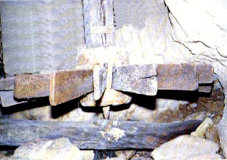
Horizontal water-wheel in a Taft, Yazd, Iran mill
Where the slope of the hills was steep and where the resulting slope of the tunnel would cause excessive erosion, the ancient engineers turned a potential negative into a positive. They could create underground rock-lined waterfalls to create a sudden loss of height in a lined area thereby reducing the hazard of corrosion by fast flowing water.
The waterfall in turn was used to drive a vertical (potential) water-wheel which turned stone mills that could make flour. Nowadays the system can also generate electricity. Horizontal (kinetic) water-wheels (shown here) were also an option for taking advantage and also reducing the flow rate of the water.

Kareez and Badgirs - Home Cooling Systems
In regions with hot summers, the kareez system with an urban area was integrated with the system for cooling homes. These cooling systems captured (gir in Persian) the hot desert wind (baud in Persian), and then cooled it by directing the breeze over the flowing water in the kareez before releasing the cooled air into the rooms of a home.
Yazd, a city in central Iran has a skyline defined by badgirs (pronounced baudgirs) and we explain the system further in Badgir section of our Yazd page.

Kareez and Yak-Chawls - Ice Making Systems
The badgir in conjunction with a kareez had a use in addition to cooling homes. They kept the domed ice-storage pits called yak-chawls cool thereby helping to keep the melting of the stored ice to a minimum.
We explain yak-chawls further in Yak-Chawl section of our Yazd page.

Further reading:

» Yazd

» Top

• © Author: K. E. Eduljee, Zoroastrian Heritage, 2007-13 • Contact • Page validated by W3C.org

Karez in Pakistan
The Baluchistan Province is in the western half of Pakistan. This province is rugged, and it's elevation is much higher than the rest of Pakistan; the area is referred to as the Balochistan Plateau. This area is also very dry. Thus, its inhabitants have, for centuries, used a unique way of gathering water.
The method is called karez. In this method, underground tunnels are constructed to gather subsoil water, through gravitational pull, at the foot of hills. This water is then either taken to the fields and villages through vertical shafts which are sunk underground, or it is drawn out at the foot of the hill where it has been gathered.
Inhabitants of Balochistan may not mean this exact definition when they use the term Karez. People of an area know the natural water ways which flow just below the sandy surfaces of the valleys of Baluchistan. Some time they appear on surface by themselves and sometime those who know them dig them out for usage. At places where this water is seeping in as a natural spring they put some sort of pound around it. All of this natural phenomena is also called karez by the inhabitants of Balochistan.
(Reference: Britannica.com)
Date/Time Last Modified: 6/17/2002 4:34:35 PM

