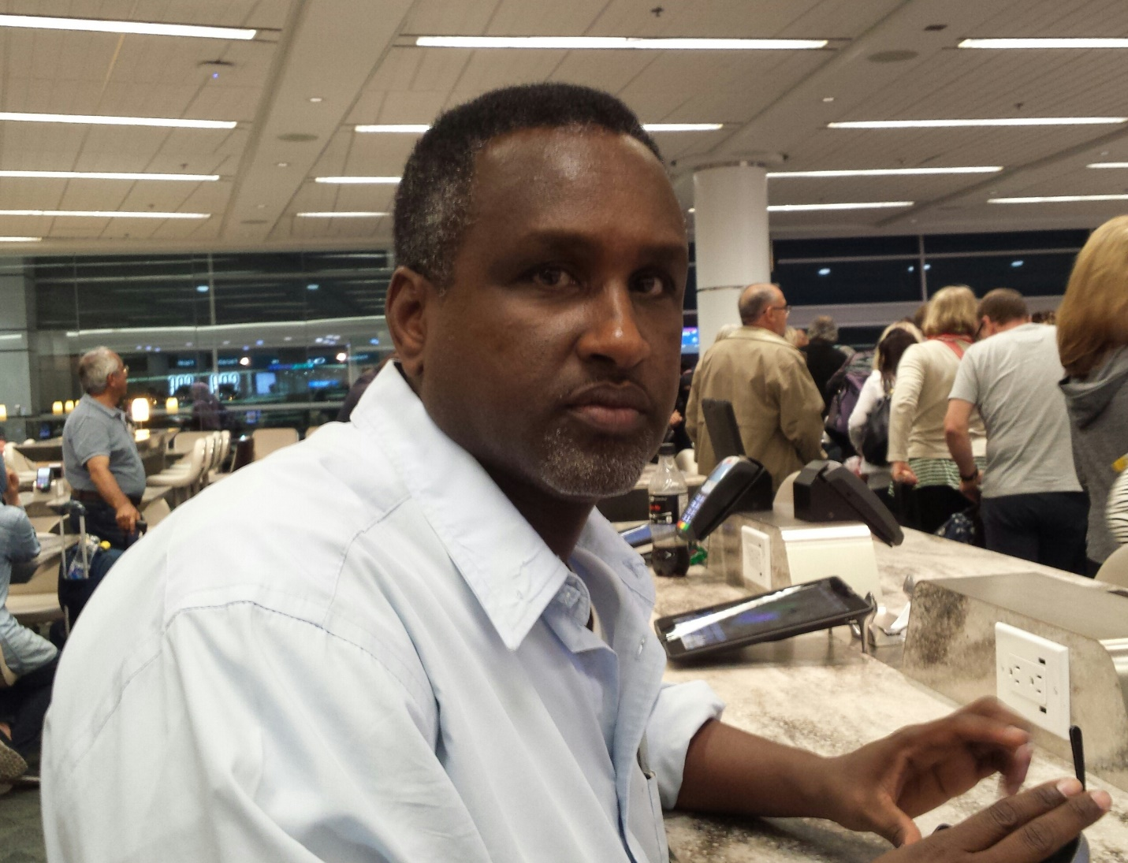
Why Waste Water? Is the theme of World Water Day 2017. No Drop to Waste in Somaliland.
The United Nations General Assembly meeting in Rio de Janeiro, Brazil has declared March 22nd as World Water Day (WWD). This important day was first proposed on Agenda 21 of the 1992 United Nations Conference on Environment and Development. Commemoration of this day has begun and gained popularity ever since. United Nations member states recognize WWD as a day of implementing UN recommendations and promoting other activities.
The Ministry of Water Resources in Somaliland celebrates and acknowledges each year World Water Day commemoration. MoWR organizes the day to bring public attention on water issues. Water is a scarce resource in Somaliland. The rainy seasons are Gu (April-June) and Deyr (September-October). Somaliland is a drought prone country. Currently, there is a severe drought plaguing the country in general. Period.
MoWR roles and responsibilities have grown significantly since its formation. As a result, the President, Mr. Siilaanyo, acknowledged the need to have a dedicated ministry for water resources. Then in June 2013, MoWR was established & separated from the former Ministry of Mining, Energy and Water Resources. MoWR’s operating budget has increased substantially for the current fiscal year 2017. Since its establishment, MoWR has attracted many donors including the Somaliland Development Fund (SDF), European Commission (EC), Al Khalifa Foundation of United Arab Emirates, German Development Bank (KFW), World Bank & African Development Bank (AfDB) just to name a few. UNICEF is the water sector lead in Somaliland.
In June 2016 the AfDB Board of Directors has approved the “Water Infrastructure Development for Resilience Program in Somaliland (WIDR)”. This is the first time, AfDB has offered financial grant in the water sector in Somaliland. Care International is the implementing agency for the WIDR program. MoWR is the executing agency for the program.
The African Water Facility through the African Development Bank’s (AfDB) grant of Euro 3.0 million for the Government of Somaliland (GoSL), is seeking to enhance the water stress situation and plan the long term water resources development plan. The consulting firms NIRAS & We Consult are commissioned to undertake the technical studies and come up with bankable investment projects.
MoWR has increased the capacity of the water sector. It has a well- established structure and trained employees and has regional and district offices throughout the country. It has decentralized its activities and celebrates WWD event each year. MoWR participates in regional and international water summits. For example, it has benefited from the participation of the recently held 4th International Water Summit & 5th International Conference on Water, Energy & Environment, which took place in UAE. In addition, MoWR has contributed to the WEDC base of knowledge by way of presenting refereed paper for the near completion of “Improving Urban Water Delivery System”.
This year’s theme is: “Why Waste Water? There is nothing to be wasted in Somaliland. Recent Knowledge, Attitude & Practice (KAP) survey commissioned by UNICEF indicates Somaliland is off-track in achieving Millennium Development Goals (MDGs) for Water, Hygiene and Sanitation (WASH). Somaliland is preparing to meet and exceed the Sustainable Development Goals (SDGs), which coincides the Somaliland Vision of 2030 for its citizens, particularly the vulnerable groups. Furthermore, MoWR has completed the National Development Plan II where WASH is prioritized.
In addition, MoWR have to think about ways to attract young graduates into the trade business. MoWR has a vocational training center in Hargeisa, the capital, and the aim is to produce professionals, such as technicians and plumbers who are in a position to carry out the day to day activities of the water points. In the near future, MoWR is planning to build another vocational training center in Burao for the eastern regions.
MoWR Data Center utilizes new technology where one can click and find out the status of any borehole online. These include the general condition, the water salinity, GPS location, beneficiaries both human and livestock and the legal status, i.e., public or private.
Under the leadership of the newly appointed Minister Hussein Abdi Boos, MoWR is at the forefront of researching, fund raising, designing, monitoring and advocating for new water points, which in effect will create opportunities for the younger generation. Senior engineers and upper management staff are at all times looking for innovative ways to advance clean water for Somalilanders.
Finally, MoWR welcomes that you have acknowledged & commemorated WWD 2017 and the Director General, Dr. A/risak Jama Nour is glad to welcome you on World Water Day 2017.
Faisal Hashi
Consultant
Ministry of Water Resources
Email: Hashi44@hotmail.com

