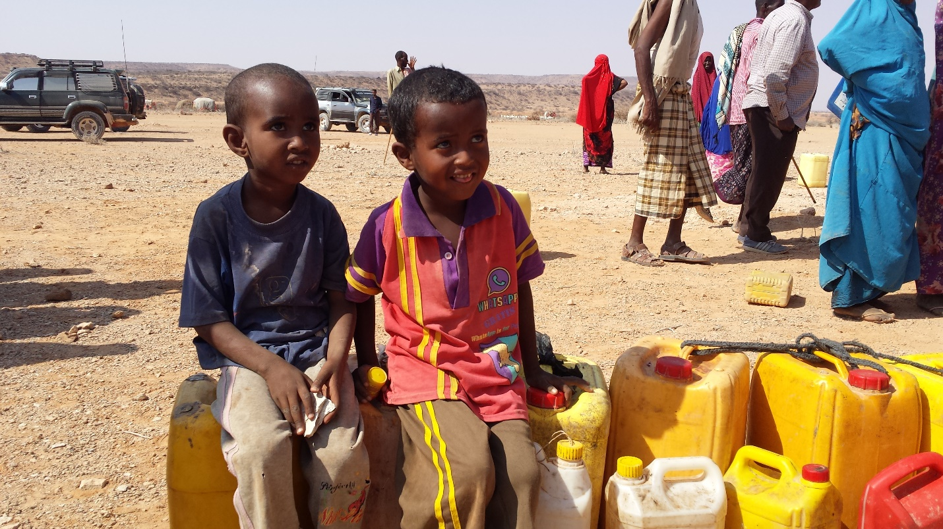
No Water, No School & No future!
A Knowledge, Attitude & Practices (KAP-) survey commissioned by UNICEF and released in August 2015 indicates Somaliland is off track in the achievement of the Millennium Development Goals (MDGs) for Water, Hygiene and Sanitation (WASH), which is one of the indicators to measure development. Somaliland is preparing to meet and exceed the Sustainable Development Goals (SDGs) for its people, particularly the vulnerable ones like women and children. According to this latest survey, women and girls carry the burden of water fetching, spending more than thirty minutes per trip to collect water.
Statistically, recent research shows, the population of Somaliland is growing fast, with the youth making up the fast-growing segment of the population. Estimates indicate 62% of the population are below 29 years old, according to the PES in 2013 survey. 66% of the population live below the poverty line, whereby urban dwellers make up 29% and 37% are rural residents. According to PES 2014, only some 28% of those in working age are fully employed. Regrettably, the unemployment and under-employment is very high among the youth population. The young generation is hit hard by the limited employment opportunities.
Currently, the country experiences severe droughts and their occurrences have become more frequent, a phenomenon attributable to climate change, a result of global warming. Droughts have negative effects on the Somali pastoral communities. Historically, severe droughts have occurred in Somalia quite frequently in recent years namely in 1964, 1969, 1974, 1987, 1988, 2000, 2001, 2004, 2008, 2011 and since 2015 according to FAO/SWALIM. For example, there were 7 droughts in the last 35 years, 6 of them were experienced in the last 15 years in Togdheer region only.
Currently, Somaliland is experiencing already two years of widespread regional drought, which has severely impacted pastoral and agro-pastoral communities. The Somaliland economy relying merely on livestock and its products accounts for more than 65% of the country’s GDP directly or indirectly and suffers therefore nowadays a major setback.

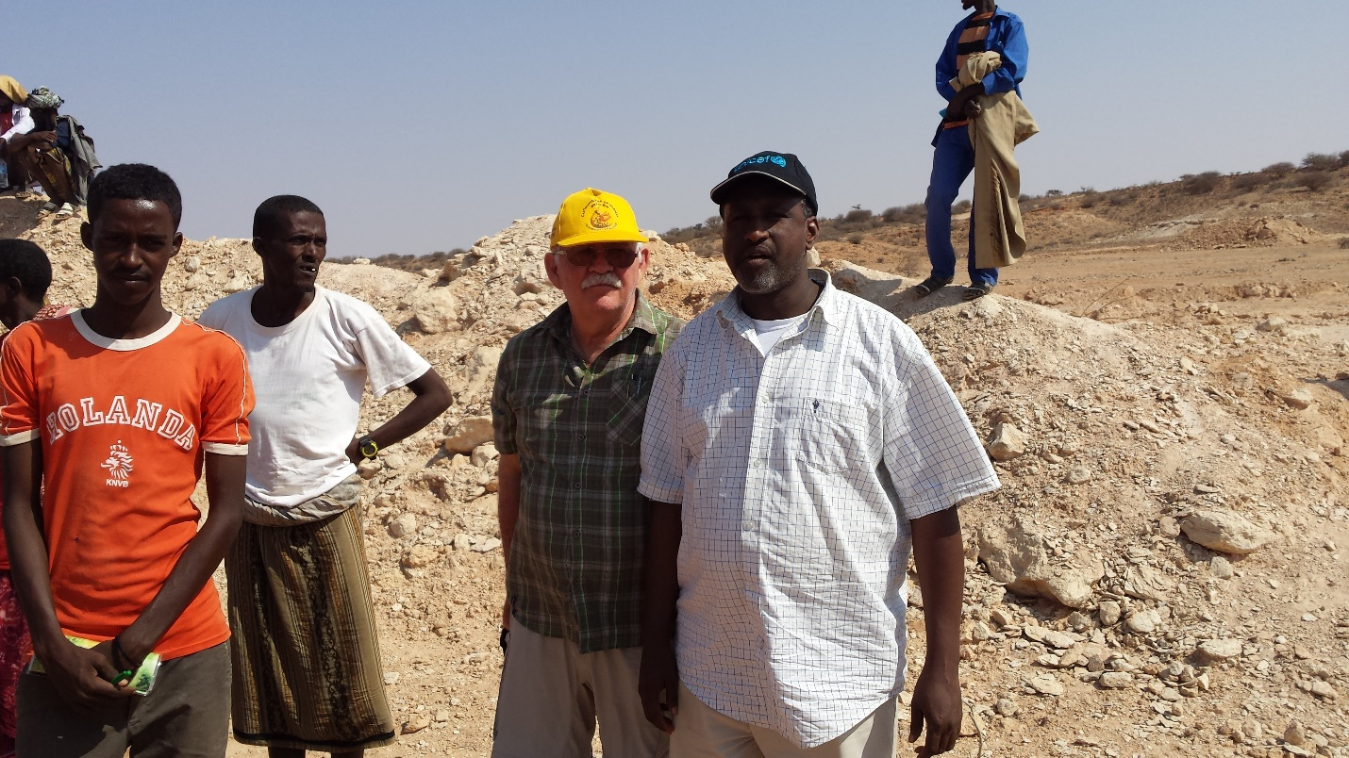

The Head of State, Mr. Siilaanyo, acknowledged already once on the helm of the country the need to have a distinct Ministry for Water Resources (MoWR). In June 2013, the MoWR was established & separated from the Ministry of Mining, Energy and Water Resources. The roles and responsibilities of MoWR have grown significantly since its creation. The MoWR’s operating budget has increased substantially for the current fiscal year 2017. Since its establishment, the MoWR has consolidated the relationship with many donors including the Somaliland Development Fund (SDF), the European Commission (EC), the Al Khalifa Foundation of United Arab Emirates, the German Development Bank (KFW), the World Bank & African Development Bank (AfDB), etc. just to name a few of them.
In June 2016, the AfDB Board of Directors approved the “Water Infrastructure Development for Resilience Program in Somaliland (WIDR)”. This was the first time the AfDB has offered a financial grant to the water sector in Somaliland. Care International is the implementing agency for the program, the MoWR is being the national lead organization for it.
The African Water Facility through the African Development Bank’s (AfDB) grant of € 3 million Somaliland is seeking to alleviate the stressed water situation and plan to set up the long-term water resources development plan. NIRAS and We Consult are commissioned to undertake the technical studies and come up with bankable projects for the water sector. NIRAS has completed phase one of the assignment.
Recently, MoWR welcomed a fact finding mission sent by Caritas Switzerland to assess emergency funding opportunities for hardest hit areas of Togdheer, Sool and Sanaag. On April 13, the mission went from Hargeisa up to Gar’adag and Fadhigaab (El Afweyn area) to witness the situation in one of the drought struck areas.
This is where the mission met the young boys and girls waiting for water brought in by the NGO Candlelight generously supported by Oxfam-UK. The situation is very dire in Fadhigaab 500 km east of Hargeisa. Children cannot attend school at this moment. They spend their days waiting for assistance to arrive, just to receive 45 litres of water for the entire Household family. The nearest functioning water point is some 70 km eastwards. Water is distributed free of charge, but is hardly sufficient.

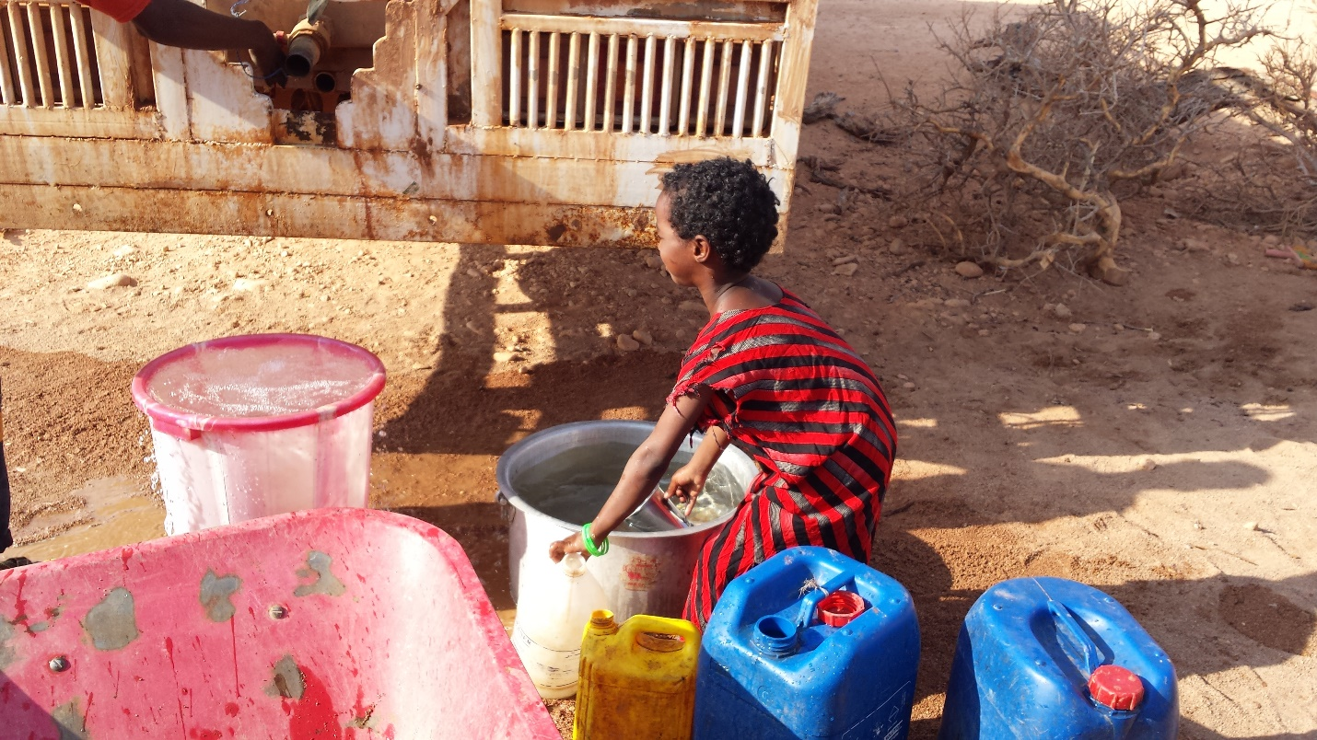

Finally, the mission met the Mayor of Gar’adag, Mr. Farah Aden. He is also chairman of the District Drought Committee. According to him the situation is very critical and the municipality is already preparing possible implications of the upcoming Gu season. There are already IDPs settlements in Gar’adag and its surroundings in the making. It is expected that those who have migrated as far as the Hawd area of Togdheer and into Puntland are coming back once the rain have come, unfortunately many of them without their previously own livestock. Mayor of Gar’adag is appealing to the international community and the Aid community to assist his drought affected communities. The area is one of the worst affected in Somaliland.

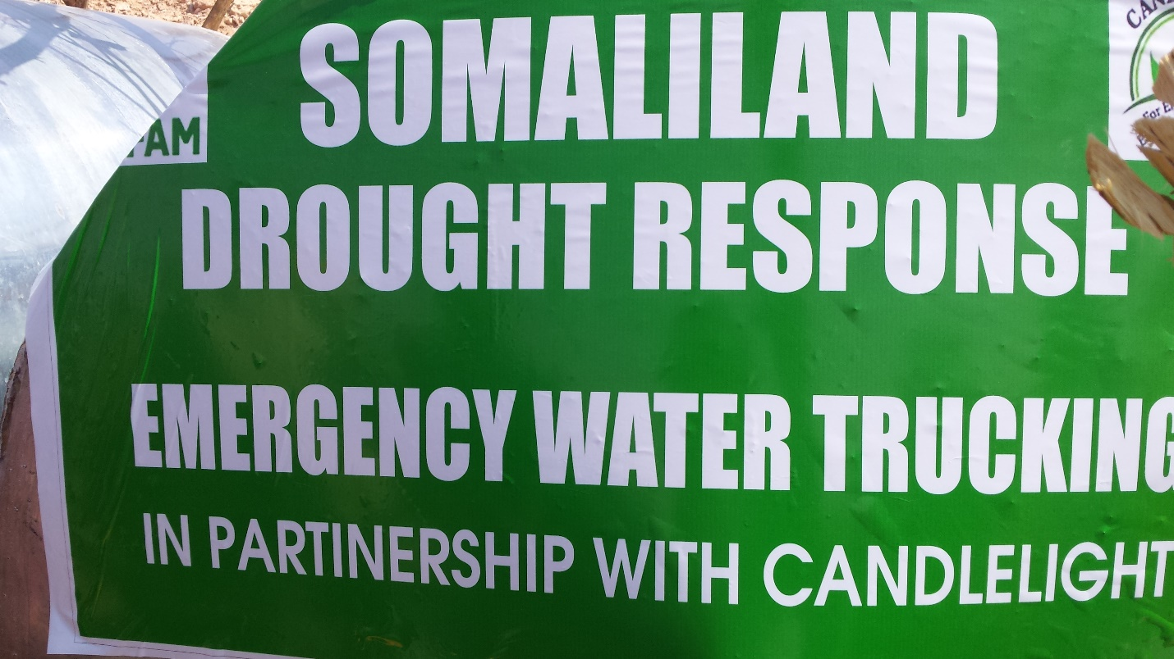

Faisal Hashi, MBA, is an independent consultant who writes on issues around development, Water, Hygiene & Sanitation (WASH) and is the founder and managing director of Adam Financial Consulting Services and is currently based in Hargeisa, Somaliland. He has worked for National City Bank, Bank One, J.P, Morgan Chase & City of Toronto as financial analyst in the US & Canada.
Hargeisa, Somaliland
He can be reached at: Hashi44@hotmail.com
www.somwash.com

