PROJECT REPORT ON SUSTAINED AGRICULTURE ORGANIC WATER FOR PLANT & FOOD HEALTH , TASTE
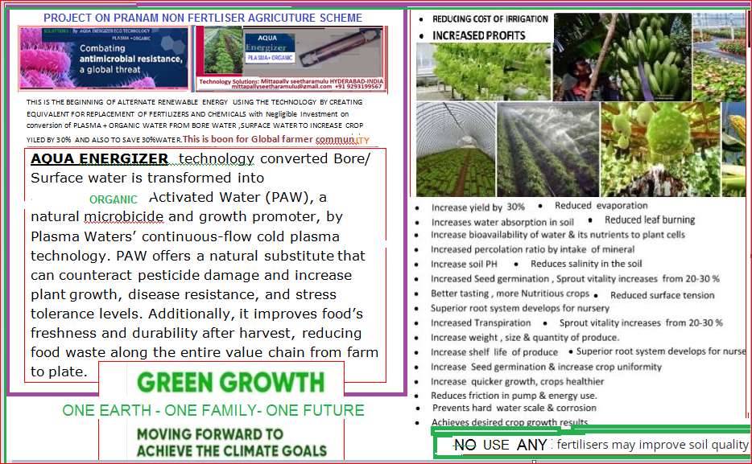

HOW IT WORKS Scientifically Proven Technology
AQUA ENERGIZER Catalytic core and vortex technology enhances permeation thus improving nutrient absorption, essentially creating the ultimate water with which living organisms can thrive. The process of liquid enrichment or activation is accomplished by circulating water or liquid through the specially engineered and blended proprietary
cores of catalytic components. The structuring action or vortex motion of the water through the chamber draws connatural energy from the catalytic cores and upon receipt by the molecules an activation of the water molecules occurs.
This process creates a structuring or clustering effect whereby the molecules become activated and energetic. The end result…a liquid that quite significantly propagates increased cell rejuvenation and growth leading to both short-term and long-term recognizable results in living organisms (human, animal, and plant life).
When water is circulated through and around the ceramic ores, resonation occurs enabling the water to become more soluble and absorbable. Through this action of water activation, living organisms also become activated, promoting better growth and health. Greenhouse raised egg plants and cucumbers utilizing our activated water have shown an increase in moisture and sugar content resulting in better flavor and healthier fruits, as well as an increase in production.
Every single cell in our body uses and needs water to fulfill its cellular purpose.
Eco-activated water provides our cells more H+ ions that can help preserve internal cellular water. This means that our cells maintain better water in their system, improving cellular function and optimum potential. Better hydration is one thing, but being hydrated with Eco-activated water not only improves cellular function but promotes optimal balance in the digestive tract enhancing self healing abilities and immune system strength.
For Plants:AQUA ENERGIZER spiral vortex flow and ceramic ores provide more H+ ions that can help preserve and increase internal cellular water. This means that the cells in plants will maintain better water in their system, improving cellular function and optimum growth potential. The clustering effect or reduction of space between the water molecules induced by the Catalytic cores on ant activation not only enhances the ability of organisms to absorb water but also effectively improves the plants ability to uptake and utilize nutrients. The plant will transpire (sweat) less allowing for a reduction of irrigation or watering needs by as much as 30-50% (water conservation).
permeate through the plants cellular membranes more readily, improving the plants intracellular water which allows the plant to uptake nutrients from the soil more efficiently.
The plants transpire less retaining more intracellular water within the plant effectively reducing watering needs by as much as 50%.
The plant grows faster and healthier becoming more disease resistant and less prone to attack by insects.
The fruits ripen sooner producing a higher yield with tastier and healthier fruits which contain more sugar content (Brix Index).
AQUA ENERGIZER remain in the cell with less water evaporation, allowing the produce to stay fresh and moist longer. More hydrogen remains in the cellular water which means the cells survive longer as intracellular water doesn’t go bad (anti-oxidation), less shrinkage and prolonged shelf life..For Animals / (Fish): Agriculture industry reports many benefits including a substantial decrease in odor (of fecal matter) in livestock operations utilizing the LifeWater ceramic ore technology for both cleaning and consumption.Results show that consumption of the ceramic enhanced water raised the grade and quality of the meat, antibiotics usage was decreased, and mortality rate was improved.In addition there are many other benefits to Eco-activated water.Agriculture: improves produce quality and quantity (Eggplant yield per acre increased 17.78%).
Improves freshness due to increased water retention of the plant.
Effectively sanitizes hot-house.
Livestock industry: chicken, pig, cow: sharp decrease in the livestock death rate (Pig death rate decreased to 3-5%) Sharp decrease in antibiotic usage.
Improves meat quality of livestock (1-2 class’s rise).
Great odor elimination results / reduction of ammonia in feces (stench decreases sharply).Effectively sanitizes livestock house.Reduces drainage processing cost.
Complete recovery of streptococcus in fish (10-20 days use).
Eliminates odor of fish in processing plant: removes fish oil adhesions.
After analysis of the water the results show that the surface tension of the water has been decreased. Not only that, the activated water evaporates at a reduced rate than normal water at room temperature. Substances mixed with the activated water such as fertilizers and pesticides effective on health of farm & Produced Food taste spoiled Richness changes.So, they can not be utilized The mixing ratio of additives can be lowered and effectiveness maintained as the surface tension of the water has been reduced. Soil also abnormal for plant growth.
.The Catalytic Core will last for a prolonged period of time (7-8yrs) without maintenance or replacement. Depending on the type of water utilized (high in mineral or iron content) occasional cleaning of the cores with ascorbic or citric acid is recommended at intervals ranging from 4 to 5 years. This ensures the ores do not become coated with substances adhere to the surface inhibiting the reduction and resonating effect of the catalytic core The cleaning process is neither complicated nor time consuming.
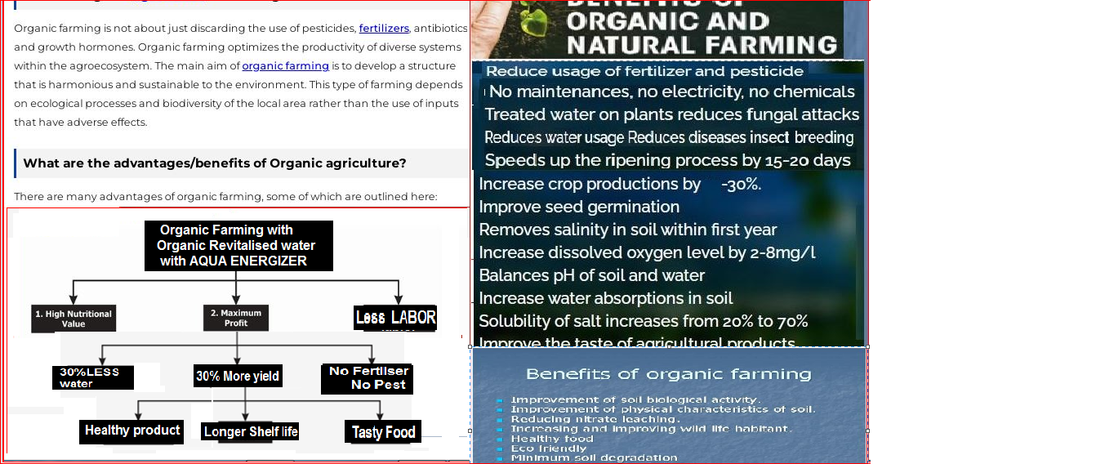
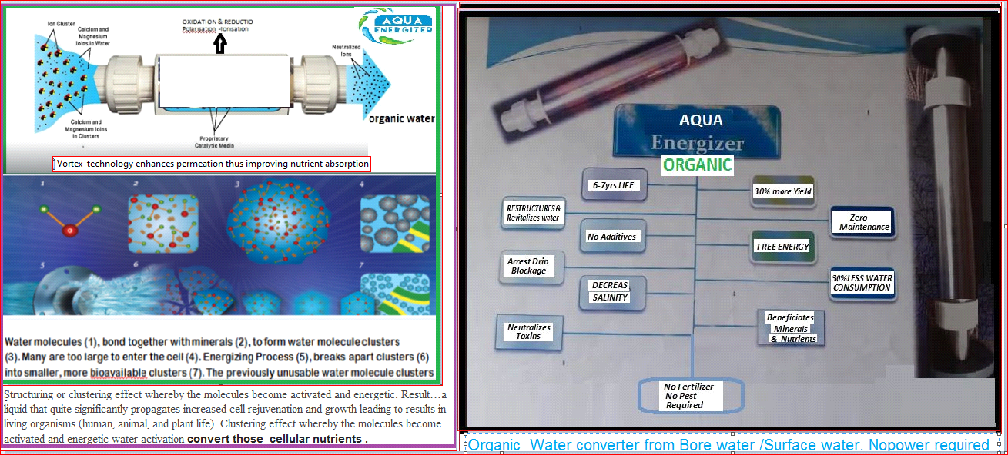
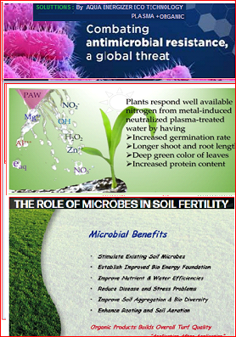

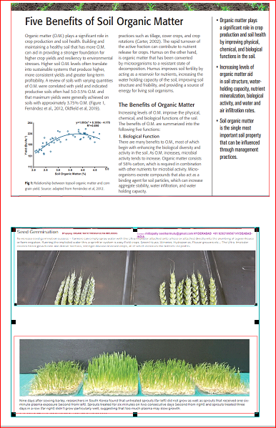
The energizer to be connected on line to the the crop feed water pipelinefor converting Organic water.
This project report prepared by Mittapally Seetharamulu ,Hyderabad –INDIA +91-9293199567 email: mittapallyseetharamulu@gmail.com

