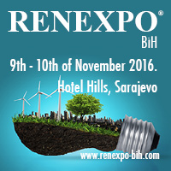 | 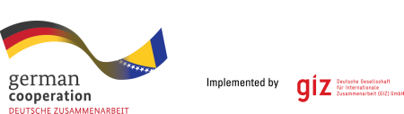  CO-ORGANIZER

CONFERENCE SPONSOR

Hydropower Conference
3 sessions: Small, Medium, Large
10th of November 2016
09:30 - 11:30 ; 12:00-14:30

SAFE THE DATE for the Hydropower Conference - 2016, in the framework of Western Balkans international renewable energy, energy efficiency, water and environment Trade Fair and Conferences RENEXPO® BiH, Sarajevo .

RENEXPO® BiH is the biggest platform for energy experts, where key players meet every year, in order to support their business, share trends, show innovation and be a voice in the society

Hydro Power Conference BiH in cooperation with GIZ - Deutsche Gesellschaft für internationale Zusammenarbeit GmbH.

Small, medium and large Hydro Power are the topics.

Representatives from the Ministry, as well as available projects and capacities, renovation of existing plants, Project Development, Engineering and Design, concessions, technologies and status on the existing situation in the Small Hydro Power sector and gap analysis.

The conference is the best opportunity to present your innovative technology, product and experience to the Western Balkan region, meet the industry and catch-up on new technological developments in the value chain from the experts!
Registration Fee per person/per conference
40,00 EUR
 | http://www.renexpo-bih.com/konferencije-registracija.html?&L=1
 | http://www.renexpo-bih.com/exhibitors.html?&L=1
 | http://www.renexpo-bih.com/visitors.html?&L=1
 | http://www.renexpo-bih.com/sponsoring.html?&L=1

Registration: Online registration for conference participation can be made starting with 1st of September at the www.renexpo-bih.com

Languages: English and Local. Simultaneous translation will be provided.

Target Audience: Operators, planners and consultants, energy suppliers and investors, financing professionals, research & science representatives, engineers, associations, local authorities / local public administration, diary industry, agri culture, investors

Planned topics: Political and legislative framework, regulatory demands, New Feed In tariffs, Technologies, Projects, Operating and maintenance, Measuring and control systems, Educational programmes, B2B meetings, Important environmental aspects, waste management (gasification), waste to energy and farming/agriculture
Publication: The lectures will be downloadable from the conference participants only, after the event.

Sponsorship: Be one of the main topics of the event!
Present your company as the main sponsor in the trade fair area or at the conferences. Sponsorship options range from key rings to the evening reception. Our varied sponsorship package caters for all budgets. Talk or write to us and we will discuss a tailor made solution.

 | Partners and Supporters  RENEXPO® BIH  http://www.renexpo-bih.com/index.php?id=657&L=0
Upcoming RENEXPO® in 2017

