Natural Desalination seawater model
In history, Maharashtra there are many forts in the sea island and inside the fort are sweet water without any external filter process. After studying history, am putting one natural desalination model of seawater.
Natural Desalination seawater model:
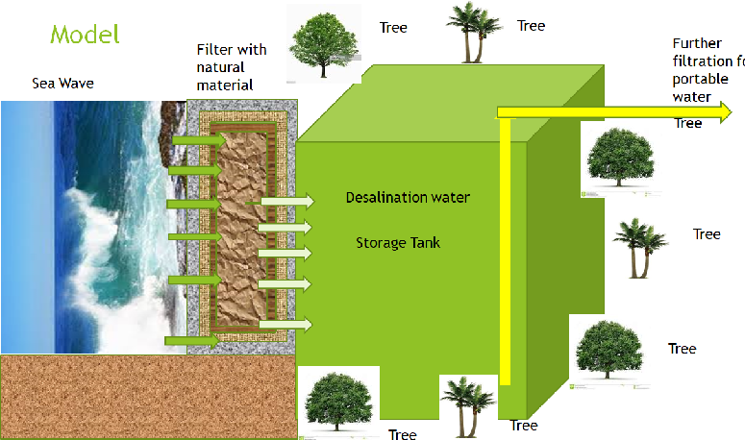
Working of the NDSW:
Filter wall will be constructed near the sea and current and wave will hit the filter wall. With the wave pressure sea water will hit on wall and it will pass through the wall.
Filter wall will be constructed with natural material and allow water passing through to collect it in one tank.
Around tank, put different types trees and allow root inside the water.
All different tree will be absorbed different minerals and reduce unwanted minerals. Finally, this water will use in WTP for further filtering for drinking water.
It will reduce operational cost and maintains cost.

