**Aqua-Saver the kinetic water valve guaranteed to save water**

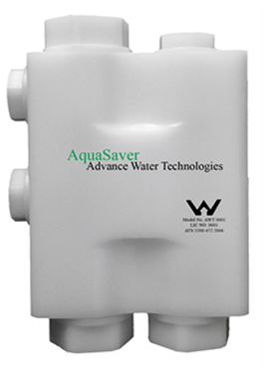 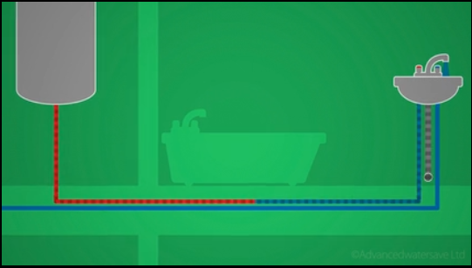 

**Needs no energy supply to save energy**

Is guaranteed to kinetically prevent the cold / tepid water running to waste while waiting for the hot water to arrive at the hot tap outlet. The product has a very simple kinetic / hydraulic action which diverts the cold / tepid water back to the boiler for reheating, or to a storage tank for non-potable use elsewhere, thus saving money for domestic, commercial and leisure water users alike. Aqua-Saver is the only fully automatic system in the world that is operated kinetically and automatically;- turn on the hot tap and it works! Aqua-Saver has passed all official testing, and has been extensively trialled. Has an excellent RoI.

**I am seeking help to manufacture and market Aqua-Saver system and my other patent applied for novel environmental products:-**

1. **Tri-brid natural energy generator**
2. **Atmospheric water generator using waste plastic bottles**
3. **Kinetic intensifier water presure needs no energy supply**
4. **Marine engine kinetic fuel saving booster;**

**Contact;**

