Ground water restoration plan for karachi, Pakistan

Table of Contents
Identify the effects of groundwater issues in Karachi: 3
Cost: 3
Recharge Resources: 3
Causes: 5
Impacts: 5
Identifying strategies: 5
Spreading Basins: 6
Recharge Pits and Shafts: 6
Ditches: 6
Recharge Wells: 6
Subsurface Dams: 7
Farm Ponds: 7
Historical Large Well across Streamlet: 7
Check Dams: 7
Injection Wells: 7
Hypothesis and Working of potential solution/s (based on calculations) 7
Geology of Karachi: 8
Hydrogeology of Karachi: 8
Solution: 9
Basin Design Size: 10
Infiltration Equation: 11
Working: 11
Implementation: 11
Areas of implementation: 11
Outcomes: 12
References: 12

Identify the effects of groundwater issues in Karachi:

According to Pakistan Bureau of Statistics, Karachi’s population has grown to 14.91 million. Karachi is a mega city of Pakistan which requires more than 1,000 million gallons of water per day for fulfilling the water need of its high population. A few years ago, only summer seasons witnessed water shortage in Karachi but now, the citizens have to face water-related crisis in all seasons. The worst hit areas are Defence, Lyari, Gulistan-e- Johar, Gulshan-e-Iqbal, Landhi, Malir, Korangi, Orangi, North Nazimabad, North Karachi, New Karachi and many other localities.
Most of the areas of Karachi depend completely on groundwater. The exploitation of groundwater at a very high rate has led to the decline of groundwater depth from 600 feet to 1,200 feet in last three years. Bore and Bore Company’s Project Manager Hydro-geologist Israr Hussain said, “The increasing number of industrial establishments in SITE and Korangi and increased consumption of underground water by these industries and lesser rains are the cause of decline in underground water level”. The 1985 water supply master plan study made a review of all potential water resources in the Karachi region including groundwater. This review concluded that other groundwater sources in the region were of relatively small magnitude with the total potential yield of all the groundwater sources within 100 km of Karachi being as insignificant as 4 mgd (18,000 ${ m}^{3}/d$)

Cost:
As the groundwater level is decreasing, the groundwater extraction cost is increasing. Boring companies charge Rs350 per feet in the area of Nazimabad in district Central and Rs800 at around sea view. The difference in prices is because boring companies use hydraulic bore at the former area while they use a drill machine at the latter because there are big rocks underneath the earth’s surface.
Boring rates in DHA are:
- Well digging charges Rs. 3000 per feet approximately
- Mechanized Boring: Boring machine shifting charges: Rs. 5000 and Boring charges Rs. 700 per feet approximately
- Manual Boring: Rs. 75000

Recharge Resources:
Level of underground water remains unchanged if it rains regularly, but this is not the case. Karachi experience dry spells most of the time in the city. Presently, Karachi is known to have five sources of recharge to its groundwater reserves. These are:
- Rainfall,
- Indus River water supply ,
- Hab-River & Hab Lake water supply;
- Polluted Layari and Malir rivers/ contributory channels draining mixtures of domestic, industrial and agricultural wastewater,
- Seawater.
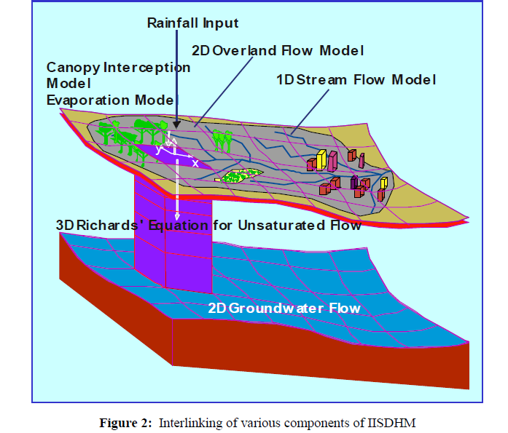
The possibilities of major contribution to groundwater recharge of shallow aquifer directly by local rainfall seems very small, due to very poor frequency of rainfall events and rainfall intensities in the Karachi and high evaporation rates. Total average annual rain fall in Karachi city is about 200mm per year based on the last 50 years record. The 70 percent of the precipitation on land is lost. Only remaining 25 percent penetrates downward to the aquifers.
Water Balance Equation for groundwater:
$$precipitation-evaporation-runoff=infiltration (R_{g})$$
200 mm – 140mm = infiltration
60mm = infiltration or groundwater recharge
In the later half of the 19th century, water for Karachi was supplied from the Dumlottee Well Field, located on the banks of Malir River in the Dumlottee area about 30 km to the northeast of the city. A number of large diameter shallow wells constructed in the Malir river alluvium provided about 8 mgd (36,340 $m^{3}/d$ ) of water to Karachi through a gravity conduit. For many years since then, the well field remained as the main source of supply for Karachi. The capacity of the system was increased to 20 mgd (90,800$m^{3}/d$) in 1923 by adding some more wells, a 15 mgd gravity conduit and two 6 mgd reservoirs. However, the supply from this system has gradually decreased over time to 4 mgd by 1985, and to 1.5 mgd in 2002 and afterwards. At present, this system can produce merely 1.4 mgd (6,300${ m}^{3}/d$) of water during only a few months after the rainy season. The system is almost dry in the rest of the year. Excessive quarrying of sand from the river bed of Malir River combined with the extensive use of groundwater by farmers in the area is considered to be the main reason for the depletion of the well yield. The overall picture of the Dumlottee Well Field is that it is no longer a reliable source of supply for Karachi.

Causes:
In Karachi, freshwater resources are very few. A number of people are not only extracting water for their own consumption, but for commercial purposes as well. Prolonged over-pumping of groundwater, or other alterations of the natural equilibrium between recharge and discharge regimes in Karachi has lead to decrease in water table specially in Clifton, Korangi, DHA and other coastal areas. Another reason for depletion is that rapid increase of settlements in these parts, affect the water being supplied. The alternative switch over to groundwater has intensively exploited the groundwater.

Impacts:
Groundwater in Karachi contains arsenic, chromium and mercury which are carcinogenic. There are no proper dumping grounds for waste in the country, therefore, all that waste goes in the soil and makes groundwater more harmful. It even carries bacteria. It could be used once it is purified by a reliable source. Even if we make it drinkable, extraction of too much of it makes earth collapse. Coastal areas have more salinity. High quantity of salt affects the performance of kidneys and eventually fails them. Calcium, magnesium, sulfate and chloride are some of the other elements responsible for destroying the quality of water.
Consequences of groundwater extraction are water level goes down. Water is a natural resource and is as precious as oil. We are depleting this natural resource by extracting water, and thus affecting our future generation. Foundations of houses weaken if too much of water is sucked out, death of people occur due to water scarcity and closing of many small scale industries that depend on groundwater. Even if the government enacts one, it is not possible to implement it keeping in view the booming population of Karachi. The government cannot go door to door and check if a well is dug inside a house. Low levels of groundwater near coastal areas may cause sea water intrusion. Seawater intrusion results in the contamination of coastal aquifers and therefore a reduction in the available water for human consumption and agriculture.

Identifying strategies:
Artificial ground water recharge is important to maintain natural groundwater as a resource, to coordinate the operation of surface and sub surface reservoirs and to overcome adverse conditions like progressive lowering of groundwater level and undesirable salinity balance in water. Groundwater recharge can be either a natural or an artificial process. The natural recharge occurs when it stems from the direct infiltration of rainfall or from the water percolation of adjacent water bodies, and the artificial recharge when it is induced by human activity such as irrigation, urbanization, construction of injection boreholes or river spreading.
Depending on the route followed by percolating water towards the water table, recharge can be classified as direct recharge when talking about diffuse infiltration of recharge water towards groundwater, or as indirect recharge when along river and other main channels.

Spreading Basins:
This method involves surface flooding of water in basins that are excavated in the existing terrain. For effective recharge highly permeable soils are suitable and maintenance of a layer of water over the highly permeable soil is necessary. When direct discharge is practiced the amount of water entering the aquifer depends on three factors—the infiltration rate, the percolation rate, and the capacity for horizontal water movement.
At the surface of aquifer, however, clogging occurs by deposition of particles carried by water in suspension or in solution, by algae growth, colloidal swelling and soil dispersion, microbial activity, etc. Recharge by spreading basins is most effective where there is layer below the land surface and the aquifer and where clear water is available for recharge.

Recharge Pits and Shafts:
Conditions that permit surface flooding methods for artificial recharge are relatively rare. Often lenses of low permeability lie between the land surface and water table. In such situation artificial recharge systems such as pits and shafts could be effective in order to access the dewatered aquifer. The rate of recharge has been being found to increase as the side slope of the pits increased.
Unfiltered runoff water leaves a thin film of sediments on the sides and bottom of the pits, which require maintenance in order to sustain the high recharge rates. Shafts may be circular, rectangular or square cross-section and may be back filled by porous materials. Excavation may be terminating above the water table. Recharge rates in both shafts and pits may decrease with time due to accumulation of fine-grained materials and the plugging effect brought by microbial activity.

Ditches:
A ditch is described as a long narrow trench, with its bottom width less than its depth. A ditch system is designed to suit topographic and geological condition that exists at the given site. A layout for a ditch and flooding recharge project could include a series of trenches running down the topographic slope. The ditches could terminate in a collection ditch designed to carry away the water that does not infiltrate in order to avoid ponding and to reduce the accumulation of fine materials.

Recharge Wells:
Recharge or injection wells are used to directly recharge the deep-water bearing strata. Recharge wells could be dug through the material overlaying the aquifer and if the earth materials are unconsolidated, a screen can be placed in the well in zone of injection.
Recharge wells are suitable only in areas where thick impervious layer exists between the surface of the soil and the aquifer to be replenished. They are also advantageous in areas where land is scarce. A relatively high rate of recharge can be attained by this method. Clogging of the well screen or aquifer may lead to excessive buildup of water level in the recharge well.

Subsurface Dams:
Ground water moves from higher-pressure head to lower one. This will help in semi-arid zone regions especially in upper reaches where the ground water velocity is high. By exploiting more ground water in upper reaches more surface water can be utilized indirectly, thereby reducing inflow into lower reaches of supply. Ground water is stored either in natural aquifer materials in sub-surface dams or in artificial sand storage dam.

Farm Ponds:
These are traditional structures in rain water harvesting. Farm ponds are small storage structures collecting and storing runoff waste for drinking as well as irrigation purposes. As per the method of construction and their suitability for different topographic conditions farm ponds are classified into three categories such as excavated farm ponds suited for flat topography, embankment ponds suited for hilly and ragged terrains and excavated cum embankment type ponds. Selection of location of farm ponds depend on several factors such as rainfall, land topography, soil type, texture, permeability, water holding capacity, land-use pattern, etc.

Historical Large Well across Streamlet:
If any historical wells are located near the streamlet, then allow the water into the well from streamlet by connecting drains. In this case the historical wells act as a recharge well so that ground water can be improved.

Check Dams:
Check dams are small barriers built across the direction of water flow on shallow river and streams for the purpose of rain water harvesting. The small dams retain excess water flow during monsoon rains in a small catchment area behind the structure.
Pressures created in the catchments area send the impounded water into the ground. The major environmental benefit is the replenishment of nearby ground water reserves and wells. The most common case of check dams is to decrease the slope and velocity of a stream to control erosion.
Injection Wells:
An injection well is a device that places fluid deep underground into porous rock formations, such as sandstone or limestone, or into or below the shallow soil layer. The fluid may be water, wastewater, brine (salt water), or water mixed with chemicals.

Hypothesis and Working of potential solution/s (based on calculations)

Geology of Karachi:
The soil of Karachi is rich in salts including sodium chloride, sodium carbonate and nitrates with some calcium, which comes from shell fragments. Generally the thickness of soils increases in the south‐east direction (Hamid et al, 2014). The maximum thickness of soils developed on alluvial deposits and dissected plateau are noted in some areas including Korangi. The trend of subsurface rocks is north‐east and south‐west orientations (Hamid et al, 2014). The vertical section up to the depth of 500 ft revealed that the rocks are mainly composed of silty sand with subordinate clayey layers. The sand is highly conductive and transmissive.
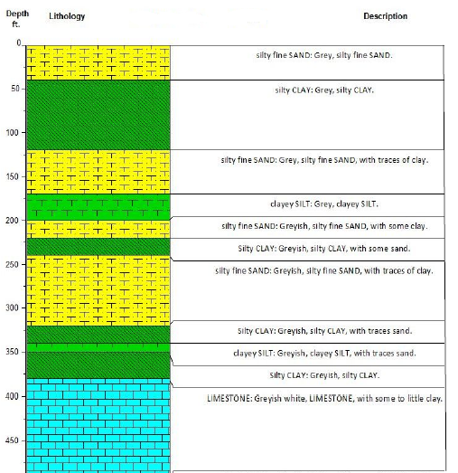

Hydrogeology of Karachi:
Hydrogeologically, Karachi lies in Malir River basin it is bounded by Hub River in the
west and Malir River on east. Malir basin is mainly drained by the Malir River followed by
the Lyari channel. Hub River follows on the western margin of the city which is temporary in nature but it is devoid of any sewage or anthropogenic influences. The coastal aquifers of Karachi are mainly recharged by Malir or Lyari Rivers (Mashiatullah, 2002) with same contribution from Hub River. Hub River is recharging the confined aquifers of Tertiary age (Nari and Gaj formations) while Malir and Lyari Rivers are mainly recharging alluvial aquifers of Quaternary age in the coastal parts of Karachi city.
As discussed earlier that groundwater of Karachi is mostly contaminated. This contamination is present in high levels in industrial areas. So before taking step to recharge the groundwater, firstly we have to combat with the contamination. Keeping in view the soil strata and budget allotted to water authorities of Karachi we propose an economical solution of treatment that is
- Biological treatment, which includes bioaugmentation, bioventing, biosparging, bioslurping, phytoremediation and some types of permeable reactive barriers.
Once the groundwater has been treated now it’s the time to recharge groundwater so that
Exploitation = Replenishment
Before implementing the best solution/technology for recharge certain factors have to be considered like:
- Location of geologic and hydraulic boundaries
- Depth of the aquifer and transmissivity of the overlying material
- Lithology
- Storage capacity
- Porosity
- Hydraulic conductivity and natural in- and outflow of water to/from the aquifer
- Availability of land, surrounding land use and topography
- Economic and legal aspects concerning the recharge
- Degree of public acceptance

Solution:
Considering the above discussed geological and hydrological conditions of Karachi the best solution for artificial groundwater recharge is recharge basins.
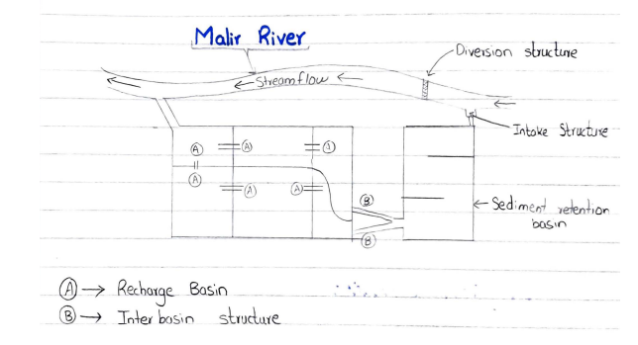
This method involves surface spreading of water in basins that are excavated in the existing terrain near the water bodies. Groundwater replenishment by means of recharge basins generally takes place through the unsaturated soil zone above the groundwater level. The process of water flow to and through an unsaturated soil is termed as infiltration. Infiltration is an unsteady-state process of flow, meaning that the flow rate varies with time under a given head.. The advantages of this method are:
- Reduces the volume of runoff from the drainage area.
- Located near the water bodies so that if flood comes it acts as a storage basin.
- Simple and cost effective to construct.
- Changes in performance are easy to observe.
- Minimum changes of bacterial contamination of groundwater because soil provides filtration facility to the water.
- Enhance the natural capacity of soil to infiltrate the water.
If we talk about the performance of recharge basins they have good water quality treatment, ecological potential and recharge potential. The amount of water infiltrated depends on infiltration potential of soil and storage capacity depends on the bulk density of the filled material.
These recharge basins also provide treatment facility to the percolating water by adsorbing chemicals present in water onto the soil and also providing biological treatment.
Infiltration basins are easy to construct, it can be planted with trees, shrubs to improve the aesthetics of the area and provide habitat for wildlife.
Maintenance of recharge basins is required to regularly inspect the clogging and fouling.

Basin Design Size:
Basin designs can be developed using two different approaches. Approach I deals with the case where available land is limited in area or a basin is to be sized with a given top surface area and a peak operating head to be determined. Approach II deals with the case where a basin is to be designed at a given peak operating head.

Infiltration Equation:
The cumulative infiltration quantity is give by:
Q = 2kt Af (H/2 + ψn) √ (t / π α)
Where
Q = cumulative infiltration flow at any time t,
ψn = capillary suction potential at natural drained moisture content prior to infiltration
α = hydraulic diffusivity
kt = hydraulic conductivity
H = maximum basin operating head, and
Af = plane flow area which is defined as the horizontal plan area of the basin at depth of H/2.

Working:
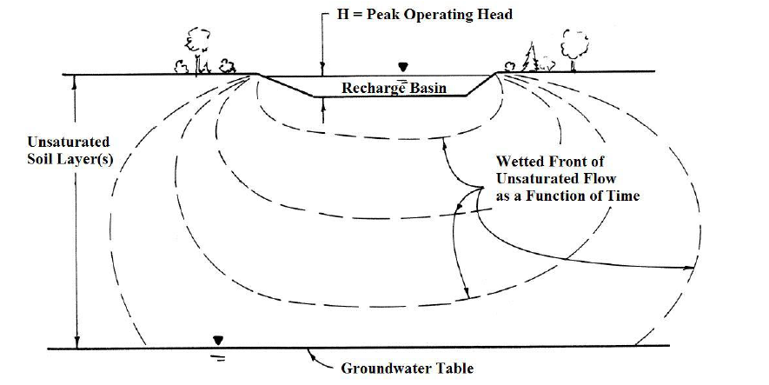

Implementation:
Any action plan for water supply cannot be implemented until the government shows its involvement.
Because of the technical complexity involved in siting and regulating artificial recharge, this technology is generally implemented at the governmental level.

Areas of implementation:
- Coastal Areas
- Along the river Malir and river Lyari embankment.
- Industrial areas like Korangi so that industries dump their treated wastewater into recharge basins.
- Areas where rainfall is expected to be high as compared to other areas.
Keeping in view the water supply and water shortage conditions in Karachi the responsibilities of companies working in Karachi like Karachi Water and Sewerage Board are:
- To extract groundwater from near the recharge basins and supply it to people.
- Implement strict laws for people who are illegally extracting groundwater.
- Implement ban on borings in houses and extraction of fresh groundwater for industrial or agricultural use.
- Charge a reasonable amount on per liter of water.

Outcomes:
Artificial recharging of groundwater by recharge basins will bring the water tables up. It will reduce the sea water intrusion near coastal areas, and will reduce the water shortage threat in Karachi. Recharging of groundwater in Karachi will bring the productivity of soil in Karachi back and will reduce the dry spells.

References:
- https://www.researchgate.net/publication/321306303_Assessment_of_Floods_and_Hazard_Analysis_for_the_City_of_Karachi_using_Simulation_Models
- https://tribune.com.pk/story/248987/kwsb-faces-shortage-of-funds/
- https://en.wikipedia.org/wiki/Climate_of_Karachi
- https://fenix.tecnico.ulisboa.pt/downloadFile/1970943312278793/GROUNDWATER%20RECHARGE.pdf
- https://www.sawayra.org/wp-content/uploads/2016/04/Karachi-Ground-Water-Analysis.pdf
- http://archive.sswm.info/es/category/implementation-tools/reuse-and-recharge/hardware/recharge-and-disposal/groundwater-rechar-0
- labs1.tribune.com.pk/aqua-final/kwsb-master-plan-jica.pdf

