Case study of watershed in southeast west of Iran and location of two earth dam.

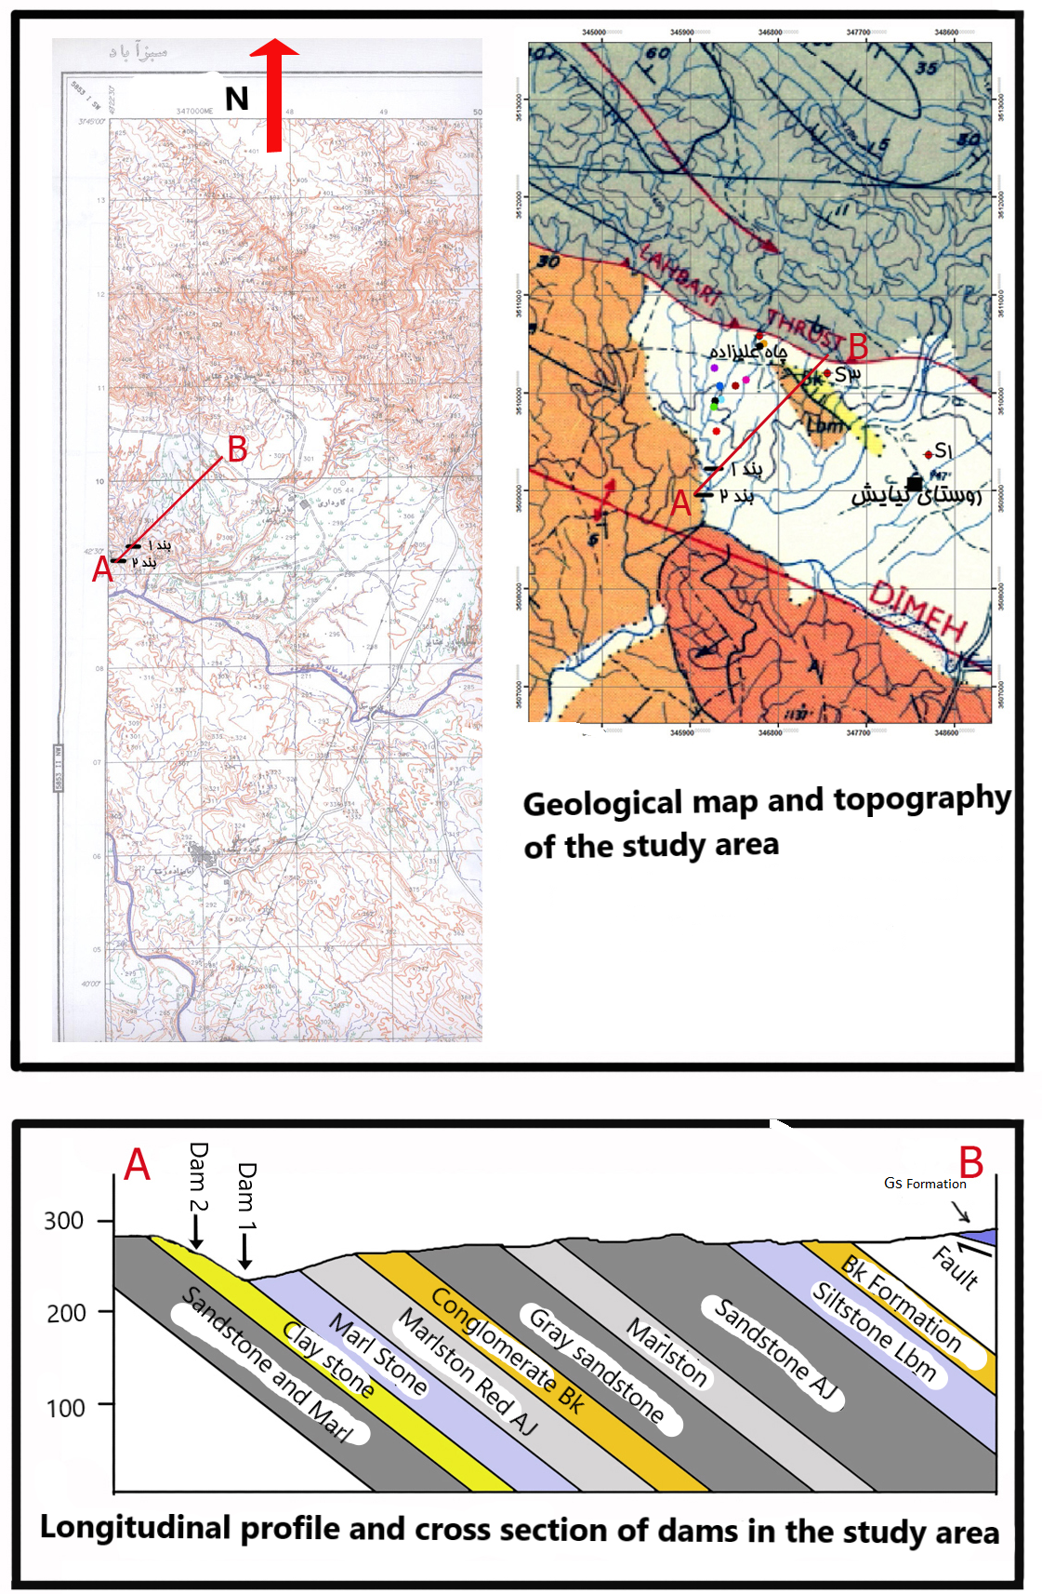
Due to recent droughts, a case study was conducted to prevent runoff, surface water and soil stabilization.
The catchment area for the proposed dams (with a height of 17 meters) is 1031250 m², 2062500 m ², respectively, and the average annual rainfall is about 300 mm, considering 10% of water infiltration, runoff from surface runoff is about 200000 m³ to 400000 m³.
Geologically, we have most of the formations belonging to Fars group and include Gachsaran formations (with evaporative sediment lithology), Mishan (with lithology of marl limestone), Aghajari (with lithology of sandstone, red marl and silt), Lahbari section (with lithology of pea-colored silt), Bakhtiari (with lithology of conglomerate) Which have been deposited as a progressive sequence from the Early Miocene to Pleistocene and both dams are located on Aghajari Formation.
From a geomorphological point of view, the soil of this region has been erodible, which has led to the formation of gullies, moat erosions and deepening of young valleys.

