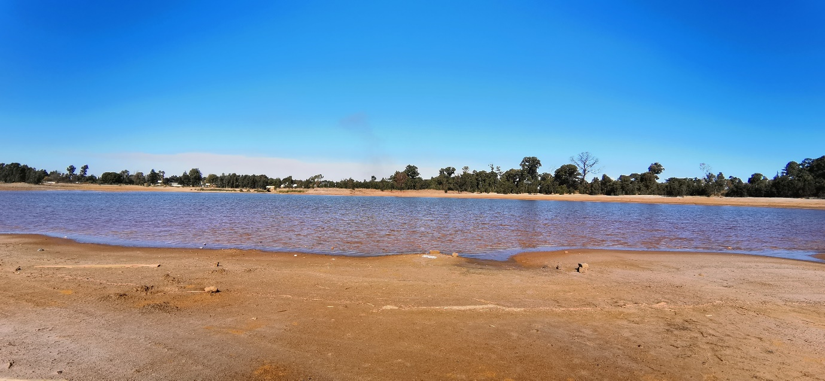
Robinson Dam in May 2022

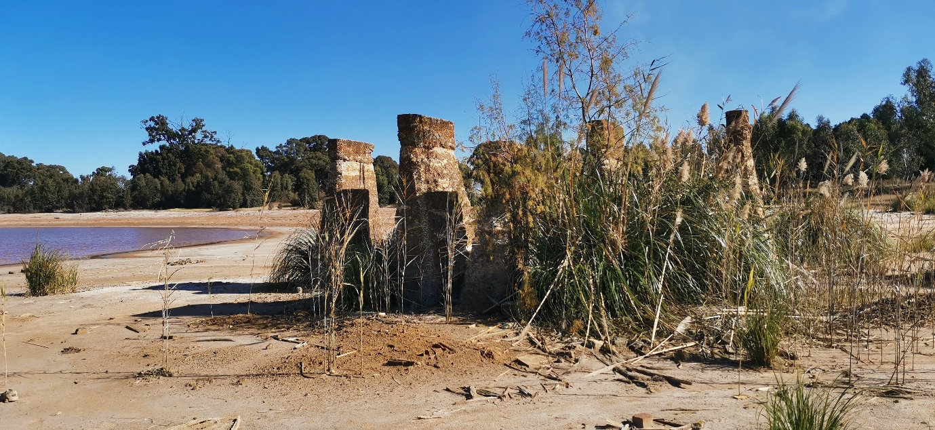
Old structures within the lake

5th June 2022
Update on the Radiation-Contaminated Robinson Dam
I haven’t seen the state of the dam for some time, but heard that it had dried up, so I thought I should go and have a look and update my information and post an update for anyone who may be interested.
The soil is orange in colour and has white streaks. It is rocky, but the rocks are friable. There is a lot of Pampas grass, suggesting the presence of gold ore. The soil is soft and fine and easily depressed by a footstep.
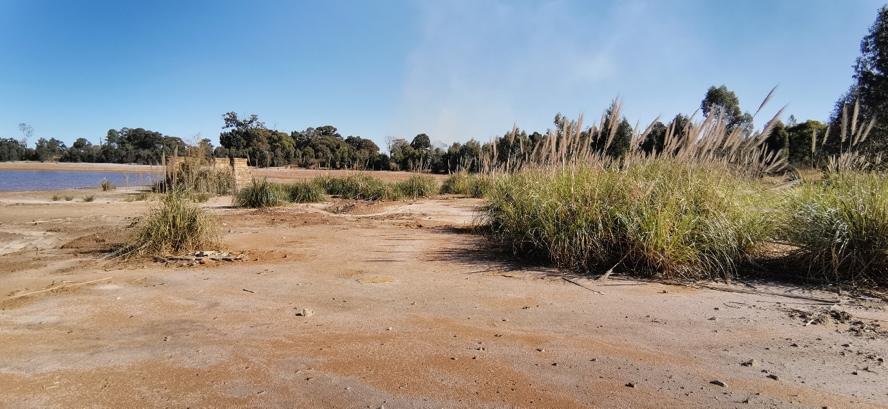
Dam and Pampas greass
Without testing of the water, soil and air, we do not know if the problem of uranium poisoning of the environment is still a major issue, but as far as I can tell from the environmental markers, the pollution is still in effect. There is no evidence of bird or animal life in the area, a significant marker that there is contamination present.
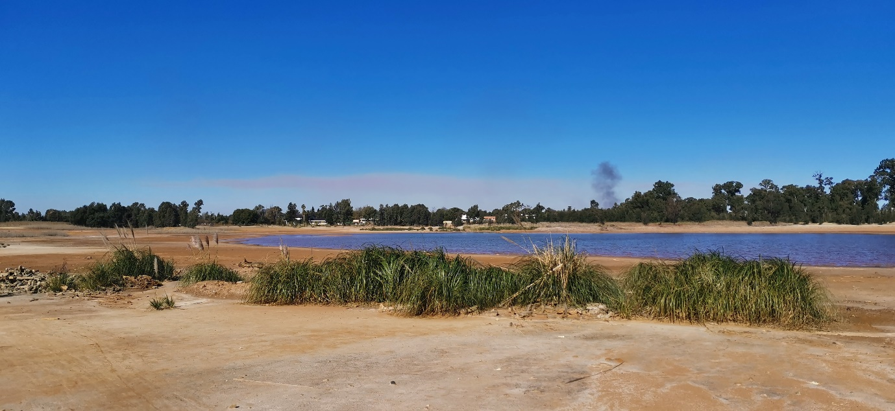
Dam and plant growth

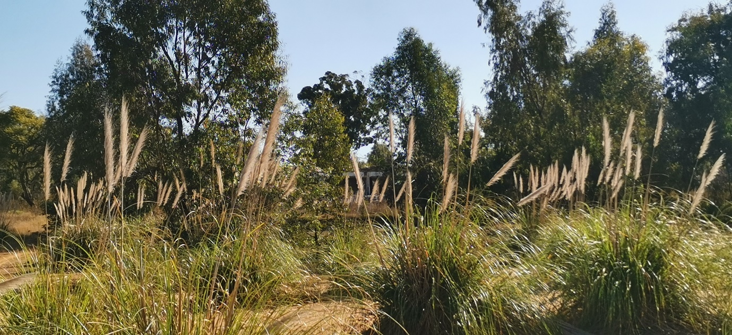
Treeline surrounding the dam

