Dear Advertisers,
Greetings from Water Today!
We are delighted to inform you that we are working on our 11th Annual Edition of WATER PAGES 2016. Every year Water Today published WATER PAGES, a comprehensive annual directory exclusively catering to Water and Wastewater Industry. Here is a once in a year opportunity to grow your business and mark your presence, so don’t miss the chance to be in this Special Annual Edition!
We would like to invite you to advertise in this special edition and promote your brand. By advertising in the special edition of WATER PAGES 2016, you will have multiple benefits:
- One-year shelf life of your relevant information on products and services offered
- Enhance your presence with our reach in the water fraternity
- Water Pages is the perfect handbook within water industry
- An exhaustive alphabetic and product-wise list of suppliers and service providers
- Soaring circulation of WATER PAGES globally during Water Today’s participation in international shows
- Presents unique business opportunities for water solutions service providers.
Water Pages 2016 will be your access key to water and wastewater professionals, as it is the Yellow Pages for the water fraternity with maximum reach and readership. Advertising options range from Rs. 2,750 to Rs.150,000!
Premium Listing is paid listing about your company’s information in the form of advertisement. You have two options to choose: Premium two-colour listing and Premium four-colour listing.
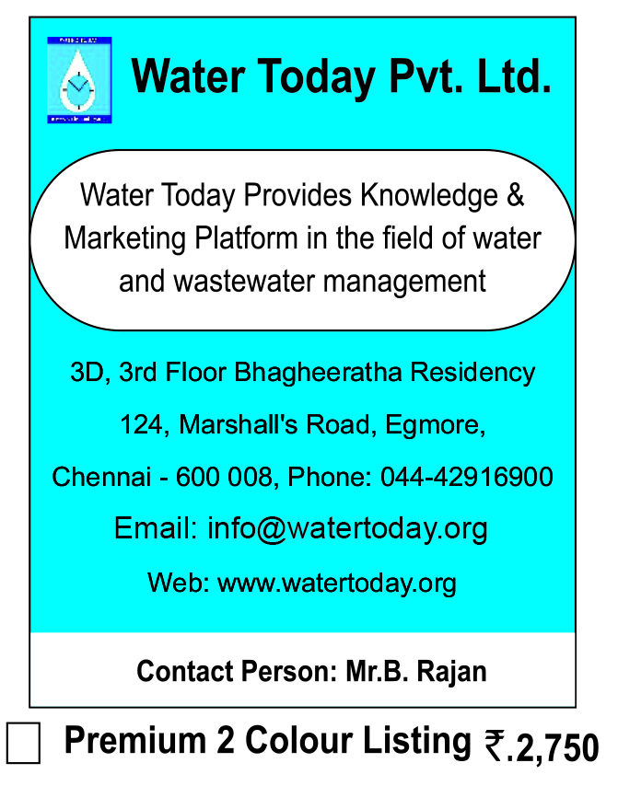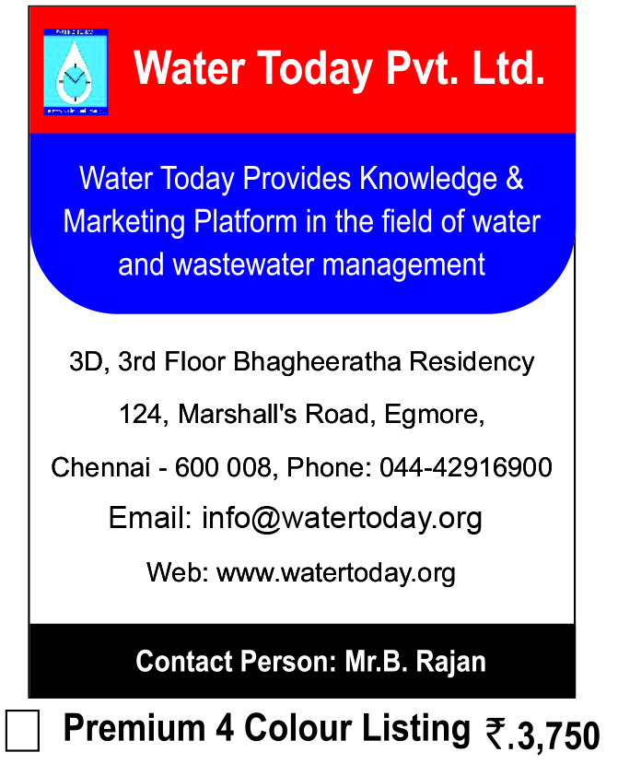
Basic Listing is free listing about your company’s contact information and category-wise business listing.
* Please note that you can choose either premium or basic listing.
About us
Water Today - The Magazine is India’s leading monthly publication providing relevant and up-to-date information that serves engineers, managers and consultants in the Water and Wastewater Industry worldwide. The magazine focuses on bridging knowledge gap across the water industry and promotes interactions geared towards better understanding of the products, technologies and services available in the market, so that you can find the best solutions for managing your Water and Wastewater.
Write to us for advertisement & listing I To subscribe Click here
For more details call us on +91 44 42916900

