Optimisation of an Activated Sludge SBR system

- 50% Energy consumption reduction.
- 50% Hydraulic throughput rate increase.
- Improved compliance reliability.

The Surge Anoxic Mix Sequencing Batch Reactor system installed at Cookstown WWTP in Northern Ireland was optimised by Strathkelvin Instruments Ltd utilising their ASP-Con (Activated Sludge Plant Controller) system. In this application the ASP-Con system is used to measure when the Biodegradable load (by measuring Oxygen Uptake Rate – OUR and Ammonium) is completely removed during each aeration cycle. Once this has been confirmed as complete the ASP-Con system takes a sample to measure the MLSS and then the SVI in each basin. The SBR control software for the basin is then stepped on to complete the settle and decant phases before being allowed to idle until the level in the Anoxic basin requires the fill/aerate cycle to restart.
This SBR basins were therefore optimised by
- Ensuring biodegradable load is completely removed during each aeration cycle.
- Avoiding excessive energy consumption by avoiding overtreatment of wastewaters.
- Maximising hydraulic throughput by maximising treatment basin availability.
- Monitoring biological measures of performance to avoid long-term issues.

SCADA system output comparing non-optimised and optimised basins over same time period.
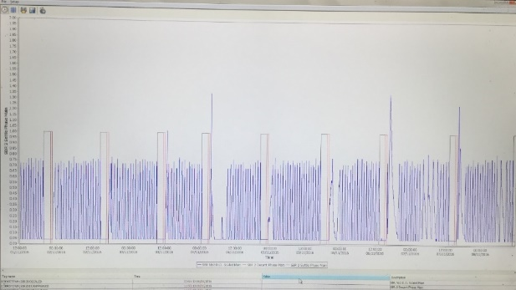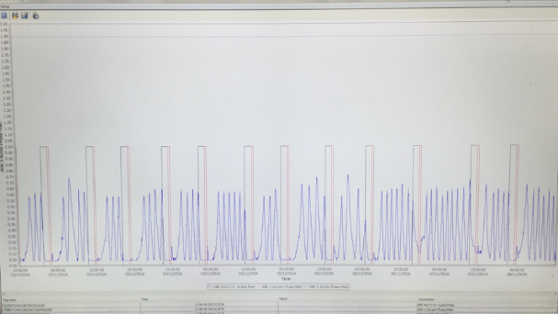
Non-Optimised
8 fixed volume cycles
12-14 Aerations per cycle
Optimised
12 fixed volume cycles
3-8 Aerations per cycle
PLC system set-up and display
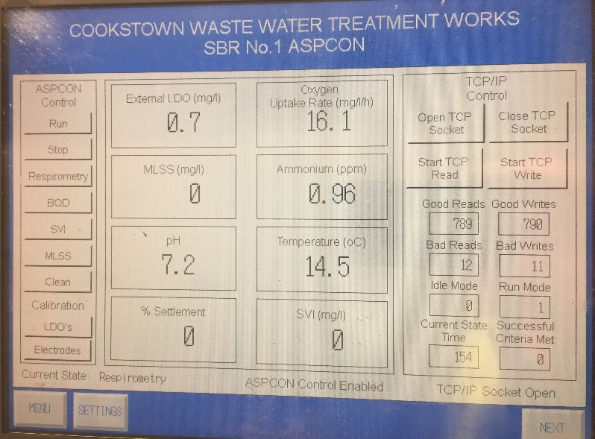
Site Energy Usage Before and After Optimisation Program Implemented.
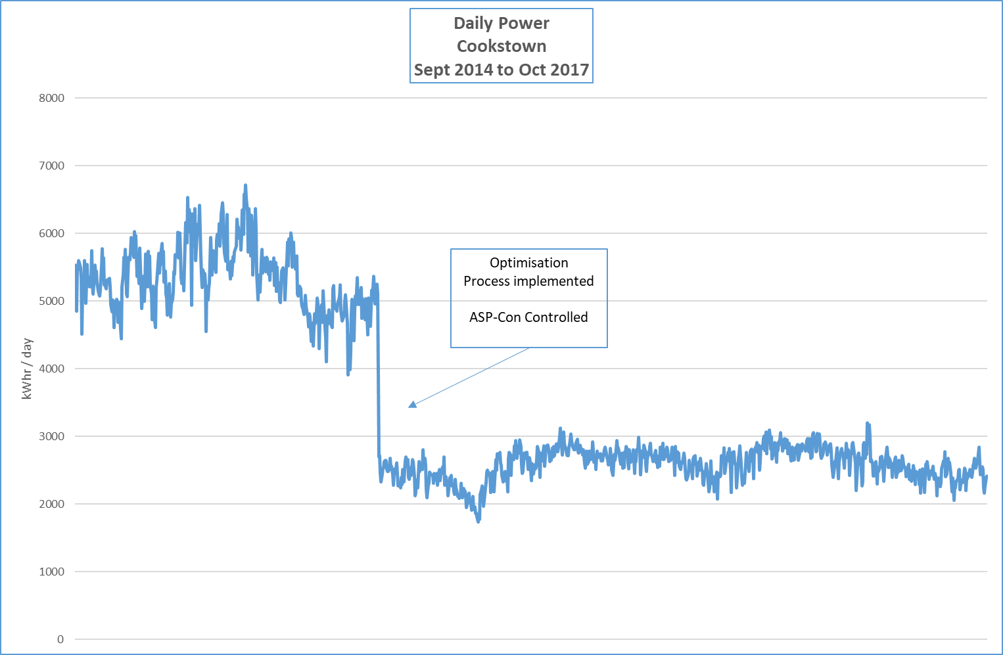

Site Operations and Management Team report that site reliability has improved substantially as a result of the optimisation project. The number of times the site storm tanks are called into operation has also significantly reduced. Eliminating overtreatment has improved settlement in the basins and reduced floating scum on the tank surfaces.

For more information contact: clare.dooley@strathkelvin.com
ASP-Con information can be found at www.strathkelvin.com/asp-con
Further examples can be found in our webinar https://youtu.be/GegIgmj9vvc

