THE RELATIONSHIP BETWEEN HYDRO-CLIMATIC VARIABLES AND E. COLI CONCENTRATIONS IN SURFACE AND DRINKING WATER OF THE RIVER KABUL BASIN IN PAKISTAN.

Iqbal MS¹, Hofstra N¹.
¹Environmental System Analysis Group, Department of Environmental Sciences. Wageningen University and Research Centre, The Netherlands.

Introduction
Diarrhoea is the second main reason of death in under developed countries (Cloete 2004, Mathers, Fat et al. 2008). Worldwide, diarrhoea remains a major public health problem (Lloyd, Kovats et al. 2007), due to non-existence, inappropriate hygiene services or practices and inaccessibility of safe drinking water. Annually, an estimated 0.7 million deaths due to diarrhoea (Walker, Rudan et al. , Åström, Pettersson et al. 2007). About 2.3 billion peoples are suffering from waterborne diseases including ≈ 60% of infant death in the world. In the river Kabul basin in the North-West of Pakistan, where this study is carried out, approximately 7% of deaths including children and adults, are attributable to waterborne diseases, such as diarrhoea, (Azizullah, Khattak et al. 2011). The prevalence of diarrhoeal disease may be affected by climate change. For instance, more diarrhoeal cases were recorded after floods due to the contamination of food and drinking water (Barlage, Richards et al. 2002).
The disease risk due to waterborne pathogens is directly related to the concentration of waterborne pathogens in surface and ground water (Lloyd, Kovats et al. 2007). Drinking water sources of this region mostly comprise open wells, dug wells or tape water lines. Open wells and dug wells are highly prone to contamination, as they overflow with surface water during floods. On the other hand, tape water lines are in continued contact with sewerage line, both lines are old and fragile. Pathogen concentration in waters are also influenced by extreme weather conditions, such as extreme precipitation and floods (Hashsham, Alm et al. 2004, Betancourt and Mena 2012). Pathogen sampling is expensive. We expect that pathogens and faecal indicator organisms (FIO) have a similar response to extreme weather conditions and therefore focus on FIO.
Objective
We determine the relationship between concentrations of Escherichia coli (E.coli) and different hydrological and meteorological parameters (e.g. discharge, precipitation, surface air and water temperature) for Kabul river in Khyber Pakhtunkhwa Province, Pakistan, over a period of 24 months in 2013-15.
Methodology
In our study region, Kabul river downstream of Warsak dam, sewage from Charsadda, Nowshera and from the big city of Peshawar (3.5 million inhabitants, (Kirsch, Wadhwani et al. 2012) and from smaller settlements is collected in sewers and directly enters river Kabul without treatment. Agriculture is practiced on the banks of the river outside the cities and more inland and manure and sometimes untreated sewage are applied to these lands as fertilizers. During floods, runoff from farm lands transports pathogens from manure that increases the chances of E. coli concentrations in River Kabul.
Samples were taken bi-weekly or daily, depending on the hydrograph. In non-flooding periods sampling was done bi-weekly. When the discharge reached 1200m³/s sampling frequency was raised to daily until discharge decreased below 1130 m³/s. We used the Most Probable Number (MPN) technique to determine the E.coli concentration of the water samples in cfu (coliform forming unit) / 100ml (Kistemann, Claßen et al. 2002, van Lieverloo, Blokker et al. 2007) from 9 sampling locations along river Kabul and 5 drinking water taps in Nowshera. We also measured water temperature on the spot. Daily river discharge (river Kabul flow) at Warsak dam and Attock stations were obtained from WAPDA (Water and Power Development Authority) Pakistan. Daily minimum, and maximum surface air temperature, and precipitation have been obtained from the three meteorological stations that are situated in our study area.

Results and Conclusion
The E.coli concentration is positively correlated with surface air temperature, water temperature, precipitation and discharge (Figure 1). The correlation with surface air and water temperature was expected to be negative, because an increasing temperature enhances the die-off rate of E. coli in surface waters. On the other hand increasing surface air temperatures melts more ice and snow in the upper river basin and this causes floods that increase the microbe load in surface water.
We studied the observed difference in E. coli concentration levels in surface and drinking water by fitting the data to a linear regression model. The resulting model includes the variables water temperature and discharge and has an adjusted R² of 0.79 for the surface water sampling point in Nowshera. For other locations and drinking water stations similar results will be presented. Surface air temperature is contributing significantly in the model (higher temperature increases discharge through melting of ice). Precipitation alone did not contribute much to the model. By adding the interactions of precipitation with other variables the overall model significance has been improved to great extent.
We conclude that hydrological variables (discharge and water temperature) explain a large part of the variance of observed E. coli concentrations. This suggests that expected climate change can indirectly contribute to increased E. coli concentrations through increased discharge and increased surface air temperature. As the sources and pathways of waterborne pathogens are similar to those of E. coli, we expect that climate change may also increase waterborne pathogen concentrations and that may ultimately increase the diarrhoeal infection risk, that is already high in the region. Figure 1a and 1b explains the correlations between the concentration of E.coli in surface and drinking water with water temperature, surface air temperature, total precipitation of the study area and that of discharge of river Kabul.
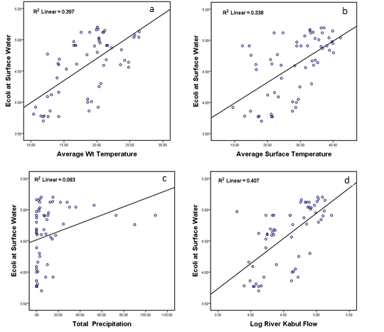

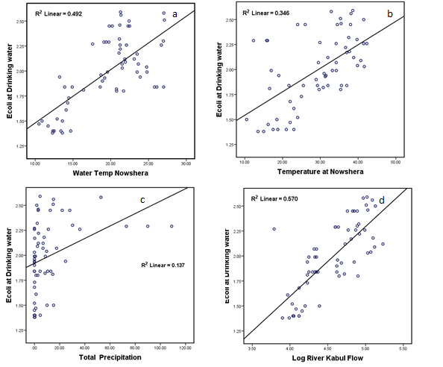
Figure 1a & 1b. Correlations between the E. coli concentration (log cfu / 100ml) and the variables discharge (a), Average water temperature (b), average surface air temperature (c) total precipitation (d) river Kabul discharge.
References
Åström, J., T. J. R. Pettersson and T. A. Stenström (2007). "Identification and management of microbial contaminations in a surface drinking water source." Journal of Water and Health 5(SUPPL. 1): 67-79.
Azizullah, A., M. N. Khattak, P. Richter and D. P. Hader (2011). "Water pollution in Pakistan and its impact on public health--a review." Environ Int 37(2): 479-497.
Barlage, M. J., P. L. Richards, P. J. Sousounis and A. J. Brenner (2002). "Impacts of climate change and land use change on runoff from a Great Lakes watershed." Journal of Great Lakes Research 28(4): 568-582.
Betancourt, W. Q. and K. D. Mena (2012). "Assessment of waterborne protozoan passage through conventional drinking water treatment process in Venezuela." Journal of Water and Health 10(2): 324-336.
Cloete, T. E. (2004). Microbial waterborne pathogens. London, IWA Publishing.
Hashsham, S. A., E. W. Alm, R. D. Stedtfeld, R. G. Traver and M. Duran (2004). "Detection and occurrence of indicator organisms and pathogens." Water Environment Research 76(6): 531-604.
Kirsch, T. D., C. Wadhwani, L. Sauer, S. Doocy and C. Catlett (2012). "Impact of the 2010 Pakistan floods on rural and urban populations at six months." PLoS Currents 4.
Kistemann, T., T. Claßen, C. Koch, F. Dangendorf, R. Fischeder, J. Gebel, V. Vacata and M. Exner (2002). "Microbial load of drinking water reservoir tributaries during extreme rainfall and runoff." Applied and Environmental Microbiology 68(5): 2188-2197.
Lloyd, S. J., R. S. Kovats and B. G. Armstrong (2007). "Global diarrhoea morbidity, weather and climate." Climate Research 34(2): 119.
Mathers, C., D. M. Fat and J. Boerma (2008). The global burden of disease: 2004 update, World Health Organization.
van Lieverloo, J. H. M., E. Blokker and G. Medema (2007). "Quantitative microbial risk assessment of distributed drinking water using faecal indicator incidence and concentrations." Journal of Water & Health 5.
Walker, C. L. F., I. Rudan, L. Liu, H. Nair, E. Theodoratou, Z. A. Bhutta, K. L. O'Brien, H. Campbell and R. E. Black "Global burden of childhood pneumonia and diarrhoea." The Lancet 381(9875): 1405-1416.

