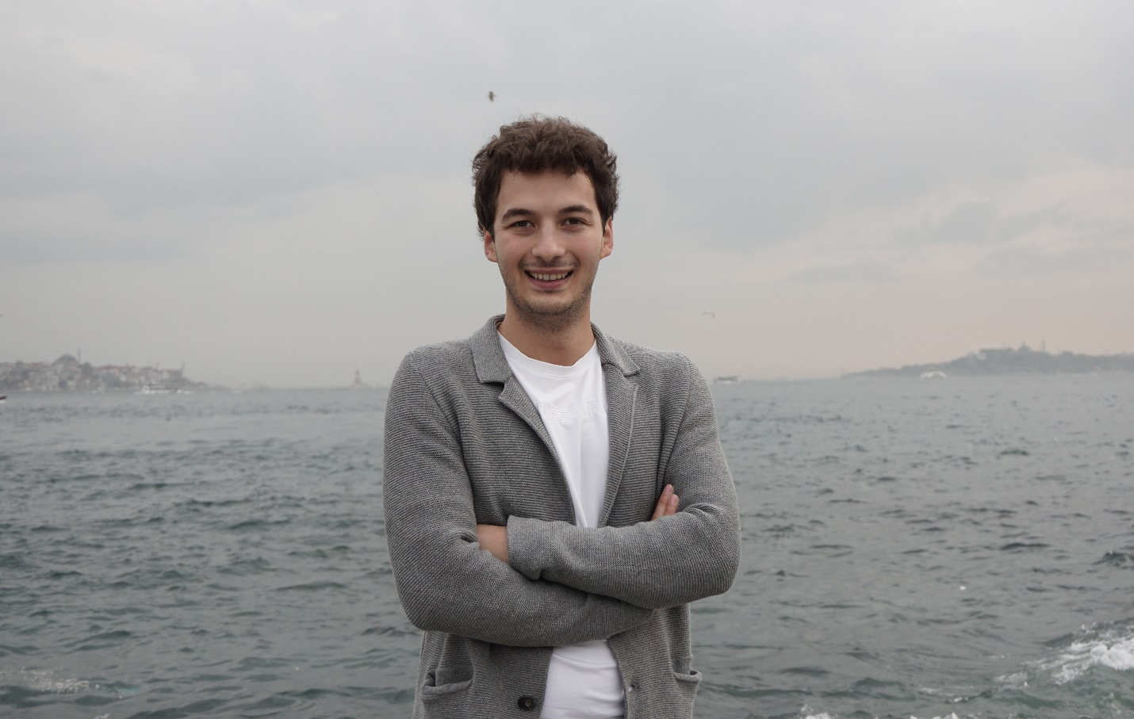

Using Nature to Solve Modern Sewage Problems: How a Turkish Entrepreneur Reinvented Wastewater Treatment to Eliminate Sludge Production

SEPTEMBER 30, 2020
Written by: Nina Aquino
Meet Enes Kutluca, 30, the Turkish entrepreneur who is the inventor and CEO of Biopipe, a sewage treatment company disrupting the water industry with their no sludge technology.
Living in Turkey, a country on the brink of a water crisis, Enes founded Biopipe Global Corp. to find innovative sources of water for tomorrow. He came up with the idea while studying engineering at the University of Bahçeşehir. “We were studying the biofilm attached growth method of treating wastewater and how biofilms manifest at the bottom of riverbeds to keep water clean,” according to Enes, “and if you look at the wastewater industry today, you will notice that most of the technologies out there are archaic, complicated and hard to maintain. But, I thought, why does it have to be so complicated? This process is already occurring in nature, so why not replicate it?”
Over the next several years, Enes began to refine his idea into a credible and functional sewage treatment system. During this process, he noticed that all systems used globally still created sludge, a valuable resource when treated properly, but is toxic to the environment when not. Currently, global production of sludge tops 20 million tons and much of it is not properly treated or disposed.¹ Keeping this in mind, Enes optimized the already existing biofilm technology and replicated this process inside a PVC pipe, creating an internationally patented system entirely free of sludge. His research culminated as his University thesis and was subsequently formalized through the creation of GreenAgeTech. This was later changed to Biopipe Global.
The business of treating wastewater from toilets, kitchens, showers, industry, etc. is a huge industry worldwide. The wastewater industry is set to grow at compound annual growth rate of 6.5% from 2019 onward, and expected to be a $211.3 billion dollar industry by 2025.² However, many of the systems currently used are antiquated technologies that produce large quantities of sludge, are costly to build and operate, and don’t always treat water to adequate levels.
Biopipe Global is continually pushing the technological envelope to provide solutions for the world water crisis. It has an installed footprint in over 15 countries with operations in Turkey, United States, India, Bangladesh, Philippines, Ethiopia, South Africa, and the Netherlands. The Biopipe system offers advantages over other systems by providing the following:
- No Noise
Using a Venturi injector, air is pulled into the Biopipe system without the use of noisy blowers used in conventional systems.
- No Odor
The Biopipe process happens in an entirely closed system with wastewater being treated within the day it’s treated.
- No Sludge
Unlike an activated sludge sewage treatment plant which makes sludge as part of its treatment process, Biopipe uses an optimized biofilm system. The only byproduct other than clean water is dead bacteria that is captured in a cartridge filter and rinsed with clean water every 1-3 months.
- Low Energy Consumption
The Biopipe system’s only electrical components include simple pumps and a control panel; thus, large energy demands from aerators and blowers are avoided.
- Low/Flexible Footprint
Other conventional wastewater treatment systems can be as high as 4x the footprint of Biopipe. Additionally, Biopipe’s unique configuration means it can be constructed as a long and skinny system or put in tight spaces.
- Easy to Maintain
Since Biopipe’s biofilm constantly regenerates itself, there is no need to add bacterial mixtures or chemicals to the system. The Biopipe system uses simple and durable materials, meaning the system’s lifespan is much longer than other systems where membranes need to be changed out often or monitored. Additionally, Biopipe is controlled remotely on an automatic system panel where no onsite operator is needed.
To keep up with the rising demand for fresh water, Biopipe maintains partnerships with several other technologies to offer innovative sources of water. Each of these technologies are breakthroughs in their respective categories, offering a circular economy solution to the world’s water crisis.
These technologies include:
Glanris Media Filtration
Glanris is the world’s 1st highly effective 100% green hybrid water purification media made from rice hulls. It uniquely combines the best features of activated carbon and ion exchange resin, making it more efficient at removing a wider range of organics and contaminants, at a fraction of the price. It's lower-cost, more effective, biodegradable, non toxic, and can easily be disposed.

Abrimix ETP (Industrial Water)
Abrimix High Shear Reactor (HSR) based on Reaction Enhancing Technology is a breakthrough approach to treatment of a wide range of industrial influents. Abrimix’s key advantages when compared to DAF are: 2-in-1 Equipment Water Treatment & Dry Product, 30% less reagents used, low footprint, can handle variable water flows & influents, and can be mobile.
By finding innovative ways and challenging archaic institutional methods currently used, Biopipe Global seeks to further the achievement of the United Nation’s sustainable development Goal 6: Water and Sanitation for All.

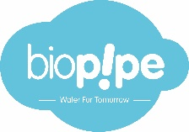

Website: https://www.biopipe.co/
Contact: info@biopipe.co

