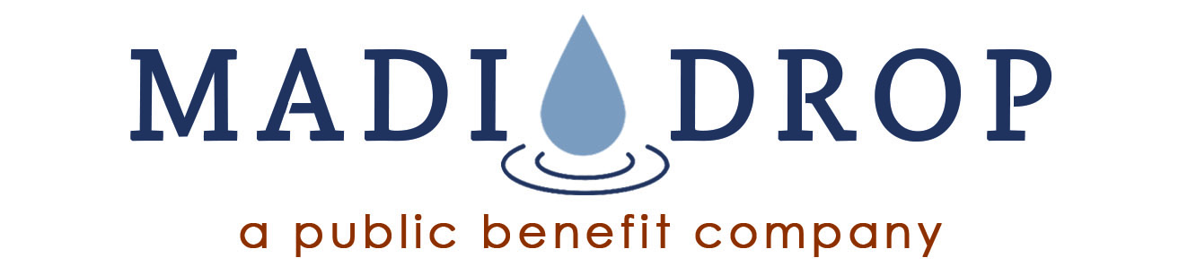
PO Box 2725, Charlottesville, VA 22902
(434) 260-3767 | info@MadiDrop.com | www.MadiDrop.com

MadiDrop PBC is addressing a major international water issue – how to treat contaminated drinking water with a low cost, easy-to-use, socially preferred solution. The all-natural MadiDrop (M-Drop) is the answer.

The M-Drop is a sophisticated technology that is simple to use. It is an all-natural ceramic tablet embedded with silver, a well-known disinfectant. When placed in a water container, it releases silver ions to reduce biological pathogens such as E.coli. One M-Drop used on a daily basis in 10 liters provides a family with safe water for at least six months. A single MadiDrop treats 2000 liters making it remarkably cost effective on a daily and cost-per-liter basis. It is engineered to have an infinite shelf life. Regardless of how long it is stored on the shelf, it releases silver ions when placed in water. The M-Drop does not affect the taste, odor or appearance of the water.

Since launching the M-Drop in October 2015, the company has provided over 20 million liters of safe water to 48,000 people in 40 different countries. With its global partners, including faith-based and humanitarian relief organizations, MadiDrop PBC is helping to educate families about safe water practices and providing them with a sustainable solution to treat and maintain their household water. Feedback from the field indicates it is universally preferred to chlorine and other chemical treatments, and it is less expensive and easier to use and maintain than many filters. Additional information, including numerous testimonials from users, can be found at the newly updated website at www.madidrop.com.

Deployment by NGOs has validated its performance and social acceptance, and many people who were introduced to M-Drops are asking to purchase replacements. Therefore MadiDrop PBC is now introducing the M-Drop to commercial channels, making it available on a broader scale and generating greater health impacts and social benefits. In particular, the company is developing relationships with social enterprise distribution networks whereby the M-Drop contributes to job creation and economic development as well as improvements in health and social welfare. The company is also expanding its reach to additional populations in urban and peri-urban settings. Recent studies by the United Nations in relation to Sustainable Development Goal 6 have documented that even water from “improved” sources is often contaminated.

On the basis of cost, ease of use, social acceptance and duration of effectiveness, community feedback confirms the M-Drop is a preferred solution to chlorine tablets and is more economical and durable than most filter systems. The M-Drop helps families take control of their daily drinking water. As a result, millions of people will have better health and life quality.

Contact:
Peter McChesney, Business Development Lead
peter@madidrop.com

