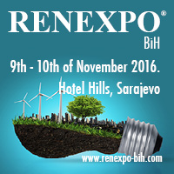 | 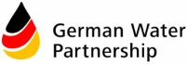 | 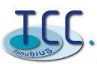

1st Water Management Conference Bosnia and Herzegovina
10th of November 2016 10:00 - 16:00

In the Framework of Bosnians biggest international platform for Energy, Energy Efficiency, Water Management and Environmental Experts RENEXPO® BiH at Hotel Hills in Sarajevo

RENEXPO® BiH is the biggest platform for energy experts, where key players meet every year, in order to support their business, share trends, show innovation and be a voice in the society

Aim of the Conference:
After a successful introduction of the water sector Western Balkans in the core of the RENEXPO® Water Management Congress in June 2016 in Belgrade, we are opening this topic in Bosnia and Herzegovina. Due to the terrible floods in the region in 2014 that happened again earlier this year, the conference that is co organized and supported by GERMAN WATER PARTNERSHIP and TCC Danubius, will feature flood protection and prevention as well as the waste water plants and treatment.

The conference will provide a full insight of the present status as well as connects the utilities with the international participants. Further all planned projects and needs will be part of the program

The conference is the best opportunity to present your innovative technology, product and experience to the Western Balkan region, meet the industry and catch-up on new technological developments in the value chain from the experts!

MAIN TOPICS:

- Status Risk Disaster Management and Waste Water plans BiH
- Public Utilities
- Framework and Legislation
- Technologies and equipment
- Private sector through PPP
- Municipalities
- River Basins Agencies
- Actively involved institutions

The Conference is taking place under the Patronage of: German Water Partnership and TCC Danubius

Registration Fee per person/per conference
40,00 EUR
 | http://www.renexpo-bih.com/konferencije-registracija.html?&L=1
 | http://www.renexpo-bih.com/exhibitors.html?&L=1
 | http://www.renexpo-bih.com/visitors.html?&L=1
 | http://www.renexpo-bih.com/sponsoring.html?&L=1

Languages: English and Local. Simultaneous translation will be provided.

 | Partners and Supporters  RENEXPO® BIH  http://www.renexpo-bih.com/index.php?id=657&L=0
Upcoming RENEXPO® in 2017
