MEDGENERA
A Biopreneurs News Network
Digital Media Coverage of Business, Finance and Innovations in Biotech, Pharma and Chemistry Industries

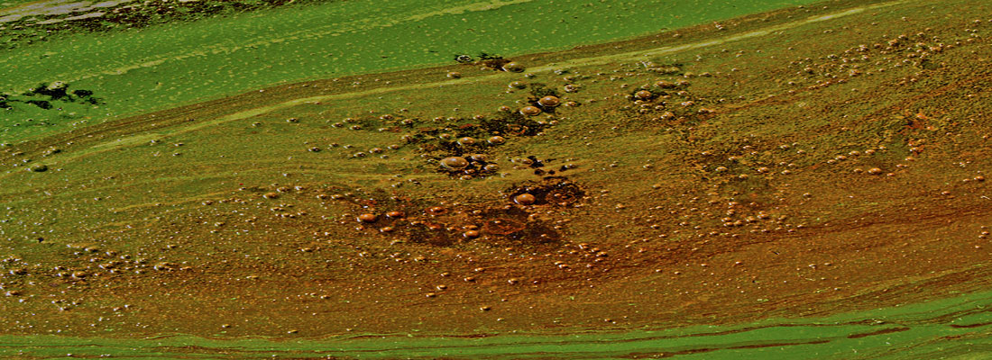
Microalgae- We See Future in This Tiny But Smart Organism
Jun 7, 20162 CommentsFeatured Greentech ReviewsBy Tiash Saha

In 21st century we can boast about all the technological advancements achieved but what if we run out of the energy needed to keep them activated?
Let’s talk about the smartest candidate for the future sustainability of biofuels, food, feed, and other co-products. In this review we will also discuss the current status of microalgae research in India together with the business and entrepreneurship perspectives of it.
The declining sources of non-renewable energies year by year are rolling out a bright and prosperous future of renewable sources of energy. Among all the renewable energy sources that the industries and entrepreneurs are looking up to, the smartest are the microscopic, fast growing, photosyntheticorganisms- ‘microalgae’. These tiny creatures can be exploited as an eternal source of biofuels as well as they provide interesting opportunities in industrial sectors like pharmaceuticals, nutraceuticals, biopolymers and so on.

Microalgae- third generation bio feedstock
Biofuels have come a long way from its first generation as organic biomass derived fuels to second generation non-food bio-feedstocks like Jatropha, cellulose to algae which belongs to third generationfeedstock for the third generation biofuels.
Microalgae as the third generation bio feedstock possess inherent advantage such as they grow fast and have high biofuel yields. According to a report, algae yield 30 times more energy per acre than various oil plants and can produce up to 100,000 lit oil per hectare per year (which is higher than any other land crop). It has high adaptability, hence can be grown under any unsuitable conditions like marine water or wastewater ponds like industrial and municipal waste waters or from household toilets and sinks, agricultural run-off, it provides an economic and environment friendly remedy for sustainable and renewable algae based biofuel.
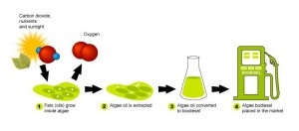
Figure 1. Biofuels production from microalgae (Photo credit: THE LAW OF ALGAE).
Other exciting applications of microalgae are in:
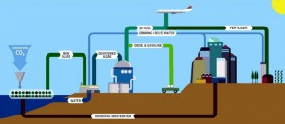
Waste water treatment: Most of the necessary nutrients suitable for cultivation of microalgaeevidenced by high algae growth rate and productivity and nutrient removal efficiency. Therefore, coupling wastewater treatment with algae cultivation may offer an economically viable and environmentally friendly way for sustainable renewable algae-based biofuel and bio-based chemicals production as well as credits for wastewater treatment. Microalgae developed in wastewater retain large amounts of lipids, carbohydrates and proteins suitable for energy production, without a biomass limit or transformation.

Figure 2. Wastewater process treatment using microalgae (Photo credit: Algae Systems LLC).
Nanomaterial: Bionanotechnology has revolutionized nanomaterial synthesis by providing a green synthetic platform using biological systems. Among such biological systems, microalgae have tremendous potential to take up metal ions and produce nanoparticles by a detoxification process. Use of such a microalgal system provides a simple, cost-effective alternative template for the biosynthesis of nanomaterials in a large-scale system that could be of great use in biomedical applications.
Carbon Sequestration Technology: Carbon dioxide (chemical formula CO2) emitted as flue gas or incoal gasification process plants could be captured through photosynthesis to generate biomass, which could be processed to generate biofuel and other valuable biomaterials. But the viability of such a system could be critically dependent upon the volume of biomass that would be generated. In this context growing algal biomass could be the right answer.
This video explains the CO2 sequestration technology by microalgae (Video credit: Algaetech International).

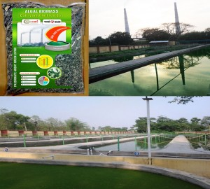India’s 1st microalgaebased carbon sequestration initiative was taken by public sector corporationNational Aluminum Corporation Limited(NALCO), which funded and initiatedmicroalgae based carbon sequestration pilot plant based on technologies ofIndocan Technology Solutions at their captive thermal power plant in an attempt to demonstrate the potentials of the technology to reduce the carbon footprints in coal based systems.
Figure 3. Mass cultivation of microalgae using local microalgae strain at NALCO (Photo credit: NALCO).

How microalgae technology a promising business sector in India?
The world is witnessing an urgent need of shifting towards cleantech industry as the consequences of global warming are getting quite apparent. Significant support is being provided to startups in cleantech area. Microalgae technology has opened up an ocean of opportunities for the entrepreneurs in terms of research and development; biofuel production; biofuel refineries and so on.
The renewable energy market is currently valued at US $17 billion and growing annually at the rate of15% which makes it a hot area for international ventures to support interesting technologies to get higher yields.
Government funding and significant supports are available in India at all stages to boost this promising algal technology in the production of biofuels.
Department of Biotechnology (DBT) funds various projects in algae technology for its exploration as a source of biofuel and development of technology for sustainable production of algae. Indian Oil and Department of Biotechnology (DBT) jointly established Centre for Advanced Bioenergy Research (DBT-ICGEB). Centre for Energy Biosciences (DBT-ICT-CEB) was established collaboratively by DBT andInstitute of Chemical Technology (ICT).
Council of Scientific & Industrial Research (CSIR) also fund projects for development of microalgaetechnology. A joint scientific project by nine CSIR- laboratories is carrying on tests for production ofbiodiesel sourced from microalgae.
Ministry of New and Renewable Energy (MNRE) and institutes like The Energy and Resources Institute (TERI) are actively involved in unfolding the ultimate potential of algae in biofuels production. MNRE in its National Policy on biofuels proposed an indicative target of achieving 20% blending of biodiesel in diesel and and 20% blending of bioethanol in petrol by 2017.
Some trials have been conducted in various institutions like IOC, ICAR, IIT Delhi to understand the effect of biofuels on automobiles. It has been confirmed that biodiesel can reduce the wear and tear of engines as well as oil pollution to a significant level.
In 2013, Ministry of Railways, Government of India, New Delhi came up with a report called ‘The Indian Railways Organization for alternate fuels, Biodiesel a Concept paper on Alternate Fuels for Indian Railways’. In the reports they projected the efforts made towards consumption of biodiesel. In association with IOCL, a train has run successfully on 510% blend of biodiesel. (Fig-2)

Figure 4. Southern railways started train using Bio-diesel (Photo credit: Indian Railways).
Field trials in association with BEST, Mumbai. Daimler Chrysler India is being carried out by Hindustan Petroleum Corporation Limited (HPCL) which completed first phase of the field trials on two C ClassMercedesBenz cars powered by pure biodiesel under hot and humid conditions.
These types of mushrooming trials to promote use of biofuels in automobiles are a clear indication of the growth of need of biofuels in the coming times which could be amply supplied by microalgae.
Under an MNRE project, CSIR-CSMCRI (Central Salt Marine Chemicals Research Institute) Bhavnagar, isolated and utilized marine yeast for converting K. alvarezzi into bioethanol as by-product.
International Centre for Genetic Engineering and Biotechnology (ICGEB), New Delhi is working on genetic modification of macro and microalgae for improvement in growth rate and biofuel production.
Chennai based Shri AMM Murugappa Chettiar Research Centre (MCRC), a Department of Scientific and Industrial Research (DSIR) recognized R&D organisation was the pioneer of algae technology in India. Their primary area of research was the species spirulina.
Chennai based Phycospectrum Environmental Research Centre (PERC) is dedicated towards research and development of algae based technology.
Some other institutes actively working towards development of microalgae technology are Institute of Minerals and Materials Technology (IMMT), Bhubaneswar; National Institute For Interdisciplinary Science & Technology, Kerala; Central Food Technological Research Institute, Mysore.
Till now microalgae has not been grown on commercial scale for energy production but many companies and research institutes are working towards this goal. This advanced technology will surely open new business opportunities and will be able to attract potential investments.
India’s rising population creates a huge domestic market demand of oils which is largely (almost 72%) imported by the government. This serves as a driving force for the strengthening of India’s own energy solutions. Therefore, the future of biofuels lies in efficient micro-algal technology.
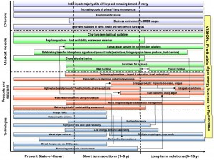
The identification of correct species and improvement of that algal strain for higher oil yield is necessary along with improvement in algal cultivation technologies and approval of rules and regulations for the development of large scale production infrastructure of microalgal energy.

Figure 5. Present and future microalgal based technology in India.

Which Indian Companies are working on microalgae technology?
Hyderabad based Algae Bio-tech India Private Limited introduced a proprietary lipid/oil yielding strains of microalgae which can be genetically modified to produce greater amount of lipid/oil feedstock for algal fuel production.
Reliance Life sciences’ Biofuel initiative is working on genetic improvement of algae. Australian Algae Tech Limited and Reliance Industries Limited (RIL) collaborated to build first Indian biofuel plant (Photobioreactor) in Jamnagar, Gujarat utilizing Algae Tech’s algae fuel technology.
A Bangalore based biofuel Startup Company Sea6 Energy, founded in 2010 primarily focuses on extraction of ethanol fuel from seaweed.
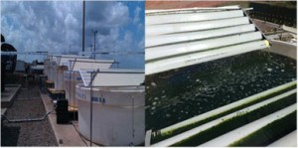
PHYCORE: A joint technology implementation programme between CORE BIOTECH, Colombia and Phycospectrumhas initiated with the successful installation of a 20 KL integrated tanks system (Pilot demonstration plant) at Pacific Rubiales oil drilling site near Bogota to treat petrochemical wastewater by employing micro algae.
Figure 6. 20 KL integrated tanks system (Pilot demonstration plant)
Abellon Clean Energy, Ahmedabad – Design and development of dual operating pilot scale bioreactor system for comparative simulation studies on algal cultivation. MNRE, 2011 – To develop an indigenousPBR, which is also capable of sequestering waste CO2.
PERC– Kolkata algal farm – Open raceway cultivation Nutrient inputs optimized and productivity stabilized Contamination controlled harvesting accomplished by a combination of autoflocculation and Chemical flocculation (PHYCOFLOC).
India harbours a potential startup ecosystem for development and promotion of biofuels. The growing interest in the Algal Biotechnology represents the foresightedness of science and research fraternity.With the rise in genetic engineering to explore and modify this unabated algae technology at its best and support for its large scale production for biofuels can promise a green and healthy future to the coming generations.
Finally, we want to leave you with a great thought, “I don’t want to protect the environment, I want to create a world where the environment does not need protection”.
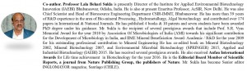
Here is the video of the first algae bioreactor house which was built in the context of the International Building Exhibition IBA 2013 in Hamburg, Germany (Video credit: www.amocean.org). This is fascinating! Isn’t it?

Featured image credit: Tina and green algae on the surface of the river. © AlexSid (Stock Photo ID: 112265270)

Previous
Shire-Baxalta Master Merger Finally Done and Dusted!
Next
Is Prevention from Zika Virus Lies Inside Human Body?
About the author
Tiash Saha
Editor. I am Masters in Science (Chemistry) from Chhatrapati Shahuji Maharaj University, India and was CSIR Network project fellow at Central Drug Research Institute, India. I have learned most (if not all) kinds of chemical reaction and published scientific research. Now I am looking forward to write about new discoveries in scientific and medicinal field.

