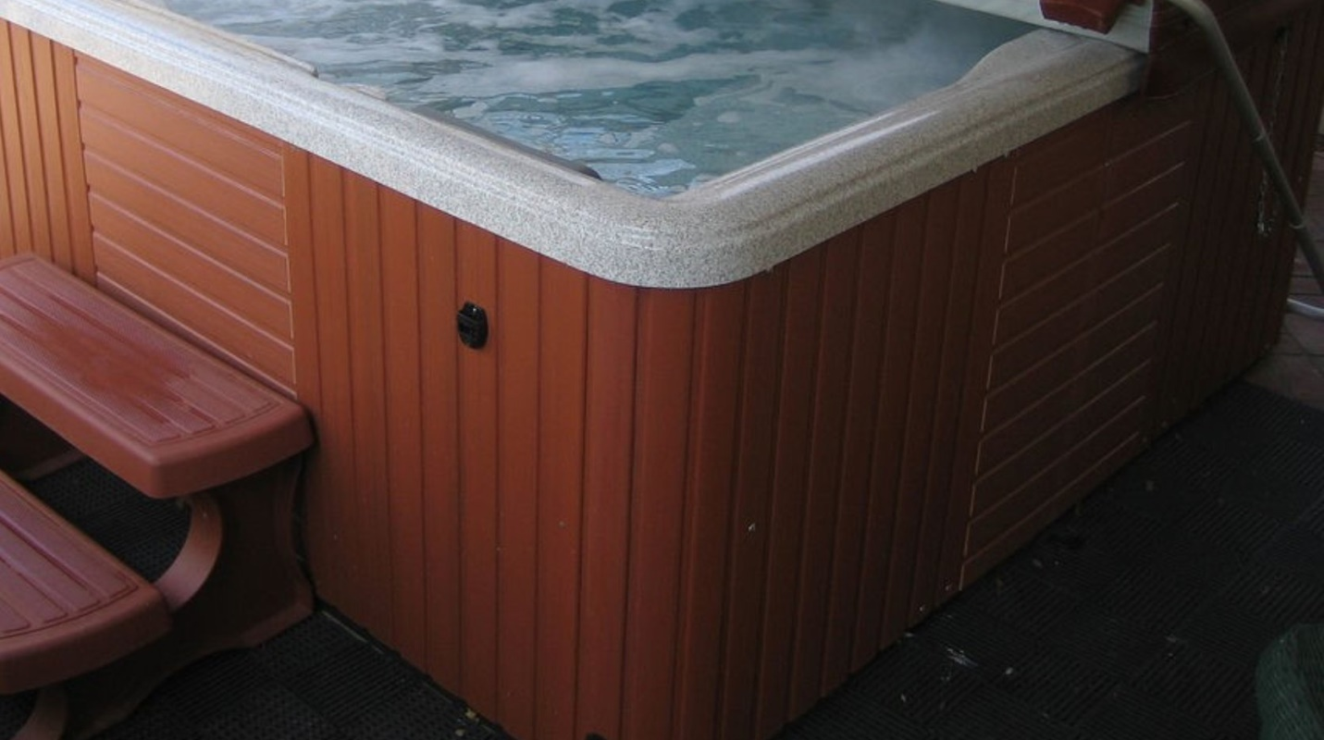

Keep It Clean in the Hot Tub

Source: Mazzei Injector Company, LLC
By Jim Lauria

With Memorial Day just around the corner, millions of homeowners are pulling the covers off their hot tubs, filling them up and getting ready for summertime relaxation. Hot tubs provide relaxation, ease aches and pains, relax sore muscles, or even—in the case of swim spas—work those muscles instead.

It’s time to look forward to some down time in the tub…but keep it clean, folks. And by that I don’t mean restrict your activities (that’s up to you as consenting adults). I mean keep the hot tub clean. And that’s harder than it sounds.

Plenty to Work With

Part of the challenge is that, according to a survey of spa dealers by the Hot Tub Retail Report, 46% said customers get most excited about price/value, 16% by curb appeal/appearance, and just 6% by the filtration/sanitizing system. (On the plus side, that’s more than the 4% who are more excited by Bluetooth audio/speaker systems.)

Clearly, the first step is mental. Right after that, though, we get into the biological issues. Hot tub sanitization is a multi-stage challenge with a multi-stage solution.

In a recent article in Aqua magazine, Robert Lowry pointed out that the average person sweats about 3 pints per hour at 102 degrees F. If that doesn’t make you sweat a little, consider that there are 186 substances in urine and sweat. The top two, urea and creatinine, sop up disinfectants and reduce their ability to kill germs, Lowry noted. That’s important, because he also mentioned that each bather brings 100 million bacteria into the hot tub, in addition to residues of an average of 9 personal care products for the average adult.

A 2005 Water Conditioning + Purification article reminded us that because spas are so much smaller than swimming pools, they have at least 10 times the ratio of bathers to water than backyard pools do. And because the water is warmer, chemical reactions happen more quickly than in pools, and solids in the water concentrate more quickly due to faster evaporation. Among those reactions are the combination of chlorine with non-living waste—oils from our bodies and all those personal care products Lowry mentioned—to form scum and soft scale that can shelter pathogens.

Legionella Threat

The scariest bacterium in hot tubs is Legionella, which thrives in warm, dirty water. Legionella burst into the public eye in 1976 after it was discovered as the cause of a mysterious pneumonia outbreak that sickened 200 conventioneers at a Philadelphia American Legion conference, killing 34 of them. Since then, the Centers for Disease Control and Prevention (CDC) estimate that Legionella is responsible for 8,000 to 18,000 hospitalizations in the U.S. every year.

If you tried to design a breeding device for Legionella, you’d probably come up with a hot tub. The bacterium thrives in water temperatures between 68 and 122 degrees Fahrenheit, multiplies in stagnant water (which describes your tub when you’re not running it), and hides behind sediment, scale and biofilms.

Then there’s the delivery system—steam and mist carrying the bacteria straight into people’s lungs. That’s why it was little surprise that the source of Legionella that caused at least 21 illnesses and three deaths among visitors to a British home improvement store was from a poorly maintained hot tub on display near the checkout line.

Multi-Stage Approach

I’m not trying to keep you out of hot tubs. Far from it—they’re great! But I am trying to inspire you to ensure that the tubs you enter are being kept clean appropriately so you can enjoy the health benefits of your spa without running any health risks.

Municipal and industrial water treatment professionals use a multi-stage approach to disinfection. You can, too.

The heart of spa disinfection systems is either chlorine or bromine, which form acids in the water, penetrate germ cells, and stop their metabolism. However, Water Conditioning + Purification estimates than only 2.5% of the chlorine in a hot tub actually performs disinfection; another 2.5% is used for residual, and 85% is tied up oxidizing other substances. Similarly, it says 80% of bromine in the tub water is used for oxidation and just 7.5% for disinfection. Scum and biofilms are the key culprits in tying up much of the rest in oxidation.

To reduce the impact of biofilms and boost the efficacy of disinfectants, many top spa manufacturers use ozone to destroy biofilms and scum. Ozone (O₃) is comprised of three linked oxygen atoms. Ozone is an extremely powerful oxidant—when ozone encounters an organic molecule, one of its oxygens jumps off the ozone and onto the target, blasting it apart in a rapid oxidation action. The other two oxygen atoms float off into the atmosphere in the O2 form we breathe in air. By introducing ozone into the water, you are destroying the films that protect Legionella and allowing your disinfectants to do their job.

You don’t want to smell ozone when you’re in the hot tub, though—that’s a sign that ozone is escaping the system (and perhaps eating away at your spa by oxidizing the finish). Instead, you want it thoroughly mixed into your water so it attacks the biofilm.

Safe Summer

If you want to learn more about the proper use of ozone in spas (hint: thoroughly mixing it into the water plays a huge role), click here. Otherwise, pull off that hot tub lid, and get ready to mix up a pitcher of the beverage of your choice. But before you grab the ice, check out the CDC’s recommendations on Legionella in spas, clean up your hot tub and get your multi-stage ozone and disinfection system in order.

Then…soak in the good times and have a great start to the summer.

