**Water Purification Unit for Rural Areas**

*(****Coagulation / Flocculation tank and Re-washable sand filter system)***

**A proposal**

*Submitted to*

*The National Science, Technology, and Innovation Plan*

**Planned & designed by : Hussein Mohamed Hussein Ibrahim**

***B. sc Agricultural Science (Honors ).***

***University of Gezira –Sudan***

***M.sc in Water resources development and management***

***UNESCO- chair in W.R.D.M Institution.***

***Islamic University.***

***Khartoum-Sudan***

***Address: H. M. H. Ibrahim***

***Khartoum state-Sudan***

***Mobile : 00966 567 248 514***

***E .mail : hussio67@yahoo.co.uk***

1. **Introduction**

Water has a wide variety of endless uses associated with it ; Common usage of water include drinking , preparing food and other domestics using .Other usage is for industry, agriculture and each usage has water quality criteria which govern the input of water to particular uses and will be different for each internal use

**1.2Water sources in poor countries**

**1-2-1 Surface water sources**

Most of the rural areas in the “Development countries”, the rural communities depend on the surface water such as irrigation channels or surface open ponds for their drinking and other domestic uses. Towards the end of the cultivation season water supply in the irrigation channels is occluded ,then the water became shallow and turbid , and by the end of rainy season the remaining water in the surface which collected in surface depressions (open ponds) becomes depleted too by vaporization, and then the both of water sources ultimately becomes turbid and contaminated, which constitutes a hazard for rural inhabitants.

This warrants upgrading water quality through purification, decreases of turbidity, and removal of pathogens .

**1.3Turbidity**

The turbidity of the surface water is resulted when the rain water running across the surface of the ground, through this running courses towards the surface depressions to form the surface open ponds it’s picks up many substances such as suspension materials , collided materials ,minerals ,salts ,organic and inorganic materials ,all these added materials causes the turbidity of water ,This turbidity provided a perfect medium and adsorption site for the chemicals , organic and biological reactions resulting the aesthetically and undesirable tastes and odor ,also the turbid water provides a perfect medium for the growth of all type of microorganisms and pathogens which is responsible for causing the people the majority of diseases and infection ,

**2.Objectives**

**2.1 General Objectives**

* The general objectives of this project is to Implement a simple technology as **A Rural water purification unit** for improving the Quality of the surface water for drinking purpose .
* Using a **Re -washable effective sand filter** as a part of the unit to remove the turbidity .
* Using simple **Coagulation tank** for water purification of drinking water

**2.2Specific Objectives**

* Upgrading water quality for poor communities .
* Decreasing the hazard of turbidity and polluted water sources
* Upgrading the poor communities water knowledge’s and to encourage them to participate in such a simple and acceptable projects.
* Providing the means of sustainability through ,the efficiency of the project, easy operation and easy maintenance units

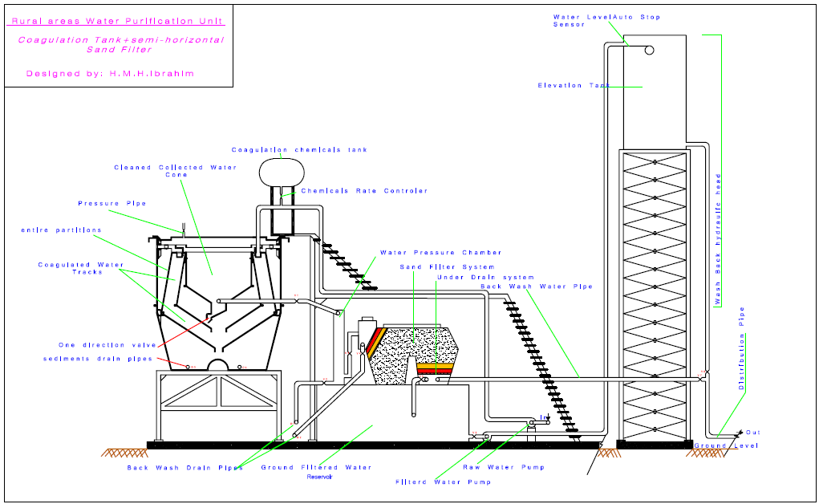

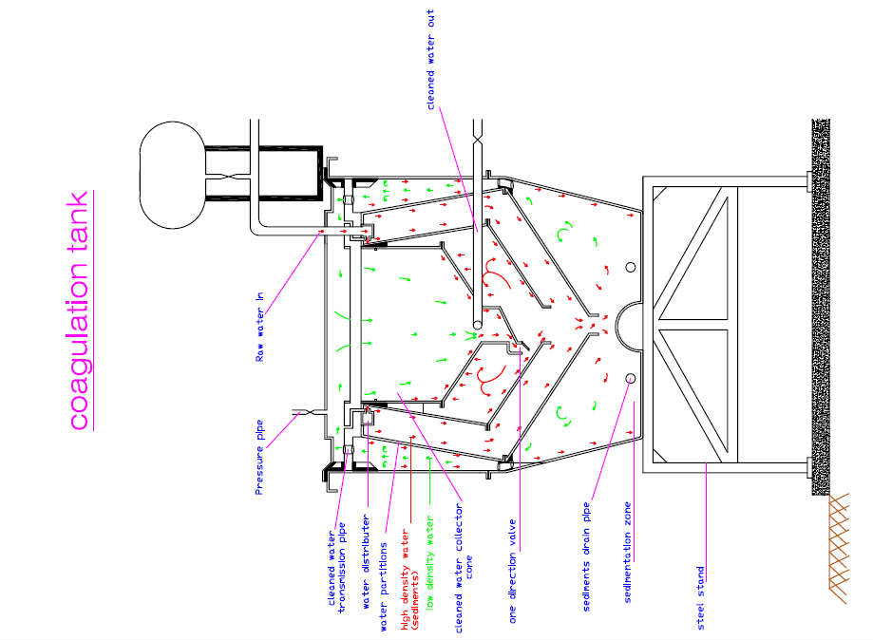

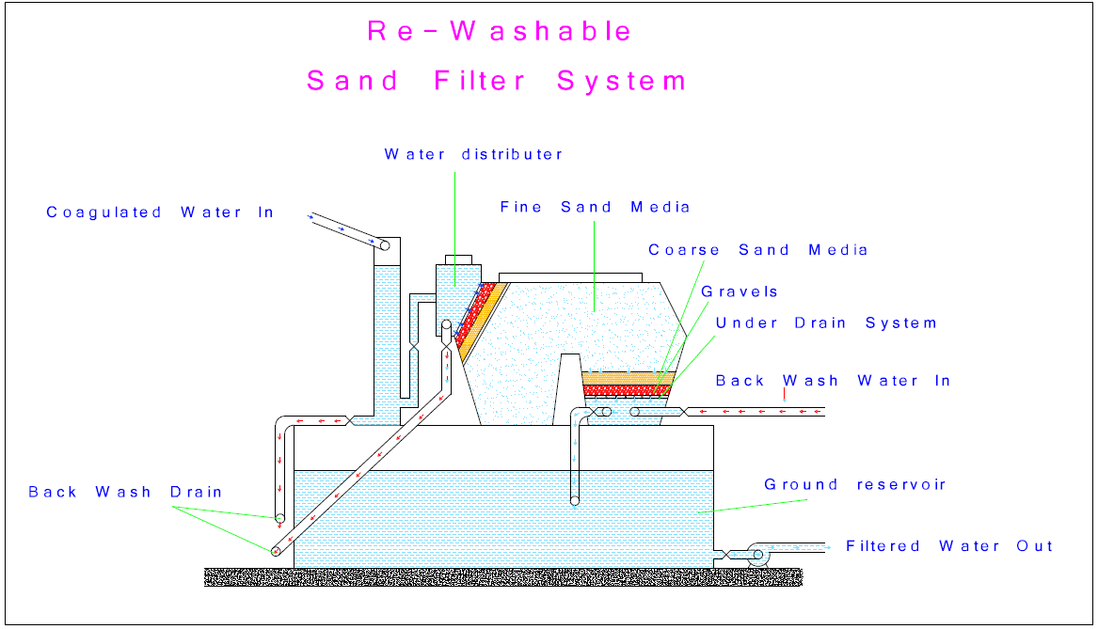

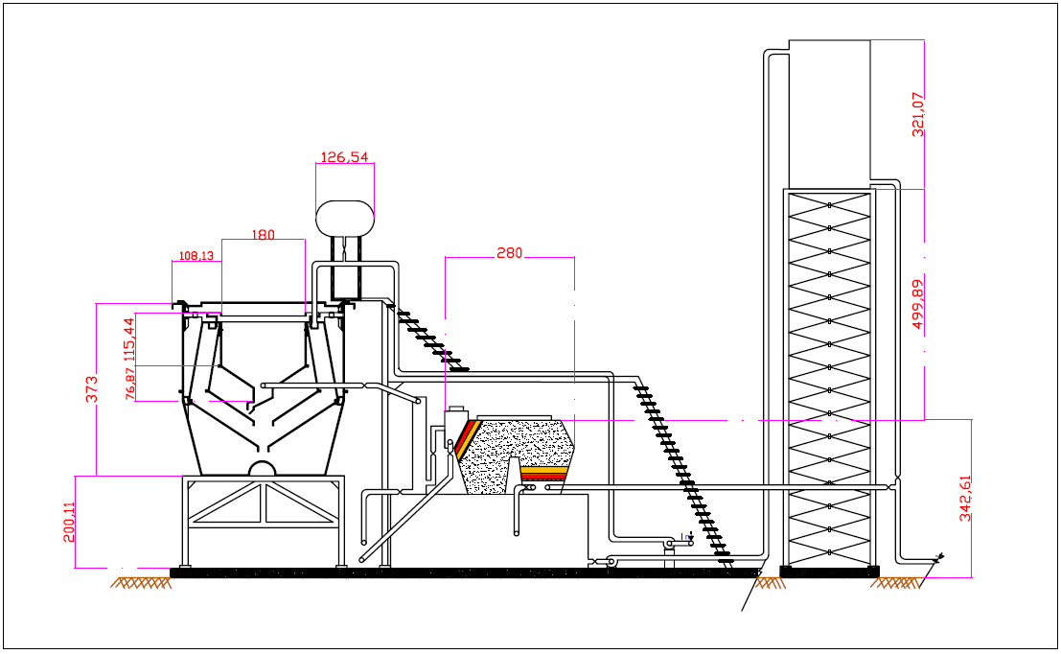

**3.The Components of the Unit** *(all Parts Illustrated in Drawing Plan)*

* 1. **Coagulation Tank [ fiber Glass made]**

1. Raw water transmission pipe 4” connected with raw water pump
2. Water distributer
3. Water Tracks
4. Clean water collector cone
5. Sediments Chamber
6. Sediments drain halls and valves
7. One direction cone valve
8. Clean water collected pipe 4” connected to sand filter system.
9. Pressure pipe with valve ½”
   1. **Coagulation chemical small tank**
10. Chemical coagulation solution tank
11. Connected pipe ½”
12. Water flow rate sensor
13. Chemical solution controller Valve ½”

**3.3 Re-Washable Sand filter unit** (fiber Glass made)

1. Pressure Chamber.
2. Connected pipe from coagulation tank to sand filter with controller valve 4”
3. Water distributer .
4. Partition with drain halls .
5. Gravels .
6. Coarse sand.
7. Fine Sand.
8. Sand filter container with partition .
9. Under drain chamber.
10. Filtered water pipe connected to ground water reservoir with valve 4”
11. Back wash drain pipe with valve 4”
12. Upper cover (removable ).
    1. **Ground clean water reservoir** (steel made).
13. Steel made ground water reservoir
14. Outlet pipe with valve 4”
15. Pump machine
16. Clean filtered water pipe connected to the elevation tank with valve 4”

**3.5 Elevation Tank**

1. Steel made tower.
2. Inlet pipe 4”
3. Fiber Glass made container tank .
4. Outlet pipe with gravity head for back wash with valve 4”
5. Distribution pipe with valve4”
6. Water level electronic sensor.(feed back when elevation tank is filled ).

**4.1 Primary settling operation (sedimentation).**

The sedimentation process has many application in the water purification of potable water. Materials that may be removed by the sedimentation included suspended solids originally present in water or dissolved solids which have been precipitated in the course of other treatment process such as coagulation ; generally suspensions in water are assumed to be dilute ,although some zone settling may occur near the bottom of the settling basin or tank ;The forces which govern the particles to settle down is the specific gravity and the Buoyant force the tow forces are counter to each other ;The settling velocity depends on decay the buoyant force or increasing the gravitation force ,according to this fact it is obviously that plain sedimentation will not be very efficient for the smaller suspended particles. Under condition normally encountered in settling tanks efficient removal of particles less than 50 µm in diameter cannot be expected.

**Collided Stability**

Collided suspensions that do not agglomerate naturally is the stable collided .and the most important factor contributed to the stability is the excessively large surface – to –volume ratio resulting from the very small sizes of the collided materials particles.

**Coagulation theory**

Chemical coagulation is the process of adding trivalent metallic salts such as AL2(SO4)3 (aluminum sulfate) or FeCl3 (ferric chloride) to the water. The theory is that the quantity of ions in the water surrounding the collided particles Which created barriers force ;the coagulation chemicals causes the decay function of the electrostatic potential ;the hydrolyses of coagulation resulting the charge neutralization towards the surface of the collided particles ,so that the net force will be attractive and no energy barriers will exist ,then the particles will agglomeration of particles into groups. Increasing the effective size and therefore increasing the settling velocity will be possible

**4-1 The description of the first stage of the water purification unit**

**4-1-1 Coagulation Tank**

The coagulation tank is a circular basin (fiber glass made ),the tank is divided with partitions to give entire circumferences ,it is also divided to several water tracks and paths ,The raw water pump is connected to the water distributer at the top of the tank surrounding the clean collected water cone , the coagulation chemical solution addition is accomplished in a previous stage as the raw water is flow toward the distributer . the controller valve connected with chemical container after the selection of the optimum dosage of coagulants are determined experimentally according to turbidity concentration of the raw water source, then the controller valve cane be calibrated and adjusted according to the volume of pumped raw water

**4-1-2 Aeration unit**

Aeration is the process that accomplished to remove undesirable gasses dissolved in water (*degasification )* .and to add oxygen to water *(oxidation)* . these gasses are biological waste products such as H2s and co2 ,which resulted from the decomposition of organic materials that have been consumed by the bacteria and other microorganism .

**4-1-3 Water distributer**

The water distributer is one part of the entire circumferences of the coagulation tank ,it has been employed to distribute the raw water equally in the entire tracks ,and permit for good mixing for the chemicals with the raw water, the natural sedimentation will be happen efficiently, the agglomeration of the suspension particles will be accelerated ,also it extremely increases the ability of the small sizes to flocculate together into large sizes particles and then it will settle down towards the sediment chamber

**4-1-4 The pressure Valve**

This part is to fill the Coagulation tank progressively with water or to empty it without resistant pressure or counter forces that could baffled the water flow .

**4-1-5 Sediment Chamber**

This chamber Located in the bottom of the coagulation tank, where the sediment resulted from the coagulation mechanism is collected and settled down, this sediments can be removed from time to time be opening the drain valves that located at the bottom of the tank

**4-1-5 Clean water collection cone**

Since the clean water is low in density than unclean water *(turbid water ),* then it will buoyant vertically over the high density water to the top of the basin , this water will be collected in the clean collector cone , the entire bounders of the cone has been designed in vertical slops to obtain more chances for the remaining suspension particle *(discrete particles )* in the clean water to agglomerate and settle down parallel to the entire slops towards the one direction valve which located at the bottom of the cone ,on the other hand the one direction valve will be closed when the tank is filed by the water and open when the water level in the cone is depleted down, that when clean water is transfer to the sand filter through the pipe connected from the coagulation tank to the sand filter for the second purification stage *(controller valve is regulated water transmission* *to the sand filter and retention time about 30 minutes needed before opening this* Water is collected in the cone according to it the low density of clean water , this process is govern by the next equation

$$∫_{b=ρ_{w G V_{p}}}$$

**Where : $∫_{b }is the bouyant force$** , $ρ_{w}water density$, $G is the grvity force$

$V_{p }is thevolume of particles$.

*When the cone is filled by water this will generate gravitation force ,this force can be neutralized by the water surrounding the outside boundaries of the cone***(buoyant force)*** ,that’s why the cone needs no supporting upon the constructing of the unit. *See* the drawing plan

**5.1 The second water purification stage**

**5-1-1 Re-washable sand filter**

This unit is consist of Semi-Horizontal sand filter.

**5.1.2 water distributor**

This chamber is to distribute the water equally to the gravel layer , and to collect and drain the back wash water upon the back wash process *See* the drawing plan

**5-1-3 Sand filter media**

The active layer is the fine sand layer , the fine sand media is located between two

layers of (gravel +coarse sand ) for the back wash purposes . *See* the drawing plan

**5-3-4 Filtration process**

When the water is percolate the sand media ,the dirt*(suspension solids) will be trapped within the micro pores in between the fine sand particles and will not pass to under drain system, the sand media is used to purify water from the majority of turbidity with efficiency up to 95% , sieve analyses is needed to determine the effective size. the recommended range for effective size is 0.1 mm to2.5 ,Uniform coefficient is must be considered too*

*\** ***Uniform coefficient****: Defined as ratio and calculate as the size opening of the sieve that will just pass 60% of the sand(d60 value )divided by the size opening that will just pass 10 % of the sand sample(d 10),then the uniform coefficient is d60/d10 recommended for the U. C is 1.5 to 2.*

**5-4-1 Filtration as a partially sterilization method**

Filtration is a unique sterilization techniques in that it removes and preventing the passages of both of living and non living bodies, and can thus be used for both clarification and sterilization of water, the sieve analysis for preparing the filtration media has been employed to give a very small pore sizes to trap the pathogens within it and restrict its growth , The smallest sizes of pathogens organisms which percolated deeply into the layers can also be trapped and then it will die -off due to luck of oxygen and nutrients.

The largest sizes of pathogens such as helminthes and warms can also be trapped on the upper surface of the gravels and coarse sand and does not percolate deeply in the sand layers ,then it will die due to the restricting of its growth and development then it can be dissolved

**5-4-2 The limitation**

The filtration process cannot guarantee that the water is 100% pathogens free .that’s why the filtration should be used as part of multi-barrier approach for providing safe drinking water. it should be followed by other means of disinfection such as chlorination , chlorination also needed for removing the water colors associated with the dissolved solids by the process

of ( water discoloration ) .

**5-5-1 Back -wash process**

After long time of functioning, the efficiency of the sand filter will slows down , the accomplishment of the collided materials and sedimentation of silt will resulted in blocking off the pores in-between the sand particles which will decrease the permeability of the sand media , the back wash should be carried from time to time, to clean and drain the sediments in order to increasing back the filtration efficiency to its normal rate .

The back wash can be accomplished by reveres the direction of water flow to the opposite to the normal water flow direction for removing the dirt and sediments , the hydraulic head can be obtained from the elevation tank to generate water flow force that can remove the dirt and sediments . the water flow direction can be reversed by opening and closing off a certain valves, the under drain chamber will transmit the back-wash water flow from the elevation tank and the upper drain chamber will collect the sediments and drain it out of the system through the drain pipes

**6-1 The storage means**

After any water purification process , storing tanks and reservoirs is needed to store the water for the peak demand ,also chlorination can be done in this stage

**6-1-1 The ground reservoir**

The ground level tank is necessary for clean water collection purposes .

**6-1-2 Elevation tank**

The elevation tank which located at high altitude above the ground surface , hydraulic head can be determined by the gravitation force, the altitude , water quantities and water column , all these factors can generate water flow force (velocity ) for water distribution for the consumers and for back -wash preprocess .an electronic water level sensor can be fixed at the top of the elevation tank for turn- on , or turn - off the water pumping towards the tank (feeding back mechanism ).

**7-1 The operation of the unit**

The operation can be carried manually or automatically , according to the availability of electricity in the certain place .

**7-1-1 Manual operation**

This simple operation can be managed by well trained operators , to managing and organizing the functioning of the unit through open and closing off specific valves ,observing and calculate the retention time needed for the mechanisms of coagulation ,filling and empting the tanks, monitoring the coagulation chemicals and determining the specific chemical doses ,monitoring the water quality , water rate and defining out the needed maintenance for the unit

Etc…

**7-1-2 The automatic operation**

This option depends on the availability of an electronic water level sensors , timers ,circuit breakers ,electronic valves and programmed controller panel .

**8-1 Water quality assessment**

Samples of water should be collected periodically before and after purification ,this samples should be analyzed by water quality laboratories to determine the physical ,chemicals and biological characteristics of product water .

**9-1 Power sources and consumptions**

The water pumps can be selected according to the availability of electricity otherwise it diesel power sources is suitable for other places .

**10-1 product capacity**

The sizes and capacity can be adjusted according to the community population ,the calculation revealed that this unit can product 6.9m3 /hr,and 165.6m3 of purified water per

a day.

