An overview of Water Governance in Tamale metropolis of Ghana
Author
Clement Kamil Abdallah
Pan African University Institute of Water and Energy Science, Algeria.
Email: kabdallahclement@yahoo.com
Introduction
Water is recognised as the most essential resource for earth’s ecosystem and human’s society. Global freshwater is often threatened by poor management, population growth couple with the recent menace of climate change. Water demand is predicted to increase by 55 percent in the world by 2050 and about 40 percent of the world population currently lives in water stress areas (OEDC, 2015).
Water resource management is crucial in ensuring sustainable water supply and maintaining the ecosystem, but this approach often fail in many countries due to poor government arrangements. Many water related problems can be attributed to governance failure at multiple levels of governance rather than to the resource base itself. Thus, water governance is imperative for water resource supply and management to succeed.
At this point one may ask, what exactly is water governance? According to Water Governance Facility, it refers to administrative systems put in place in terms of social, political and economic to influence water use and management and delivery of service at different levels of the society. (http://watergovernance.org/governance/what-is-water-governance/ ). In a simpler term, water governance is a set of systems to control water resource development and management with regards to decision-making. Thus, it is all about decision making in water management and supply, who makes the decisions, how they are made and who is affected by those decisions (Moench et al., 2003). Water governance covers allocation of water resources between competing users, water storage management, aquifer extractions, regulations on discharge (Julia and Richard, 2008), and regulatory policies, legal frameworks exercise by formal and informal institutions. The new concept of combining formal and informal institutions is known as distributed governance (Charles, 2006). The notion of water governance aims at capturing the complexity of processes that determine the delivery of water related services for societal needs and that provide the context within which water management operates (GWP, 2003).
Effective water governance is pivotal for achieving sustainable development goal six. Over the years many governments across the world spend valuable resources and efforts to achieve the goal of good water governance (Verkerk, Hoekstra and Gerbens, 2008). This article seeks to outline water governance system in Tamale metropolis, Ghana with regards to its water supply systems and management, decentralized institutions, policies, regulations, legal frameworks, challenges of water governance and recommendations for way forward.
Background of Tamale Metropolis
Tamale metropolis was established by legislative instrument (LI 2068). It is one of six metropolitans and the fourth largest cities in Ghana. According to the 2010 population census, its population stands at 233,252 representing 9.4 percent of the region’s population (Ghana Statistical Service, 2014) The size of Tamale is approximately 922km sq. The city experiences severe harmattan winds in the dry season from November to January. The Metropolis is poorly endowed with water bodies. The only water systems are a few seasonal streams, which dry up during the dry season. The other water bodies include dugouts and dams (UNHabitat, 2009).
Map of Tamale
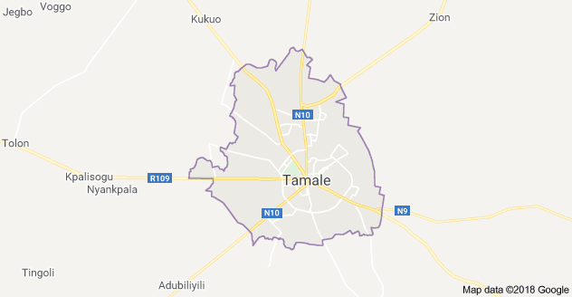
Source: Google Maps, 2018

Topography and drainage
The Metropolis is generally flat with gentle undulating low relief. The altitude ranges from 400 to 800 ft. above sea level. The Metropolis is poorly endowed with water bodies. The only natural water systems are a few seasonal streams which have water during the rainy season and dry up during the dry season. All these streams have their headwaters from Tamale which is situated on a higher ground. Aside this, some artificial dams and dug-outs have been constructed either by communities or Non-Governmental Organisations in the Metropolis. Two of such dams are the Datoyili and water works dams. These dams and dug-outs serve as watering sources for animals as well as for domestic purposes. Despite this poor drainage situation, the Metropolis still has the potential for irrigation schemes. For instance, the Pagazaa stream has a potential that could be irrigated for agricultural purposes (http://www.tamalemetro.gov.gh/tamalemetro/?profile-of-tamale-metro&page=5143 )
Climate and rainfall pattern
The Metropolis experiences two main seasons during the year – the dry and the raining seasons. The dry season starts from late October to early May. Farming activities noted for this period are: harvesting of rice, cassava, Yam, drying of foodstuffs, preparation of farmlands and raising of yam mounds. This season is also noted for hunting and burning of bushes for game. Most fire disasters occur during this period. The temperature is also good for solar and wind energy. Dry harmattan winds from the Sahara are experienced during the months of November to February. The coldest nights in the year are experienced in the months of December, January and February, while the hottest nights are experienced in the months of March, April and May. The second season which is, the raining season, span from late May to early October. The annual average rainfall is 1200mm (http://www.tamalemetro.gov.gh/tamalemetro/?profile-of-tamale-metro&page=5143 )
Sources of Drinking Water Supply in Tamale
The populace of Tamale metropolitan area enjoys a satisfactory water supply system. Daily water access stands between 15 and 500 liters of water per household (GWCL, 2010) The source of drinking water in the metropolis are boreholes/wells, pipe born water and informal water vendors. According to Fauster, about 40percent of the population depends on boreholes/wells, 39percent on pipe born water and 18percent on informal water vendors (Fauster, 2014). With regards to quantity of water use per day, Fauster observed in his research that connected household uses more water about 60 gallons per day than unconnected households. The figure below shows the various sources of drinking water in the Tamale.

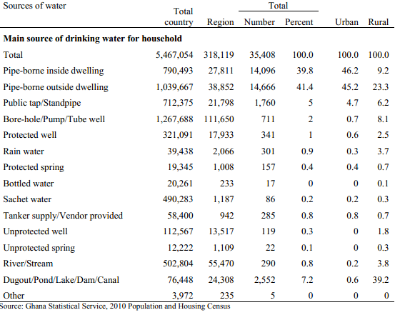
Water Supply and Management in Tamale Metropolis
The water supply system in Tamale was established in 1972 with the construction of an intake from the Nawuni river with a treatment plant at Dalun, the capacity at then stood at 19 million liters per day(Mld) (GWCL, 2010). Since then the metropolis enjoyed constant water supply until 2000 to 2007 when the populace started experiencing erratic supply as there was many instances of acute shortages. In 2008, the main treatment plant had a boost, the capacity was upgraded to 44 Mld with 20,000 m³ reservoir at Tampe-kukuo Yepalsi (Biwater, 2014).
Water supply and distribution is the sole responsibility of Ghana Water Company Limited(GWCL). It was created out of Ghana Water and Sewerage Cooperation(GWSC) in 1999 during Urban water Reforms, and decentralized to all the regional capitals in the country. Prior to that water supply in Ghana was under GWSC. GWCL service provision is only centered within the central business district and its suburbs, however water service in rural communities in the metropolis is done by Community Water and Sanitation Agency(CWSA). Due GWCL inability to extend water to rural communities, CWSA was created to aid water supply in rural communities. Sources of water supply they provide includes boreholes/wells, dug outs and community stand pipes.
The two water supply agencies within the metropolis uses different operating strategies, CWSA involves local government in water supply making more participatory. Thus, District assemblies are pivotal in water and sanitation. On the other hand, GWCL is centered within urban Tamale and local government is not involved in water supply and management. Tamale metropolitan assembly is only responsible for sanitary issues and not water (Kanton, 2008). The table below depicts the distribution of responsibilities in water supply and management;
Distribution of roles in provision of water
Roles | TMA | GWCL | CWSA | MWH | PURC
Leadership |  | √ | √
Policy formulation |  |  |  | √
Planning |  | √ | √
Budgeting |  | √
Financing |  |  |  | √
Operation and maintenance |  | √ | √
Brokerage |  |  | √
Regulation |  |  |  |  | √
Source: extracted from George and Meine, 2012 and reconstructed by the author.
As observed from the above table, the water governance structure does not include Tamale metropolitan assembly in water supply and management. Ministry water and Housing is responsible for policy formulation process. Water policies such National Water Policy and Water and Sanitation Policy was formulated by the ministry. The Public Utility Regulatory Commission was set up under the public utility regulatory act (act 538) in 1997. It regulates the utility services in water and electricity.
Informal water sector also exists in Tamale, due to poor water supply and lack of finance to connect to GWCL, most households in Tamale depend heavily on the informal sector for water. Though their services are regulated by GWCL, only few are registered to operate. Fauster observed that about 98percent of water vendors in Tamale were not having operating license (Fauster, 2014).
One of the main objectives of water governance is to ensure sustainable use and management of water resources. Water Resource Commission(WRC) of Ghana was established by the water act 1990, with the responsibility to manage all water bodies in Ghana. In the metropolis, all water users both commercial and domestic are required to register for water use permit. The department is fully decentralized through out the regional capitals of the country to carry out its duties. However, the registration for water use permit is ineffective in the metropolis especially for domestic users, few commercial water users are able to acquire permits to extract water. From the 2016 report of water users registered in Ghana, Tamale registered only one permit out of 225 registrations recorded (WRC, 2016). WRC is also responsible for formulating policies, rules and regulations for effective management of water.
Another regulatory body that plays relevant role in water resource management Environmental Protection Agency. It was established in 1994(Act 490) and given the responsibility of regulating the environment and implementing government policies. EPA unit in Tamale regulates any activity that might have adverse effects on the environment. They carry out environmental impact assessment, give permits for companies to operate.
Challenges of Water Governance in Tamale
Water governance structure is clearly outlined with GWCL as the main supplier of water, though other institutions such PURC, WRC, EPA and CWSA exist to regulate and ensure effective management and allocation of water resources in the metropolis. The governance system is bedeviled with complex challenges that hinders its effective performance.
Economic and political challenge; it is observed that water provision in Tamale is done through combination of distributed monopoly and deconcentration. Roles are embodied within the structures of the GWCL, the government structure does not permit the involvement of other government institutions in service delivery in the metropolis. As compared to other districts such as Savelugu Nantong district, the water governance structure permits multiple roles by involving other government institutions. More so, external parties such as NGOs and expertise are called on board to ensure effective water service delivery. From 19993 to 2003, Savelugu Nantong district recorded more success in water delivery supply and related services (George and Meine, 2012). Financially, CWSA lacks the capacity to deliver its functions. It depends heavily on NGOs to provide water to communities.
Lack of stakeholder participation is another hinderance to effective water governance in Tamale. GWCL structure does not allow the participation of local government in service delivery. TMA is not involved; water users are just seen as service beneficiaries. Domestic water users have developed lackadaisical attitude towards GWCL, Fauster revealed in his research that most populace of Tamale are unwilling to pay water bills because poor services (Fauster, 2012)
Logistics and human resource problems is another challenge of water governance. Regulatory institutions such EPA lacks the logistics and adequate human resource to conduct environmental impact assessment, but rather depend on individuals and companies seeking environmental permit to conduct the impact assessment. Most often permit seekers conduct assessment to suit their interest (Williams et al, 2012).
Conclusion
This paper presented an overview of water governance system in Tamale metropolis and showed the water supply system and responsible institutions. Stakeholder participation in water supply and management is climacteric for effective water governance. Tamale lacks that in its water supply system, as a result its water supply experiences erratic and acute shortage of water supply from time to time. For to achieve SDG six, participation in its water governance initiative is invaluable. The informal sector water system can help expand supply to communities who are not connected to GWCL. Also, if well regulated it could be a revenue source for the metropolitan assembly. Effective water governance will be further enhanced if government invest in capacity building of staffs in the various regulatory agencies.
Reference
Laryea-Adjei, G. and van Dijk, M.P. (2012) ‘Changing water governance in Ghana through
decentralization’, Int. J. Water, Vol. 6, Nos. 3/4, pp.215–23.
Aleo Awepuga F. (2015) ‘Water Scarcity in the Tamale Metropolis and the Role of the Informal Water Sector in Urban Water Supply’ KNUST.
Kanton Osumanu I. (2008) ‘Private Sector Participation in Urban Water and Sanitation Provision in Ghana: Experiences from the Tamale Metropolitan Area (TMA)’ Environmental Management 42:102–110 DOI 10.1007/s00267-008-9107-5.
UNHabitat. (2009) ‘Ghana: Tamale City Profile’ ISBN Number: (Volume) 978-92-1-132182-1.
Batchelor, C. (2006) ‘Water governance literature assessment’ accessed from http://pubs.iied.org/G02523/ on 5th January, 2018.
OEDC. (2015) ‘OECD Principles on Water Governance’ accessed from https://www.oecd.org/cfe/regional-policy/OECD-Principles-on-Water-Governance-brochure.pdf on 5th January.
Global Water Partnership. (2003) ‘Effective Water Governance: Learning from the Dialogues’ GWP Secretariat. Stockholm, Sweden.
Verkerk M.P, Hoekstra A.Y and Gerbens-Leenes P.W. (2008) ‘Global water governance: Conceptual design of global institutional arrangements’ UNESCO-IHE Institute for Water Education, Delft, the Netherlands.
Ghana Statistical Service. (2010). ‘2010 Population census’ accessed from www.statsghana.gov.gh on 5th January, 2018.
Biwater. (2014). “Tamale Water Supply Expansion & Optimisation, Ghana.” Biwater. Accessed
http://www.biwater.com/Articles/273257/Biwater/BW_home/water_treatment/water_treatment_projects/Tamale_Ghana.aspx accessed on 5th January, 2018.
Bucknall, J. and Damania R. (2008). ‘Good Governance for Good Water Management’ Environment Matters 2006 — The World Bank Group.
Williams, T.O.; Gyampoh, B.; Kizito, F. and Namara, R. (2012) ‘Water implications of large-scale land acquisitions in Ghana’ Water Alternatives 5(2): 243-265.

