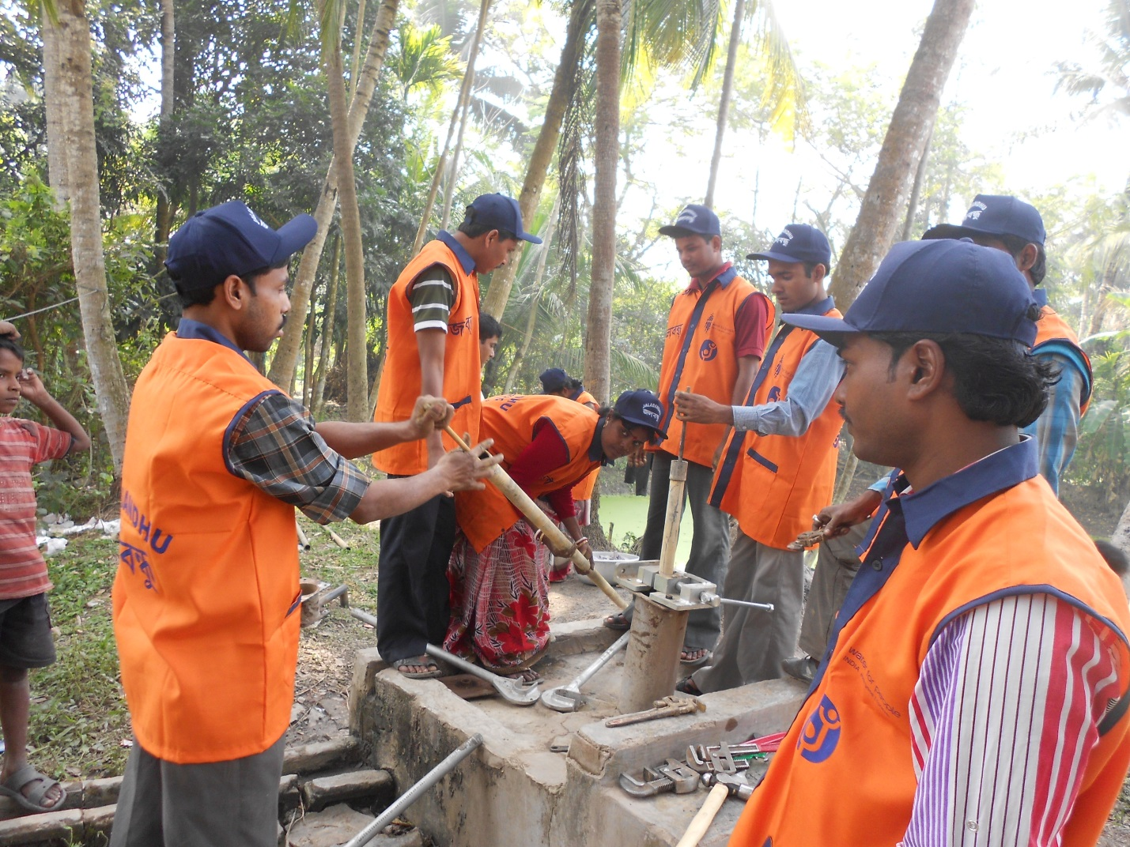
“It doesn’t matter who you are, or where you came from. The ability to triumph begins with you. Always.” -Oprah Winfrey
Unlike the other women of Mayapur village under Mayapur Gram Panchayat, Budge Budge 1 Block of South 24 Parganas, West Bengal, India, 32 year old Shikha Dolui’s life was not restricted to petty household work, she was engaged in Community Health Care Management Initiative (CHCMI) as village level group worker. After the intervention of Water For People in her village to ensure the access of safe drinking water and along with that means to sustain the accessibility an operation and maintenance system was adopted which was named as “Jalabandhu”. The term “Jalabandu” in local language means friends of water. These Jalabandhu’s were introduced as mobile mechanics for the broken water pumps installed in the community. Local youth were trained to become Jalabandhu’s as a means for providing them with a substitute income along with that it was an effort which could ensure the sustainability of the water-points. Sikha Dolui opted to join the Jalabandhu program as it would enable her to contribute more to her family income disregarding the fact that the job of a mechanic is often considered as a masculine job.
She was a good learner and within a short span she became a skilled and well equipped hand pump mechanic for both PHE-6 and IM-II. With her impressive communication skills she developed a strong relationship with the Local Government (Gram Panchayat) and community which ensured her with ample of repairing work. Since, 2012 she have been working in Mayapur Gram Panchayat area. At present she looks after 11 hand pumps in her area and she have formed two water committees for the maintenance of the points. Moreover, she procured her trade license which ensured her sustainability in this particular trade. For her business promotion she has printed her own letterhead, bill and stamp. In the last six months Shikha have drawn an income of Rs. 15000/- from this profession. Now the local government is ready to give her contracts for pipe line water point maintenance and other plumbing works.
Shikha is now determined to have a really strong foothold in this trade to shape up her son’s future along with her husband.

