Drain excrement
beginning of the emptying drain up
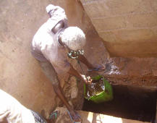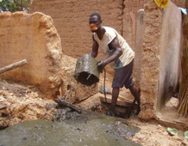

Immersion drain Drain cleaning End
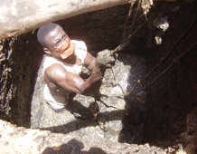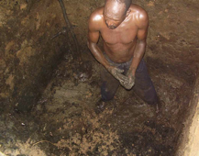

straw mound knoll children's games
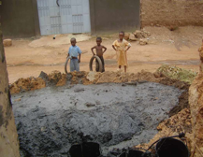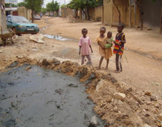

This reservoir is drained after over 10 years of filling. The fecal matter is transformed into mud. There was no sewage treatment.
The drain on the mulch causes two types of pollution
1 Some of the liquid seeps into the ground
2 Infiltration erodes support bearer ground walls of the dwelling.

