The World Bank
Terms of Reference
Myanmar: Rapid Multi-Hazard Risk Assessment of the Yangon Region Water Supply Network and Infrastructure System

- Project Background and Objectives
Myanmar ranks second out of 187 countries in the 2016 Global Climate Risk Index and ninth out of 191 countries in the INFORM Index for Risk Management. Over the past 25 years, Myanmar has suffered 24 disaster events affecting more than 4 million people and causing US $4.7 billion in damages. A preliminary financial-risk assessment estimated expected annual economic losses of more than US $184 million due to natural disasters, equivalent to 0.9 percent of GDP. From July to September 2015, the country suffered from severe floods and landslides, cutting economic growth by 0.8 percentage points, and disproportionally affecting segments of the population that were already poor and vulnerable.
Yangon City is at risk of flooding, with extreme events occurring 6 to 10 times per year when heavy rainfall coincides with high tides during the monsoon season when the rivers are apt to flood. The prevailing geological structures, along with surface geological conditions associated with an alluvial delta, soil characteristics, and tectonic settling, also make Yangon a highly earthquake-prone area.
Natural disasters (including the M5.8 earthquake in the Taikkyi region in March 2017) have damaged water supply facilities and infrastructure in the Yangon region, including 5% of the concrete supports of the Gyobyu Pipeline (a 69-km-long pipeline connecting the Gyobyu reservoir and downtown Yangon). Should critical network elements such as this be compromised, Yangon City’s water supply would be compromised, leaving entire communities without safe and reliable drinking water. These emergency events could arise from inundation of facilities, loss of electricity, or damage to infrastructure. Emergency events can also pose a cascading effect across interconnected infrastructure systems, with both direct and indirect economic impacts.
The objective of these consulting services is to assist the Yangon Regional Government and the Yangon City Development Committee (YCDC) to plan risk mitigation investments through a rapid multi-hazard risk assessment and cost-benefit analysis to plan, prioritize, and scope economically and technically viable resilience measures for the water supply network serving Yangon City. The assignment will cover the most critical (from a service continuity perspective) of the: (i) abstraction and treatment, (ii) bulk transmission, and (iii) reticulation and distribution infrastructure.
Major deliverables will include: (i) first-order estimation of potential damage and economic loss estimates for exposed assets, (ii) prioritization of key risk reduction interventions, (iii) preliminary cost estimates, and (iv) technical inputs to Terms of Reference for the detailed design of retrofit solutions for the priority assets identified.
- SCOPE OF WORK
The consultant will be required to work closely with YCDC’s Engineering Department Buildings (EDB) for the duration of the assignment. The Section Head Engineer of EDB will be the key focal point for the consultant for all matters related to the assignment, including all coordination and communication with other departments, as required. YCDC’s Engineering Department - Water and Sanitation (EDWS) will be a critical counterpart to this assignment and should be engaged early, through the EDB focal point and World Bank nominated person(s), to ensure an appropriate understanding of the local context and relevant institutional policies and procedures. The consultant shall include nominated representatives from the World Bank in all correspondence with EDB and shall consult directly with the Bank’s nominated person(s) throughout the assignment including for clearances/ coordination of field missions, and the like.
Task 1: Preliminary Assessment / Inception Phase
The consultant shall review the available documentation on: (i) hazard and risk assessments conducted for Yangon Region, (ii) the water supply network for Yangon City (including abstraction facilities and infrastructure that may be outside Yangon region), and (iii) exposure information for individual infrastructure elements.
The consultant shall prepare and submit an Inception Report setting forth the results of the review outlined above. All components of this Task should be developed based on international experience and global good practice. The report should include:
- A general assessment of the available data
- Proposed approach and methodology for Tasks 2 through 4
- Timelines
- Any other relevant topics.

Task 2: Water supply network criticality analysis
With the objective of securing the availability of safe drinking water after disasters, the consultant will undertake an analysis of the system reliability and redundancy of the water supply network, from (i) source, (ii) abstraction and treatment, (iii) bulk transmission, to (iv) reticulation and distribution infrastructure.
Network criticality analyses are fundamental for understanding the potential costs of disaster losses, and the benefits of interventions, for assets that function as part of -- and cannot be considered separately from -- larger networks. They are particularly essential to understanding critical infrastructure, where the downstream costs of service interruption can far exceed the replacement costs of these assets. In prioritizing individual elements for risk assessment (Task 3), the consultant will take the consequences of service interruption into account, and will select the most critical assets for further study under Task 3. These consequences may include, but not be limited to:
- The duration of disruption
- Geographical extent of the impact, affected population
- Cascading impacts. Which consequences will the disruption of the individual asset bring about on other network elements or services?
The image below provides a summary of the main water sources and supply networks for Yangon City
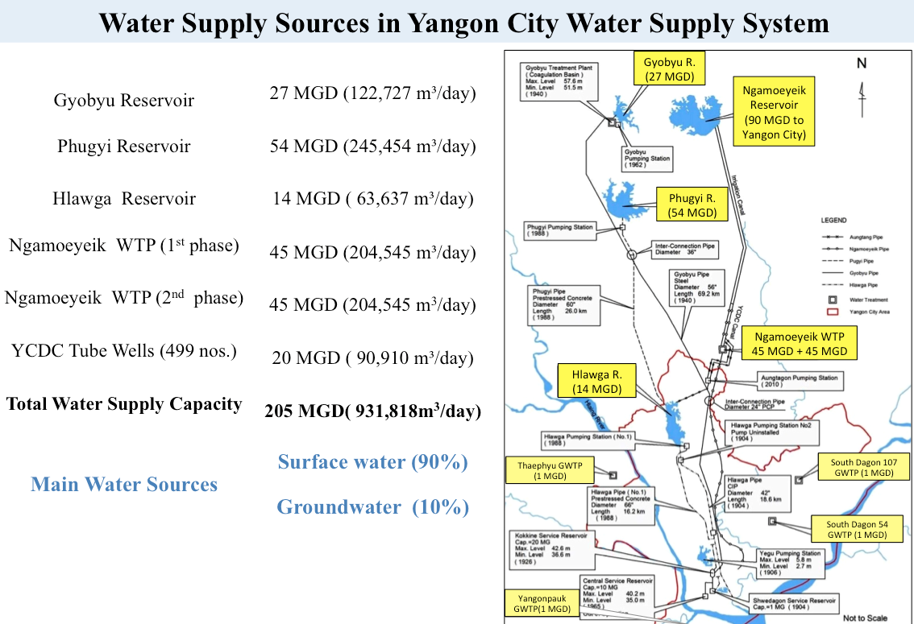

Water supply to Yangon City is sourced from four main reservoirs, all of which are managed by YCDC’s EDWS, except for the Ngamoeyeik Reservoir which is managed by the Ministry of Agriculture and Irrigation (MAI). Water is transferred to the city via a range of ageing cast iron, pre-stressed concrete and steel transmission pipelines, some of which are over 100 years old. The attached (see appendix 001 folder) ‘Water supply options for the growing megacity of Yangon’ major thesis, prepared by a current staff member of YCDC EDWS, provides a more detailed overview of the supply network and its components. A summary of the key network elements and available technical documentation is included below:
- Gyobyu Reservoir and Pipeline
- The Pegu Yomas Scheme for Water Supply to Rangoon – Journal Article (1948): describes the construction methodology for the reservoir and pipeline
- Structural Drawings (1940) – partially complete
- Transmission pipeline profile, GIS and pipeline rapid visual condition assessment report (2017)
- Phugyi and Hlawga Reservoirs and Pipeline
- Phugyi Reservoir (1995) - Full set of structural drawings, including Phugyi retention structure and appurtenant works (geological profiles, pumping stations), Hlawga pumping station and outfall structure
- Phugyi to Hlawga + Hlawga to Yegu Pumping station pipeline profiles and long sections
- EDWS presentation on historical failures and frequencies of Phugyi pipeline failures
- Ngamoeyeik Reservoir, canal and Water Treatment Plants (WTP)
- Construction information relating to the Ngamoeyeik Reservoir Earthen Retention Structure (with concrete conduit and spillway)
- DWGs for open canal and WTP design (stages 1 & 2 implemented same design)
- Overview document including reservoir information related to the process of constructing the drinking water system, reservoir water supply condition
For a more complete overview of the water supply network and available technical documents, the consultant should refer to the appendices index sheet, and associate appendices. It should be noted that no technical drawings, to the Bank’s knowledge, exist for the Hlawga Reservoir which was constructed in 1904.

Task 3: Risk assessment and prioritization
To conduct the multi-hazard risk assessment of the most network-critical elements (as identified in Task 2), the consultant will:
- Identify applicable hazards for the study region that are likely to result in major disruption to water service provision in Yangon City. Hazards to be assessed include (but are not be limited to) earthquake, subsidence (as appropriate), liquefaction (as appropriate), flood and wind.
- Compile regional hazard data (maps, intensity, return periods) for the selected hazards.
- Perform a structural condition assessment for the selected assets (based on Task 2).
- Assess non-structural components.
- Assess the expected performance of the asset (and develop first-order estimates of damages and losses) under relevant scenario events.
- Define the set of risk reduction alternatives, relevant design criteria, first-order cost estimates, technical and other requirements sufficient to inform feasibility studies and detailed engineering design. The consultant may make recommendations as to the targeted performance level of the infrastructure system, for example: (i) Service continues without interruption during and after the disaster; (ii) Service is interrupted and some misalignment and minor damage is acceptable, but the supply can be restored within a short time, or (iii) the network is damaged to a severe extent such that restoration of service takes many days or weeks.
- Develop criteria/tools to assist YCDC to prioritize risk reduction investments based on criticality, vulnerability, and CBA.

Task 4: Provide technical assistance to YCDC to develop the Terms of Reference for feasibility studies and detailed engineering design
A key deliverable of this assignment is to provide technical support to YCDC to prepare the terms of reference for the subsequent downstream works to be undertaken by YCDC. The TOR should be informed by this assignment and be developed in close consultation with EDB and the World Bank. It must outline all necessary requirements for a firm, through the World Bank’s Quality and Cost Based Selection (QCBS) procurement method, to undertake the following for the priority investments identified and agreed under this assignment:
- Conduct detailed structural investigation and risk assessment of identified priority critical infrastructure
- Conduct financial assessment, including cost-benefit analysis at asset level
- Prepare feasibility studies and detailed engineering designs, specifications and cost estimates.

Qualifications
The assignment will be undertaken by a firm/s, with established expertise and reputation in the field of risk assessment and disaster risk reduction for water supply systems.
One of the lead firm’s team members is expected to fulfill the role of Team Leader, to be the chief communication partner for the client and other external parties, to coordinate and manage the implementation of the assignment including all necessary personnel deployment, purchases, and project administration, to supervise the work of all team members and guide them as necessary, to carry out those tasks for which no professional specialist will be deployed, to manage the dialog and interface with primary counterparts and the World Bank, to compile and submit the deliverables stated above and ensure quality control and timely delivery of all deliverables.
The Team Leader is required to have the following qualifications:
- International Specialist with at least 15 years of experience leading similar projects.
- Full-time staff member of the firm leading the engagement. The Team Leader may not be a Consultant to the lead Firm.
- Master’s degree in a relevant discipline including structural, civil or water engineering
- Recognized expertise in the area of specialization.
- Demonstrated experience in project management, procurement and contract administration
- Ability to coordinate contributions of specialists in other disciplines to complete a joint product.
- Extensive expertise in disaster risk assessment / reduction for water supply systems.

Additional Key Staff may include, but not be limited to the following (note that some of these positions/skills may be combined):
Disaster Risk Assessment Specialist
- At least 8 years’ experience carrying out risk assessments of similar scope.
- Master’s degree in a relevant field.
- Significant hazard and risk assessment experience and capabilities, including specific seismic hazard/ risk assessment expertise

Structural / Earthquake Engineer
- Masters qualified Structural / Earthquake Engineer with at least 10 years’ structural design experience
- At least 7 years’ experience carrying out site investigation, seismic risk assessments and detailed structural assessments of water supply related infrastructure, including in data-poor contexts (desirable)
- Specific experience with assessment of pipeline networks, retention and intake structures (highly desirable)

Geotechnical Engineer
- Masters qualified Geotechnical Engineer with at least 10 years’ site investigation and design experience
- Should be familiar with recognised seismic procedures, considerations and standards and must have demonstrated experience in geotechnical investigations for similar types of projects.

Technical Editor with prior experience in editing published technical documents for the World Bank or a similar multilateral or bilateral organization is required.
The Consultant shall estimate and propose the number of key professional staff-weeks and support staff-weeks that are necessary for the various tasks of the assignment to fulfill all the requirements for the execution of the services. Consultant firms are encouraged to develop their own methodology, staffing plan, and work approach to accomplish the TORs.
Support staff and backstopping
The Consultant shall provide backstopping services as applicable during the assignment. In addition, the Consultant shall provide necessary support staff to cover the needs for secretarial services, drivers, and any other administrative and operational needs during the performance period.
Mobilization schedule
The Team Leader shall be mobilized for a sufficient number of days to guarantee the efficient management of the project. Sufficient flexibility in the Team Leader’s assignment schedule should be foreseen to allow participation in events relevant for the successful completion of the assignment.
- DELIVERABLES/SPECIFIC OUTPUTS EXPECTED FROM CONSULTANT
The final deliverables shall be:
- Camera- and print-ready, fully designed, technically edited documents in English with charts, pictures and diagrams all in high-resolution. It is the consultant firm’s responsibility to secure all necessary copyright permissions for secondary material used.
- A 5 to 10-page Executive Summary of the key issues for decision makers, including high resolution graphs, charts and diagrams.
- Geospatial data should be delivered as shape files (for vectors) and geotiff (for rasters), both of which must contain basic metadata and projection information.
The final products are expected to be such that the relevant national and local authorities have complete understanding of, are in complete agreement with, and in a form that supports implementation of risk reduction investments. The final documents are expected to be visually attractive, user-friendly, comprehensive publications.
Items | Outputs | Payment milestone  (in percent) | Indicative date
Mobilization | Signed contract | 10 | May 1, 2018
Task 1 | Inception report containing detailed work plan and methodology | 20 | May 14, 2018
Task 2 & 3 | Draft network criticality, risk assessment, and prioritization report | 30 | June 29, 2018
Task 4 | Draft technical sections of Terms of Reference for feasibility studies and detailed engineering design | 20 | July 6, 2018
Final Report |  | 20 | July 31, 2018

The consultant will report and submit all deliverables to the World Bank Task Team Leader. No part of the research or analyses may in any form or by any electronic or any other means be reproduced, or shared with others without the prior permission of the World Bank.
Supporting Resources for the Assignment
The Consultant will be responsible for arranging all necessary permits and visas to facilitate work. The Consultant is also responsible for all office space, accommodations, communications, data collection, printing, workshop, and travel costs. These items should be included in their proposal.
- SPECIFIC INPUTS TO BE PRESENTED BY THE CLIENT
Please see OneDrive Folder:
https://worldbankgroup-my.sharepoint.com/:f:/r/personal/asaldivarsali_worldbank_org/Documents/MM%20DRM%20Project%20Component%203/Rapid%20Multi%20Hazard%20Risk%20Assessment%20for%20Yangon%20Regional%20Water%20Supply%20Network%20and%20Infrastructure%20System?csf=1&e=ELmhh6

- Appendices Index Sheet – Summary of available data for rapid risk assessment
- Appendix Folder 001 – Water distribution network overview documents
- Appendix Folder 002 – Gyobyu – available reservoir and pipeline details
- Appendix Folder 003 – Phugyi and Hlawga - available reservoir and pipeline details
- Appendix Folder 004 – Ngamoeyeik reservoir, canal and WTP docs
- Appendix Folder 005 – Township pipeline – available GIS data

GermanWatch.2016. Global Climate Risk Index 2016. https://germanwatch.org/fr/download/13503.pdf.
INFORM. 2016. Results Report 2016 (link); Myanmar Country Profile (link).).
Preliminary World Bank analysis based on data from EM-DAT database.
World Bank / Global Facility for Disaster Reduction and Recovery.2012. ASEAN. Advancing Disaster Risk Financing and Insurance in ASEAN Member States: Framework and Options for Implementation.
The consultant should refer to WB Procurement Guidelines for more details http://documents.worldbank.org/curated/en/796061468126898713/Guidelines-selection-and-employment-of-consultants-under-IBRD-loans-and-IDA-credits-and-grants-by-World-Bank-Borrowers

