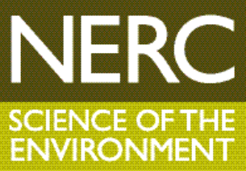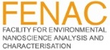

Small Things Matter:
The Risks and Rewards of Nanomaterials
University of Birmingham Nicolson Building, Winterbourne, Edgbaston Park Road, B15 2TT
Tuesday 23 May 2017, 09.30-16.15

You are invited to participate in a nanotechnology Industry Workshop hosted by the FENAC (Facility for Environmental Nanoscience Analysis and Characterisation) team in the Nicolson Building, overlooking the delightful gardens of Winterbourne House.

The Scope
This workshop is aimed at people who currently require or anticipate the need for advanced characterisation and understanding of nano-scale materials or processes, either for industrial applications, standardisation or regulatory compliance.

Nanomaterials may be intentionally introduced, accidentally released, or occur naturally in our environment. FENAC offers expertise in the development and characterisation of all nanomaterials, as well as their fate and behaviour in the environment: in fresh water, estuary and seawater, in soils, in culture media for organism growth and within biological tissues. Toxicity testing is also carried out at FENAC, monitoring interactions with whole organisms and human cells.

You will hear first-hand from FENAC users, the Facility’s own research experts and our instrument manufacturers, how our equipment and expertise can be used to solve the challenges facing the nanotech sector. A tour of FENAC’s laboratories will be included in the programme.

Your participation will help us to focus the future activity of the facility on providing the right services and solutions to your industry research and development, and we look forward to welcoming you for a lively and interactive programme on the day.

Registration
The Workshop is free to attend though pre-registration is required here

To find out more about FENAC visit http://www.birmingham.ac.uk/facilities/fenac/index.aspx

