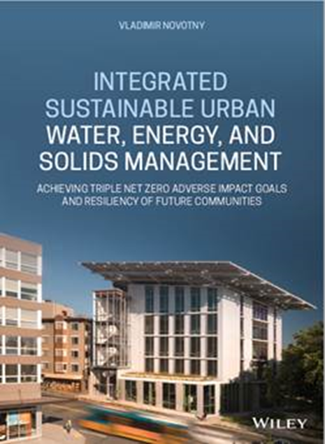
Wiley Book Announcement
Integrated Sustainable Urban Water, Energy and Solids Management:
Achieving Triple Net-Zero (TNZ) Adverse Impact Goals and Resiliency of Future Communities
Author Vladimir Novotny
ISBN: 978-1-119-59365-2 February 2020
The 416 pages book includes also extensive references section
A guide for urban areas to achieve sustainability by recovering clean water, hydrogen energy, and resources from used (waste) water and waste solids
Integrated Sustainable Urban Water, Energy, and Solids Management presents an integrated and sustainable system of urban water, used (waste) water, and waste solids management that would achieve the TNZ goals of saving and protecting water resources, recover energy and other resources from used water and waste solids, including plastics to achieve net zero (or better) carbon emissions, and minimizing or eliminating the need for landfills.
The book shows how to reduce emissions of greenhouse gasses to net zero level, or better, through water conservation, recycling, and generating blue and green energy from waste by emerging tested and known emission free technologies, such as anaerobic treatment of waste liquids producing methane, codigestion of biodegradable solids followed by microbial electrolysis to produce hydrogen, indirect gasification of combustible and organic residual solids to produce syngas (CO + H₂) followed by hydrogen fuel cells producing energy from syngas, methane and hydrogen, and concentrating and sequestering CO₂ from flue gases. Installing solar power on houses and wind power in communities complement the efforts to achieve the TNZ goals. Water conservation and stormwater capture can provide good quality water for diverse applications from natural and reclaimed water to blue and green energy and other resources for use by present and future generations.
Vladimir Novotny is Professor Emeritus at Marquette University, Milwaukee, WI and North-eastern University, Boston, MA, and was also managing partner at AquaNova LLC. He has over 50 years' experience in teaching and research in the fields of water quality and environmental management, wastewater treatment plant design, and nonpoint pollution identification and management. Since 1980 he authored and published 15 professional books on water quality, urban sewerage and wastewater treatment, diffuse pollution and, in this century, on water quality management, and on sustainable water, energy, and resource management in future communities.
https://www.amazon.com/Integrated-Sustainable-Energy-Solids-Management/dp/1119593654
https://books.google.com/books/about/Integrated_Sustainable_Urban_Water_Energ.html?id=VircwAEACAAJ

