SRK – article on water stewardship in mining

Water stewardship gives mines the broader view

With South Africa’s growing demand for water – and the impact of climate change on rainfall variability and water supply security – the need for a systematic approach to water stewardship in mining has never been greater.
Water management has long been a focus in the mining sector, according to Lindsay Shand, associate partner and principal environmental geologist at SRK Consulting. In 2014, for instance, the International Council on Mining and Metals’ water stewardship framework outlined a standardised approach for mining companies, recognising that water connects an operation to the surrounding landscape and communities.
“In our past work with mining clients, SRK often only addressed a particular challenge or project, rather than taking the broader view,” said Shand. “There is today, however, a growing recognition that a high-level, concerted approach to water stewardship is not only the environmentally responsible route to take, but also contributes to building the resilience of the mining operation.”
This resilience lies in the ability to identify and manage the myriad of water-related risks that operations face, she said. These might include water supply uncertainty, compliance issues related to water quality, and downstream discharge impacts. A water stewardship approach can provide the foundation for pro-active planning and action to avoid incidents that could threaten operational continuity or even viability and present a liability to downstream water users.
Tools for progress
While the focus for mining operations is generally on the specific challenge at hand, the larger corporations are starting to see the value of the bigger picture on water-related issues, concurred Fiona Sutton, principal consultant at SRK Consulting.
“Often, the scope and demands of water stewardship may seem a daunting prospect at operational level,” said Sutton. “This is one of the reasons why best practice tools are so useful, such as the International Water Stewardship Standard from the Alliance for Water Stewardship (AWS*).”
She highlighted that the AWS Standard offers a globally applicable framework for major water users to understand their catchment and their own water use and impacts, with practical guidance on how to effectively manage these impacts.
“Practical steps and guidance in the AWS Standard help water users to improve their water practices for better on-site water performance, while also contributing to wider sustainability goals,” she said. “Water crises are being exacerbated by climate change and are now acknowledged as societal risks due to their far-reaching consequences.”
Catchment care
Water stewardship considers impacts not only on the mine site but in the wider catchment in which a mine operates, according to Dr Simon Lorentz, principal hydrologist at SRK Consulting.
“Risks specific to the company can be direct, which disrupt actual mining operations, such as the non-availability of water supply to manage operations like waste disposal,” said Lorentz. “They can also be indirect, where supply chains are disrupted due to water supply issues or poor water quality.”
He noted that catchment-specific risks are influenced by local water resource management and governance effectiveness in dealing with factors such as increasing demand and unpredictability driven by climate variability. They are also affected by local infrastructure adequacy, the amounts of pollution being disposed into water bodies, and the resulting quality of available water.
“In one of our projects, we worked closely with a mine and the responsible authority to ensure that the quality of the naturally saline groundwater from an open pit was an acceptable quality before being discharged from site,” said Shand. “This strategy was guided by the presence of sensitive farming activity downstream of the mine and was made possible by taking the broader water stewardship approach.”
Strengthening reputations
The central position of water in many of the United Nation’s Sustainable Development Goals (SDGs) is another reason why many mining companies are starting to embrace water stewardship more systematically, said Sutton. Many corporates align their strategies with the SDGs, and many of those are relevant to water. While Goal 6 on Clean Water and Sanitation is key, others that depend on access to water include No Poverty, Zero Hunger, Good Health & Well-being, Sustainable Cities & Communities, and Life Below Water.
“An added advantage of the AWS Standard is that it allows mines to be accredited once they have met the detailed range of requirements,” she said. “This is valuable in terms of companies’ reputations – whether in the eyes of investors, financial institutions, regulators or the general public.”
Credible benchmark
The AWS’s position as a member of ISEAL assures stakeholders that its water stewardship framework has been reviewed by an independent and competent body. The framework and the accreditation therefore provide a credible benchmark that can be trusted as a true indication of commitment.
“SRK’s decades of experience in the mining sector, combined with its depth of expertise in water-related disciplines, positions us well to guide mining companies in their water stewardship journey,” said Shand.

Words: 782

[Side-bar]
Covering the bases
Applying the principles of water stewardship on mines involves a range of considerations – both regulatory and strategic. On a recent project in which SRK Consulting was involved, the process involved the following among the various relevant areas to be covered.
- Water use licensing – a regulatory requirement which now also includes the need to consider climate change impacts
- Reduced water consumption alternatives
- Water quality monitoring
- Challenges arising from the salinity of discharge water – considering upstream water quality conditions and downstream water users
- Public consultation and disclosure – including a community water supply project

Images and captions:
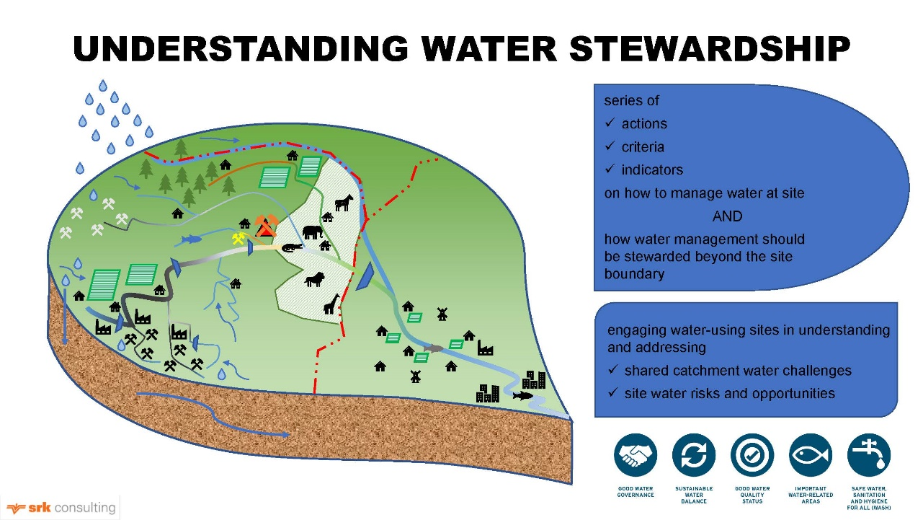
A site in a catchment taking cognizance of the effects of upstream activities on a site (red triangle) as well as the potential impact of site operations on downstream water users

Lindsay Shand, associate partner and principal environmental geologist at SRK Consulting

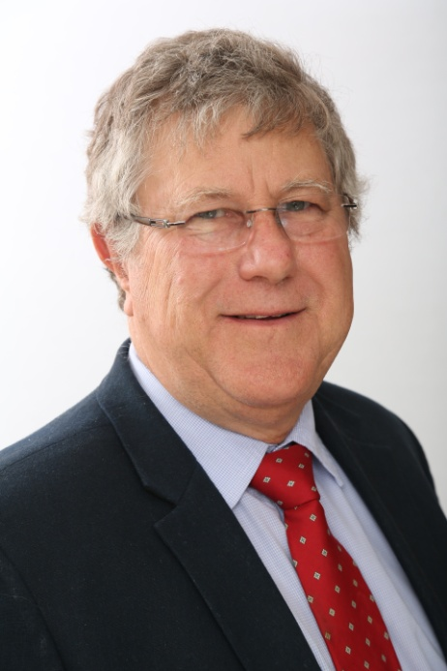
Dr Simon Lorentz, principal hydrologist at SRK Consulting
Fiona Sutton, principal consultant at SRK Consulting

About SRK
SRK is an independent, global network of over 45 consulting practices on six continents. Its experienced engineers and scientists work with clients in multi-disciplinary teams to deliver integrated, sustainable technical solutions across a range of sectors – mining, water, environment, infrastructure and energy. For more information, visit www.srk.co.za

