Designing Transboundary Agreements: What can we learn from existing Water Treaties?

Transboundary water treaties are becoming more common in the world’s international rivers. Progress has been made, but a treaty’s design matters as much as its existence. Integrated Water Resources Management (hereafter, IWRM) remains a best practice in transboundary water management and negotiating bilateral or multilateral water treaties for cooperation in resource sharing and management. The foundation framework of IWRM and understanding of the larger socio-economic and socio-political elements remain pivotal in designing transboundary agreements. The first blog post in this series (https://thewaternetwork.com/_/integrated-water-resource-management-iwrm/blog-Jl6/transboundary-waters-building-political-will-for-cooperation-WjFmhOhVLrkJnuUcu924-g) explored why countries can be reluctant to sign treaties with their neighbours over the use and protection of their shared water resources. This post will explore how elements of good design can steer the agenda implementation and impact, once the consensus for an agreement has been reached.

Researchers and strategists report that formal agreements between countries that set rules for the use of their shared water resources are known to reduce the chances of conflict. UNU-INWEH’s synthesis report of 2015 ‘Water Cooperation’ (http://inweh.unu.edu/portfolio/water-cooperation-views-progress-way-forward/) discusses how formal agreements enable better protection of water and the environment, and that limit the ecosystem and economic harm caused by fragmented, ‘race to the bottom’ policies. However, the components of these agreements matter greatly. There are a number of stumbling blocks that can be encountered – nonetheless, the good news is that treaty design is mostly within the realm of the negotiator. Such obstacles to reaching a lasting cooperative agreement can easily be corrected.

What Works? What Doesn’t…
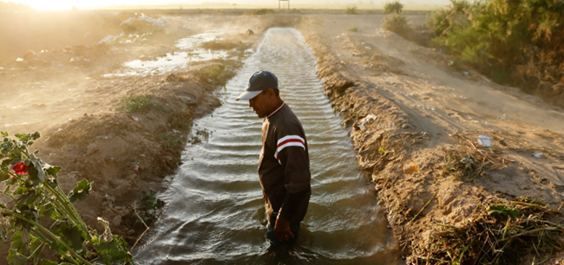
Evolving legal agreements are one way to respond to emerging water and climate issues. Above, representatives of the US and Mexico sign a minute that updates the terms of the US-Mexico International Boundary and Water Commission. These updates have enabled coordination on restoring water flows to the Colorado River Delta. Source: http://america.aljazeera.com/articles/2015/4/27/us-mexico-water-pact-brings-life-back-to-colorado-rivers-parched-delta.html

International agreements over water resources have only recently begun to incorporate issues of water conservation, environmental sustainability, limitation of and adaptation to climate change. Treaties dating back hundreds of years or to the early 20th century tend to focus on navigation and hydropower development, not sustainability. Although some older agreements have been modified over time to respond to environmental and climate change concerns, many have retained elements that do not align with currently accepted best practices in harmonizing water governance. For example, fixed water allocation amounts set in a 1944 US-Mexico water treaty could not be met under extended droughts in the 1990s and 2000s – in response, reform is ongoing in the joint commission.

Internationally recommended approaches to governing water, such as the 1997 UN ‘Watercourses Convention’, 1992 ‘Dublin Principles’ and the closely related concept of IWRM, have emerged in response to problems that develop under earlier, often fragmented national approaches. Twenty years of experience with these approaches to institution strengthening has led to a multitude of academic findings on how these high-level policies and laws can best work in practice. Attention should be paid to these findings as IWRM, including transboundary cooperation where needed, continues to be highlighted in the development Agenda 2030 portfolio-the Sustainable Development Goals (UN SDGs 6.5, 14, and more).

Treaty components can be sorted into a framework of elements that are known not to work (because they lead to conflict or fail to address water resource stress and degradation), elements that are recommended as ideal, and elements that have worked in practice (which may not align fully with international best practices, but have allowed cooperation efforts to survive). Let us understand this further by analyzing case-examples from various parts of the world.

Issue/Component | Ideal | What to avoid | Has worked in practice
Scope of treaty (Number of countries involved) | Full participation of all watercourse states | Excluding key players | -Cases such as the Mekong and Nile where some basin states are not full participants but still share valuable data
Scope of treaty (Geographic scale) | River basin is the recommended scale for management | Fragmented national policies in different parts of the same basin | -Partial basin coverage, as long as key areas are included (e.g. the Canada-US International Joint Commission, an example of adaptive management and cooperation since 1909)  -‘Problem-shed’ focus where resources are limited  -Aquifer or wetlands boundaries used instead where more appropriate
Legal authority of River Basin Organizations (RBOs) created by treaties | RBO has legal authority over water and some voice in governing related systems | RBO has no legal authority | -RBO has clearly specified functions – in many cases authority has grown over time
Water allocation between two or more countries | -‘Reasonable and equitable use’ but also ‘no harm’ caused to downstream states (1997 Watercourses Convention) | Fixed allocation amounts (US-Mexico until recently) | -‘Flexible but specific’ requirements such as proportional water allocation.  -Specifies when emergency drought/flood conditions apply
Information and  knowledge sharing – important for adaptive management | Joint knowledge gathering and full sharing of data and information | Data being hoarded by national ministries (concerns over validity can lead to trust issues, as in Southern Africa in the 1980s)  -Treaty doesn’t specify when or how often information and knowledge will be shared | -Automated information sharing and flood warnings (such as in the Elbe and across the EU)  -Joint information collection, fact-finding as a first step for an RBO  -Frequent in-person meetings to build relationships and allow for less formal exchanges of ideas
Dispute resolution – a commonly needed element in managing international waters | Some process specified; international mediation is available if needed | No dispute resolution mechanisms discussed in the treaty, leading to ‘ad hoc’ processes that can be seen as unfair | -Treaty clarifies mutually acceptable processes of resolving conflicts
Joint infrastructure, financing – a new element with a long term potential | Equitable funding of joint projects, financial support to watercourse states who bear higher costs of joint decisions | Unilateral development without going through agreed approval processes | -Financial transfers for projects, payment for ecosystem services (such as South Africa’s scheme to pay previously unemployed individuals for ecosystem restoration and protection)

In some cases, countries have formed agreements that do not clearly specify key responsibilities- a gap that often leads to disputes. A lack of dispute resolution processes can compound this problem, since regional or international conflict resolution procedures may not address local concerns or less technical elements of the dispute, such as questions of national reputation and dignity in conflicts. Ad hoc responses to disputes can also be perceived as unfair or illegitimate ‘retaliation’ since the parties did not agree beforehand. For all of the components reviewed in the table above, it is best for signatories to be clear and specific. However, specific ecological goals often change over time as new scientific information emerges, so this component should be adaptive and allow for periodic review.

Why don’t treaties incorporate these elements?
It seems self-evident that a clear and specific agreement will cause less disagreement than one that does not even mention information exchange or conflict resolution requirements. However, some legal terms are inherently hard to define, such as ‘reasonable use’ – countries may leave these issues for future joint decision-making. Experts argue that this ambiguity can be deliberate: it makes it easier for governments to reach the end of negotiations and to justify the treaty to their own population. However, as ambiguous language sometimes covers up fundamental disagreements that have not been resolved, these agreements are weak and likely to lead to disputes. For example, cases where states could not agree on existing levels of water use at the time of signing a treaty are unlikely to agree on the treaty’s effects on water use.

Many states do not have the political stability or economic resources to design and maintain water agreements: information may be lacking, or the changes the treaty requires may be unpopular. When we talk about more than half the world in a state of political fragility and conflict (Map 1) compounded by poor income and low livelihood opportunities (Map 2), the strategic relevance of clear and specific institutional arrangements to manage common and shared resources becomes apparent.

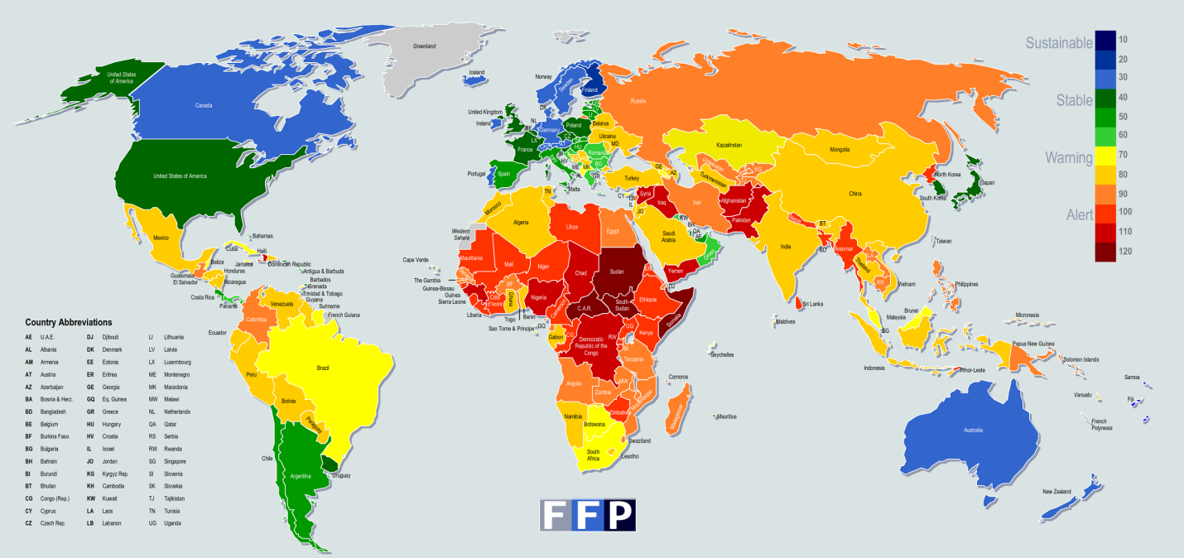
Map 1: ‘Fragile states’ in the world, from stable (blue and green) to less stable (yellow, orange and red). Source: The Fund for Peace, http://fsi.fundforpeace.org/

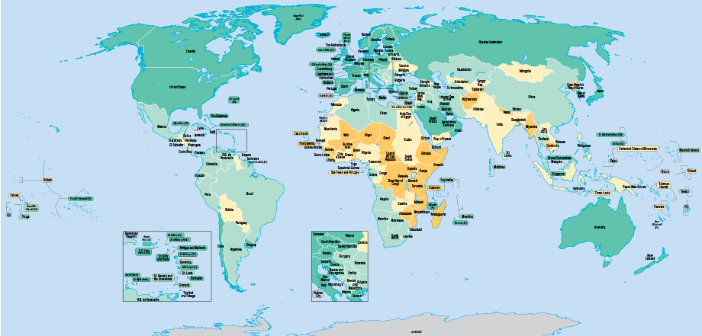
Map 2: Income per capita in 2015, from lower (orange) to higher (blue) levels. Poorer states are often more fragile. Source: World Bank, http://data.worldbank.org/maps2015

Pathways for Progress
Specificity but the ability to adapt some requirements over time is the best practice for countries seeking to form a water treaty. However, data limitations can delay such agreements, and limited resources can affect the implementation of key requirements, such as a jointly agreed-upon IWRM framework. This suggests that negotiations should start with joint fact-finding on water use, if baseline water information is a point of contention. The international community can assist with financial and knowledge support, mediation in negotiations if needed, and perhaps allowing more flexibility to local conditions in IWRM’s operational elements: for example, using aquifer boundaries as a more relevant geographical unit of water governance than river basins, in areas where groundwater extraction is high. In summary there is no blueprint that can apply to resolve transboundary water management challenges and conflicts, as specific are the problems to a region so are solutions. The bottom line is to refer a success story or lessons leant that mostly closely resembles the situation.

The good news about treaty design issues is that they are easy to correct – it is completely possible for negotiating governments to rewrite them to reflect the changing dynamics of ecological, socio-economic, cultural and political systems. A first step in reaching durable, resilient treaties and cooperation is for negotiators to be aware of priority issues (irrigation, hydropower, biodiversity conservation, and more) based on systematic evaluations and case studies from the past. Good treaty design is like a structural framework available that offers a solution to any case if the involved parties can evaluate benefits and potential downsides of their proposition towards a common agreement. For a water treaty to be operational successfully both the political motivation to cooperate and strong institutional design are needed.

Authors

Catherine ​Chisholm and ​Nidhi ​Nagabhatla ​

United ​Nations ​University – ​Institute for ​Water, ​Environment and ​Health ​

UNU-INWEH - ​The UN Think ​Tank on Water ​

204-175 Longwood Road South

Hamilton, ON L8P 0A1

CANADA

Brochmann, M. (2012). Signing River Treaties—Does It Improve River Cooperation? International Interactions, 38(2), 141-163.
Gerlak, A. K. (2015), Resistance and Reform: Transboundary Water Governance in the Colorado River Delta. Review of Policy Research, 32: 100–123.
Dinar, S., Katz, D., De Stefano, L., & Blankespoor, B. (2015). Climate change, conflict, and cooperation: Global analysis of the effectiveness of international river treaties in addressing water variability. Political Geography, 45, 55-66.
UNEP (2009), Making Payments for Ecosystem Services Work. http://www.diversitas-international.org/resources/outreach/ArriagadaPerrings_2009_UNEPpolicybriezfESPayment.pdf
Tir, J., & Stinnett, D. M. (2012). Weathering climate change: Can institutions mitigate international water conflict? Journal of Peace Research, 49(1), 211-225.
Fischhendler, I. (2008). Ambiguity in Transboundary Environmental Dispute Resolution: The Israeli—Jordanian Water Agreement. Journal of Peace Research, 45(1), 91-109.

