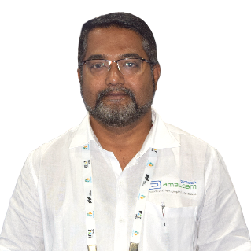

– ***Ashutosh Vadanagekar*** is the Managing Director of Amalgam Biotech. Ashutosh’s expertise is his knowledge of Production process industries because of his past experience of commissioning close to 55 different ETPs & ZLD plants in India & overseas. He has an overall experience of 24 years, of which 12 years have been spent at Wastewater sites in commissioning & troubleshooting the plants. Ashutosh undertakes wastewater training & consulting assignments at an individual level. His work profile in Amalgam Biotech is focused on New product development & site troubleshooting. Ashutosh can be reached at +91-9657711558 – [ashutosh@amalgambiotech.com](mailto:ashutosh@amalgambiotech.com)   
  
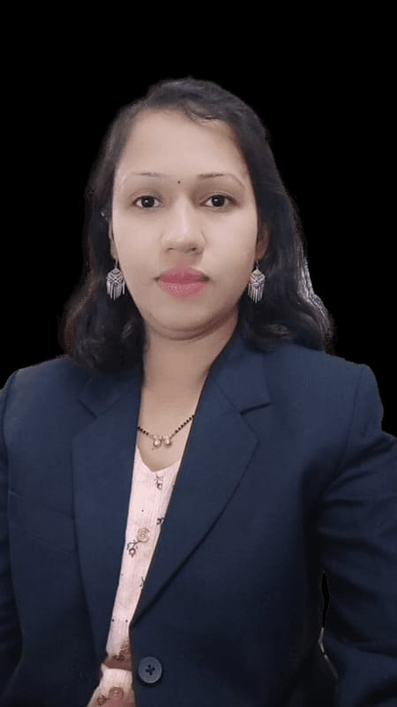  
– ***Swati Joshi*** has done masters in Environmental Sciences & professional courses, ISO certifications and has diversified rich experience in the fields of Environment, safety & Health, education for 12+ years. She has received "Shrusti Mitra" Award from Govt. of Maharashtra in 2013. Her article is published in book "Jana Manasatil Paryawaran" by Dept of Environment, Govt of Maharashtra. Her environmental awareness series broadcasted on All India Radio. She is **Application Analyst** in *Amalgam Biotech* and contributing in product testing. She plays a vital role in achievement of various certifications. Her work profile in the company is also focused on the publications of products success stories and R & D activities.

**About the Amalgam Biotech :**

Amalgam Biotech is a Bio-technology based company.   
**For Wastewater Treatment (BactaServe):**  
We provide customized sustainable solutions for different categories of wastewater treatment and solid wastes; in the form of Specialized Bacterial cultures for Industries like Pharma, Textile, Chemical, Dairy, Tannery, Slaughterhouses, Food Processing, Oil Refineries and others. We are also associated with the Government of India Research Institutes for Specialized technologies for treating specific wastes.  
**For Odour Control (OdoServe):**  
We have an Odour control system for Neutralizing the Odour from both Industrial and Domestic-Municipal segments. We are associated in giving solutions in the form of product additives for the removal of odour from finished product lines like recycled plastic, rubber, craft paper, pyrolysis oil, others

**For Process Additives (NutriServe):**

We are providing the products mainly essential micronutrients that nourishes the essential bacteria’s for aerobic and anaerobic process associated with WWTP. The other products mainly required in enhancing the conditions of Aerobic and Anaerobic Process is also being manufactured and supplied like BOD enhancer, Supply of Nitrogen-Phosphate from Organic sources, others.

Amalgam Biotech

* Helps in Providing optimised and sustainable solutions for different category waste

* A Biotechnology company is one-stop solution for your generated waste type.

* Has expertise in ETP-CETP-WWIP-STP process.

* Hands-on experience in Primary, Secondary and Tertiary treatment processes.

* Has Engineering solutions for Odour Control Systems.