Dear Patron,

Greetings from Water Today!
AN UNPARALLELED KNOWLEDGE & INFORMATION RESOURCE

Every month, the magazine publishes relevant case studies and technical articles based on the highlighted topic for the issue, written by renowned industry experts from the national and the international scene. Besides, the magazine also cover various information and news related to water treatment plants, types of treatment plants, technical information and products launched by OEM and events in the water and wastewater sector around the world. Our annual directory, Water Pages is a massive compilation of all the Indian companies engaged in the Water and Wastewater Industry.

Moreover, Water Today’s E-mag can now be viewed online www.watertoday.org. You can view the monthly edition from anywhere at any time! Free online viewing is for a limited period only. Online subscriptions will begin soon.

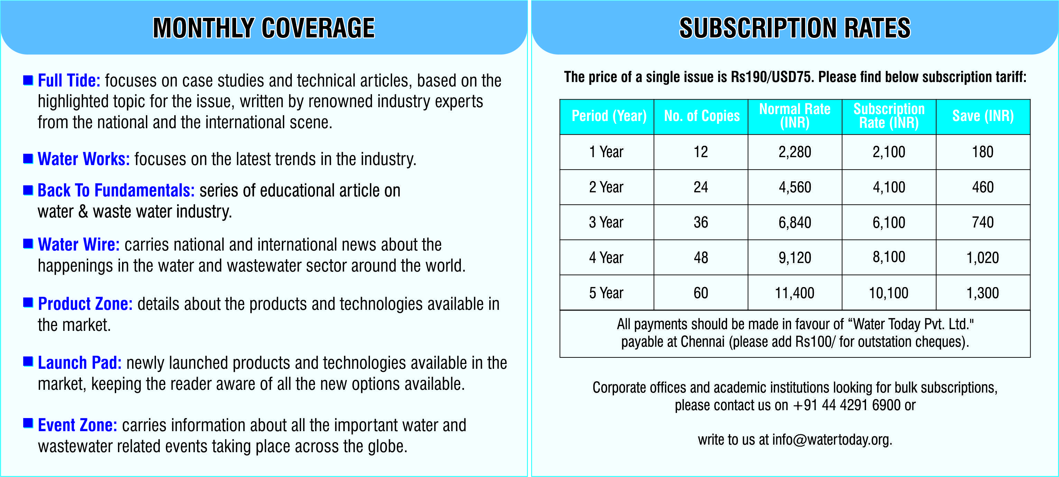
Every issue of the magazine is focuses on the relevant topics that are derived keeping in mind the trending ideas in the water and wastewater industry. Besides the articles are always been imperatively focused and delved deep into the technicality and practice considering its impact on the industry which is the need of the hour.

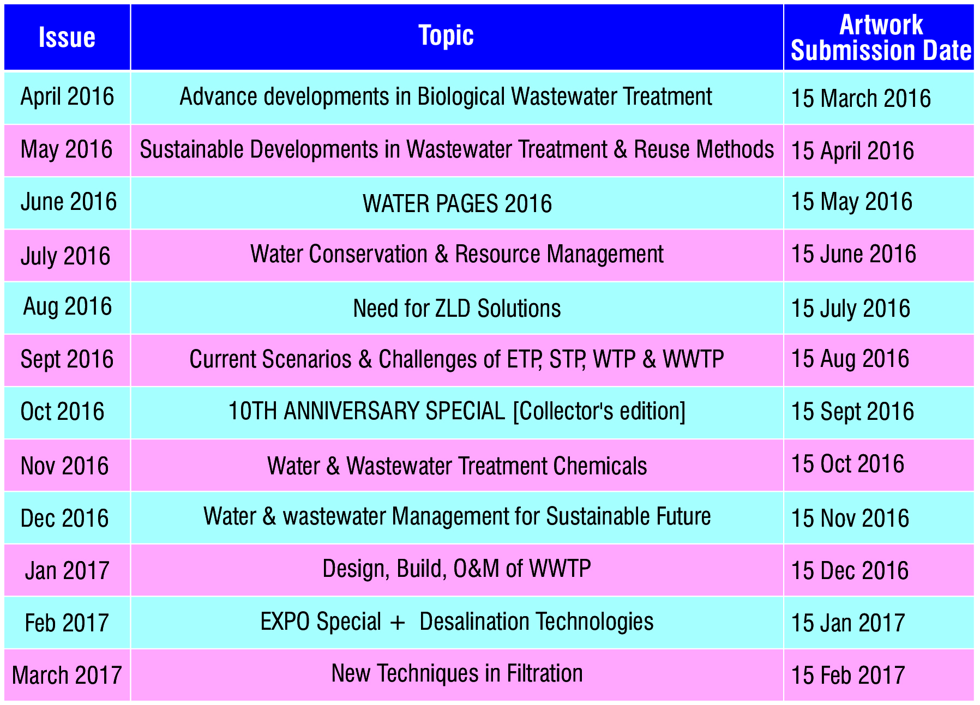

We hope this information has helped you understand about us and how we can be a valuable source of information to you. For subscription related queries call us on 044-4291 6900 or write to us!

