REAL-TIME WATER QUALITY MONITORING: A tool towards better water governance in Jordan

Tharwh Qutaish¹, Farouq Alomari, Haitham Saleh, Samer Mousa, Muath Haddar and Almoayied Assayed
“Royal Scientific Society”
PO Box 1438, Amman 11941, Jordan
¹ corresponding author: e-mail: Tharwh.qutaish@rss.jo

Keywords: Real-Time Water Quality Monitoring, governance, telemetry, surface water

Abstract. Jordan is considered to be one of the four poorest countries worldwide in water resources. The main challenge for the future is meeting the growing national water demand for the medium to long term and keeping the water sources quality out of any pollution sources. In this paper, the Jordan first experience regarding the real-time water quality monitoring systems which was established since year 2003 by Environment Monitoring Research Central Unit (EMARCU) at Royal Scientific Society (RSS) under the Higher Council for Science and Technology (HCST) umbrella is presented. The main hardware of the system consists of measuring sensors, a microcontroller, a wireless communication system, and database. It detects water temperature, dissolved oxygen, pH, electric conductivity, COD, turbidity and nitrate in a pre-programmed time interval. The gathered information is demonstrated in graphical and tabular formats through a customized web-based portal to better serve relevant end-users. To ensure the effectiveness and reliability of the real-time monitoring system, quality assurance, quality control and quality assessment procedures have been implemented. It was concluded that the real-time system has great prospect and can be practically used for environmental monitoring by providing stakeholders with relevant and timely information for sound decision making.
1 introduction

Depending on the quality of water, it may either be a source of life and good health or a source of diseases and deaths. The growing environmental degradation in recent years brought about by development, population increase and climate change increases the need for researchers to look into its negative impact in the environment, especially in water sources and its implication. Increasing water pollution in oceans, lake, and river triggers worldwide demand more advanced methods in environmental monitoring systems particularly in the field of water quality monitoring.

Water quality is affected by both point and non-point sources of pollution, which include sewage discharge, discharge from industries, run-off from agricultural fields and urban run-off. Other sources of water contamination include floods and droughts and due to lack of awareness and education among users. The need for user involvement in maintaining water quality and looking at other aspects like hygiene, environment sanitation, storage and disposal are critical elements to maintain the quality of water resources.

Water quality monitoring is defined as the collection of information at set locations and at regular intervals in order to provide data which may be used to define current conditions, establish trends, etc.,.The main objectives of online water quality monitoring include measurement of critical water quality parameters such as microbial, physical and chemical properties, to identify deviations in parameters and provide early warning identification of hazards. Also, the monitoring system provides real time analysis of data collected and suggest suitable remedial measures.

The traditional method for monitoring of the water quality is such that the water sample is taken and sent to the laboratory to be tested manually by analytical methods. Although by this method the chemical, physical, and biological agents of the water can be analyzed, it has several drawbacks. Firstly, it is time consuming and labor intensive. Secondly, the cost for this technique is very high due to the operation cost, labor cost and equipment cost, and most importantly it is difficult to make critical decisions in the real time. Therefore, the real-time monitoring compared to the conventional water quality testing techniques, real-time water quality monitoring has many advantages such as accuracy, high sensitivity, good selectivity, speed, fast response and low long run cost.

The aim of this paper is to document the first Jordan’s pioneered real-time water quality monitoring system, which was established in 2003 and is managed by the Royal Scientific Society since that time. The system ultimate goal is to foster public health, protect environment and ensure sustainability.

2 BACKGROUND
Jordan is one of the poorest countries in the world in terms of water availability. Jordan’s renewable water resources are limited and insufficient to meet the escalating national demand. The main water resources in the Kingdom consist of surface water, groundwater and non-conventional water sources. The quantities of all these resources for the year of 2020 was estimated 1,286 Million m^{3,}. According to the Ministry of Water and irrigation, the quantity of surface water used for various purposes in year 2020 was about 363.9 Million m³, representing almost 28% of the total water supply, of which 55.1% used for agricultural purposes and 40.9% used for municipal purposes through the King Abdalla Canal.
Water security has become a major domestic issue as population increases rapidly with refugees entering the country. The global COVID-19 pandemic added more environmental stresses to an already vulnerable and arid country. The need to have water for domestic use, irrigation, and industrial and environmental protection, coupled with deteriorating water quality and control of water-borne diseases, poses serious water sustainability challenges in Jordan. The economic development of the past two decades has created enormous pressure on the quality of the groundwater and surface-water resources.
The National Project for Real-Time Water Quality Monitoring (NP-RTWQM) system was first introduced to Jordan in year 2003 by the Environment Monitoring Research Central Unit (EMARCU) at Royal Scientific Society (RSS) and under the jurisdiction of the Higher Council for Science and Technology (HCST). The NP-RTWQM is an online water quality monitoring program that was established to support the country in assessing the quality of available water resources. The objectives of the NP-RTWQM are threefold:
- To collect water quality data on the major surface water resources in Jordan.
- To provide a national water quality platform for surface water in Jordan.
- To improve water governance in Jordan through providing credible and transparent water quality data.

The National Project for Real-Time Water Quality Monitoring consists of 13 stations installed at Yarmouk, and Zarqa Rivers in addition to King Abdullah Canal and inlet and outlet of King Talal Dam (Table 1). The stations were geographically distributed in a way that covers all major surface water sources in Jordan (Figure 1).

.
Table 1: Monitoring station locations

Site Code | Name and location of the site
M1 | Yarmouk River/Wadi Khalid
M2 | King Abdullah Channel/North Tunnel Outlet
M3 | King Abdullah/Tiberias Conveyor Outlet
M4 | King Abdullah Channel/ Wadi Al-Arab Dam Pump Station
M5 | King Abdullah Channel/Deir Alla Intake
M6 | King Abdullah Channel/Intersection with Zarqa River
M7 | King Abdullah Channel/ Karameh Dam Turn-out
M8 | Zarqa River/Al-Hashimyah Bridge
M9 | Zarqa River/Tawahin Al-Odwan Bridge
M10 | Zarqa River/King Talal Dam Inlet
M11 | Zarqa River/King Talal Dam Outlet
M12 | Jordan River/Majame Bridge
M13 | Jordan River/King Hussein Bridge

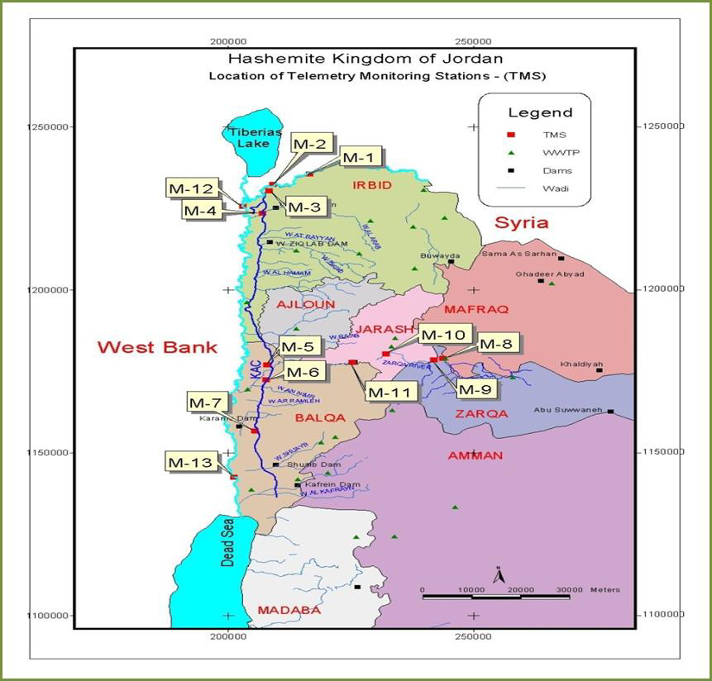

Figure 1: Distribution of the monitoring stations on Jordan's surface water sources

2.2 Project Organizational Structure

In order to institutionalize the project and ensure its sustainability, EMARCU manages the NP-RTWQM through a multi-stakeholder committee. The project organizational structure is shown in Figure 2.

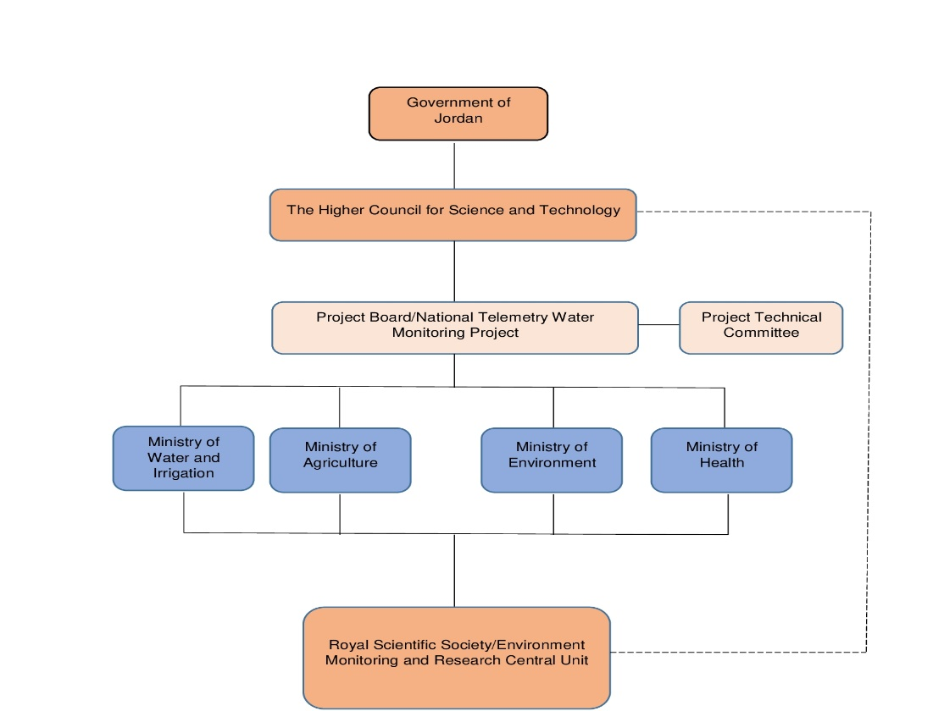

Figure 2: The organizational structure of the NP-RTWQM

The NP-RTWQM has a steering and technical committee each of which includes the Ministry of Environment, Ministry of Health, Ministry of Water and Irrigation, Ministry of Agriculture and Miyahuna LLC Water Company. The technical committee meets every three months to follow up the project progress, challenges, deliverables, stations results, sensors calibration and system accreditation, while the steering committee meets upon HCST request.

2.4 Measuring Parameters

The essential parameters of the water quality vary based on the application of water. For example, for aquariums, it is necessary to maintain the temperature, pH level, dissolved oxygen level, turbidity, and the level of the water in a certain normal range in order to ensure the safety of the fish inside the aquarium. For the industrial and household applications, however, some parameters of the water are more essential to be monitored frequently than the others, depending on the usage of the water. For the National Project for Real-Time Water Quality Monitoring the technical committee members agreed to monitor the following parameters in an hourly basis:

- pH: The hydrogen-ion concentration is an important quality parameter of both natural waters and wastewaters. The usual means of expressing the hydrogen ion concentration is as pH. Although pH usually has no direct impact on consumers, it is one of the most important operational water quality parameters. Careful attention to pH control is necessary at all stages of water treatment to ensure satisfactory water clarification and disinfection.
- Temperature: Temperature is another important quality parameter that should monitored as it will impact on the acceptability of a number of other inorganic constituents and chemical contaminants that may affect water taste. High water temperature enhances the growth of microorganisms and may increase taste, odor, color and corrosion problems
- EC: Electric conductivity is one of the parameters monitored in the real time systems as it gives an indication regarding Total Dissolved Solids (TDS) which comprise inorganic salts (principally calcium, magnesium, potassium, sodium, bicarbonates, chlorides and sulfates) and small amounts of organic matter that are dissolved in water. TDS in water originate from natural sources, sewage, urban runoff and industrial wastewater.
- Turbidity: a measure of the light-transmitting properties of water, is another test used to indicate the quality of waste discharges and natural water with respect to colloidal and residual suspended matters. Turbidity readings at a given facility can be used for process control as well.
- Dissolved oxygen (DO): Dissolved oxygen (DO) is required for the degradation of organic content by aerobic microorganisms. The actual quantity of oxygen (as well as other gases) that can be present in solution is governed by: (1) the solubility of the gas, (2) the partial pressure of the gas in the atmosphere, (3) the temperature, and (4) the concentration of impurities.
- Nitrate (NO₃): Nitrate is found naturally in the environment and is an important plant nutrient. It is present at varying concentrations in nature and its concentration can give an indication regarding the nitrogen cycle.
- Chemical Oxygen Demand: COD test is used to measure the oxygen equivalent of the organic material in wastewater that can be oxidized chemically it is an important parameter for water quality especially for the water coming out from treated wastewater plants.

3 Stations’ COMPONENTS
The National Project for Real-Time Water Quality Monitoring system components are as follows:

3.1 Stations Hangar

Each iron closed station hangar has; the measuring devices, computer, modem, and air-condition. Figure 3 shows how is the monitoring station hangar looks like from inside and outside.
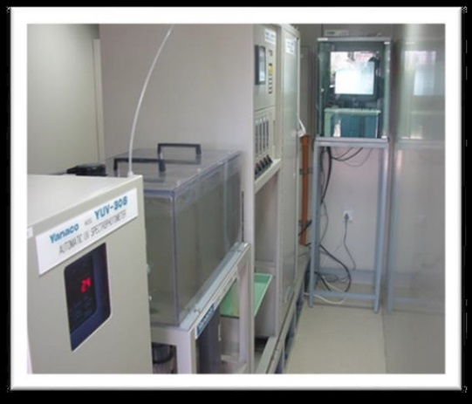
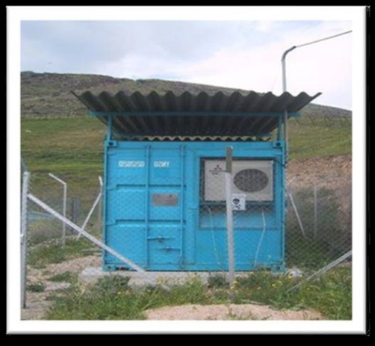

Figure 3: Inside and outside measuring station hangar

3.2 Telemetry System

The concept of telemetry reflects technology that allows the measurement of data result from a distance converted into digital data that is transferred to the analytical site for processing and use. Although this term typically refers to the transmission of wireless data (such as the use of radio signals, and ultrasonic or infrared signals), it also includes the transmission of data via other means of communication such as phone or computer networks, fiber-optic lines, and other telecommunications methods. Many telemetry systems currently use modern cellular networks services such as (GSM) and (SMS) to send and receive telemetry data that are characterized by low cost, wide geographical spread, speed, and high data transfer capability.

Figure 4 below describes the telemetry network from the monitoring stations of the NP-RTWQM until the end user of the system.

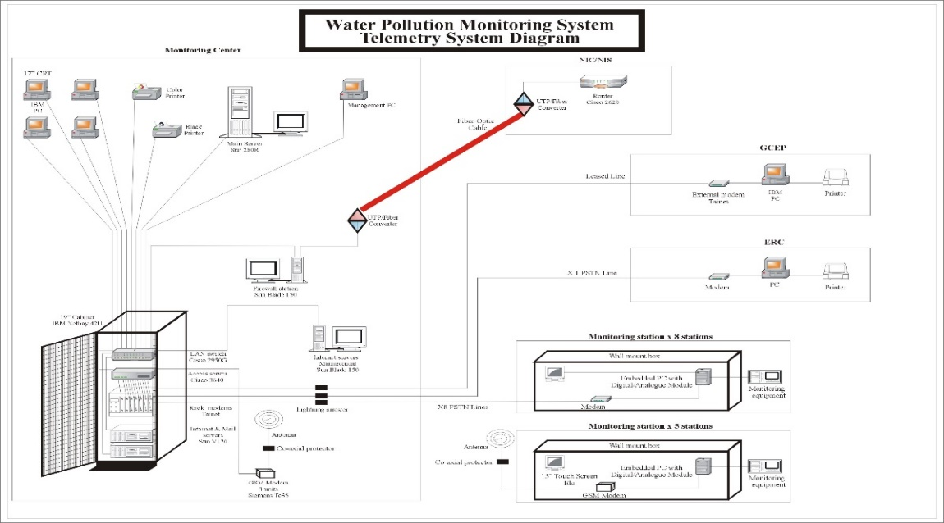

Figure 4: Remote Network System in Monitoring Stations

As shown in Figure 4, The NP-RTWQM consists of the following elements;
- Measuring Sensors: the system consists of sensors, which measure the water quality parameter such as pH, turbidity, conductivity, dissolved oxygen, temperature, COD and nitrate.

- Computer: the station computer is connected to the measurement sensors through data acquisition card installed in it, all the readings and operational status signals (analog and digital) measured issued by station’s sensors are collected by the data acquisition card. The telemetry software installed on the station’s computer collects reads and stores these signals, converts them into the measure values. The software sends those values through the system's communication network automatically to the database server in the Environmental Monitoring and Research Central Unit.

- System Communication Network: At the beginning of the project, the network consisted of landlines and two lines adopting the GSM cellular service for communication; Due to the presence of some stations in remote and border areas, it was difficult to connect landlines. Each computer is connected to a MODEM connected to a telephone line (GSM line), and all these Lines are connected to a Router at EMARCU center. The data sent from the 13 monitoring stations is stored in the central unit's database server. In 2006, at the direction of His Excellency the Minister of Environment/Chairman of the Project Board and sponsored by Zain Company, the network in all stations was transformed into GPRS cellular service, where the data is encrypted online through a link (VPN) between the central unit and Zain. The use of the GPRS system has several advantages compared with other cellular service including but not limited to:

    - Data transmission efficiency is higher: (GPRS) efficiency is much higher than the landline lines, which most often suffer from delays in the transmission besides the length of the transmission period at a time, as well as the large capacity of the communication channel compared to the landline lines and (GSM) service.

    - Saving in communication billing invoices, the landlines as well as the GSM cellular service bills depend on the duration of the communication and not on the volume of data sent, whereas (GPRS) depends on the volume of data sent regardless the duration of the connection. It should be noted here that this is the first time in Jordan that GPRS has been used for scientific projects.

- Database: All the transmitted data are preserved in database server and the data can be displayed in project website

4 QUALITY ASSURANCE, CONTROL AND ASSESSMENT
To ensure the effectiveness and reliability of the NP-RTWQM that operated by EMARCU, quality assurance, quality control and quality assessment procedures are regularly conducted. It should be mentioned here that EMARCU work is the only online system in the Middle East accredited by the United Kingdom Accreditation Services UKAS) according to the (ISO 17025) requirements, Moreover the system is (ISO 9001:2015) certified by (Lloyd's).

4.1 Quality Assurance
Quality Assurance (QA) includes all high-level activities, structures and mechanisms used to ensure and document the accuracy, precision, completeness, effectiveness and representativeness of NP-RTWQM. Quality assurance ensures the overall integrity of the program design and consists of two separate but interrelated activities: Quality Control (QC) and Quality Assessment.

The quality assurance program elements that implemented at EMARCU include:
- Provincial RTWQ monitoring program plan.
- Ensuring probe maintenance and warranty checks are carried out in compliance with manufacturer recommendations.
- Personnel qualification and training.
- Technical procedures for sampling and conducting field and analytical work.
- Troubleshooting of instruments, recording equipment, installations, transmission of data and corrective action plans.
- Record keeping including chain of custody for grab samples, logbooks and instrument calibration records.
- Implementation of QA/QC procedures including data verification and validation.
- Preparation of analytical reports, data packages and NP-RTWQM web page.
- Assessments to determine whether personnel are adhering to program requirements and following internal procedures.
- Expert peer review of NP-RTWQM design, QA/QC procedures and data analysis.
- Keep up to date on emerging RTWQ technology, QA/QC procedures, and analysis techniques.
- Develop firsthand knowledge of each individual watershed through observation and field visits.

4.2 Quality Control
Quality control refers to the technical activities employed to ensure that the data collected are adequate for quality assessment purposes. This includes feedback systems to ensure activities are working as planned and intended, and to verify that procedures are being carried out satisfactorily. The quality control program elements at NP-RTWQMP include:
- Maintenance and calibration of the probe and its sensors on a monthly basis.
- Inspection and maintenance of NP-RTWQM stations.
- Field readings taken at the time of removal and reinstallation of the probe for maintenance and calibration purposes using calibrated field instruments.
- Collection of a water quality grab sample at the time of reinstallation of the probe to be sent to a laboratory for analysis.
- Updating maintenance forms with collected field instrument readings after reinstallation.
- Updating spreadsheet with grab sample results once laboratory analysis is complete.

4.3 Quality Assessment
Quality assessment activities are implemented to quantify the effectiveness of the quality control procedures. Quality Assessment program elements at EMARCU include:
- Comparison of field results (taken during removal and reinstallation with the field instrument) with the chronologically closest NP-RTWQM results from the probe to evaluate the amount of drift observed in water quality parameters over that period.
- Evaluate whether field and actual readings are within acceptable ranges, by how much the reading is off (if not within acceptable ranges), and reasons why the parameter reading may be off.
- Calculate long-term and monthly period summary statistics using the corrected data.
- Produce time series graphs for each parameter and evaluate for gaps, data errors, and guideline exceedances for pH, dissolved oxygen and turbidity.
- Publishing and daily updates of NP-RTWQM data from telemetry sites on the Water Resources Division web page for review.
- Preparation of auxiliary information to aid in the review of water quality records.
- Produce a monthly period report for each station, including any problems with maintenance, calibration and QA/QC procedures; any data issues; time series graphs and summary statistics for each parameter; brief explanations for observed results; and data qualification statements.
- Produce an annual report for each station at the end of each calendar year.
- Archiving of all monitoring data records.

5 results Analysis
As mentioned earlier, the real-time water quality data are sent out on hourly bases from the 13 monitoring stations through the telemetry system and analyzed using special management system. This system compromises of two data analysis strategies:

- Characterize typical water quality at each monitoring location: data from each monitoring
location is analyzed on daily, monthly and yearly basis to characterize typical water quality at the monitored site. Two approaches are used in this strategy as described below:

- Analysis of time-series plots to understand typical water quality: analyzing time-series plots to understand typical water quality viewing time-series plots is an effective way to get an initial sense of the range of water quality values typically seen at a monitoring location, as well as the frequency and patterns in water quality. Changes in the water characteristics at a monitoring location can often be identified through a visual analysis of time-series plots, as illustrated in Figures 5 and 6, which shows how the water temperature changes during the days of the year compared with air temperature in two monitored locations. The seasonal variation of the monitored parameters and locations are also studied, as illustrated in Figures 7 and 8.

Figure 5: Comparison between minimum air and water temperature in two locations

Figure 6: Comparison between maximum air and water temperature in two locations

Figure 7: Season water temperature variation for one of the monitored locations

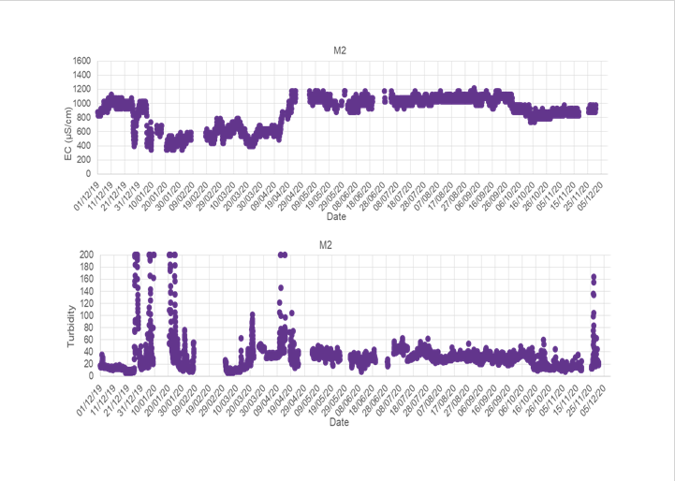

Figure 8: Turbidity and EC trend in Winter season for one of the monitored locations

- Statistical analysis to define the range of typical values for monitored parameters: In addition to time-series analysis of water quality variability, statistical calculations can provide precise quantification of each parameter’s typical range of measured values. Table 2 shows the results of common statistical calculations for one of the monitored locations.

Table 2: Data statistical analysis
Test (Unit) | Yearly readings statistical analysis | Location
 |  | (A)
Temperature  (°C) | Average | 22.1
 | Minimum reading | 11.3
 | Maximum reading | 30.3
 | Standard deviation | 4.6
 | Total number of readings | 8277
 | Total number of analyzed readings | 7360
pH (SU) | Average | 7.96
 | Minimum reading | 7.57
 | Maximum reading | 8.45
 | Standard deviation | 0.13
 | Total number of readings | 7503
 | Total number of analyzed readings | 4809
EC (µS/cm) | Average | 809
 | Minimum reading | 391
 | Maximum reading | 1123
 | Standard deviation | 116.3
 | Total number of readings | 8084
 | Total number of analyzed readings | 7595

- Identify anomalies and clusters in online water quality: An anomaly is an instance where data is different than expected at a monitoring location. Anomalies can be reflected in one or more parameters and can last for time periods ranging from minutes to days. A data anomaly is not necessarily indicative of abnormal water quality. For example, an anomaly could be caused by an instrument malfunction that results in inaccurate data.

System analysts should have a good sense of typical water quality at each monitoring location and thus be able to identify anomalies in the data. At this point, time-series plots of the evaluation dataset for each monitoring location is reviewed to identify anomalies. Some judgment is necessary to distinguish between anomalies and normal variability. However, when in doubt it is better to identify all suspected anomalies and to review data in two-week intervals for monitoring locations with a high degree of variability and four-week intervals for monitoring locations with relatively stable water quality. Details of each anomaly usually documented, noting the monitoring location, start date and time, end date and time, and parameters that were anomalous. Figure 9 and 10 provide examples anomaly case happened in one of the monitored locations.
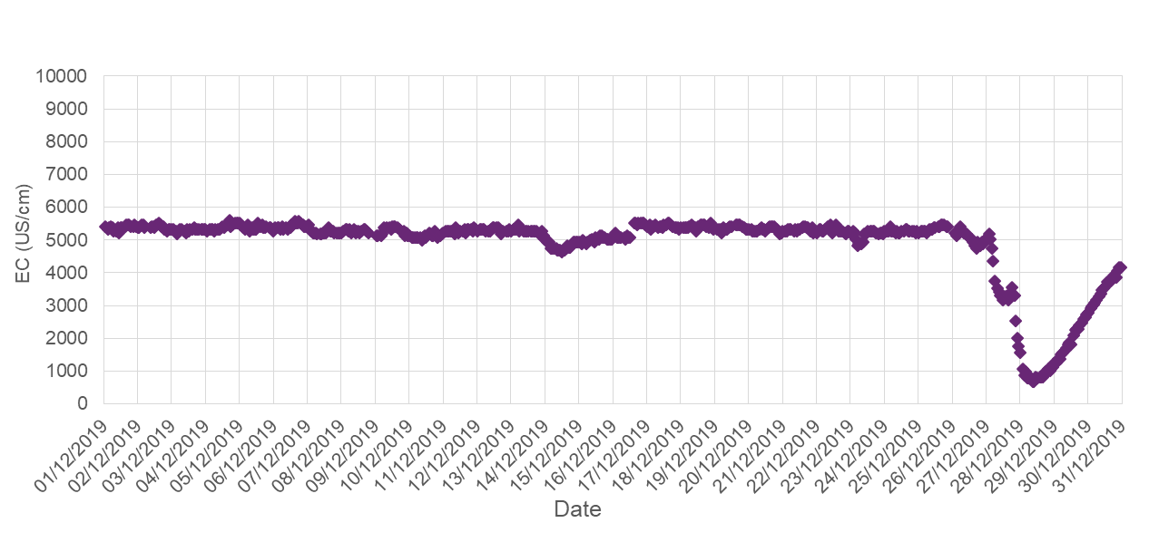
Figure 9: The effect of heavy rain on source salinity

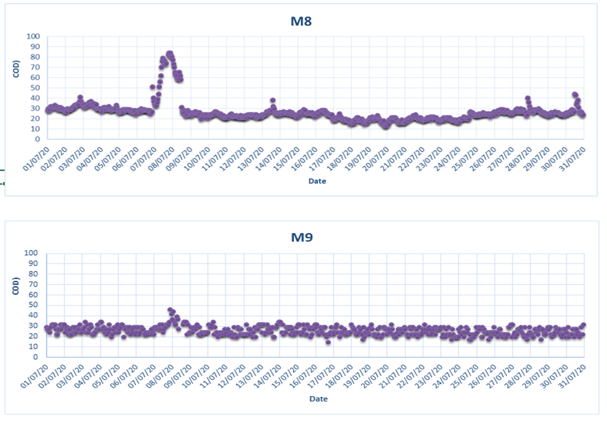

Figure 10: COD anomaly case

6 the role of this system in enhancing water governance in Jordan

Rogers and Hall (2003) define water governance as the range of political, social, economic, and administrative systems established for the development and management of water resources and water services at all scales. In other words, it is set of systems that control decision-making with regard to water resources in a transparent and participatory way with a high level of accountability. Looking from the governance lenses, NP-RTWQM identifies surface water threats more quickly, make critical environmental decisions more insightfully, and meet increasing regulatory requirements and ultimately building more resilient water systems that withstand climate, pandemic, social and other emergencies and continue to serve public health and safety.
Also, the NP-RTWQM achieves the combination of transparency, accountability and participation (TAP) which creates a framework for water integrity so that the water sector can protect the environment and optimize its use for food, energy and consumption. The TAP combination was achieved through offering accessible high-quality data and information that are understandable and usable, delivery of improved and efficient services and participation of all stakeholders in deciding how water is used, protected, managed and allocated.

7 CONCLUSIONS
The availability of water resources has never been as scarce as it is today. At the same time, pollution levels in the water are imposing a bigger challenge than ever. Traditionally, water quality monitoring has been a largely manual process, with field data collectors gathering physical grab samples at various surface water locations in cases of pollution, illegal discharges, harmful runoff and climate-induced threats. Physical field samples are taken back to the lab for analysis. This single-point-in-time sampling process provides varying results and delays the most effective action when remediation or other action is necessary. The National Project for Real-time Water Quality Monitoring (NP-RTWQM) is managed by RSS/EMARCU and uses technologically advanced monitoring sensors to collect surface water quality measurements at Yarmouk and Zarqa rivers, King Abdallah Canal and King Talal Dam on real-time basis. The data are collected through a telemetry system and made available for analysis and action in a real time. The stations of NP-RTWQM are calibrated continuously using strict quality assurance procedures. The data are shared with all water operators and decision makers in Jordan to be then stored in a digital platform. The NP-RTWQM creates a high-density dataset for fast analysis through a cloud-based data analytics platform and enhances the resilience and water system in Jordan through providing a timely and transparent information about water quality. The NP-RTWQM is an excellent example of a good water governance where water utilities, government and research institutions are collaborating to provide reliable and transparent water quality data that are essential to have right decisions and efficient management.

8 ACKNOWLEDGEMENTS
The authors acknowledge Japan International Cooperation Agency (JICA) for their Generous financial support for initiating the program in Jordan and the Higher Council for Science and Technology (HCST) for their continuous support.

references

Alexander T. Demetillo, Michelle V. Japitana and Evelyn B. Taboada “A system for monitoring water quality in a large aquatic area using wireless sensor network technology” Sustainable Environment Research volume 29, Article number: 12 (2019).
S. Geetha and S. Gouthami “Internet of things enabled real time water quality monitoring system” Smart Water (2017) 2:1 DOI 10.1186/s40713-017-0005-y.
Niel AC, Reza M, Lakshmi N “Design of Smart Sensors for Real-Time Water Quality Monitoring” (2016) J IEEE Access 4: 3975–3990.
Muinul H, Syed I, Alex F, Homayoun N, Rehan S, Manuel R, Mina H “Online Drinking Water Quality Monitoring: Review on Available and Emerging Technologies (2014). Crit Rev Env Sci Tech 44(12):1370–1421
Jianhua D, Guoyin W, Huyong Y, Ji X, Xuerui Z “A survey of smart water quality monitoring system” (2015). Environ Sci Pollut Res 22(7):4893–4906.
Yashwanth Gowda K.N and Vishali C, Sumalatha S.J and Spoorth G.B” Real-Time Water Quality Monitoring System” (2020). International Journal of Engineering Research & Technology (IJERT) ISSN: 2278-0181 Published by, www.ijert.org NCAIT - 2020 Conference Proceedings.
EMARCU Annual report “The National Project for Real-Time Water Quality Monitoring” 2021.
MWI “Water Budget” 2020.
Fanack Water “COUNTRY REPORT: Jordan Water Report” (2022)https://water.fanack.com/jordan/ Accessed on 8/9/2022.
EMARCU Annual report “The National Project for Real-Time Water Quality Monitoring” 2019, 2020 and 2021.
EPA” Exploratory Analysis of Time-Series Data to Prepare for Real-Time Online Water Quality Monitoring” 2012.
Rogers, P. and Hall, A.W. “Effective Water Governance”. Technical Committee Background Papers No.7, Global Water Partnership (GWP) (2003)
WIGO 2016: Transparency, Accountability & Participation | WIN (waterintegritynetwork.net) accssed on 11/9/2022.

