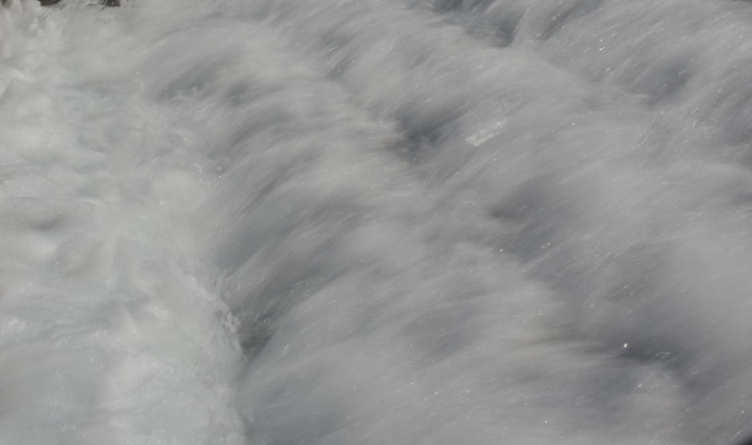

Water Cascade - Steve Werblow

An Open Letter to Jeff Bezos: Use Your Resources to Protect Our Most Precious Resource
Published on June 4, 2018

Jim Lauria
Water Business Leader
24 articles

Dear Mr. Bezos:
Economist Harold Pollack's New York Times article suggesting priorities for your philanthropic work was a fun read for those of us who would love to imagine what we would do with $131 billion. Unlike Pollack, I'm not going to tell you how to give away your money—you earned it, it's yours, and you can do what you want with it.
I'm more interested in addressing the challenge you tweeted last June, when you asked for ideas to guide philanthropy that can happen fast—as you described it, "at the intersection of urgent need and lasting impact."
Jeff Bezos, I'm looking to you for leadership on water. Not just because your business is named after the river that delivers the world's largest volume of fresh water to the sea, but because your business is built on water. Applying the intelligence and foresight that drove you to develop Amazon into a global presence that has forever altered online shopping and retail in general, you could deeply impact a resource that literally slips through our fingers every day. And there is no issue that encompasses both urgent need and lasting impact.
Water is embedded in every megabyte of data that logs orders on Amazon.com, keeps track of inventory and organizes a packing list for your shipping cartons (as well as in every product sold on the site). A single silicon chip factory can use 2 to 4 million gallons of ultra-pure water per day to manufacture computer components, enough water to supply as many as 50,000 homes. And it takes 7.5 gallons of water to extract 1 gallon of petroleum to make resin for computer cases or fuel for the trucks that deliver those smiling boxes.
Assemble those water-intensive parts into servers and look at the water needed to run them. The electricity to power Amazon's huge server farms is all about water, from the fracking solution used by the millions of gallons to extract natural gas to the water needed to spin turbines in a generating plant. There's the water pumped in and out of the server farms' massive cooling systems and still more water behind the electricity running the huge presses at the Washington Post—not to mention the vast supply of water it takes to pulp and process the acres of newsprint that delivers the paper's news to its readers.
Then there's the produce and meat at Whole Foods. From 28 gallons of water to produce a potato to 1,840 gallons to produce a pound of beef, our dinner plates are floating on a massive wave of water.
And how about the new healthcare company you, Warren Buffet and Jamie Dimon announced in January? Healthcare starts with access to clean water—without the pathogens, arsenic and other contaminants that threaten human health—and requires extremely clean water to prevent outbreaks of disease like Legionella, which can be harbored in pipes and sheltered by biofilm and slime.
And that's not even starting to talk about the massive infrastructure upgrades that most cities vying to host the next Amazon headquarters will have to install to supply up to 50,000 workers.
Mr. Bezos, you are famous for your efficiency and frugality—essential attributes for conservation and innovation. Your standard operating procedure is to demand ideas in no more than 6 pages, with context and approaches to the solution. So in less than 500 words, here goes:
Please commit the resources it will take—not just money, but management, planning, architecture and engineering, and even marketing—to make Amazon, Whole Foods and the Washington Post leaders in water innovation and conservation. Use less, recycle more. Help us find ways to reduce the water footprint of complex businesses like yours. Then tell us how you did it.
Promote books by hydro-luminaries, the water experts who brought us The Big Thirst, Cadillac Desert, Unquenchable, When the Rivers Run Dry and Blue Death. When your search algorithm picks up a leader in business, kick up links to these life-changing tomes. Heck, turn those books into documentaries for your Amazon Prime audiences, or become a publisher of books on water yourself. The titles portend a grim read, but you and your customers will find inspiration and details that could guide us all to a deeper appreciation of water and massive improvements in water management.
You seek approaches to problem solving that differ from previous efforts. As the owner of businesses that are each at the top of their game and each capable of pushing or pulling the rest of their industry toward greater efficiency, the scale and vision you bring to this challenge are unique. You can aggregate the best practices from around the world and apply them at a level that can have profound impact on retail, tech, publishing and food.
What's in it for the customer, you ask? Health. Energy. A higher standard of living. A legacy. And, ultimately, survival on Earth.
All it takes is vision, dedication and enough resources to protect our most precious resource: water. And when you someday get up into space, you can look down at our blue planet and know that you're making a difference with all that water.

