The importance of a sea water intake
Since I started working my father-who worked as a geologist- advised me that the most important part of a desalination plant was neither the cartridge filters nor the membranes and not even the high pressure pumps. By that time, 16 years ago, he advised me that with a well designed sea water intake, most of the problems that can turn up while running the facility are due to a defficiently designed sea water intake. I mean, not only will the life of electromechanical equipments be longer but the chemical reagents consumption can be reduced during the exploitation of the desalination plant hence carrying out a diminishment on the facility functioning costs.
There are two kinds of sea water intakes: open intake and beach well intake. Within the last desalination program of the former Spanish Government called "AGUA" the construction of twenty one large desalination plants was scheduled. Most of them had a sea water open intake. That was due to the difficulty to find the appropriate sea water beach wells with enough capacity to satisfy the ply requirements for the scheduled facilities. Furthermore, the different layouts involved some terrains expropiation that need to be made as soon as possible and also the requirements to be achieved during the plants operation were very strict. In addition, the possible adverse effects during the wells perforation, such as mutual affection between them, their colmatation as a consequence of a bad quality inlet water became an additional drawback for this kind of solution to be adopted.
Facing this situation and with the necessity to provide the closer populations with desalted water, most of them were designed with an open intake. It seemes that with the extremely necessity of that time it was urgent the hydrogeological studies to be carried out in order to guarantee the optimal water quality.
Another reason was the public pressure to the Ministry of Environment for the desalination plants to be built up what involved this kind of water intakes. The problem had to be solved and the solution should be immediately done.
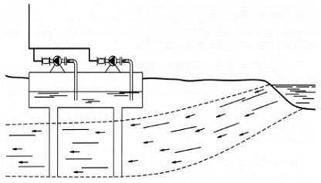
On the left hand drawing, an example of this kind of sea water intake can be seen. For it to be constructed, the soil conditions must be optimal in order to get a very good quality of sea water.
With this type of water intake, a very common kind of pollution can be produced due to sea water inlet into the aquifer what originates a sea water decrease and consequently an salted water increase. This kind of phenomena is known as marine intrusion and takes place during the two phased coexistence between filtered and sea water phases, when the second one heads to the first one.
These effects can be studied from different points of view.
a) Hidrogeological: They let you know the hydraulic caracteristics from the aquifer and any aspects that let contribute to an adequate hydrogeological study.
b) Hidrogeochemical: Based on the ionic compounds of the water and they are limited by the analitic difficulty, which are both expensive and complex.
c) Geophisycal: Some measurements must be made in order to determine porosity, nature and salinity of the solution.
d) Geochemical: With great accuracy, the origin of the salting processes of the water can be predicted. Hence, a variation and modification of the water properties within the aquifer are produced.
If, on the other hand, the soil does not have the required conditions in order to make a water collecting, due to its permeability an open intake will be the proper solution.
This kind of intake, generally, is carried out by submarine outfalls which usually have great dimensions not only in bore but also in lenght in order to ensure both the water quality and quantity for the facility.
In the other drawing, below, this type of water intake -laid by means of big vessels pipe transporters- can be seen. Their material could be GRP or PE, prevailing the economic conditions over the functioning.
