

TAYFUR WATER SYSTEMS
We , Tayfur Water Systems Co. are established in Izmir, Turkey. We are manufacturer and exporter of valves for the agricultural irrigation systems and for fire systems in the industrial areas.

Our brand name is TYPHOON and our products under the name of TYPHOON are : HYDRAULIC CONTROL VALVES , PLASTIC HYDRAULIC CONTROL VALVES , BACK FLUSHING CONTROL VALVES, AIR RELEASE VALVES , FOOT VALVES ,PLASTIC AIR RELEASE VALVES and FLUSHCON FILTER BACKWASH CONTROLLERS.
As Tayfur Water Systems , we are in successful projects in social , industrial and agricultural areas by our technical staff.
We can offer good prices , good terms for delivery and best quality with our staff.

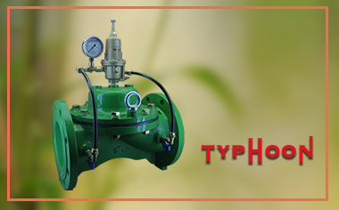
We enclose herewith our catalog in the attachment. Please don’t hesitate to contact with us if you have any question for our products or when you have any design to do the manufacturing in Turkey.

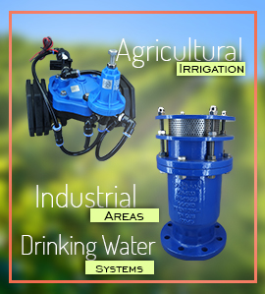
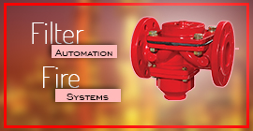

WATER | SYSTEMS
FOR ALL

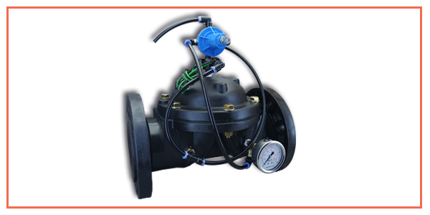
Flanged Plastic Control Valve

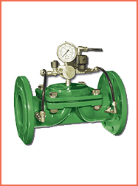
Hydraulic Control Valves

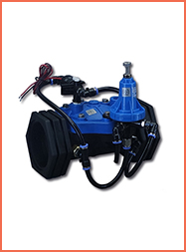
Plastic Hydraulic Control Valves

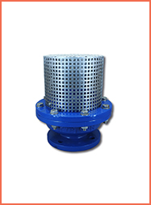
Foot Valves
.

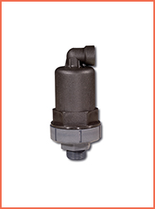
Plastic Air Valves

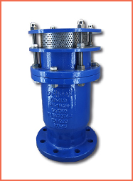
Non Slam Dynamic Air Release Valve

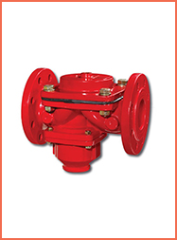
Backwash Control Valve
.

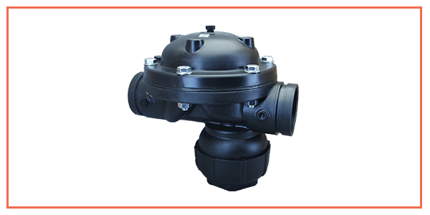
Plastic Backwash Control Valve


Karacaoglan Mah.6172 Sok. No:19/D
Isikkent-Bornova/Izmir
Phone +90 232 458 49 99 / +90 232 457 60 88
Fax +90 232 458 57 67
E-mail ece@tayfursu.com.tr
unsubscribe | forward email to a friends | view online

