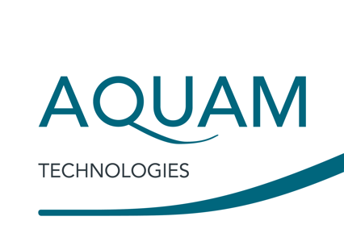

6 December 2018

Press enquiries to: Natasha Wiseman Tel: +44 (0)7880 502547
Email: natasha@wiseonwater.com

PRESS RELEASE

Aquam makes senior appointments to industrial team

MANCHESTER, UK: Global pipeline infrastructure company Aquam Technologies has strengthened its UK team for industrial and commercial markets with three senior appointments this year. Stuart Henderson has been appointed Director - Industrial & Commercial and is heading up Aquam’s UK growth strategy across multiple sectors including food & beverage, industrial process, public sector estates and hotels & leisure.

The team will also work closely with water retailers, providing their clients with the support services necessary to pinpoint, fix and mitigate leakage and corrosion in ageing pipeline infrastructure. Henderson has over ten years experience of the UK water retail market and previously worked for both Severn Trent Water and Scottish Water.

Paul Henderson has also joined Aquam as Senior Business Development Manager and will support businesses wanting to understand and manage risk associated with pipelines and water management. He has delivered programmes of works for the maintenance of critical drinking water infrastructure for over 20 years.

Aquam’s third appointment to the industrial & commercial team is Operations Manager Jon Shelton, who will oversee clients’ infrastructure projects. Shelton has over 30 years’ experience working with some of the UK’s leading installers of pipelining technologies.

Aquam managing director, Tim Bowen, said, “I’m delighted to welcome Stuart, Paul and Jon to Aquam as we embark on a period of rapid growth in UK industrial and commercial markets. Aquam is well established in utilities in the UK and the same services and technologies for pipeline diagnostics and rehabilitation can deliver huge benefits to clients in other sectors.”

Stuart Henderson said, “This is an exciting time for Aquam as we grow our UK business and open up our technologies and services for pipe surveying, leak detection, pipelining and cleaning to all markets. Most of our operations can be delivered without disruption to buildings’ occupants and fixtures and fittings, which is especially important to hotels, commercial offices, hospitals, prisons, schools and industrial facilities.

“There is huge potential for Aquam in the UK and I look forward to working closely with Paul, Jon and the team to deliver our strategic growth plan and reach new clients.”

Aquam’s specialist technologies for assessing and rehabilitating pipeline infrastructure are available globally and are already well established in the UK utilities and in commercial and industrial markets in North America. They include Investigator and LDS1000 pipe survey and leak detection tools and Nu Line blown-in epoxy pipeliner and Nu Drain cured-in-place pipe (CIPP), which are ideal for non-disruptive rehabilitation of small-diameter networks within facilities.

www.aquamcorp.co.uk

Image and captions

Images can be downloaded here or email natasha@wiseonwater.com.

Press enquiries to:
Natasha Wiseman, WiseOnWater
E: natasha@wiseonwater.com
M: +44 (0)7880 502547
For further information, please contact:
Paul Henderson, Senior Business Development Manager – Industrial & Commercial, Aquam Technologies
T: +44 (0)844 543 3540
E: phenderson@aquamcorp.co.uk

Issued on behalf of:
Aquam Technologies, Kingsley Hall, Bailey Lane, Manchester Airport, Manchester M90 4AN
http://www.aquamcorp.co.uk

About Aquam

Aquam Technologies is a global provider of technology solutions for water and energy distribution infrastructure. We ensure the health, longevity, safety and reliability of vital resources for water & gas utility, municipal, commercial, residential and industrial markets. Our award-winning proprietary technologies address water scarcity issues by the diagnosis, cleaning and remediation of aging infrastructure. Aquam also provides end-to-end service solutions and technologies for the maintenance, life extension and full rehabilitation of network distribution infrastructure, which include: Nu Flow Technologies, a leader in small-diameter infrastructure rehabilitation technologies; Specialized Pipe Technologies (SPT), a pipe assessment & rehabilitation services provider; Aquam Pipe Diagnostics, a global pipeline assessment specialist. Aquam services are available in North America, South America, Europe, Africa, Australasia and the Middle East. For more information visit www.aquamcorp.co.uk.

