Water and Food: One Man’s Vision

Source: Mazzei Injector Company, LLC

By Jim Lauria

Angelo Mazzei has always thought locally and acted globally. Born and raised in California’s San Joaquin Valley— one of the world’s most productive farming regions—Angelo worked for his uncle’s 10,000-acre farming operation after graduating from college. There he saw a pressing need for a system that would allow farmers to safely and efficiently inject fertilizer into their irrigation water—a task made even more challenging with the 1968 introduction of high-pressure water supplies through the California Aqueduct, a 400-mile-long water conveyance system. A new approach was vital.
Mazzei’s innovative Pipeline Flash Reactor―now fine-tuned with state-of-the-art computational fluid dynamics (CFD) modeling―packs powerful mixing and shearing action into an area only the length of 3 to 5 diameters of the mainstream pipeline.
Mazzei thought back to an industrial engineering class he’d taken at Fresno State, which introduced him to the Venturi principle. By directing the flow of liquid through a constricted section of pipe, he could decrease the fluid’s pressure and create a vacuum that would draw and blend liquid fertilizer into the main water flow of an irrigation system. On a lathe in his garage, he crafted a new injector optimized for the job and received his first patent. In 1978, he and his wife Mary formed the Mazzei Injector Company at their Bakersfield home.

As Mazzei Injector Company outgrew their home location and moved into their current facilities, Angelo focused on building a team of dedicated professionals who stress innovation, quality and customer service. Angelo believes that you are only as good as the people around you, and that team focus has led the company to where it is today.



Angelo Mazzei harnessed the Venturi principle to efficiently combine water with air, oxygen, or ozone, revolutionizing water treatment and irrigation.

Breath of Fresh Air

Angelo views the world in hydraulic terms. Working with his team, Mazzei solved a very local problem—the smell of a vegetable processing plant’s wastewater lagoon upwind of his Bakersfield home—by using his venturi injectors for wastewater treatment. Mazzei approached the processor and offered to develop an injector system that would aerate the lagoon and minimize odors caused by anaerobic bacteria.

The resulting AirJection wastewater system revolutionized lagoon aeration, which was typically done with multiple mechanical “splashers” floating in the pond—requiring extensive maintenance and only as efficient as the lowest-performing unit—or expensive bubble systems. By contrast, the Mazzei aeration solution required just a single pump on-shore to send water through a Mazzei injector, dramatically reducing operating costs and maintenance.

Within weeks, the water in the lagoon lightened in color. Odor, nitrogen and biochemical oxygen demand dropped dramatically, allowing the company to land-apply the treated water. And Angelo and Mary could open the windows of their home again.
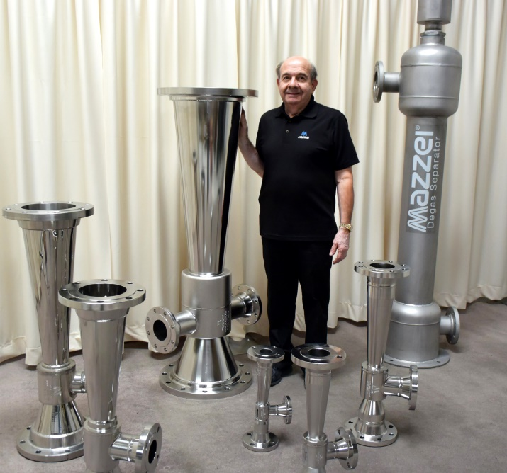

Angelo Mazzei’s home-built venturi injectors launched a business that has grown to global scale and become indispensable for water treatment at all scales, from irrigation lines and hot tubs to massive municipal and industrial installations.

Think Like a Potato

While Angelo was working at Mazzie Farm, his uncle would say to him, “If you want to grow potatoes, you have to think like a potato.” Mazzei Injector Company took that philosophy, and their growing experience in aerating water, to get to the root of a problem that was hampering crop yields. The development team realized that crops need air around their roots, which is one of the driving forces behind tillage. That spurred Mazzei to develop venturi injectors to draw air into irrigation water to aerate the root zone.

Mazzei expanded on the advice and thought like a bubble, which led to further innovations—patented Mass Transfer Multiplier (MTM) nozzles that shear gas bubbles more efficiently, enhancing mixing and gas transfer, and the Pipeline Flash Reactor (PFR) that creates a compact, in-line mixing zone in just a few feet of pipe.

These tools have revolutionized mixing and contacting in water treatment. Enhanced mixing is especially important in the treatment of water with ozone, a highly effective sanitizer that can be very difficult to dissolve in water.

Farmers and food processors use ozonated water for a wide range of sanitation practices, including clean-in-place (CIP) protocols, line flushing, wastewater treatment, and the treatment of cooling tower water, which can harbor deadly Legionella bacteria.

Of course, Mazzei injectors can aerate more than just water. In fact, they are popular among winemakers for aerating grape juice during the fermentation process.
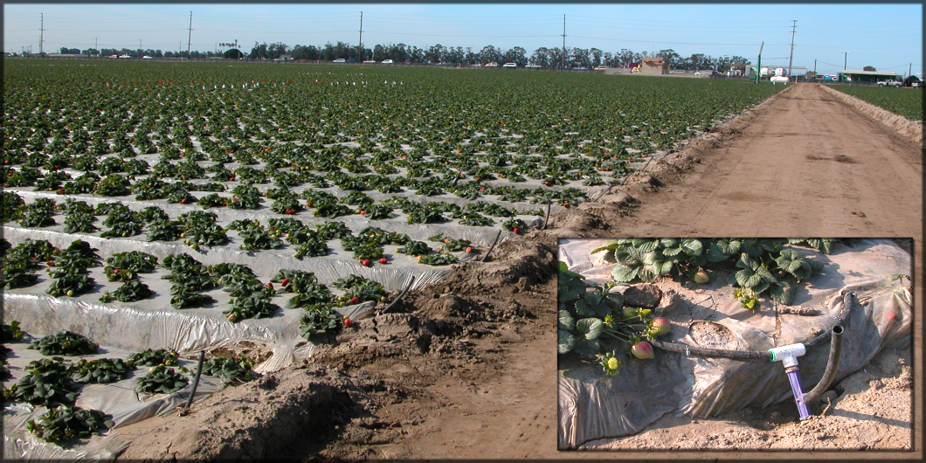

Angelo Mazzei’s early passion for agriculture lives on in his company’s strong focus on providing farmers around the world with tools that improve the blending of irrigation water with precise rates of air or fertilizer.

Vital Resource

Located in the California Central Valley, the company is keenly aware of the pressure placed on the region’s dwindling water supply. By enhancing the efficiency and efficacy of treating process water and wastewater, Mazzei technology is being used to turn what was once a waste product into water that can be utilized for irrigation or other non-potable uses—and even drinking water—helping relieve pressure on domestic water supplies. Proper treatment can also make it possible for water users to discharge processed water into the environment, boosting stream flows and benefitting wildlife.

Cutting-Edge Science

Angelo is a hands-on inventor—people who know him have no problem imagining him hand-crafting his early prototypes and testing his designs in the field. But he’s also a big supporter of cutting-edge science which is evident in the team he has built.

Mazzei Injector Company has a Computational Fluid Dynamics (CFD) department headed by an on-staff engineering PhD. Sophisticated CFD modeling tools allow experts to analyze the performance of product designs, assess complex multi-phase flow systems, and optimize the sizing and placement of equipment in those systems. Though the company has not lost focus on the importance of quality crafting, it has come a long way from its garage workshop origins.

Right from the start, the company recognized the value of teaming up with farmers, food processors and scientists to perfect the Mazzei products and track their performance. Through collaborations with the International Center for Water Technology at Fresno State, Mazzei has advanced the AirJection irrigation system, documenting yield increases in cantaloupes of as much as 34 percent, quality and yield improvements in watermelon, and boosts in the yields of many other crops in real-world farm conditions.

Recently, researchers at Fresno State working with colleagues from Memorial University of Newfoundland used cutting edge DNA analysis to determine that portions of a farm field irrigated with an AirJection system were home to a balance of bacteria less likely to produce volatile nitrous oxides and more likely to leave plant-available nitrate in the root zone.

Still Thinking Fertilizer

Since the first fertilizer application challenge in the 1970s, Mazzei has continued to improve fertigation tools for farmers in California and around the globe.

Today, the stakes are higher than ever. Fertilizer is costly. Excess nutrients can contaminate groundwater and surface waters. In streams, lakes and the ocean, excessive nutrient loads can create algal blooms (which occurred dramatically in Lake Erie a few years ago, shutting down municipal drinking water supplies in many cities) or hypoxic “dead zones” like the ones in the Gulf of Mexico and the Baltic Sea.

The Mazzei Tru-Blend proportional fertigation system is the latest approach to precisely and efficiently blend liquid fertilizer and irrigation water. The Tru-Blend system applies the precise rate and balance of nutrients during every stage of the crop growth cycle. In addition to creating a well-mixed blend, the Tru-Blend system provides extensive records that can help farmers stay in compliance with growing regulatory scrutiny.

For Angelo Mazzei, thinking like a bubble—or an injector, or a potato—enables him to guide his team to develop new insights and unlock a wide range of solutions for their California neighbors and people all over the world. Building on the 20 Mazzei patents and a culture of innovation, the Mazzei in-house team of engineers, scientists and specialists under Angelo’s leadership are looking towards the future. Mazzei is developing and applying innovative, science-based technologies to make more efficient use of the world’s water resources.

