4 Customer Engagement Lessons from the Top 10 Water Utilities with the Highest JD Power Customer Satisfaction Rankings
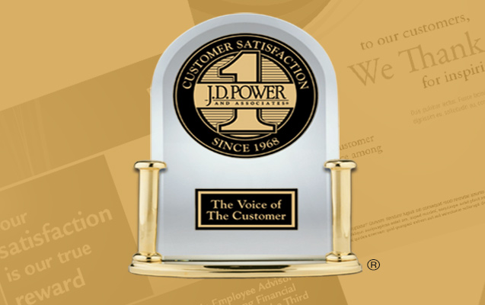

In 2016, JD Power released its first ever ranking of customer satisfaction for water utilities. The focus was on the 84 utilities across the United States serving at least 400,000 people. This size constraint leaves out many excellent utilities in the small to medium range, but because it features the largest utilities in the country, it offers an opportunity to learn what the biggest, most resourced utilities are doing to foster customer engagement. .
Here’s what the top 10 JD Power Ranked Water Utilities from across the United States are doing to engage their customers.
Number 1: Leverage Technology to Ease Transactions & Foster Transparency (L)
Utilities are guaranteed to hear from their customers during two situations – when they are paying their bills and when they have issues. Leading utilities make those engagements easy and less painful. They have automated their transactional systems, allowing consumers to register personal accounts online to track usage and pay bills.
100% of the top performer enable online billing & payment. Many offer online usage dashboards that provide comparative analyses of use across customers and segments, and FAQs that address pressing questions. Top performing utilities use technology to enable seamless engagement between consumers and their utility.
Number 2: Engage on Multiple platforms (E)

Top performing utilities use between 3 to 5 online and social media platforms to engage with their customers. Almost all of them have Twitter and Facebook accounts. A large number also have YouTube video channels where they post infomercials, and Flickr or Instagram accounts for sharing pictures, videos and images.
Number 3: Actively Educate their Customers (A)
Top performing utilities do a great job of engaging their customers. Beyond the basic provision of a platform that eases transactions, they offer great value added content that educates and inform their users. They provide content in areas like water conservation tips, water sources, rebate programs, affordability programs, community engagement activities, repairs and outages, job announcements, as well as water quality metrics.
Top performers frequently link to other great content from outside organizations, such as the EPA WaterSense program, Value of Water Campaign, Think Before You Flush, etc.

Number 4: Partnership with other stakeholder (P)
Many public utilities are part of a city government’s public works department. The best performing utilities leverage this fact for customer engagement. They have web sites and social media platforms that build on what other city government sites/services do.
Water customers are also energy customers. Citizens that purchase water and energy from public utilities will also need to pay their taxes, renew their vehicle tags, pay for parking tickets, etc. The best performers share common platforms wherever possible and customize when necessary. That way, costs are kept down, higher site traffic is generated, enhancing the quality and quantity of customer engagement.
The practice is not limited to public utilities. Some privately run utilities have operations across counties and states. By and large, much of what a water customer seeks to learn in Connecticut is no different from what a consumer in California is interested in knowing, and shared platforms are also common among the Private operators.
Miami Dade and NYC Environmental Protection offer great examples of how Cities can make this partnership model work.

The WaterLEAP™ attributes - LEAP Your Way to the Top
In an industry that still largely calls customers by the (terribly) transactional name of rate payers, it is refreshing to know that customer centric behaviors are getting adopted. It is not accidental that the best performers also happen to have excellent customer engagement habits.
The featured utilities are Miami Dade (1st), Orlando Utilities Commission (2nd), Gwinnett County (3rd), Monroe County Water Authority (3rd), Aquarion Water Company (5th), NYC Environmental (6th), San Antonio Water (7th), California Water Service (8th), Colorado Springs Utility (9th), Charlotte Water (10th) and Cobb County Water System (10th)

