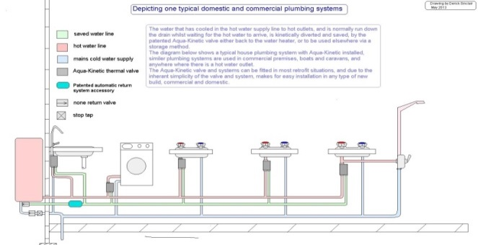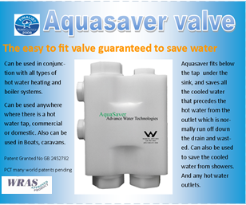
Aqua-Saver Summary
In the UK, from domestic dwellings alone, we waste over 1000 Olympic sized swimming pools of water EVERY DAY, whilst waiting for the hot water to arrive at the outlet. That is approximately £1.336 BILLION per year of hard earned cash:. In countries like Australia, and parts of USA, the loss of such vast amounts of water is more serious than the financial loss, and there is twice this amount wasted from commercial properties.
Aqua-Saver can be used with any hot tap outlet, or water heating system throughout the world without modification to either. It will prevent the cold / tepid water running to waste while waiting for the hot water to arrive.
The product has a very simple kinetic / hydraulic action which diverts the cold / tepid water back to the boiler for reheating, or to a storage tank for non-potable use elsewhere, thus saving money for domestic, commercial and leisure water users alike. Aqua-Saver is the only fully automatic system in the world, and simply very cheap to produce. It needs no external energy supply; the entire system is purely kinetic in operation.
The product is also of value to the water utility supplier by reducing the energy demands for pumping and treatment works. There are consequential environmental benefits from reducing water wastage and the demand for energy to re-treat and pump the water again.
Due to the huge volumes wasted this way, a Parliamentary bill has already been passed and added to the statute books in Australia, to make this saving method a mandatory fitting in all future new builds, when supplies available, and indications are the Uk will follow. Having passed all the stringent water testing standards, we intend to be the first supplier. The Australian government will make available installation grants to both domestic and commercial users.

Additional information
Patent Numbers;-
GB2452782A Thermal kinetic valve…Granted
GB2008002989 Kinetic automatic water return system
AU2008299694 Thermal kinetic valve Granted
US2001000972 Thermal kinetic valve Granted
GB0815489.0 Kinetic intensifier Pending
0910059.5 kinetic automatic water return system
Company registration Advanced Water Save Ltd
Company number 07936306
Contact;- 001144(0)151 6371586
Mobile;- 07964629313
Email;-advancewatertech@aol.com
Web;- www.advancedwatersave.com

