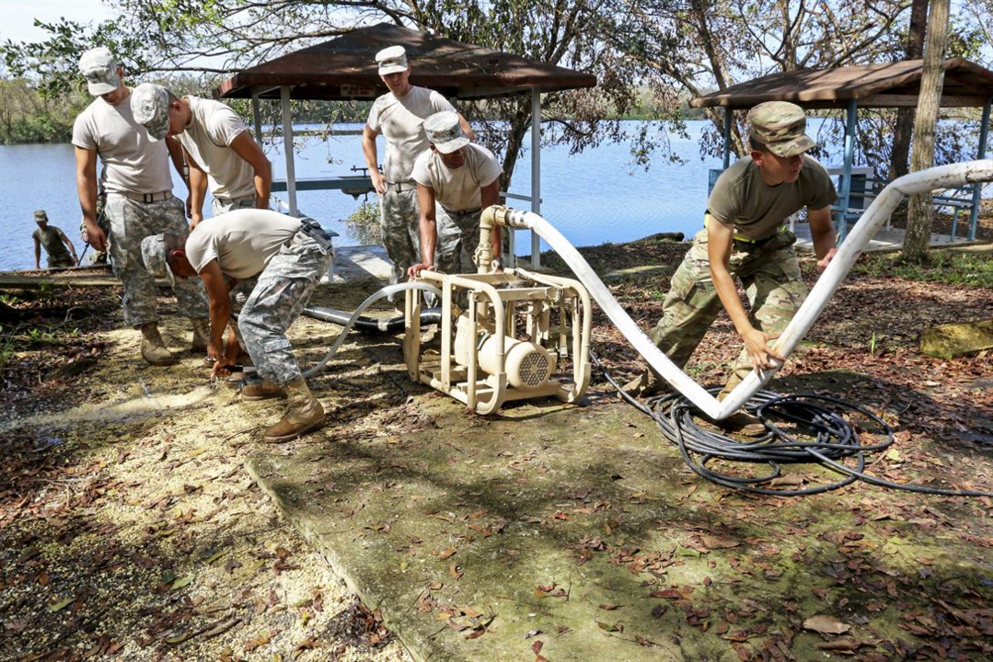

The Water Industry Wants You: Careers in Water Are a New Way for Veterans to Serve Our Country
Published on July 3, 2018


Jim Lauria
VP, Sales & Marketing
Mazzei Injector Company, LLC
25 articles

Independence Day is a great time to thank our nation's veterans for their service and reflect on the sacrifices they and their families have made on our behalf. This year, it's also a great time to add a plea—and an opportunity—for further service in the defense of our country: to take the skills they learned in the military and apply them to the water industry.
The water industry needs you. That's partly because thousands of baby boomers will be retiring from the industry in this decade, but also because you've got the right stuff for the job.
It's not a big leap. Of course, many Army Corps of Engineers and Seabees veterans are trained specialists in infrastructure and water. So are the sailors who maintain the state-of-the-art water and wastewater systems that keep huge shipborne cities on patrol for months at a time, or the Air Force, Marine and Army veterans who keep bases large and small operating—and flowing with water—around the world. Then there are the quartermasters and drivers and machinery operators who know how to keep things moving.
But there's more. Like all those veterans who work to win hearts and minds, build communities and support local development in the mountains of Afghanistan, the wetlands along the Tigris, and villages around the world. And the National Guard veterans who rise to the challenge of serving communities at home and abroad after disaster strikes, getting water systems and other vital services back online. Not to mention the countless officers and non-coms who lead teams toward their goals, even in circumstances most of us could never imagine.
You've got the discipline. The focus. Experience working in an environment full of rules and full of change. The stamina, the stress management and the never-quit attitude. And the willingness to serve, defending our nation.
Historically, the American military has defended water resources ranging from Korea's Chosin Reservoir in the bitter winter of 1950 to author Steven Burchik's deployment to Saigon's water treatment plant in 1968...and beyond. Now there's a chance to serve at home, and a deep need on the part of our nation for that service.
Few industries are as vital to our nation's security as water. The ability to turn on a tap and access a reliable supply of clean water is one of our greatest freedoms. (So is our ability to flush a toilet and know that the wastewater will be treated or disposed of safely.) Clean water keeps us healthy and secure.
Looking more broadly, water is a strategic resource, an angle I covered in a blog post titled "Water and the Art of War," about China's use of water as an instrument of strength and leverage.
As water professionals, it's our job to approach our industry's need for skilled and talented people with a strategic approach. We've got to reach out to our veterans, to tap this great national resource, for the good of our industry and the good of our country.
The American Water Works Association has led the way with a special Military Second Career track in its Work for Water program, aimed at the 7 million veterans in today's workforce who are joined by an additional 200,000 armed service members transitioning to civilian life every year. One of the things that really struck me about AWWA's effort is that they deeply value your military service and experience. As Dan Sensor and Saul Singer note in their brilliant book Start-up Nation, American industry often doesn't know how to read a military resume and recognize the skills it reflects (which, on the contrary, the authors point out is a strength of Israeli businesses and part of the key to their success). AWWA does, and the organization is eager to connect veterans with good-paying jobs in the water sector.
This is something I've seen at Mazzei Injector Company, too. Our founder, Angelo Mazzei, served in the Army National Guard in California. His son-in-law, design engineer Ken Cobar, is an Air Force veteran. Municipal sales director Jim Jackson served in the Navy, while Jim White and Cal Terrasas are Army veterans. I believe their service provides an underpinning for the company's can-do approach and its commitment to country and community.
Veterans of America's armed forces—Army, Navy, Air Force, Marines and Coast Guard—thank you for your service, and for your commitment that has allowed us to celebrate 242 years as a free nation. Accept our gratitude and consider the opportunity to continue serving here at home as part of a dedicated and proud water industry.
Image credit: Army Reserve soldiers purify water from Guajataca Lake, Puerto Rico, Oct. 9, 2017. The operation will provide potable water for residents in nearby Isabela. The soldiers are assigned to the 973rd Quartermaster Company, 346th Transportation Battalion, 166th Regional Support Group, 1st Mission Support Group. Army photo by Pvt. Alleea Oliver

