Building Resilience in Water Utilities: The Work of Operators Without Borders
Operators Without Borders (OWB) serves as a vital resource for water and wastewater utilities in developing nations and disaster-stricken regions. This Vancouver-based charity focuses on restoring access to safe drinking water and effective wastewater management services, with a commitment to capacity building and alignment with the United Nations Sustainable Development Goals (SDGs). Since its inception in 2017, OWB has mobilized over 100 volunteers and delivered services valued at nearly $2 million, marking a significant impact in communities worldwide.
The origins of OWB trace back to the aftermath of Hurricanes Irma and Maria in 2017, when Bernard Ettinoffe, General Manager of the Dominica Water and Sewerage Company (DOWASCO), highlighted the pressing need for skilled assistance. Valerie Jenkinson responded by assembling certified water operators from Canada and the United States to aid in recovery efforts. From this response grew a vision to address broader challenges in water and wastewater management, particularly in disaster preparedness, recovery, and capacity building.
Central to OWB’s mission are its diverse initiatives, which span technical training, disaster response, operational assessments, and the development of Standard Operating Procedures (SOPs). Through these efforts, OWB has delivered Incident Command System (ICS) workshops and disaster response training to more than 500 professionals globally. In collaboration with the United Nations Environmental Programme (UNEP), OWB provided wastewater treatment, collection and water distribution training in Nakuru, Kenya, leading to operator certifications. Its technical guidance has helped utilities worldwide improve operational efficiency and safety through more than 225 SOPs made available at no cost.
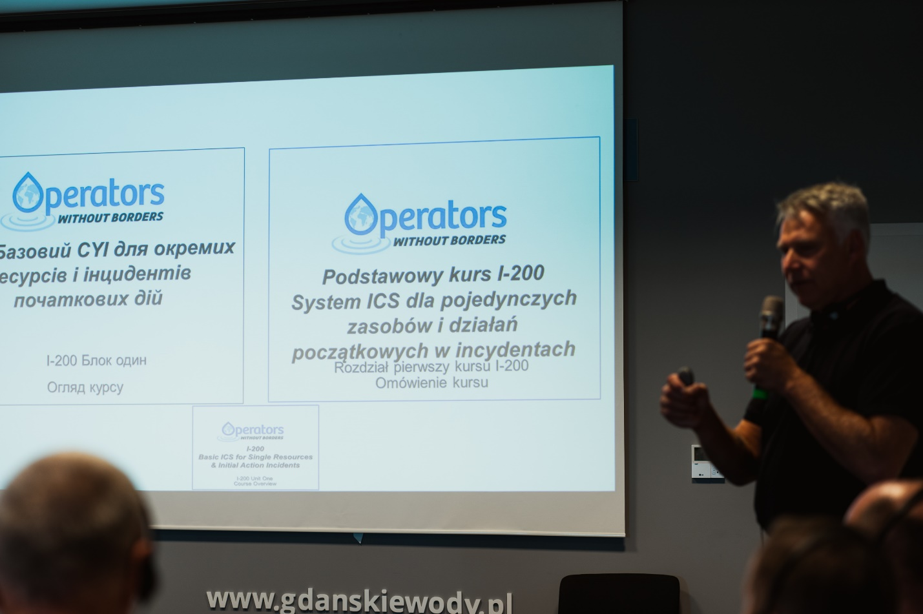
Photo 1. OWB Volunteer Instructor Greg Solecki providing Incident Command Systems (ICS) 200 Level Training in Gdańsk, Poland to Polish and Ukrainian operators in September 2023.
OWB’s disaster response activities highlight its vital role in addressing urgent needs. In Dominica, the organization assisted in restoring water services following Hurricane Maria, repairing wastewater treatment plants, and training operators. Similar efforts in Grand Bahama after Hurricane Dorian included safety repairs and water quality management. These projects underscore OWB’s capability to adapt swiftly to emergencies and contribute to long-term resilience in affected regions.
Sustainability and long-term impact remain at the core of OWB’s philosophy. The HANWASH initiative in Haiti exemplifies this commitment, where OWB’s technical assistance reduced non-revenue water levels in Pignon from 80% to 35%. In Ukraine, OWB developed guidance documents for containerized water treatment units to ensure continued operations during and after the ongoing conflict. These examples illustrate OWB’s focus on building local capacity and fostering sustainable practices.
Despite its successes, OWB faces challenges, including logistical complexities, cultural differences, and varying local conditions. To address these obstacles, the organization relies on comprehensive planning, strong local partnerships, and a commitment to empowering communities through training and mentorship. These strategies enable OWB to deliver tailored solutions that meet the unique needs of each region.
Collaboration is a cornerstone of OWB’s approach. The organization works closely with partners such as the Caribbean Water and Sewerage Association (CAWASA), UNEP, Rotary International’s HANWASH initiative, and the Global Water Operators’ Partnerships Alliance (GWOPA). Partnerships with Canadian and American organizations, including the Environmental Operators Certification Program (EOCP) and the Water Environment Federation (WEF), further enhance OWB’s ability to deliver specialized training and operational support.
OWB’s impact is driven by its dedicated volunteers, who bring expertise in water and wastewater operations, disaster response, and environmental sustainability. These professionals donate their time and skills, with OWB covering deployment expenses or coordinating local support for accommodations and transportation. This model not only ensures effective project implementation but also fosters a culture of giving back within the water management community.
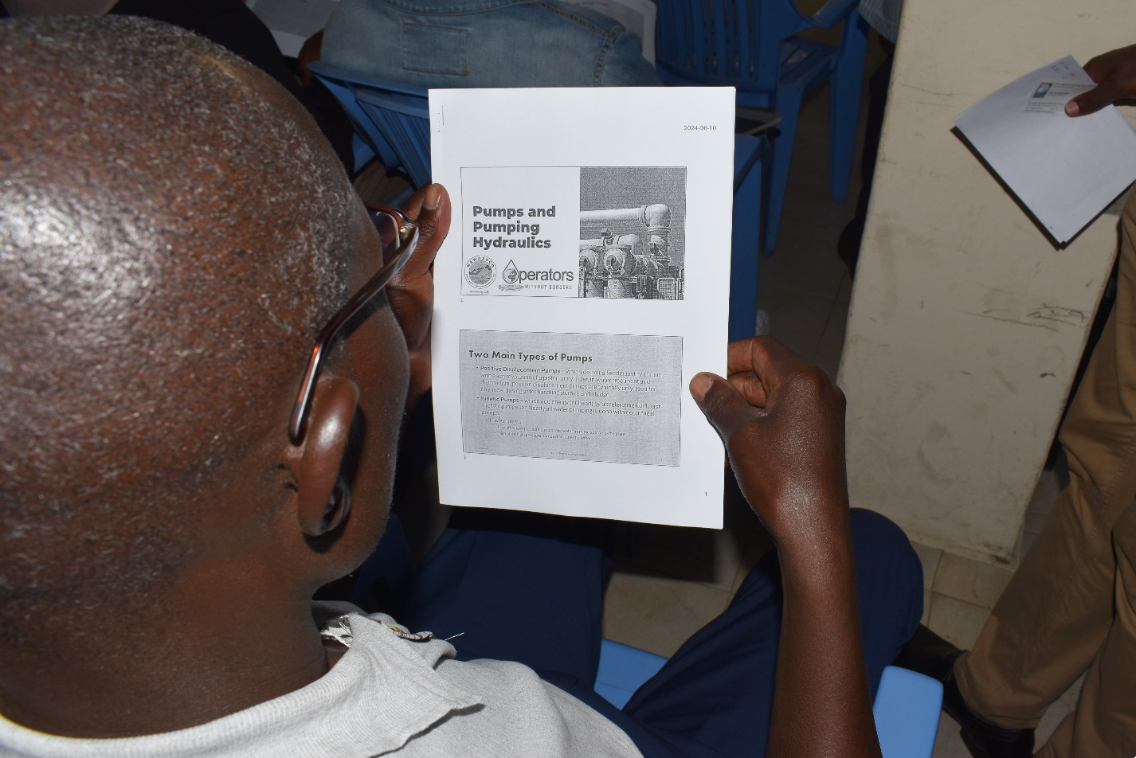
Photo 2. Nakuru Water and Sanitation Services Company Limited (NAWASSCO) operator reading instructional handout during the June 2024 training in Kenya.
Looking ahead, OWB aims to expand its training programs and establish new strategic partnerships. The organization is preparing to respond to potential emergencies in the Caribbean during the 2024 hurricane season while also strengthening its global presence through initiatives like OWB Australia. By continuing to develop innovative solutions for water and wastewater challenges, OWB seeks to amplify its impact and further its mission of building resilience in vulnerable communities.
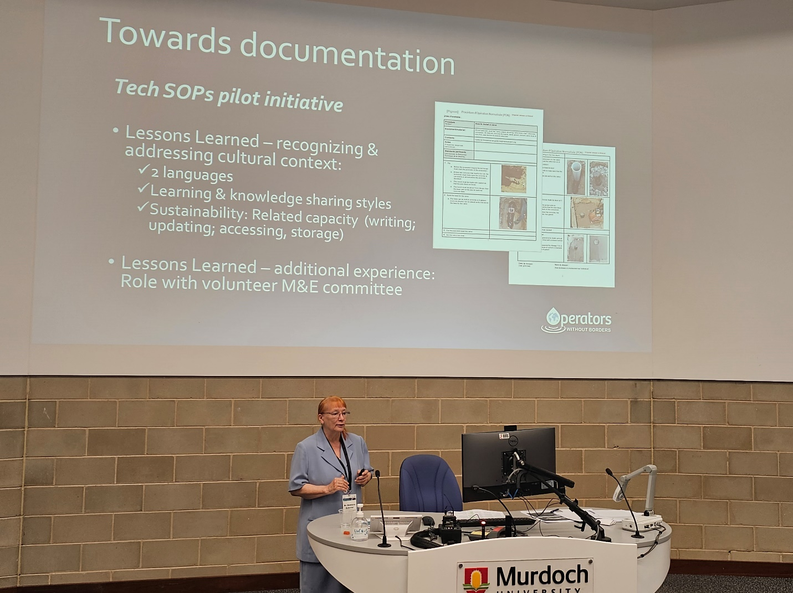
Photo 3. OWB volunteer Madeleine at the IWA Conference held in Perth Australia (November 2023)
Individuals and organizations can support OWB by volunteering, donating, or becoming members. Membership fees contribute directly to sustaining OWB’s initiatives, while donations fund travel and operational expenses. Volunteers with relevant expertise are essential to the success of OWB’s programs, ensuring the delivery of high-quality training and technical support.

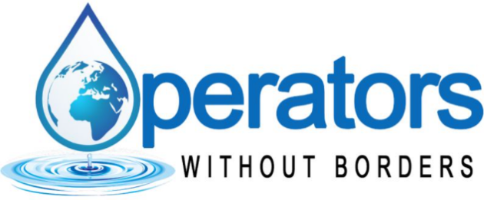
For more information to volunteer, donate or become a member, visit Operators Without Borders, or reach us at info@operatorswithoutborders.org



About the Author
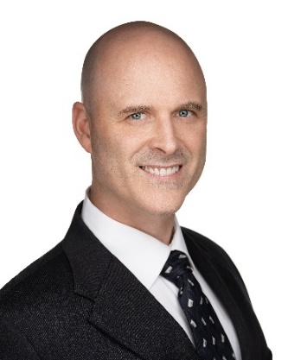
Mike Hewitt is a business development consultant with 20 years of experience in operations management, water treatment, environment, and emergency response. Through Almaquin Enterprises Limited, he provides services like business development, technical writing, data analysis, and water treatment consulting. His clientele spans several sectors, including military, aviation, oil and gas, mining, environmental management, and facilities operations and maintenance. Additionally, Mike volunteers with Operators Without Borders.


Written courtesy of
Almaquin Enterprises

