FluMET: Cerium Based Adsorber

- Reactions for Fluoride ion is adsorption
- Cerium based adsorber resin can be flexible use for volume ranges
- pH and Redox substances need controlling with pre-treatment
- Adsorbs Fluoride ions under the level 1 mg/liter
- Annual replacement 10% of volume
- Adsorbed Fluoride can be removed from filter by regeneration. Allowing for smaller filter and cheaper running cost.
- The active component of the adsorber is a mixture of Ce(OH)₄ + CeO₂ x nH₂O
- The active component is supported by an EVOH (ethylene vinyl-alcohol copolymer resin) framework. EVOH is a food grade resin with the following structure:
- Adsorption capacity:
  - Dependent on the Fluoride concentration and the pH of the input water
  - Maximal fluoride concentration is 30 mg/liter
  - pH is optimal between 3 and 3.5
  - Equilibrium capacity: Maximum amount of Fluoride adsorbed in a liter of resin

- Saturation
  - The measured fluoride content of the filtered water follow a saturation curve
  - For a number of days depending on the actual capacity the output fluoride level will be close to 0 mg/l

Regeneration I.

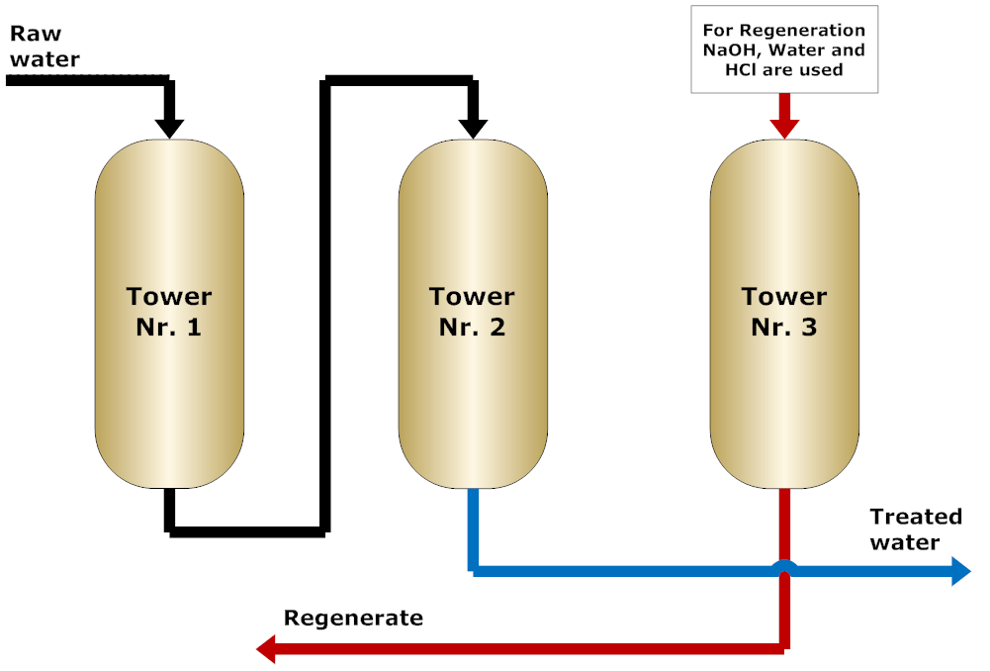

Regeneration II.

