TREATING SLAUGHTER HOUSE WASTES

Optimum Slaughtering Process

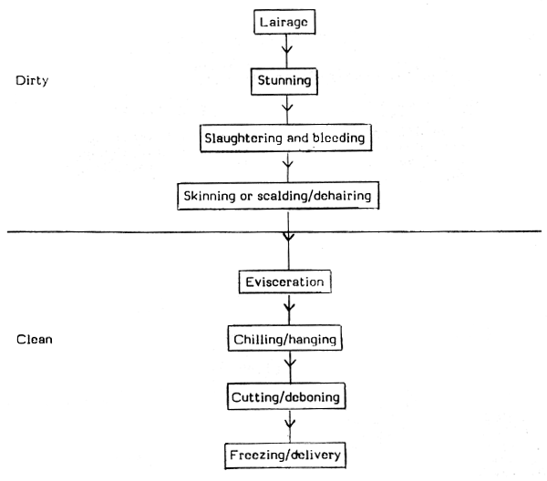

The slaughtering process differs by species and region and may be controlled by law as well as religious laws. Typical procedures are follows:
• Cattle (mostly bulls, cows, and buffaloes) are received by truck or rail from Houses, farms, or feedlots.
• The livestock is subjected to veterinary inspection.
• The veterinary doctor shall examine thoroughly not more than 12 animals in an hour and not more than 96 animals in a day.
• The veterinary doctor after examining the animal shall issue a fitness certificate in the form specified by the Authorities for this purpose.
• Separate isolation pens will be provided in slaughter house with watering and feeding arrangements
for animals suspected to be suffering from contagious and infectious diseases, and fractious animals,
in order to segregate them from the remaining animals.
• The livestock’s are arranged in the holding area of the slaughter house according to the class of
animals to be slaughtered and the said holding area shall have water and feeding facilities.
• Every animal after it has been subjected to veterinary inspection shall be passed on to a lairage for
resting for 24 hours before slaughter.
• Cattle are herded into holding pens.
• Cattle are rendered unconscious by applying an electric shock of 300 volts and 2 amps to the back of
the head, effectively stunning the animal, or by use of a captive bolt pistol to the front of the cow's head (a pneumatic or cartridge-fired captive bolt). Swine can be rendered unconscious by CO2/inert gas stunning. .
• Animals are hung upside down by both of their hind legs on the processing line.
• The carotid artery and jugular vein are severed with a knife, blood drains, causing death through
exsanguinations.
• The head is removed, as well as front and rear feet. Prior to hide removal, care is taken to cut around the digestive tract to prevent fecal contamination later in the process.
• The hide/skin is removed by down pullers, side pullers and fisting off the pelt (sheep and goats). Hides can also be removed by laying the carcass on a cradle and skinning with a knife.
• The internal organs are removed and inspected for internal parasites and signs of disease. The viscera are separated for inspection from the heart and lungs, referred to as the "pluck." Livers are separated for inspection, tongues are dropped or removed from the head, and the head is sent down the line on the head hooks or head racks for inspection of the lymph nodes for signs of systemic disease.
• Carcases are subjected to intervention to reduce levels of bacteria. Common interventions are steam, hot water, and organic acids. Carcases can be electrically stimulated to improve meat tenderness.
• Carcases are chilled to prevent the growth of microorganisms and to reduce meat deterioration while the meat awaits distribution.
• The chilled carcase is broken down into primal cuts and subprimals for boxed meat unless customer
specifies for intact sides of meat. The remaining carcase may be further processed to extract any
residual traces of meat, usually termed advanced meat recovery or mechanically recovered meat,
which may be used for human or animal consumption.
• Waste materials such as bone, lard or tallow, are sent to a rendering plant. Also, lard and tallow can be used for the production of biodiesel or heating oil.
• The wastewater, consisting of blood and fecal matter, generated by the slaughtering process is sent to a waste water treatment plant.
• The meat is transported to distribution centers that then distribute to retail markets

WASTES GENERATED
Slaughterhouse wastewater is very harmful to the environment.
Effluent discharge from slaughterhouses has caused the deoxygenation of rivers (Quinn and Farlane 1989) and the contamination of groundwater (Sangodoyin and Agbawhe 1992).

Blood, one of the major dissolved pollutants in slaughterhouse wastewater, has a chemical oxygen demand (COD) of 375 000 mg/L (Tritt and Schuchardt 1992). Slaughterhouse wastewater also contains
high concentrations of suspended solids (SS), including pieces of fat, grease, hair, feathers, flesh, manure, grit, and undigested feed (Bull et al. 1982). These insoluble and slowly biodegradable SS represented 50% of the pollution charge in screened (1 mm) slaughterhouse wastewater, while another 25% originated from colloidal solids (Sayed et al. 1988).

VALUE ADDED PRODUCTS FROM THE WASTE
Meat can be rendered into Meat Meal
Bones can be calcined into Calcined Bone Meal
Intestines can be used as Animal Casings
Hair can be used to produce Protein Hydrolysates
Blood can be used to separate Haemoglobin or converted into Blood Meal
Horns and Hooves can be used for making buttons, fertilizers, fire extinguishers etc.
Teeth can be used to prepare Calcium fluoride phosphate.
Mutton tallow can be recovered for use in Soaps.
Glands can be used in pharma.

DISPOSAL OF WASTES:
Sewer discharge
Sewer discharge of wastewater without preliminary treatment is mostly used by smaller slaughterhouses located close to municipal treatment plants. Domestic wastewater, generally
much lower in BOD and inorganic nutrient concentration, dilutes the slaughterhouse wastewater and makes it more amenable to biological treatment.

Land application
Land application of slaughterhouse wastewater by spray irrigation has been mainly used in the USA (Bull et al. 1982).
The advantages of the system are its simplicity and low cost.
The disadvantages include possible surface and ground water contamination, odour problems, greenhouse gas emission, and soil pore clogging from excessive fat loads. Application on
constructed wetlands could also be used as a polishing treatment for biologically treated wastewater (John 1995).

TREATMENT OF WASTES GENERATED
Accurate information on wastewater characteristics is a key factor in the design of adequate treatment facilities.

To provide a general basis for design and operation, it is necessary to provide a rational description of
related processes in terms of microbial kinetics, emphasising the required wastewater characterization for the assessment of biological treatability. Although this rational approach is now adopted for domestic wastewater treatment plants, it is still largely overlooked in the treatment of industrial wastewaters.

Besides, the high variability of wastewater composition and, therefore, the different biodegradability characteristics of the effluents of each industrial category make characterisation essential for an appropriate design of a treatment plant. In fact, variations in waste composition are very high even in the same type of industry (such as slaughterhouses), depending on the production procedures, by-products’ recovery and cleaning procedures.

On the other hand, the traditional activated sludge process is likely to exhibit serious difficulties in direct treatment of strong wastewaters such as slaughterhouse effluent. These difficulties are not only limited to high aeration costs and high levels of waste sludge produced, but also involve oxygen transfer problems.

For this reason, anaerobic pretreatment is an efficient and cost-effective solution for this kind of wastewater.

Thus, optimum the design of a treatment plant for such a specific type of wastewater as slaughterhouse effluent requires adequate information on the level of biodegradation that can be achieved using aerobic and anaerobic processes.

Parameter (mg dm3)
Total COD 2400-11000
Soluble COD 780–10000
Total BOD5 1000-4600
Soluble BOD5 1800-2480
TSS 220–910
VSS 600-950
TKN-N 100–700
NH3-N 30–325
Total phosphate 3.3–120
Ortho-phosphate 0.8-1.4
Chloride 1850-2550
Grease and oil 50–275
pH 6.5–10
Physico-chemical treatments
Grit chambers, screens, settling tanks, and dissolved air flotation (DAF) units are widely used for the removal of SS, colloidals, and fats from slaughterhouse wastewater. In DAF units, air bubbles injected at the bottom of the tank transport light solids and hydrophobic material, such as fat and grease, to
the surface where scum is periodically skimmed off. Camin (1970) surveyed wastewater treatment in over 200 meat packing plants in the USA and concluded that, compared to aerobic and anaerobic systems, air flotation was the least efficient treatment in terms of dollars per weight of BOD removed.

Blood coagulants (e.g. aluminium sulphate and ferric chloride) and/or flocculents (e.g. polymers) are sometimes added to the wastewater in the DAF unit to increase protein flocculation and precipitation as well as fat flotation. Chemical- DAF units can achieve COD reduction ranging from 32 to 90%,
and are capable of removing large amounts of nutrients (Johns 1995). However, operational problems have been reported, and the system produces large volumes of putrefactive and bulky sludge that requires special handling and further treatment (Johns 1995).

Aerobic treatment
In aerobic digestion, microorganisms degrade organics in the presence of oxygen. Bélanger et al. (1986) described the operation of a 1000 m3 aerobic lagoon treating slaughterhouse wastewater in southwestern Québec. Twenty-four submerged emitters transferred 850 litres of oxygen per minute. Influent BOD5 ranged from 1500 to 3000 mg/L and hydraulic retention time (HRT) averaged 11 days. Effluent BOD5 concentration was generally below 50 mg/L, except in winter when it reached 645
mg/L and remained high for almost two months due to cold conditions in the lagoon. The system required daily maintenance by a trained technician and daily drainage of accumulated sludge. One disadvantage of aerobic systems is the generation of large quantities of biological sludge that must be treated before disposal.

Besides lagoons, extended aeration systems and trickling filters have been the most popular aerobic processes for the treatment of meat packing and slaughterhouse wastewater (Bull et al. 1982). High BOD removals are reported but effluent SS concentrations are often elevated due to poor sludge settleability (Johns 1995). In addition, oxygen requirements and treatment time increase steeply with wastewater strength. For this reason, aerobic digestion is considered less economical than anaerobic
treatment for wastewaters with COD concentrations above 4000 mg/L, and with the development of high-rate anaerobic reactors the cut-off level may be lower than 4000 mg/L (Rudd 1985).

Aerobic systems, however, could be used for final purification and nutrient removal, following physico-chemical or anaerobic treatment, wherever slaughterhouses must treat their wastewater to river discharge standards.

Anaerobic treatment
During anaerobic digestion, organics are degraded by a diversity of bacteria into methane in the absence of oxygen. Anaerobic systems are not used in Canada but they represent an interesting
alternative for treatment at the plant.
Their advantages are:
1. a high efficiency in reducing COD in soluble and insoluble form;
2. a low sludge production of only 5% to 20% of that generated by aerobic systems (Speece 1996);
3. the recovery of usable energy in the form of methane;
4. no aeration energy requirement;
5. no chemical handling;
6. the biomass can remain unfed for long periods without deteriorating.

Anaerobic treatment can be divided into two main categories, low-rate (lagoons) and high-rate systems.

Anaerobic lagoons
Anaerobic lagoons have been one of the most extensively used systems for treating slaughterhouse
wastewater in the USA and Australia, where climatic conditions and land availability permitt the construction of large lagoons (Johns 1995; Rollag and Dornbuh 1966). Low capital, operational, and maintenance costs combined with a high efficiency in reducing polluting charges have all contributed to the popularity of lagoons. The disadvantages of lagoons include the large area requirement, odor problems, and the emission of methane, one of the major contributors to greenhouse gas, with
a heat-trapping capacity 20 to 30 times that of carbon dioxide.

Odor and gas emissions can be contained by covering lagoons. Dague et al. (1990) described the operation of a large covered anaerobic lagoon treating hog slaughterhouse wastewater. Influent BOD5 ranged from 1600 to 4800 mg/L and the HRT was 13 days. Reduction in BOD5 and SS averaged
87% and 81%, respectively.

SOLID WASTES IN SLAUGHTERHOUSES
The solid wastes from slaughterhouses are varied depending on the kind and scale of operations. Usually the quantity of wastes per animal is large in small scale operations where the recovery of offals is ineffective. In simple operations animals are slaughtered and have a very limited amount of by-product processing. Its main products are fresh meat in the form of whole, half or quarter carcasses or in smaller meat cuts. While in modern complex slaughterhouse does extensive processing of by-products. In such plants at least three additional operations; rendering, paunch and viscera handling, blood processing, and hide and hair processing are taken place. By these operations maximum recovery of edible and inedible materials from the offals is done and that results less production of wastes.

The main wastes of small scale slaughterhouses in our country includes hides, skins, blood, rumen contents, bones, horns, hoofs, urinary bladder, gall bladder, uterus, rectum, udder, fetes, snout, ear, penis, meat trimmings, hide and skin trimmings, condemned meat, condemned carcass, oesophagus, hair and poultry offals (feathers, head). Only few of these by-products can be used directly.

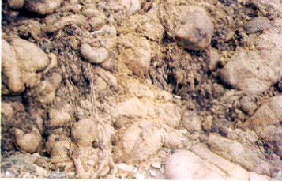

The high fat and protein content mean that slaughterhouse waste can be considered a good substrate for the anaerobic digestion process, due to its expected high methane yields. However, slow hydrolysis rates and inhibitory process have been reported.
In particulate materials that are difficult to degradable, such as animal by-products, hydrolysis must be coupled with the growth of hydrolytic bacteria, and this factor can limit the overall degradation
rate (Vavilin et al., 2008). Furthermore, lipids can cause biomass flotation and wash-out; and during lipid hydrolysis by extracellular lipases, long-chain fatty acids (LCFA) are produced.
These intermediate products have been described as inhibitory species (Rinzema et al., 1994). Also, ammonia is generated during protein degradation and its inhibitory effects on anaerobic digestion
(in the form of NH3) has been reported elsewhere (Hansen et al., 1998).

The cattle meat and fatty waste fractions corresponded to 44% of the slaughterhouse solid waste production. Due to its high lipid content, this fraction still provides an income for the slaughterhouse facility.

The data collected on the solid waste quantity generated in the bovine, goat, sheep and pig slaughter houses by CPCB through a survey is shown table 2. Average solid waste generation from bovine slaughter houses is 275 kg/tonne of live weight killed (TLWK) which is equivalent to 27.5 per cent of the animal weight. In case of goat and sheep slaughter house, average waste generation amounts to be 170 kg per TLWK which is 17 per cent of animal weight. Solid waste generation from pig slaughtering is 2.3 kg/head equivalent to 4 per cent of animal weight.

Table 2: Quantity of Solid Waste
Animal Kg/head Kg/TLWK % of Animal weight
Bovine 83 275 27.5
Goat/Sheep 2.5 175 17
Pig 2.3 40 4

The solid waste of slaughter houses can be broadly classified into two categories i.e. vegetable matter such as rumen, stomach and intestine contents, dung, agriculture residues, etc,.and animal matter like inedible offals, tissues, meat trimmings, waste and condemned meat, bones etc. These waste streams can be segregated and treated separately.

Slaughter house waste contains mostly biodegradable matter. Characteristics of solid wastes from goat and sheep slaughtering are given in table 3.

Table 3: Characteristics of slaughter house waste
Parameters Value
Moisture, % 69.45
Total solids, % 30.55
Volatile solids, % 87.95
Fixed solids, % 12.05
Org. carbon, % 23.32
Total nitrogen, % 2.71
Phosphorous, mg/g 4.19
Potassium, mg/g 6.9

Currently there is no organized system for the disposal of solid wastes in most of the slaughter houses in the country. The entire solid waste is collected and dumped along with MSW or disposed of as land fill. In few slaughter houses, dung and rumen digesta are collected separately for composting.
Methods of handling viscera, paunch and intestines Viscera can be recovered as edible products (e.g. heart, liver). They can also be separated for inedible rendering or processing.

The paunch contents, ‘paunch manure’ (partially digested feed), is estimated to range from 27 to 40
kg/animal. The paunch can be handled in four ways:
1. Total dumping- all of the paunch contents are flushed away into the sewer
2. Wet dumping- the paunch contents are washed out and the wet slurry is screened on the presence
of gross solids, which are subsequently removed
3. Dry dumping. The paunch contents are dumped for subsequent rendering or for disposal as solid
waste without needless water flushing
4. Whole paunch handling- the entire paunch may be removed, intact, for rendering or for disposal as
solid waste.

Intestines may be rendered directly, or hashed and washed prior to rendering. For the processing of
intestines de-sliming prior to thorough washing is necessary.

The recommended methods of slaughterhouse wastes disposal are composting, bio-methanation and
rendering. Selection of appropriate method, however, depends mainly on type of wastes and its quantity.

Incineration is also a known option for the treatment of slaughter house waste.

Classification of solid wastes
The Solid Wastes are classified based on their constituents. The classification are detailed in table 4

Table 4: Solid Wastes are classified based on their constituents.
Category Constituents of waste
Type-I waste
Vegetable matter such as rumen, stomach and intestine contents, dung, agriculture residues etc.
Type II waste
Animal matter such as inedible offals, tissues, meat trimmings, waste and condemned meat, bones etc.

Management of Solid Waste
Large slaughter house are mostly in cities and located in congested areas. They generate substantial quality of solid wastes, which have to be processed in environmentally acceptable manner. For the large slaughter houses, Bio-methanation of type-I waste and rendering for type-II waste are suggested. Bio-methanation requires less space, which is advantageous for the slaughter houses with land constraints. Bio-methanation for type I waste and rendering for type II waste should also be considered for medium size slaughter houses with an alternative of composting. In the case of small slaughter houses, sophisticated and capital intensive technologies is unviable due to low volume of wastes and non-availability of other infrastructure facilities. For small slaughter houses, a more pragmatic approach would be to make use of natural process such as composting. This would be financially and technically viable and can be acceptable by the small slaughter houses. The best practicable methods currently available for processing and disposal of different wastes for
the slaughter houses are detailed in the table 5.

Table 5: Methods for processing, utilization and disposal of solid wastes from slaughter house

Waste Constituents of wastes SH Category Method(s)
Type I
Vegetable matter such as rumen, stomach and intestinal contents, dung, agriculture residues etc.
Large Biomethanation
Medium Bio-methanation /Composting
Small Bio-methanation /Composting

Type II
Animal matter such as inedible offals, tissues, meat trimmings, waste and condemned meat, bones etc.
Large Rendering
Medium Rendering /Composting with type-I waste
Small Composting with type-I waste

Composting
Composting involves the aerobic biological decomposition of organic materials to produce a stable humus-like product. This is a common practice of wastes stabilization but requires proper understanding of the following steps.
• Feedstock and nutrient balance: Controlled decomposition of the wastes requires a proper balance of organic materials which contain the right nutrient mix. The ratio must be established on the basis of available carbon rather than total carbon. An initial ratio of 30:1 for carbon:nitrogen is considered ideal.
To adjust the carbon: nitrogen ratios, different biosolids should be added.
• Particle size: Grinding, chipping, and shredding materials increases the surface area on which the
microorganism can feed. Smaller particles also produce a more homogeneous compost mixture and
improve pile insulation to help maintain optimum temperatures. If the particles are too small, however, they might prevent air from flowing freely through the pile.
• Moisture content: Microorganisms living in a compost pile need an adequate amount of moisture to
survive. Water is the key element that helps transports substances within the compost pile and makes
the nutrients in organic material accessible to the microbes. Organic material contains some moisture in varying amounts, but it needs to be supplied on requirement. Excessive moisture can create anaerobic conditions, which may lead to rotting and obnoxious odors.
• Maintaining pH: pH affects the amount of nutrients available to the microorganisms, the solubility of heavy metals, and the overall metabolic activity of the microorganisms. A pH between 6 and 8 is
normal.
• Oxygen flow: Turning the pile, placing the pile on a series of pipes, or including bulking agents such as vegetable matter shall help in better aeration of the pile. Aerating the pile allows decomposition to occur at a faster rate than anaerobic conditions. Care must be taken, however, not to provide too much oxygen, which can dry out the pile and impede the composting process.
• Temperature: Microorganisms require a certain temperature range for optimal activity. Certain
temperatures promote rapid composting and destroy pathogens. Microbial activity can raise the
temperature of the pile's. If the temperature does not increase, anaerobic conditions (i.e., rotting) occur.
Controlling the previous four factors can bring about the proper temperature.

Process for Treatment of Solid Waste
The slaughter house waste i.e. type I and type II waste, can be used for compost making. The agriculture residue and dung from the lairage, ruminal and intestinal contents, blood, meat cuttings, floor sweepings, hair, feathers, hide trimmings can be stabilized by composting.
The compost stack is prepared by making heaps of waste and for preparation of compost stack, the alternate layers of type I waste and type II waste should be built up to a height of 4 to 5 feet. The heap should preferably be laid direct on the ground. It is advisable to put a layer of about 6-inch of course material, such as maize or millet stalks, banana stumps, straw, grass, small twigs etc. underneath in order to achieve proper ventilation.
In case type II waste contains large organs such as kidneys and lungs or other similar wastes,
then they are not put in whole but need to be minced or chopped into 2 to 3 inch pieces. For better results it is advised to mix these pieces with earth and evenly spread out in the centre of the heap where the temperature is high. Higher temperature in compost keeps rats, dogs or other vermin away. The ruminal and intestinal contents provide sufficient moisture for a start of bacterial activities. As such no water is required initially.
To achieve optimum conditions for the bacteria, moisture and proper aeration must be maintained from start to finish. A gradual reduction in height will follow, because of the shrinkage of decomposed matter. At least two turnings are required to obtain a uniform compost material. The first turning is normally advised after 2 to 3 weeks and the second turning after 3 to 4 weeks. The compost can be removed after 4 to 5 weeks. This is reasonably enough time for composting, although it depends on many factors, such as type of material, size of heap, ambient temperature etc. The quality of compost can be improved gradually with experience by proper combination of different wastes, providing appropriate time intervals for mixing, and moisture control.

Anaerobic stabilization
Biomethanation of slaughterhouse is done in many places. The success of the process, especially the
effective removal BOD has led Biogas plant to be acceptable for slaughter house. Biomethanation plant can be constructed in two ways. The gas is produced in one or more digesters and then it can be stored in a separate gas holder from where it is drawn as and when required. The other alternative is that the digester and gas holder are built so as to form one single unit. The gas is produced in the lower part of the structure, while the upper tank serves as a gas holder. While the second option is extremely simple and cheap in construction, but it has the disadvantage that gas production is affected during recharge. On the other hand, with a separate gas holder, continuous supply of gas can be assured even when one or more digesters are being charged. It is, therefore, more practicable for larger units to have separate gas holders.
Conventional Biogas Plant: Conventional floating drum type biomethanation (biogas) plant. An inverted drum with a diameter slightly less than that of cylindrical digester serves as gas holder. The plant delivers gas at uniform pressure and provides good seal against gas leakage. It is reliable and has proven performance for cattle dung processing. However, the plant feed on slaughter house wastes such as rumen and paunch contents, dung etc. will also exhibit same performance when loading rate is maintained about 0.5 - 0.6 kg volatile solids / m3/day. The waste should be suitably diluted before feed. The plant can handle feed with solid content up to 8 percent.
The anaerobically digested sludge has higher nitrogen content than compost manure. The sludge should be dewatered by sand filtration or filter press. The dried sludge can be utilized as manure in field. The filtrate is recycled for preparation of feed slurry, which contains microorganism. The biogas can be used for boiler or power generation. The economics of a typical biogas plant processing 1250 kg/day of waste is presented in the table 6.

Table 6: Economics of a biogas plant
Particulars Value
a Waste processing 1250 kg/d
b Capital cost Rs. 15 lakh
c Operation & maintenance cost Rs. 1.5 lakh /year

Potential returns
e Biogas generation 42.5 m3/day
f Equivalent power @ 2kwh/m3 85 kwh/day
g Cost of power @ Rs. 3/kwh Rs. 0.918 lakh/year
h Quantity of manure 164 kg/day
i Cost of manure @ Rs. 2/kg Rs. 1.18 lakh /year
Savings after O&M [(i+g)-c] Rs. 0.6 lakh/ year

The success of a biomethanation plant depends on several factors, such as the quality of the raw materials, temperature, ratio of water to solids, and also on the type of bacteria present.

High Rate Biomethanation
The essential elements of a high rate biomethanation are complete mixing and uniform temperature with more or less uniform feeding of the substrate. Pre-thickening or dilution of the digester contents are optional features of high rate digestion system. The benefits of high rate biomethanation are reduced digester volume requirement and increased process stability. In high rate biomethanation system, there is proper arrangement for operation control and safety measures. Complete mixing of substrate in the high rate digester creates a homogeneous environment throughout the digester. It also quickly brings the feed into contact with microorganisms and evenly distributes toxic substances, if any, present in the wastes. The entire digester is available for active decomposition, thereby, increasing the effective solids retention time. Temperature is one of the important environmental factors. In the cold climate areas, digester heating is beneficial because the rate of microbial growth and therefore, the rate of digestion increase with temperature.

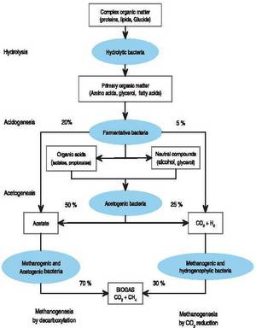

Wastes consisting of rumen and paunch contents, dung, agriculture residue, fat and blood is processed in the high rate plant. The solid wastes from different sections are collected in dissolution tank. The dissolution tank is used to adjust moisture and solid ratio and mixing the waste thoroughly. The waste containing up to 12 per cent solids is passed through shredder, which reduces solid waste size to required level. Waste is now pumped to digester. Hydraulic retention time of waste in the digester is about 25 days. At organic loading rate up to 2.5 kg/m3/day, the digester can give up to 55 per cent efficiency in terms of volatile solid destruction. In digester optimum temperature of about 36 °C is maintained with the help of heat exchanger.

The digester has all accessories such as temperature and pressure indicators, overflow, safety valve etc.
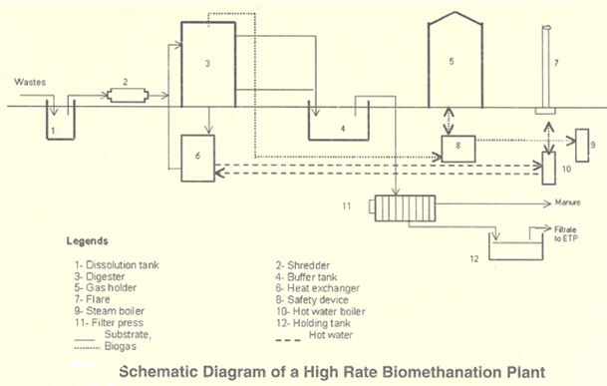

Specific biogas production in high rate plant is about 0.8 m3/kg of volatile solids destroyed, having electrical equivalent of 2.11 kwh/m3 of gas. Economics of a typical high rate biomethanation plant catering to 60 tonnes/day of waste is worked out in table 7.

Table 7: Economics of a high rate bio-methanation plant
Particulars Value
a Waste processing 60 tonnes/day
b Capital cost Rs. 3.8 crores
c Operation & maintenance cost Rs. 31 lakhs /year
d Interest and depreciation @ 16 % interest,
plant life 15 years
Rs. 68 lakhs /year
Potential returns
e Biogas generation 2600 m3/day
f Equivalent power @ 2.11 kwh/m3 5500 kwh/day
g Cost of power @ Rs. 4.5/kwh Rs. 89 lakh /year
h Quantity of manure 7000 kg/day
I Cost of manure @ Rs. 2/kg Rs. 50 lakhs /year
Savings [(g+i) – (c+d)] Rs. 40 lakh/ year

The plant generates about 2600 m3 biogas and 7 tonnes manure in a day which can give additional income of Rs. 40 lakhs per annum.

Rendering
This is a useful method for the physical separation of fats from solids and water. All the animal matter such as inedible offal, tissues, meat trimmings, waste and condemned meat, bones etc. can be processed in a rendering system as the main constituents of animal matter are fat, water and solids. Rendering is affected by heating and rupturing connective tissue of individual fat and muscle cells so that raw fat and other material bound within is freed. In rendering, fat recovered is used for industrial purposes, such as soap and greases.

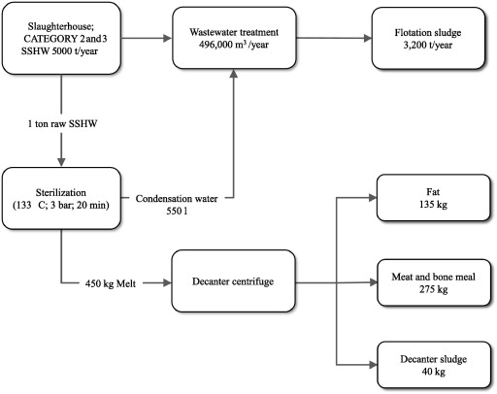

Fat recovered from flesh of healthy parts can also be used for edible purposes. Solid portion, which is known as meat meal or bone meal, is utilized for the manufacture of stock feed and fertilizers.
All the animal matter i.e. type II wastes such as inedible offal, tissues, meat trimmings, waste and condemned meat, bones etc. can be processed in rendering system. The main constituents of animal matter are fat, water and solids. The objective of rendering process is to physically separate the fat, the water and the solids. This is affected by heating and rupturing connective tissue of individual fat and muscle cells so that raw fat and other material bound within is freed. In rendering, fat recovered is used for industrial purposes, such as soap and greases. Fat recovered from flesh of healthy parts can also be used for edible purposes. Solid portion, which is known as meat meal or bone meal, is utilsed for the manufacture of stock feed and fertilizers.

Rendering is carried out in dry rendering or wet rendering plants. In both the processes, large pieces such as heads, bones etc are reduced in size by shredders or other machinery. Large soft offals are also cut to size before processing. Intestines, stomach and similar soft materials contain manure and, therefore, they are opened and cleaned before feeding to rendering plant.

Wet Rendering:
The name wet-rendering is applied where the raw material is processed with added water or
condensate derived from steam. The wet-rendering tank is usually a vertical, cylindrical boiler, having a coneshaped bottom, with a gate valve outlet.

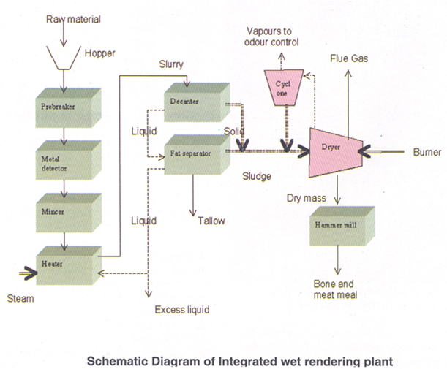

At the top of the tank there is a manhole through which raw material is loaded, and also a valve through which obnoxious gases escape without reducing the pressure. Steam is injected from the bottom of the tank.

Several draw-off cocks on the side of the tank, at different levels, enable the fat and water to be removed.

After the raw material is loaded, the manhole is tightly closed and steam is let into the mass. The steam pressure used will very with the material.

The higher the pressure, the quicker the disintegration. For this reason, large plants often render the offal at a pressure of 4 kg/cm2. However, high pressure may reduce the quality of the material, especially of the fat. For this reason, a pressure of 3 kg/cm2 is usually maintained in the tank.

The time required to disintegrate the tissue and free all the fat varies from four to six hours, depending on the character of the offal. After cooking is completed, the contents of the tank are allowed to settle for about two hours. After settling, clean divisions are formed between the digested material, water and fat. The fat, having the lowest specific gravity, will be on the top, the sludge and solids having the high specific gravity will be at the bottom. The center will be occupied by water. Gradually the pressure is reduced to that of the atmosphere, and then the water and fat are ready to be drawn off through the side cocks. If the fat level is below a cock, the level can be raised as required by addition of water.

After the fat and tank water have been removed, the gate valve is opened and the digested mass of meat and bones is taken out. At this stage the mass may contain up to 55 percent moisture and about 15 percent fat which can be dried in the dryer to obtain meat meal or bone and meat meal.

For large operation, integrated continuous rendering plants are used. An integrated rendering plant consists of pre-breaker, metal detector, fat separator, dryer and hammer mill. Total yield of bone and meat meal by wet rendering system is about 30 per cent of raw material weight and tallow about 10 per cent. For large operation, integrated continuos rendering plants are used. An integrated rendering plant consists of prebreaker, metal detector, fat separator, dryer and hammer mill.

Dry Rendering:
In this process, all the unwanted moisture is eliminated from type II wastes without the loss
of any nutrient by using specially designed cooker. The dry rendering cooker, is a horizontal steam jacket equipped with a set of agitators, which keep the material in continuous motion. The steam is applied to the jacket only and not to the material to be processed, as in wet-rendering. The material remains in the cookers for about 4 to 5 hours in most plants. Steam pressure in the cooker jackets usually ranges from 3 to 4 kg/cm2. The dry heat transmitted from the steam jacket to the raw material converts the moisture present in material into steam, which gradually builds up the
internal pressure of cooker. This pressure, combined with agitation, disintegrates the material and breaks down the fat cell. Dry rendering therefore works on steam pressure develop from the moisture contained in the raw material itself, and not as in wet-rendering, from the pressure created by injected steam.

In the wet-rendering process, the fat floats on top of the liquid and is separated out. In dry-rendering, the fat is released from the fat cells but is still dispersed throughout the material. The fat in the solids may be removed by either a hydraulic press or by using a centrifugal turbine fat extractor.

The whole process, i.e., sterilization, digestion, and drying, take place in cooker only. Therefore, there is no loss of nutrient. The dry rendering process allows approximately 20 percent higher yield than the wetrendering, as the water containing water-soluble extractives and proteinous suspended matter is not discarded. The dry rendering plants have units such as metal detector, pre- breaker, cooker, fat extractor and hammer mill.

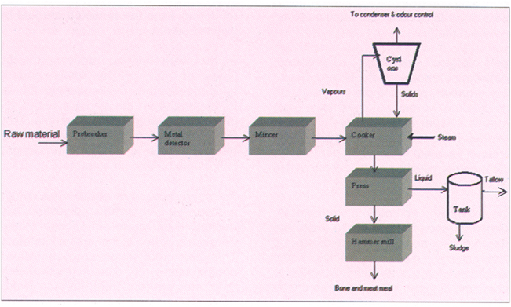

Economics of dry rendering plant installed in a mechanized slaughter house has been worked out and
presented in table 8.
On an average the plant renders 65 tonne/day of animal matters to produce 20.25
tonnes bone and meat meal and 8 tonnes tallow in a day.
Table 8: Economics of a dry rendering plant
Particulars Value
a Waste processing 65 tonnes/day
b Capital cost Rs. 4 crores
c Operation & maintenance cost Rs. 12 lakhs /month
d Interest and depreciation @ 16 % interest, plant
life 15 years
Rs. 6 lakhs /month
Potential returns
e Bone and meat meal production 20.25 tonnes/day
f Cost of bone & meat meal @ Rs. 9/kg Rs. 47 lakhs /month
g Tallow production 8000 kg/day
h Cost of tallow @ Rs. 18/kg Rs. 37 lakhs /month
Savings [(f+h) – (c+d)] Rs. 66 lakh/ month

WASTE WATER TREATMENT
The increased automation in carcasses dressing together with the incorporation of washing at every stage (scalding, bleeding, evisceration and tripe treatment) have increased water consumption in slaughterhouse facilities. Wastewaters are normally subjected to a primary treatment which generally includes the use of screens, settlers and fat separators. Some slaughterhouse wastewater treatment plants (WWTP) have a secondary anaerobic reactor, usually based on upflow anaerobic sludge blanket (UASB) or expanded granular sludge bed (EGSB) reactor systems, due to the high organic content of the intake. Several successful experiments at laboratory, pilot and industrial scale with such wastewater and reactor configurations are reported in the literature
(Kim and Shin, 2010).

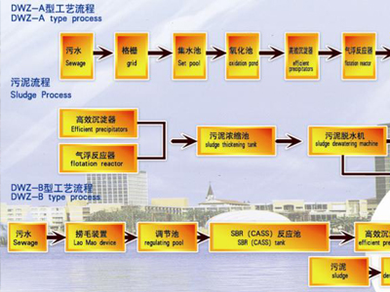

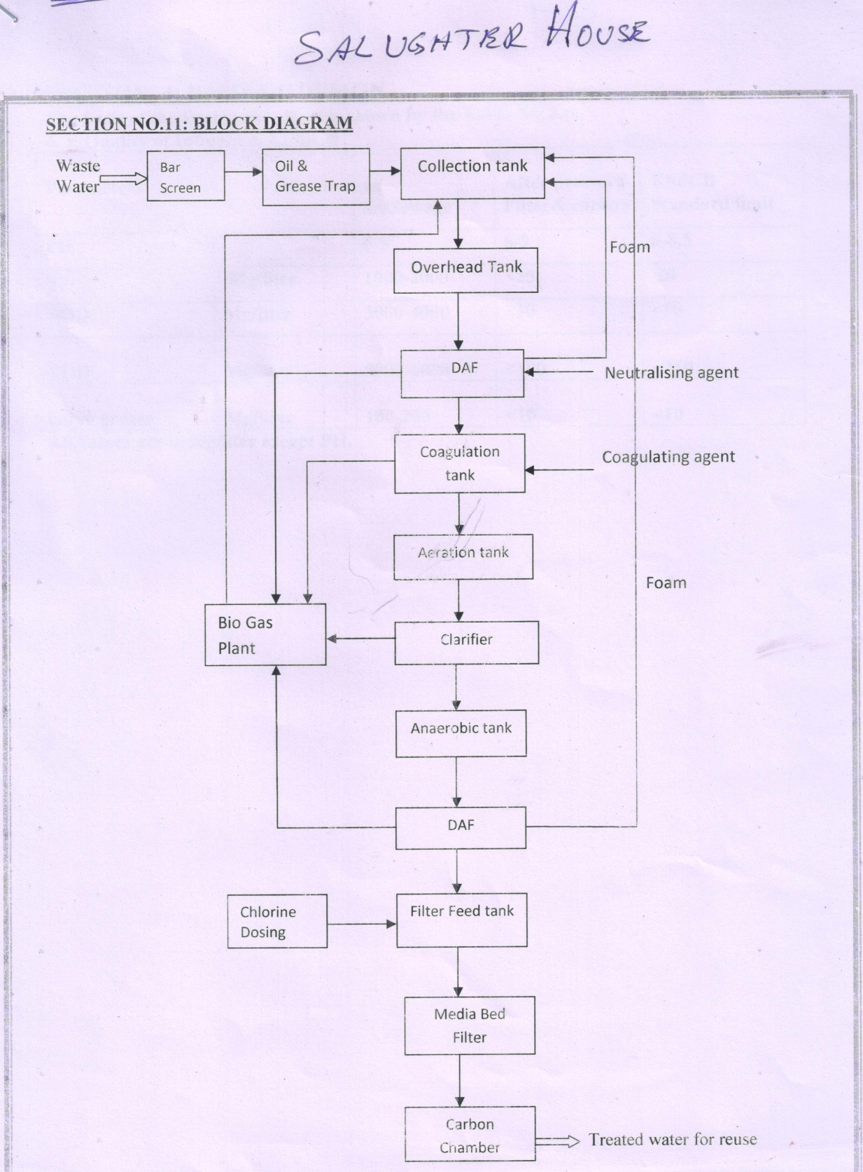

The slaughterhouse also produced other waste streams, such as waste blood, waste from the slaughterhouse wastewater treatment plant (WWTP) and wastewater, which correspond to 82% of total waste production. The WWTP at the slaughterhouse consisted of a primary treatment facility that included several screens and a dissolved air flotation system (DAF). Consequently, screened waste and DAF sludge were also considered as waste material flows in the
present assays.

Bacterial counts ranged from 4.8 × 106 to 5.8 × 105 /100 mL of total coliform (TC), 8.2 × 104 to 3.2 × 104/100 mL of Fecal coliform (FC), 5.2 × 104 to 2.0 × 104/100 mL of Fecal streptococcus and 1.2 × 104 to 2.0 × 103/100 mL of Escherichia coli for abattoir effluents.

Pathogens present in animal carcasses or shed in animal wastes may include rotaviruses, hepatitis E virus, Salmonella spp., E. coli O157 : H7, Yersinia enterocolitica, Campylobacter spp., Cryptosporidium parvum, and Giardia lamblia

The average quality of the generated wastewater could be characterised as having a total COD of around 7300mg dm_3, highly soluble in nature, a low BOD5/COD ratio of 0.44, a significant total N (TKN) concentration of 690mg dm_3 and a total P concentration of only 3.3mg dm_3, very much
below the level that would be required to sustain biological treatment.

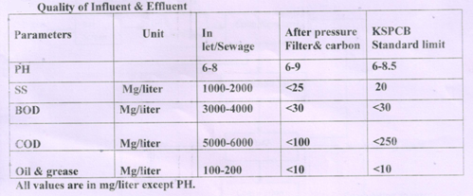

OPTIMUM PARAMETERS OF THE TREATED WATERS
- Biochemical Oxygen Demand (BOD) and suspended solids of less than 30 mg/L,
- total nitrogen should be less than 15 mg/L and
- total phosphorus less than 5 mg/L.
- Where no direct human contact with the water is anticipated, then the level of thermotolerant coliforms can rise to not more than 1,000 per 100 mL.

PARAMETER Before Treatment After Treatment
Total coliform (TC) 4.8 × 106 to 5.8 × 105 /100 mL 1 x 104/ 100 ml
Fecal coliform (FC) 8.2 × 104 to 3.2 × 104/100 mL 1 x 103/ 100 ml
Fecal streptococcus 5.2 × 104 to 2.0 × 104/100 mL 1 x 103/ 100 ml
Escherichia coli 1.2 × 104 to 2.0 × 103/100 mL 1 x 102/ 100 ml
Total Suspended Solids 2400- 4200 mg dm_3 40- 80 mg dm_3
Total COD 7300 mg dm_3 60 mg dm_3
BOD5 3200 mg dm_3 30 mg dm_3
Total N (TKN) 690mg dm_3 15 mg dm_3
Total P 3.3mg dm_3 3.3 dm_3

Summary of treatment options

Recommended Methods for processing, utilization and disposal of
solid wastes from slaughter house
Type of Waste |  | Constituents of wastes | Category of Slaughter House |  |  | Method(s)
Type I | Vegetable matter such as rumen, stomach and intestinal contents, dung, agriculture residues etc. |  |  | Large | Biomethanation
Type I |  |  |  | Medium | Biomethanation  Or  Composting
Type I |  |  |  | Small | Biomethanation  Or  Composting
Type II | Animal matter such as inedible offals, tissues, meat trimmings, waste and condemned meat, bones etc. |  |  | Large | Rendering
Type II |  |  |  | Medium | Rendering  Or  Composting with type-I waste
Type II |  |  |  | Small | Composting with type-I waste  Or  Burial*
*Should be considered as provisional measure.
Incineration can also be used, which is one of the effective means to treat volatile waste. These methods will reduce solid waste disposal problems in slaughter houses.
As seen above there are no universal methods.
We have to make tailor made solution for each case depending on the volumes and process.

All most all by-product of slaughter house can be utilized. However, various circumstances do not always permit by-product recovery. The reasons may be inadequate quantity of materials, lack of markets, cost of processing etc. In such instances, they simply form part of waste lot for which different methods of processing and disposal have to be considered. For the slaughter house wastes composting, biomethanation and rendering systems are suggested. Selection of appropriate method, however, depends mainly on type of wastes and its quantity. Incineration is also an option for treatment of slaughter house waste.

In previous decades, solid slaughterhouse wastes were usually treated by rendering process, providing the slaughterhouses with a valuable source of income. In recent years, because of BSE (bovine
spongiform encephalopathy) the economic value of these materials has been substantially reduced and in many cases they have to be disposed off as waste (EC no 1774/2002). Further modifications to
European Parliament and of Council Regulations regarding disposal and uses of animal by-products (EC no 92/2005) allow biogas transformation if approved pre-treatments are applied, depending on the by-product category (according to the sanitary risk: pasteurization, high pressure and temperature or alkaline pre-treatment).

TREATMENT SUGGESTED
SOLID WASTES:
Dilute Somguard 10 ml/L and spray liberally on the solid wastes daily and the entire working Areas once in a week.
Dilute Oxyrich 2.5 g/ L and sprinkle liberally on the solid wastes daily and the entire working Areas once in a week.
Dilute Flyshield 5 ml/ L and spray liberally on the solid wastes daily and the entire working Areas once in three days.
Dilute MSW 365 2.5 g/ L and sprinkle liberally on the solid wastes daily and the entire working Areas once in a 10 days.

WASTE WATERS:
USE Somguard 10 ml/KL /Day
USE Oxyrich 5 g/KL /Day
USE SHWWTP 2.5 g/KL /Day
USE Trifloc 1 g/KL /Day

REFERENCES:
1 Orhon D, Evaluation of industrial biological treatment design on the basis of process modelling. Wat Sci Tech 38:1–8 (1998).
2 Standard Methods for the Examination of Water and Wastewater, 20th edn, American Public Health Association/American Water Works Association/Water Environment Federation, Washington DC, USA (1998).
3 Ekama GA, Dold PL and Marais GvR, Procedures for determining COD fractions and the maximum specific growth rate of heterotrophs in activated sludge systems. Wat Sci Tech 18:91–114 (1986).
4 Reichert P, Aquasim – A tool for simulation and data analysis for aquatic systems. Wat Sci Tech 30:21–30 (1994).
5 Reichert P, Schulthess R and Wild D, The use of Aquasim for estimating parameters of activated sludge models. Wat Sci Tech 31:135–147 (1995).
6 Henze M, Grady CPL Jr, Gujer W, Marais GvR and Matsuo T, Activated Sludge Model No 1, IAWPRC Sci and Techn Report No 1, London (1987).
7 Orhon D and Artan N, Modeling of Activated Sludge System, Technomic Publ, Lancaster, PA (1994).
8 WPCD, Water and Waste Management in the Canadian Meat and Poultry Processing Industry, Environmental Protection Service, Canada (1981).
9 Tritt WP and Schuchardt F, Materials flow and possibilities of treating liquid and solid wastes form slaughterhouses in Germany. A review. Biores Tech 41:235–245 (1992).
10 Johns MR, Developments in wastewater treatment in the meat processing industry: a review. Biores Tech 54:203–216 (1995).
11 Eremektar G, Ubay C¸ okgo¨ r E, O¨ vez S, Germirli Babuna F and Orhon D, Biological treatability of poultry processing plant effluent: a case study. Wat Sci Tech 40:323–329 (1999).
12 Okutman D, O¨ vez S and Orhon D, Hydrolysis of settleable substrate in domestic sewage. Biotechnology Letters 23:1907–1914 (2001).
13 Go¨rgu¨n E, Ubay C¸ okgo¨ r E, Orhon D, Germirli F and Artan N, Modelling biological treatability for meat processing effluent. Wat Sci Tech 32:43–52 (1995).
14 Orhon D and Ubay C¸ okgo¨ r E, COD fractionation in wastewater characterisation – the state of the art. J Chem Technol Biotechnol 68:283–293 (1997).
15 Orhon D, C¸ okgo¨ r Ubay E and So¨zen S, Experimental basis for the hydrolysis of slowly biodegradable substrate in different wastewaters. Wat Sci Tech 39:87–95 (1999).
16 Spanjers H and Vanrolleghem P, Respirometry as a tool for rapid characterization of wastewater and activated sludge. Wat Sci Tech 31:105–114 (1995).
17 Del Pozo R and Diez V, Anaerobic pre-treatment of slaughterhouse wastewater using fixed film reactors. Biores Tech 71:143–149 (2000).
18 Sayed S and de Zeeuw W, The performance of a continuously operated flocculent sludge UASB reactor with slaughterhouse wastewater. Biol Wastes 24:213–226 (1988).
19 Kennedy KJ and Droste RL, Anaerobic wastewater treatment in downflow stationary fixed film reactors. Wat Sci Tech 24:157–177 (1991).
Annual Report 2000-2001; Department of Animal Husbandry and Dairying, Ministry of Agriculture, Govt. of India, New Delhi; p13.
Comprehensive Industry Document: Slaughter house, meat and seafood processing industry; COINDS/38/1992; Central Pollution Control Board, Delhi; pp 34-39.
Indian Standard : 8895-1978, Guidelines for handling, storage, and transportation of slaughter house by-products; Bureau of Indian Standard, New Delhi.
Indian standard: 4393-1997, Basic Requirement for an Abattoir; Bureau of Indian Standards, New Delhi.
Techno-economic Feasibility Report for Modernization of Slaughter House at Idgah (1990); Municipal Corporation of Delhi, Delhi; pp 32-33.
Bio-Energy News, Vol. 5, No. 1, March 2001; National Bio-Energy Board, Ministry of Non-Conventional Resources, Govt. of India, New Delhi; pp 7-11.
Proceedings of the Workshop on 'High rate biomethanation treatment of abattoir wastes' (2000), prepared and published by Central Leather Research Institute, Chennai and Ministry of Non-conventional Energy Sources, Govt. of India, New Delhi; pp 7-14.

