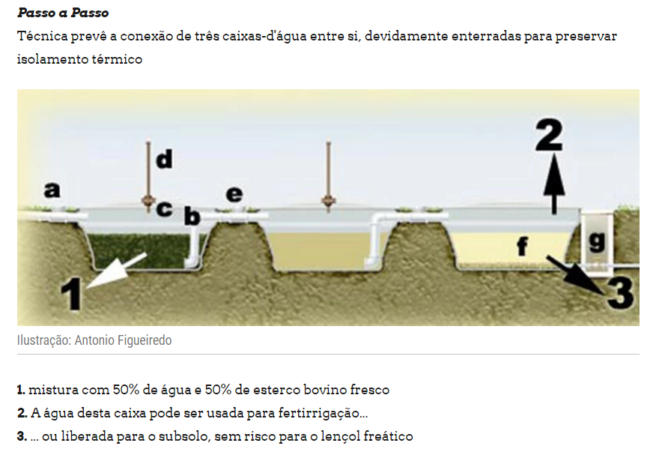
The technique foresees three interconnected enclosures between them properly buried to maintain the thermal insulation.
- Mix with 50% water and 50% fresh bovine manure.
- The water in this box can be used for fertilization.
- Or released to the subsoil, without risk to the water table.

