

UNIVERSITY OF ENERGY AND NATURAL RESOURCES, SUNYANI
ASSESSING SAFE DRINKING WATER AT GHANA WATER COMPANY LIMITED, SUNYANI MUNICIPAL AND ITS HUMAN HEALTH RISKS
A DISSERTATION SUBMITTED TO THE DEPARTMENT OF ENVIRONMENTAL MANAGEMENT
SCHOOL OF NATURAL RESOURCES
BY
EMMANUEL MENSAH
(UEB2314922)
&
JANET AIDOO DANQUAH
(UEB2309220)
SUPERVISOR: Ms. SYLVIA ADEPA

IN PARTIAL FULFILMENT OF THE REQUIREMENTS FOR THE AWARDS OF BSC. IN NATURAL RESOURCES MANAGEMENT

LIST OF FIGURES

Figure 1: Map of the study area 5
Figure 2: Diagrammatic Preentation of assessing drinking water quality and its human health risks 6

TABLE OF CONTENTS
LIST OF FIGURES ii
CHAPTER ONE 1
1.0 INTRODUCTION 1
1.1 Background of Study 1
1.2 Problem Statement 3
1.3 Justification 4
1.4 Objectives 4
1.4.1 Main Objective 4
1.4.2 Specific Objectives 4
1.5 Research questions 4
1.6 Research hypothesis 5
CHAPTER THREE 6
3.0 METHODOLOGY 6
3.1 Study area 6
3.2 Conceptual Framework 7
3.3 Materials and methods 7
3.3.1 Sampling Size 7
3.3.3 Sampling Technique 8
3.3.4 Data Collection 8
3.3.5 Data Analysis 8
3.4 Expected outcomes 8
REFERENCES 9

CHAPTER ONE

1.0 INTRODUCTION

1.1 Background of Study
According to (Appiah-Effah et al., 2019), access to potable water is a fundamental right that is required for optimal health and well-being. As a result, the UN General Assembly has expressly called for steps to provide "safe, clean, accessible, and affordable drinking water and sanitation for all" (Shaheed et al., 2014). However, (Berger et al., 2006) stated that water has several purposes and hence seen as an essential of life because water is used in the majority of human activities. In Ghana, the Ghana Water Company Limited (GWCL) is legally mandated to ensure safe drinking water standards. The Public Utilities Regulatory Commission (PURC), Ghana Standards Authority (GSA), Environmental Protection Agency (EPA), and Water Research Institute are among the other regulatory bodies tasked by law with safeguarding, enhancing, and ensuring the quality of any water used by the public, including bottled mineral water.

According to the GSA (2008), regulatory organizations routinely monitor or inspect the processing plant to ensure that the water supply meets set international standards. Water flowing through municipal water systems in cities is appropriately purified using enhanced water purification technology to remove pollutants from the water source (surface water or groundwater) before delivered to communities. As a result, while water obtained directly from a lake, stream, or river without treatment may be of questionable quality, water from a tap is generally safe to drink. However, Pye and Patrick (1983) stated that contaminants consist of microorganisms such as bacteria, protozoa, and viruses; inorganic substances (such as salts and metals); organic chemical pollutants from industrial operations and petroleum use; and pesticides and herbicides.
According to (Mythrey et al., 2012), water mostly consumed and used in the home for general household activities such as cooking, washing, and bathing. For many years, the need of adequate water quantity for human health recognized, and there has been much debate over the relative importance of water quantity, water quality, sanitation, and hygiene in protecting and promoting health (Cairncross et al. 1990). According to the World Health Organization (WHO, 2019), access to dangerous drinking water sources is one of the world's biggest concerns since it endangers both health and the environment, particularly in developing nations.
Water quantity is directly affected by poor water quality in several means. Contaminated water cannot be used for domestic, commercial and industrial purposes effectively reducing the quantity of useable water in a region (UNDESA, 2013). However, (Esrey et al., 1995) claimed that, despite this awareness, international recommendations or rules for minimum water volumes that domestic water supply should offer for homes are still largely lacking. Water quality is commonly assessed by standards that consider its suitability for drinking, human contact safety and the general wellbeing of the ecosystems.
Drinking water quality rules and regulations are designed to provide safe and clean water for human consumption while protecting human health (US EPA, 2002). The presence of dissolved mineral elements in water can have an impact on its quality for home and industrial uses. For instance, deposits of soft carbonates and hard sulphate can be formed by Ca 2+ and Mg 2+ ions in water, which can reduce the cleaning effectiveness of soap in boilers and water heaters. According to the World Health Organization (WHO, 2019), access to unsafe drinking water sources is one of the world's most pressing issues since it endangers both health and the environment, particularly in developing countries.

For people who do not have access to water sources at their homes, municipal water supply requires a significant time and energy investment (United Nations, 2003). This is because public water providers in many developing-country cities have failed to provide enough water supply to homes (Nickson, 2002). Low-quality and insufficient coverage, poor cost recovery, high labor costs and low labor productivity, and a substantial state subsidy have all been blamed for this failure (Panayotou and T, 1997). However, it has been argued that political participation in the sector leads to poor service delivery by public water providers (Schwartz et al., 2011).

Once more, (Biswas and K, 2006) emphasized that a growing proportion of urban inhabitants lack access to water due to factors such as population expansion, fast urbanization, low economic development, and a lack of proper management and technical capacity.

1.2 Problem Statement
Recent statistics from the World Health Organization (WHO) and United Nations Children’s Fund (UNICEF) Joint Monitoring Platform (JMP) indicate that over 844 million people still lack access to potable water and 2.3 billion people lack access to improved sanitation. It is evident that on the global scale, sanitation lags behind water as only 68% of the world’s population has access to basic sanitation compared to 88.5% with access to basic water services. The current situation in Africa is even more disturbing as only 28% of the people in sub-Saharan Africa have access to basic sanitation (WHO/UNICEF, 2017).

Access to quality drinking water is crucial for human life, yet many residents in Sunyani Municipal struggle to access it, putting their health at risk. Despite its importance, the safety of drinking water supplied by GWCL in Sunyani Municipal is unknown, and the accompanying human health hazards are little understood. This study aims to address this knowledge gap and identify areas for improvement to ensure access to safe drinking water for all.

1.3 Justification
Access to quality drinking water is essential for human life, yet residents in Sunyani Municipal face significant challenges in accessing safe drinking water, putting their health at risk.
Despite efforts by the Ghana Water Company Limited (GWCL) to improve water services, the existing initiatives and associated human health hazards in Sunyani Municipal are not well understood.
This study aims to bridge this knowledge gap by investigating the current state of drinking water access, identifying areas for improvement, and informing strategies to ensure universal access to safe drinking water in Sunyani Municipal

1.4 Objectives

1.4.1 Main Objective
The study seeks to assess and improve safe drinking water at Ghana Water Company Limited in Sunyani Municipal.

1.4.2 Specific Objectives

The study seeks to:
- Assess the quality of drinking water provided by GWCL, Sunyani Municipal.
- Investigate residents' perceptions of the water provided by GWCL, Sunyani.
- Assess the treated water's compliance with local and international drinking water quality standards in GWCL, Sunyani.

1.5 Research questions

- What is the physical, chemical, and biological quality of drinking water supplied by GWCL in Sunyani Municipal, and does it meet the required standards?
- What are the perceptions and attitudes of residents in Sunyani Municipal regarding the quality of water provided by GWCL in Sunyani Municipal?
- To what extent does the treated water supplied by GWCL in Sunyani Municipal comply with local (Ghanaian) and international (WHO, ISO, etc.) drinking water quality standards, and what are the implications for public health?

1.6 Research hypothesis

H0: There is no significant difference in health outcomes among residents receiving water from GWCL, Sunyani Municipal, across different levels of water quality parameters (good, moderate, poor).

H1: There is a significant difference in health outcomes among residents receiving water from GWCL, Sunyani Municipal, across different levels of water quality parameters (good, moderate, poor).

CHAPTER THREE

3.0 METHODOLOGY

3.1 Study area
Geographically, Sunyani Ghana Water Company lies between a latitude of 7° 19' 22 ' ' N and a longitude of 2° 19' 38' ‘W.This study will be conducted in Sunyani Municipal, Ghana (Bono Region), with a focus on Sunyani Ghana Water Company Limited (GWCL).
Stakeholders (management, operations, and decision-making processes) and the Residents (living in Sunyani Municipal who receive water services from GWCL) of Sunyani Ghana Water Company Limited (GWCL) make up the research population.
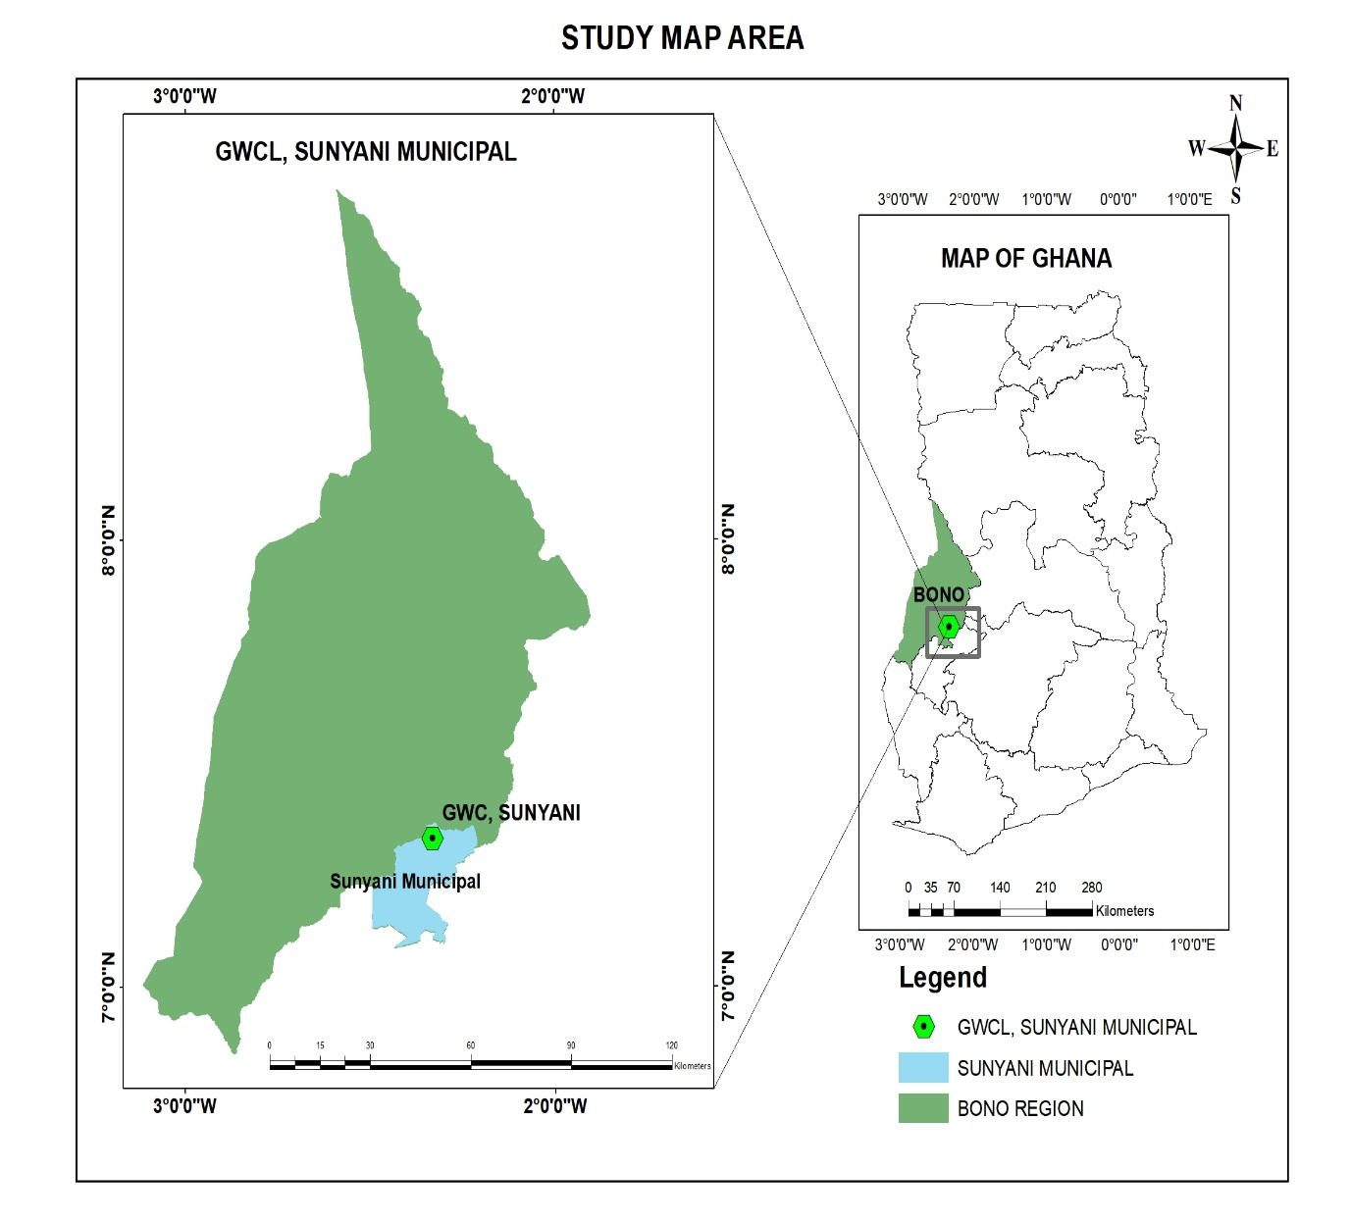

Figure 1: Map of the study area

3.2 Conceptual Framework

"This study's main goal is to assess and improve safe drinking water at Ghana Water Company Limited in Sunyani Municipal. The conceptual framework guiding this research is shown in Figure 2, which illustrates the relationships between water quality (water quality parameters), water treatment facilities (GWCL, Sunyani Municipal), Ghana Water Company Limited's services (Compliance with local and international standards) and the ultimate outcome of safe drinking water and human health risks."
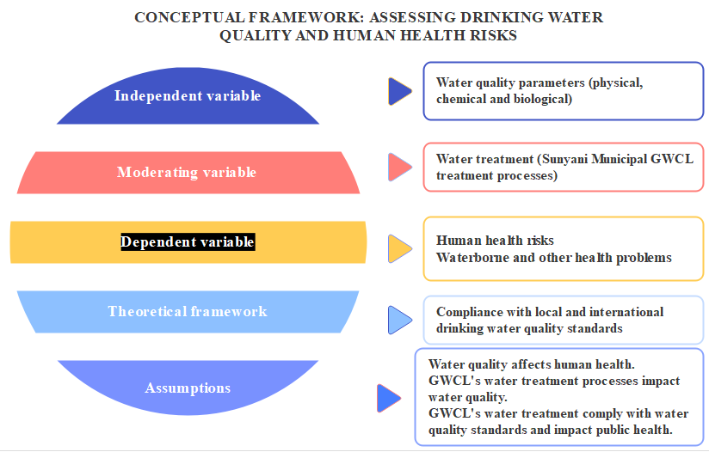

Figure 2: Diagrammatic Presentation of assessing drinking water quality and its human health risks

Materials and methods

3.3.1 Sampling Size
With regards to Yamane’s sample size formula for population less than 10,000, the sample size will be calculated using the sample calculator with margin of error of 5% confidence level 90%.
n= (N x ( $e^{2}$))
((N-1) x (C²) + ($e^{2}$))
Where n= sample size, N= Population size estimated, e= desired level of precision (5%) and C=Confidence level (95%)

3.3.3 Sampling Technique
A mixed sampling approach will be used in combining stratified sampling for water quality analysis (30 samples from 3 strata) and simple random sampling for the residents' survey (60 residents to be selected from the GWCL customers.

3.3.4 Data Collection
A structured questionnaire will be used to solicit information from 60 residents who receive water services from GWCL in Sunyani Municipal and 30 water samples from 3 strata for analysis.

3.3.5 Data Analysis
Descriptive statistics (mean, standard deviation, frequency, and percentage) and inferential statistics (ANOVA) will be used to summarize, describe, and model the relationships between water quality parameters and consumer perceptions.

3.4 Expected outcomes
It is expected that at the end of the study:
- Assessing the quality of drinking water provided by GWCL, Sunyani Municipal will be ascertained
- Investigate residents' perceptions of the water provided by GWCL, Sunyani Municipal will be ascertained.
- Assess the treated water's compliance with local and international drinking water quality standards in GWCL, Sunyani will be ascertained.

REFERENCES

Appiah-Effah E, Duku GA, Azangbego NY, et al (2019). Ghana’s post-MDGs sanitation
situation: an overview. J Water Sanitation Hygiene Dev; 9: 397–415.

Berger T, Birner R, Mccarthy N, et al (2006). Capturing the complexity of water uses and water
users within a multi-agent framework. Water Resource Management; 21: 129–148.

Cairncross, A. M. (1990). Health impacts in developing countries: new evidence and new
prospects. J. Inst. Water Envt. Mgt. 4(6):571-592.

Esrey, S. A., Feachem, R. G., Hughes, J. M. (1985). Interventions for the control of diarrhoeal
diseases among young children: improving water supplies and excreta disposal facilities. Bul. Wld. Hth. Org. 63(4):757-772.

Mythrey RC and Ramachandra N (2012) Water: the elixir of life.
Int J Res Ayurveda Pharm; 3: 769–771.

Pye, VI. and Patrick, R. (1983). Ground water contamination in the United States.
Science Vol. 221, no. 4612 pp. 713-718

Shaheed A, Orgill J, Montgomery MA, et al (2014). Why ‘‘improved’’ water sources are not
always safe. Bull World Health Organ; 92: 283–289.

United Nations Department for Economic and Social Affairs (UNDESA). Water Quality,
International Decade for Action ‘Water for life’ 2005-2015 http://www.un.org/waterforlifedecade/quality.shtml Retrieved on 13/10/13

WHO/UNICEF. Progress on Drinking Water, Sanitation and Hygiene: 2017 Update and SDG
Baselines - Launch version. 1st ed. Geneva: World Health Organization and the United Nations Children’s Fund (UNICEF

