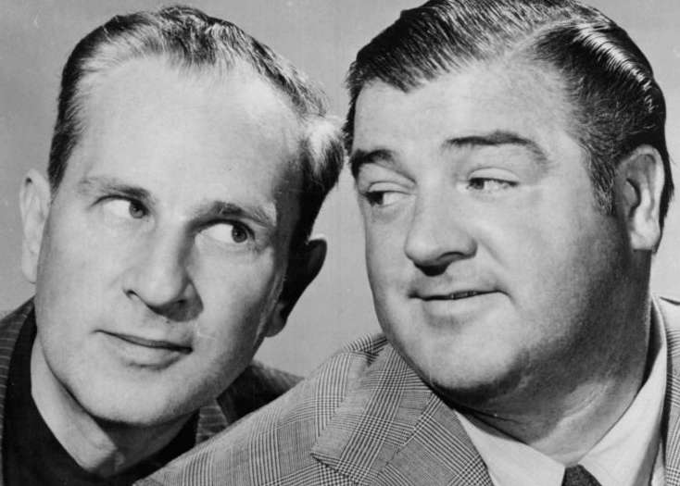
What Abbott and Costello Can Teach Us

About Water

Source: Mazzei Injector Company, LLC

by Jim Lauria

World Water Day (Thursday, March 22nd this year) does a great job of focusing our attention on water issues. And especially with storms on the East Coast and drought in the West, not to mention the looming possibility that officials will have to shut off the taps in Cape Town sometime this summer, a lot of the messaging around water is pretty much like being smothered in a wet blanket.

For a previous World Water Day, I shared tips to help people reduce their water footprint—pointers like reading your water bill, irrigating less, eating more vegetables, cutting back on driving, and reducing consumption of goods and electricity. I didn't want to re-visit that instructional approach, so as I often do when I'm looking for inspiration, I went to my bookshelf.

There are some great books about water, but admittedly, most of them take a grim stance. The Big Thirst by Charles Fishman, Unquenchable by Robert Glennon, When the Rivers Run Dry by Fred Pearce—they're all phenomenal works by some of the world's leading hydro-luminaries. But the titles alone washed over me with a feeling of helplessness.

Many of us go looking for some comic relief when things start looking bleak, so that's the approach I'm going to take to mark 2018's World Water Day.

Seek the Masters

When I need a laugh, I find myself going back to the original masters of broadcast comedy: Abbott and Costello. It's not just Lou Costello's great physical comedy, or the fact that one of their most famous routines is all about water (if you don't remember the Niagara Falls shtick, check it out.) It's that their ingenious wordplay holds up after all these years. One of their best-loved routines is the brilliant "Who's On First?" which draws on their roots in burlesque theater.

I got to wondering what Abbott and Costello would make of today's water situation with their rapid-fire patter. I imagined myself discussing the concept of embedded water, talking with Bud Abbott and Lou Costello about how waterlogged much of our economy is, awash in the water required to maintain our productivity in everything from steel ingots to hamburgers to a kilowatt of electricity.

I could hear myself explaining the big issues in water, like the need for monitoring and evaluation—the growing importance of logging the amount of water in the products we consume and the energy we generate. With a water logging data set, we can learn how much we actually use and where we can conserve. After all, we can't manage what we don't measure. As Costello might have said, we need to be water loggers before we get waterlogged.

Who's On First?

I shared this vision with professional comedian Steve Bhaerman. All of a sudden, it was like we were backstage at a vaudeville theater with my comic heroes. And this is what emerged:

A: Is that product waterlogged?

C: I dunno, how do I find out?

A: You water-log it.

C: If I don’t want it to be waterlogged, why do I wanna water-log it?

A: Yes, you water-log it because you don’t want it waterlogged.

C: That’s my point. If I don’t want it waterlogged, why water-log it?

A: Because water-logging is the only way to find out if it’s waterlogged.

C: So, is it waterlogged before I water-log it?

A: You won’t know until you water-log it.

C: I DON’T WANT TO WATER-LOG IT!!!

A: Then you'll never find out if it's waterlogged.

This World Water Day, don't overlook the seriousness of the global water situation. Remember that measuring water consumption in all its forms—water-logging—makes us cognizant of how waterlogged our system is. Look for ways to understand your own water footprint (sites like http://waterfootprint.org/en/ can help). But don't forget to take a few minutes for a good laugh.

