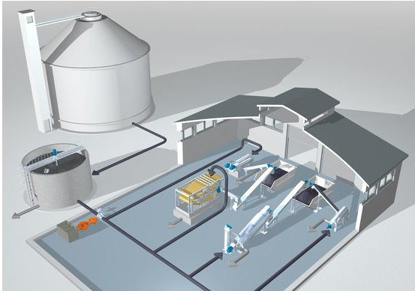
“Anaerobic sludge digestion releases Ammonium, Magnesium and Phosphate (MAP), which under certain conditions (pH, temp, ions conc., etc) can form Struvite in digesters and downstream dewatering facilities.
It can result in scaling in pipelines and on walls of process equipment.”

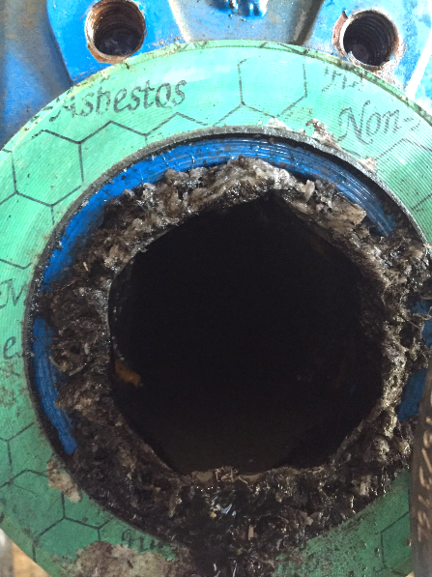
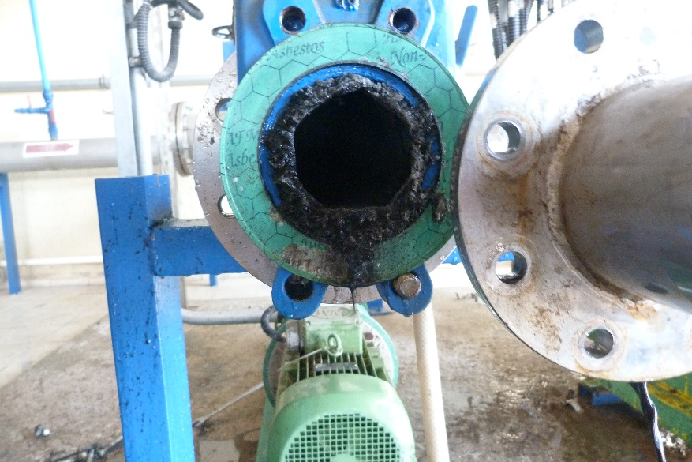
Eskisehir Municipality was affected by a hard struvite form and they were unable to break it even by hand.
For this reason BASF Water Solutions conducted specifc lab tests and finally proposed to use a combination of ANTIPREX MSA and BURST LX80 to destroy such formation. Here some pictures of the pipes before treatment:

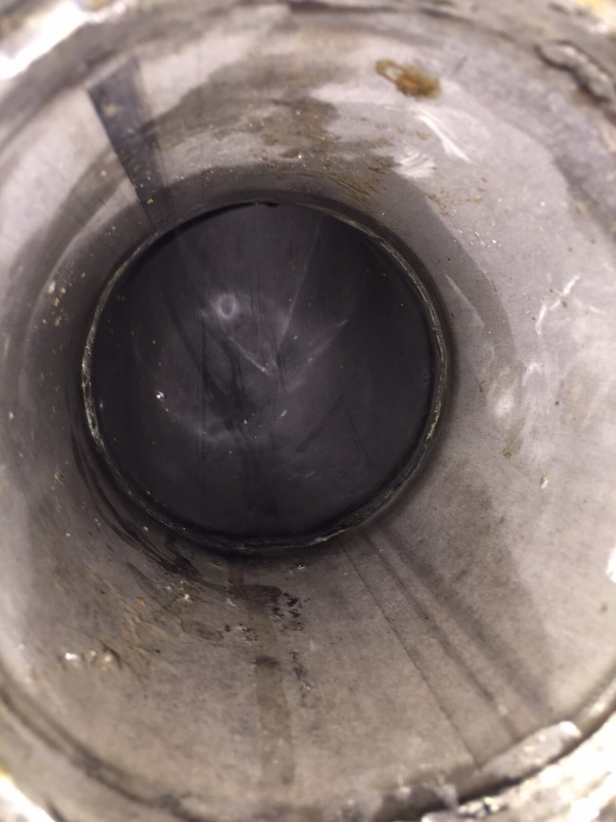
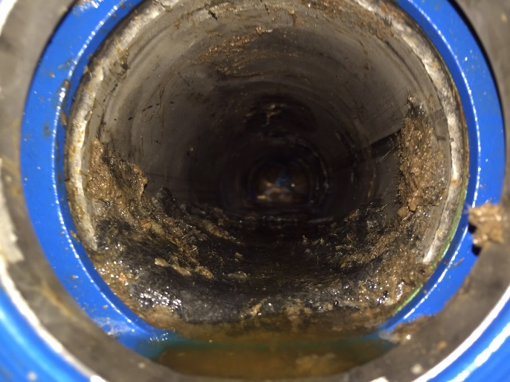
After the test the pipe was washed and it was looking clean as seems in the photos.

The benefits of this treatmet are evident, Struvite has been successfully removed from the pipes with consequent reduction of employees involved to clean up such pipes, like in the past.
In addition, the dosage of ANTIPREX AD 1020 XP, scale inhibitor which might help to avoid future Struvite formation, with consequent benefits for the plant –no need to stop the process with consequent cost saving.
Eskisehir followed BASF Water Solutions suggestion, making different test with Antiprex MSA and Burst LX80.
After couple of trials they identified the best combnination to get excellent results;
A solution made with 10 % of Antiprex MSA and 5% of Burst LX 80 was circulated about 16 hours.
After this time the solution was very dirty because all the struvite form was completely dissolved.

