“Community Based Sewage Treatment through Hybrid Constructed Wetlands System, embedded with Value Addition Interventions, to Enhance Water Availability, Bio-diversity, livelihood Generation and Reduction in Water Born Disease in Rural Environment – Pakistan”
Col. Islam-ul-Haque, Basic Services Manger- UN-HABITAT, Pakistan
islamhaq3@yahoo.com islam.haque@unihabitat.org.pk

General
1. Approximately, 80% of World’s wastewater is being discharged into water bodies and in Pakistan, 90-95% of 8000 MCM / year generated wastewater finds its way to water bodies which is causing massive surface and ground water contamination . Due to devoid of prudent wastewater management practices, particularly in Pakistan’s context, raw sewage is invariably being used for vegetable farming and for other agriculture purposes , which contributes and triggers food chain contamination. This is the major reason of prevalence of water borne diseases in Pakistan, especially in rural environments where there is no concept of sewage treatment systems.

2. Furthermore, in a typical villages of Pakistan, wastewater is being collected through open channels and stored into an earthen pond, located right in the middle of the village, which not only contaminate local ground water aquifer but also provide habitat to various vectors and viruses. Moreover, villages’ water supply scheme are installed on the bank / or near the stagnant wastewater pond which causes bacterial contamination while pumping out water for drinking and for other purposes. This bad state of environmental sanitation is causing all types of water sources contamination and contributes towards prevalence of water born diseases, including polio etc. The best examples of such un-hygienic wastewater management and water supply schemes are shown in the photographs, as shown in figure-1, below;
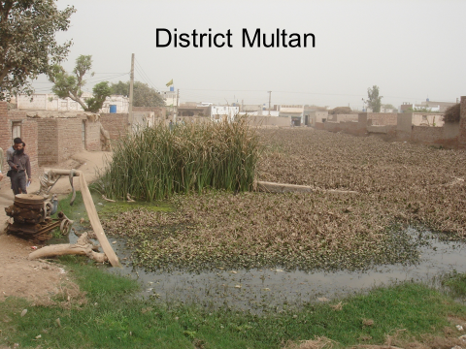
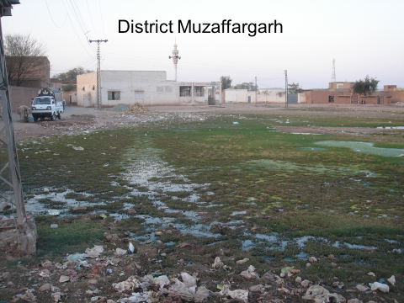

Figure-1: Wastewater management practices in the villages of districts Muzaffargarh and Multan

3. Mostly, huge centralized mechanical types wastewater treatment plants are in use which are cost intensive , both in terms of capital and recurring cost. Resultantly, due to lack of sufficient recurring finances and energy crises / shortages, these sewage treatment plants becomes non-operational after few years of their installation . Moreover, huge centralized sewage treatment plants are difficult to manage and sometimes becomes technically non-viable due to longer chain of wastewater collection system etc and thereafter judicious reuse of treated water in the close vicinity of treatment plant becomes difficult.

4. The usefulness of sewage treatment cannot be denied by any country or nation, but due to involvement of heavy capital investments, they let their wastewater to drain off into water bodies. Therefore, keeping in view these obvious impediments, it was envisaged to have nodal system (de-centralized) wastewater treatment plants, which are easy to manage and treated water can be / will be used in the areas from where it is being generated. Hence, keeping this narrative in mind, community based constructed wetlands system, for sewage treatment through bio and phyto-remediation was designed and installed at village Chattal, district Chakwal ( an arid area) which is functioning well and being sustained from selling the treated water to farmers and harvesting the various aquatic plants . Enormous positive impacts on drinking water contamination reduction, crop productivity and on human health were measured.

5. Temporal analysis carried out for verification of treatment, in this regard monthly Wastewater samples collected at Inlet point before entering into screening unit and treated wastewater were collected at outlet. The detailed analysis for Chemical Oxygen Demand (COD) and Biological Oxygen Demand (BOD) were got analyzed from PCRWR-Islamabad. Analysis report showed significant reduction of COD & BOD i.e. 86.1% & 91.4% respectively which are well under the permissible limits of Pak-EPA. Aesthetic value of treated water is remarkably improved after treatment as turbidity reduced from 15 NTU to 2 NTU.
Detailed Health survey carried out at village Chattal, before hybrid constructed wetland innervations and after one year of this intervention to ascertain the efficiency of the intervention on health & hygiene. The result showed significant reduction in diarrheal & Hepatitis diseases i.e. 92.5% & 40% respectively and substantial improvements in socio-economic and health & environment conditions of the rural population of village Chattal.
Besides, improved health and hygiene environments , the said intervention embodies / build resilience amongst the target community against climate change adverse impacts, in the context of additional water availability ( treated water ) for irrigation and lowering migration trends towards urban centers for livelihood generation.

Case Study – Sewage Treatment through Constructed Wetlands, embedded with Value Addition
Interventions for livelihood Generation & for Post Project Sustainability

6. Hence keeping in view the deplorable sanitation situation in the rural environments of Pakistan, Plan International Pakistan undertook the assignment of construction of sewage treatment through hybrid constructed wetlands in village Chattal , district Chakwal –Pakistan . The efficiency of the facility and impacts has shown tremendous reductions in water borne diseases. The brief of this project / case study is as under;

Project Location:

7. Village Chattal is situated in district Chakwal-Pakistan , which is water scarce area with high mortality and morbidity rates . The location of proposed constructed wetlands is shown in figure-2, below;

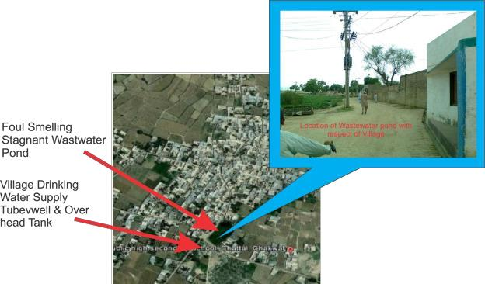

Figure -2 Location of Foul Smelling wastewater storage pond , located near village water supply scheme and surrounded by houses - Village Chattal, district Chakwal –Pakistan

Project Objectives

9. Following salient objectives have been envisaged; 2

- To protect fresh / drinking water sources from contamination, being caused by un-managed wastewaters in rural environments.
- To build resilience against climate change adverse impacts, amongst the community, in the context of additional water availability ( treated water ) for irrigation and migration towards urban centers
- To create improved health and hygiene environments by reducing mortality and morbidity rates.
- To increase the water resources potentials for irrigation by recycling the treated domestic wastewater through hybrid system of constructed wetlands.
- To enhance food security and income generation opportunities at local / village and community levels, especially to marginalized communities / families.
- To create awareness and advocacy among the community for adaptation of improved health and hygiene practices and replication of this model elsewhere.

10. The project design is based on gravity flow regime to ensure project sustainability which will reduce both capital and recurring costs.

Project Information
Type of Project | Small Scale, urban development, low cost sanitation
Type of Project | development demonstration
Project Completion Period | Start of project: July 2011
Project Completion Period | End of Project: May 2012
Design Value | 400 households, population 2400 discharge 38400 gallons /day
Capital Cost | RS. 3.3 Million
Planning, Designing, Construction, | Eco-STEPS Inc. , Islamabad -Pakistan
Funding Agency | Plan Pakistan (Plan International)
O&M Cost | Village Committee manage the site, as no electricity involved in
O&M Cost | operation so O&M cost is zero

Project Design Components

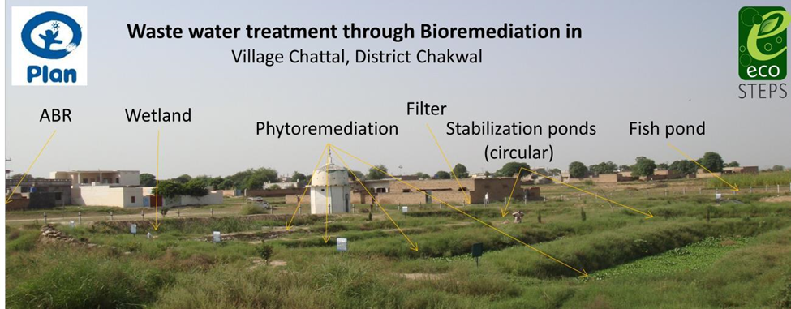
Figure-3: Plan view of various components

Post Project Impacts
11. WaterAid Pakistan , alongwith district health representatives carried out monitoring and impact evaluation of the facility and came up with following positive impacts on human health, drinking water sources and on the overall village sanitation environments ( table-2 & figure-3)

Table-2: Statics showing Reduction in water borne diseases

S#1 | Ratio of Diseases like diarrhea Before the Vet land project | Ratio of Diseases like diarrhea after the Wetland project
Analysis | 130-150 patients per month | 10-11 patients per month
S#2 | Ratio of Diseases like Hepatitis Before the Vet land project | Ratio of Diseases like Hepatitis after the Vet land project
Analysis | 15 Patients from Village | 09 Patients from Village out of 15

Figure-3: Comparisons of various reduction

Reduction in COD and BOD
12. Water samples of treated wastewater got analyzed from third party ( PCRWR Labs- Islamabad ) which showed tremendous decrease in COD and BOD values, as shown in figure-4 & 5, below;

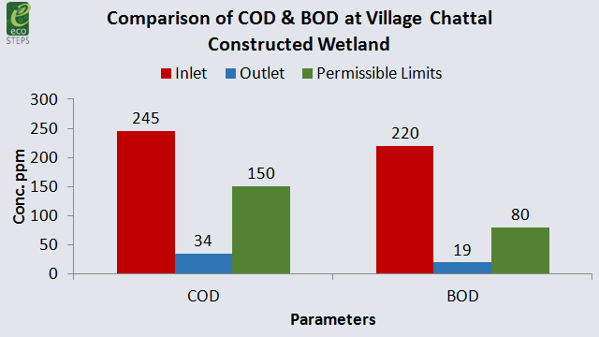

Improvement in NTU Values
NTU values of treated water were reduced from 15 to 2 NTU , as shown in figure-7 , below
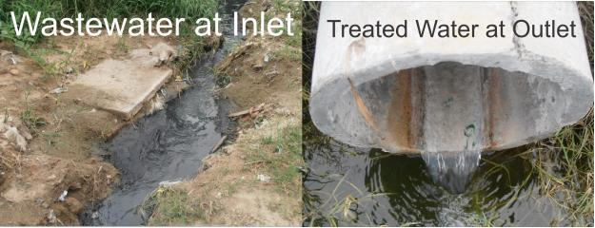

Figure-4 &5 ; comparison of Physical Appearance of influent and effluent

Revenue Generation from Value addition Interventions

13. Following revenue generation interventions are being practiced to generate incomes for post project sustainability

a. Sale of treated water - Reused for agriculture purposes

The area is arid in nature, therefore, availability of treated wastewater to be used in agriculture has motivated the local participation manifolds.

b. Fish Breeding in treated water pond
In addition, different stakeholders (policymakers, water management institutes, health institutes, inter
national development agencies) can use the site as a model, demonstration and promotion platform for mainstreaming decentralized Hybrid constructed wetlands wastewater treatment be adapted to small and medium sized communities.

c. Harvesting of Aquatic Plants
Regular harvesting of various aquatic plants is being carried out to for production of poultry feed, animal fodder and manure , which also generate sizeable revenue for operation & maintenance of the wetlands system .
e. Fruit Orchard fruit orchard , comprising of various fruit plants species, specially lemon ,was established and sizable revenue is being generated for post project sustainability and further development .

f. Herbal garden has also been established for additional revenue generation and also to be used for the local community.

g. Integrated farming consists of poultry, livestock and vegetable farming, as aquatic plants provide sufficient quantity of feed and compost for these activities.

h. Enhanced Bio-Diversity
Due to enabling environment, various flora & fauna species have been seen in and around wetlands, specially turtles' , reptiles and migratory birds etc, as shown in the figure-6 , below

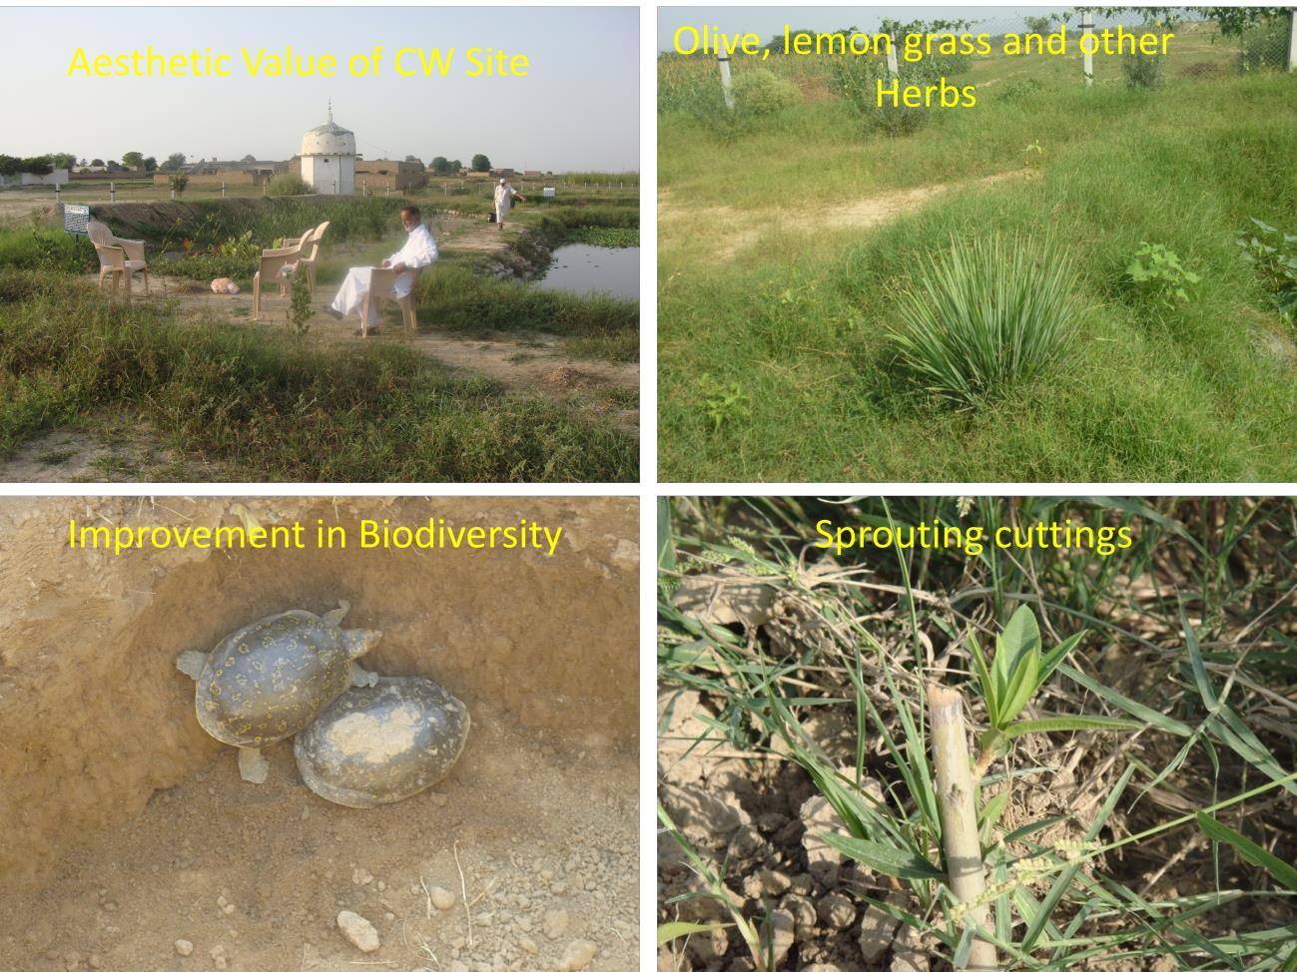

Figure-6: Improved biodiversity conditions -various flora and fauna species

14. Conclusion

Hybrid constructed wetland was made partially operational in December 2012 and became fully functional in May 2013.. Temporal analysis carried out for verification of treatment, in this regard monthly Wastewater samples collected at Inlet point before entering into screening unit and treated wastewater were collected at outlet. The detailed analysis for Chemical Oxygen Demand (COD) and Biological Oxygen Demand (BOD) were got analyzed from PCRWR-Islamabad. Analysis report showed significant reduction of COD & BOD i.e. 86.1% & 91.4% respectively which are well under the permissible limits of Pak-EPA. Aesthetic value of treated water is remarkably improved after treatment as turbidity reduced from 15 NTU to 2 NTU.
15. Detailed Health survey carried out at village Chattal, before hybrid constructed wetland innervations and after one year of this intervention to ascertain the efficiency of the intervention on health & hygiene. The result showed significant reduction in diarrheal & Hepatitis diseases i.e. 92.5% & 40% respectively and substantial improvements in socio-economic and health & environment conditions of the rural population of village Chattal.

16. This small / decentralized community based sewage treatment facility is cost effective, environment friendly, financially & economically viable and sustainable. This model is suitable for the rural communities and can be replicated elsewhere to ensure conducive health environments, enhancement of biodiversity , livelihood generation and to overcome the water scarcity for enhanced crop productivities etc

Pictorial view of the constructed wetlands is shown in the below photographs

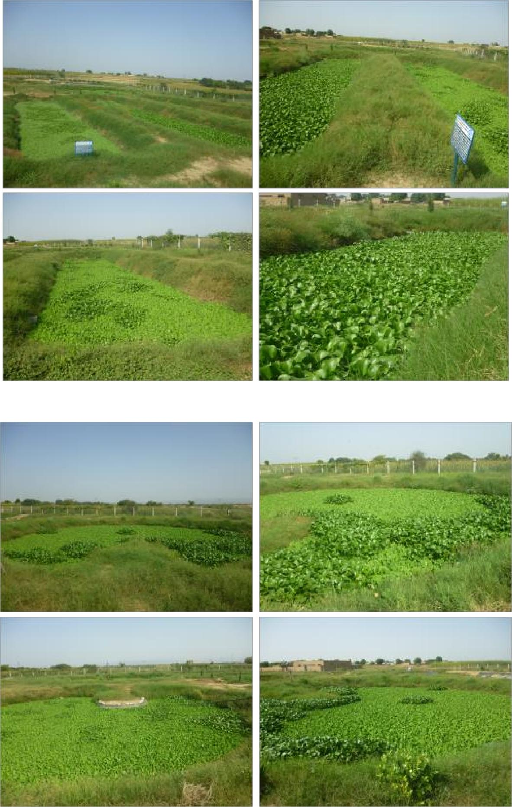

Figure-7: Pictorial View of Site after Completion- a process of bio & phyto-remediation

