Earth Sustaining Sciences

Solutions for sustainable industry, environment & society through Science

SABR
Symbiotic Aquatic Bio-Reactor
Brief

Symbiotic Aquatic BioReactor
SABR offers the opportunity to reduce and remove challenging effluent issues, develop effective re-utilisation and achieve compliant environmental release of process affected waters and water overburden from mines, industrial processing operations, intensive agriculture and natural environmental disasters in an economic, commercial and eco-societally acceptable manner.
The Earth Sustaining Sciences approach is to utilise SABR process bioremediation to treat waters and soils achieving and utilising beneficial outcomes to assist in the immediate remediation of on-site and off-site environmental systems.

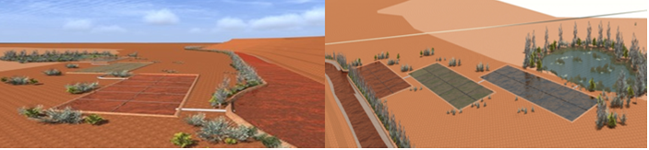

Summary
SABR - Symbiotic Aquatic BioReactor Application for Mine and Process Affected Water Management

Earth Sustaining Sciences Institute developed the Symbiotic Aquatic BioReactor SABR process over 20-years and proven that the Symbiotic Aquatic BioReactor system (SABR) can treat extreme acid mine drainage and mine effluent, extreme alkaline process effluent and other mine, process, agricultural and natural event affected waters and soils. The process based upon the understanding of examined chemistry demonstrated in water and soil body samples collected and analysed is founded in the development of microbiological manifolds; bacteria and elements working in unison creating treatment colonies to act upon constituents in a manner that delivers a desired outcome.
The SABR process can be applied to economically and naturally treat affected waters and soils to a level allowing effective utilisation, disposal on-site, or discharged off-site with negligible risk, within compliance requirements. The SABR approach is to free a location of unwanted water volume through the utilisation of tailored symbiotic bioreactors to reduce or remove metals, metalloids and sulfates, therefore reducing contamination of environments. The process can be followed by the SABR BioSolve and SABR Fertigation processes to fully remediate and rehabilitate soils to agricultural and societal applications.
The initial considerations are determined through wet chemistry and once understood, using cost effective small-scale pilots to determine the required specific bio-tuning and the potential of the functioning system to deliver desired results. Donor geology, commodity beneficiation process and water chemistry are important indicators in the demonstration of the SABR system abilities to successfully address the treatment issues. A pilot programme to apply bio-solutions over a 30-day period, delivering indications within a 7-day period is usually recommended.
The SABR water treatment application studies are conducted in the form of:
- Site and regional assessment and potentials study,
- development of a project plan and development of substrate and minimal risk microbiological manifold,
- Laboratory design of tailored SABR bio-reactor application pilot and system,
- Installation of tailored SABR bio-reactor application pilot system,
- Operation of tailored SABR bio-reactor application pilot system,
- Report on findings; and
- Design and operation of solutions systems as per client requisites.

Earth Sustaining Sciences have demonstrated effective solutions in Australia, Oceania, Asia, United States, Middle East, China, Mongolia, Africa and Papua New Guinea with the support of governments, regulatory authorities, commercial operators and communities Acid Mine Drainage and minerals Process Affected Water remediation project thus attempted, which is more than 40. To date solutions have been effective in coal mines, gold mines, copper mines, copper processing effluent, platinum mines, iron ore mines, phosphate refining effluent, phosphogypsum effluent, acid refinery effluent, rare earth polymineral effluent, power station effluent, fly ash improvement and fly ash effluent, tailings facilities in coal, gold, iron ore and phosphate operations and remediation of disturbed ecology and reinvigoration of riverine, riparian, wetland and soil systems. The SABR BioCell approach to mineral and process affected waters has been advanced and demonstrated the following in separate applications.

1. Gold mine heavily metalliferous pit lake water pH 2.88 to pH 9 in 360hrs.
2. Gold mine radionuclide reduction from above 30 µg/L to zero in 360 hrs.
3. Polymetals mine radionuclide reduction from above 110 µg/L to zero in 24 hrs.
4. Gold mine arsenical pit lake water 890 μg/L to 3 μg/L in 24hrs.
5. Platinum mine metalliferous waste discharge water pH 4.3 to pH 6.9 in 24hrs
6. Acid refinery heavily metalliferous waste discharge water pH 0.5 to pH 3.9 in 48hrs.
7. Phosphogypsum heavily metalliferous water pH 1.5 to pH 4.8 in 48hrs.
8. Coal mine heavily metalliferous pit water pH 1.9 to pH 6.4 in 60hrs.
9. Coal fired power station alkaline water pH 9.8 to pH 5.3 in 60hrs and to pH 6.5 in a further 20hrs.
10. Coal fired power station alkaline fly ash pH 9.8 to pH 5.3 in 60hrs and to pH 6.5 in a further 20hrs.
11. Coal mine heavily metalliferous underground decant water pH 1.5 to pH 5.6 in 60hrs.
12. Coal mine underground decant water pH 2.5 to pH 5.4 in 24hrs and to pH 7.4 in 260hrs.
13. Copper mine effluent from 2.25 pH to 7.2 pH in 12 hours and 6.5pH to 7.8 pH in 4 hours.
14. Gold mine tailings storage heavily metalliferous water pH 4.3 to pH 5.5 in 24hrs.
15. Gold mine waste dump heavily metalliferous water pH 1.5 to pH 6.5 in 24hrs.
16. Iron ore mine heavily metalliferous pit water pH 2.46 to pH 7 in 24 hrs.
17. Copper mine effluent from 3.76 pH to 7.4 pH in 23 hours.
18. Copper mine effluent from 2.1 pH to 7.2 pH and pyrite effluent from 5.5pH to 7.8 pH in 12 hours.
19. Alumina effluent and red mud tailings from above 13+ pH to below 7 pH in 50 hrs.
20. Mine pit lake desalination by 50% in 168 hrs.
21. Gold mine heavily contaminated soils remediated from zero growth to complete growth in 2,000 hrs.
22. Seawater desalination 71% in 72hrs., research continuing.
23. Crop biostimulant fertigation increasing growth by up to 300% and advancing germination by up to 30%.

***SABR pH improvements are accompanied by desirable metals, metalloids and other contaminants reductions; (chemically, the two processes go hand in hand), as shown in the following real case data tables and graphs; with results measured according the ANZECC 2000 Guidelines

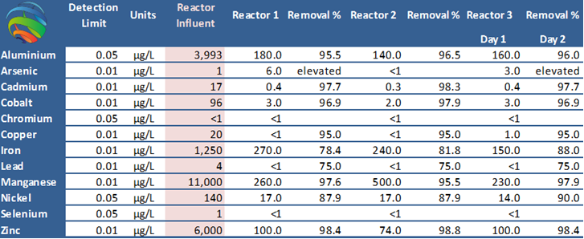
Table 1. First gold mining operation SABR treatment 2010 – Australia

Note: Donor pit water 2.88 pH treated to 9 pH mitigating damaging flows to one of Australia’s most pristine National Parks.
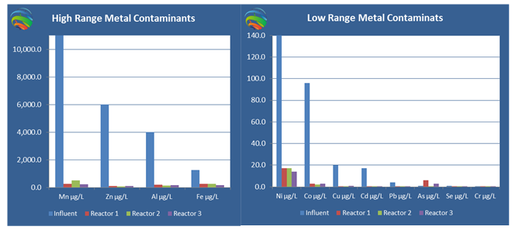
Figure 1. Metal reductions from Table 1
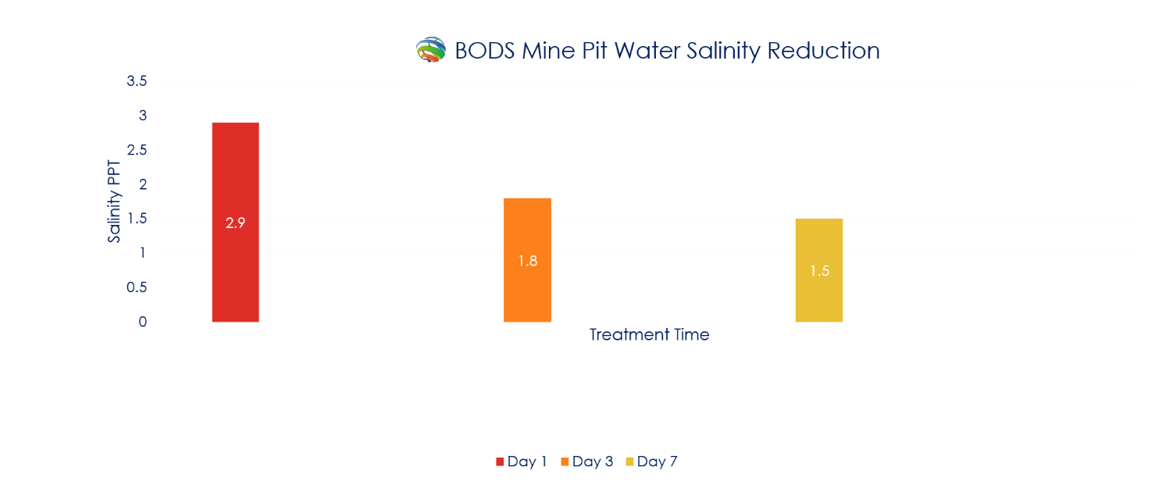

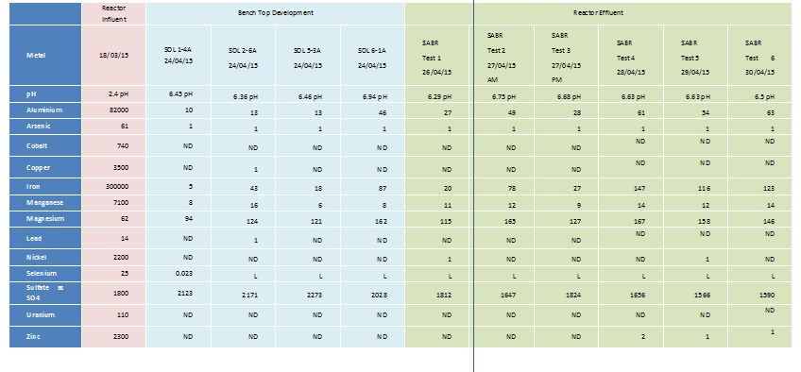Table 2. Iron Ore Mine effluent SABR treatment 2015 – Australia.
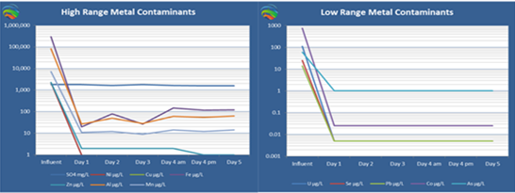
Figure 2. Metal reductions from Table 2

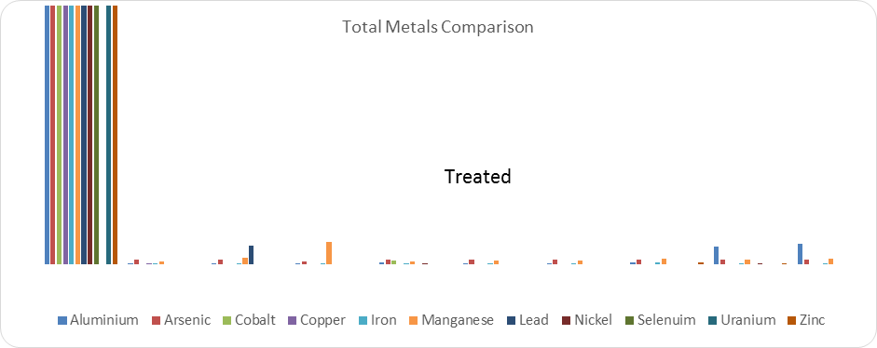
Figure 3. Total Metal reductions comparison from Table 2

Treatment of Mine and Process Affected Water
ESS have demonstrated their all- natural Endemic Biological Manifold System (SABR) can remediate all levels of water pH and metals and metalloid contamination delivering positive outcomes acceptable across the board water and soil chemistry solutions.

It is common industry practice to dilute and discharge mine affected waters into riverine systems or to treat contaminated mine drainage using expensive and restrictive chemical or reverse osmosis methods. In most conventional treatment systems that respond to acidic effluent, metals as contaminants are removed through the constantly measured addition of alkaline chemicals (e.g., NaOH, Ca(OH)₂, CaO, Na₂CO₃, or NH₃) to meet guideline effluent limits. In the case of highly alkaline effluent, as in red mud for example, seawater flushing and further acidification are the historically prosed solutions.

The chemicals used in these treatment systems present significant capital and operational costs, especially when required in large quantities, and often fail to effectively remove the desired level of contaminants without significant unwanted residual issues that require further and often complex management. Additionally, large volumes of CO₂ may be released when alkaline chemicals are added. The operation and maintenance costs associated generally include labour, energy, pumping, aeration and mixing, followed by the difficulty in disposal of significant quantities of metal-laden sludge.
It is not unusual for water treatment costs to be continually excessive at sites that are otherwise considered to be quite successfully remediated or reclaimed. Globally, extensive wetland, lagoon, stream and river systems have been significantly affected by mine and process affected drainage from sites that were believed appropriately closed or simply abandoned before the enactment of effluent management regulations and compliance requisites.
Governmental reclamation agencies, local conservation organisations, watershed associations and resources corporations all consider the treatment of contaminated mine and process discharge to be a high priority, although significantly financially problematic and difficult in methodology. The financially problematic treatment of such situations has a set of improved solutions with the utilisation of the SABR process.
The high cost of water treatment and associated management places a serious economic burden on active mining and processing companies, stakeholders and governments, especially regarding abandoned mines or sites that store significant inventory of unwanted high risk materials. The high cost and widely known restrictions of conventional mechanical and chemical treatment can significantly reduce the economic water treatment ability of both corporations and governments, especially at remote, heavily waste laden and abandoned sites. In the main, insufficient funds are available for substantial cost, moderate solutions delivery remediatory programmes.
The issues need to be Eco-Societally sustainable. Solutions need to deliver to the triple bottom-line.

SABR Process Solutions
Following 20 years of development and proving, the SABR system, an all-natural, passive, local taxa multiple biological manifold water, soil and environment treatment system has proven to consistently remediate Acid Mine Drainage (AMD) of less than 0.5 pH to 8.7pH (up to 9pH) and Process Affected materials (PAM) greater than 13.8 pH to 7 pH stripping up to 99% of metalliferous contaminants across the metals suite significantly reducing the electrical conductivity (Ec).

The SABR system can be applied to improve and remediate the position alkaline process waters (APW) and other Process Affected Waters (PAW) proving the treatment of waters and soils between 0 and 14 pH.

The process has demonstrated great abilities in radiogenic waters and soils, stripping 99% of contaminants.

The system has been successfully utilised in the remediation of highly alkaline, metalliferous muds and fly ash with outstanding success.

The remediation of dissolved salts has advanced significantly to the development stage of an all-natural economic desalination symbiotic bioreactor system, SABR-BODS which demonstrated 50% desalination of mine water with trials in seawater currently delivering 71% desalination. The opportunity for the treatment and effective re-utilisation, release of and remediation of the on-going build-up of negative or excess water volumes is considered possible in most environments and applications with the application of SABR bioremediation.

ANZECC 2000 Trigger Values for Fresh Water µgL⁻¹
Level of ANZECC Protection (% Species)
Metals and Metalloids | 99% | 95% | 90% | 80%
Aluminium | 27 | 55 | 80 | 150
Arsenic (As111) | 1 | 24 | 94 | 360
Arsenic (As V) | 0.8 | 13 | 42 | 140
Beryllium | ID | ID | ID | ID
Boron | 90 | 370 | 680 | 1300
Cadmium | 0.06 | 0.2 | 0.4 | 0.8
Chromium (CR 111) | ID | ID | ID | ID
Chromium (CR V1) | 0.01 | 1.0 | 6 | 40
Cobalt | ID | ID | ID | ID
Copper | 1.0 | 1.4 | 1.8 | 2.5
Iron | ID | ID | ID | ID
Lanthanum | ID | ID | ID | ID
Lead | 1.0 | 3.4 | 5.6 | 9.4
Manganese | 1200 | 1900 | 2500 | 3600
Mercury (Inorganic) | 0.06 | 0.6 | 1.9 | 5.4
Molybdenum | ID | ID | ID | ID
Nickel | 8 | 11 | 13 | 17
Selenium | 5 | 11 | 18 | 34
Silver | 0.02 | 0.05 | 0.1 | 0.2
Thallium | ID | ID | ID | ID
Uranium | ID | ID | ID | ID
Vanadium | ID | ID | ID | ID
Zinc | 2.4 | 8.0 | 15 | 31

Table 3. Australian New Zealand Conservation Council ANZECC Guidelines 2000 Freshwater Guidelines Trigger Values

The target median water quality discharge limits for site excess waters are assessed as derived from the Australian New Zealand Conservation Council Water Guidelines (ANZECC) 2000 Water Quality Guidelines.

- Default trigger values of toxicants for protection of freshwater aquatic ecosystems, applied at the 90% level of protection for typical highly disturbed ecosystems, which will be hardness modified (HMTV’s) based on site specific measurements of hardness at the time of discharge.

Earth Sustaining Sciences tailors water management measures to contribute to overall operational and environmental value by improving the quality of both immediate and future discharge. Such discharge may immediately and/or eventually report to the receiving environment. The aim of improving target median water quality limits to allow the application of the ANZECC 2000 Trigger Values for protection of freshwater aquatic systems at the 90% level of protection, targeting the approach to the 95% level of protection is to utilise SABR in continually significantly improving ecosystem condition.

Mine Site Water Inventory SABR Treatment Application
Earth Sustaining Sciences have proven that the SABR process can treat water volumes based upon the water chemistry demonstrated in the samples collected and analysed. The SABR Environmental Management System can treat waters and soils to an appropriate level allowing them to be effectively utilised with appropriate environmental and economic position.

BioReactor Process
Bioreactor is a generic term for a system that degrades or sequesters contaminants in water (surface and groundwater) and soil mediated by micro-organisms. SABR reactors can be either an enclosed chamber or open such as a constructed wetland. Here we discuss the combination of using both closed and open systems to processes acid mine waste. The role of innovative ESS symbiotic bioreactor technology in treating Process Affected Waters (PAW) will reduce the potential for serious environmental damage, which places ecosystems under pressure, destroys habitat and generates extensive and expensive reclamation costs.

Bioreactor treatment systems allow the use of selected relatively low cost, naturally occurring, specifically manipulated and managed recycled or waste materials and associated bacteria and endemic inoculants to deliver AMD and potentially non-acidic metalliferous and dissolved salts PAW solutions as a passive short-term or long-term management methodologies.

Site-specific adaptations are integral in the total PAW treatment methodology especially where exceptionally high levels of dissolved salts are present. Such systems can include organic reactors, natural geochemical reactors, specialised manganese oxidizing bacteria (MOB) reactors, and wetland settling and polishing systems.

Each cell within a SABR system may be configured to perform identical, dual or differing roles to treat the influent AMD or PAW such as pH neutralisation, specific metals removal, removal of metal sulfides and hydroxides and dissolved salts. The multiple biological manifold methodology does incorporate the use of specific sulfate reducing bacteria (SRB) however it is the utilisation of a significant combination of other taxa in manifolds that achieves the effective complex process that more fully manages metals, sulfates and dissolved salts, which is the reason for individual tailored applications to determine appropriate design for each site.

Generally, bioreactor systems are subject to seasonal variability in performance; however, this fluctuation can be effectively managed by appropriate design to ensure successful continued passive treatment of highly metalliferous and exceptionally acidic waters, with tailored applications to treat alkaline, high dissolved salt, and high dissolved metalliferous concentrations in waters and soils.

Passive treatment systems require periodic maintenance only and the infrastructure footprint depends upon the volume of water to be treated and the treatment time available to manage the required volume, which develops the required flow rate of waters through the system. The first complete commercial SABR AMD system on mine application in 2010 demonstrated that AMD can be effectively passively treated to remove up to 99% of contaminant metals, and sulfates to the meet high standards. Further, treated waters could be utilised as vegetation support waters for wetland and species redevelopment and management, especially in the dryer periods, and were released through aquatic systems with negligible risk. Similar successes have since been demonstrated in agricultural applications, advancing to high nutrient low risk agricultural solutions. Another system installed in 2009 recedes to dormant in the ephemeral wetlands during the dry season and reinvigorates to active in the wet season, still in 2016 treating mine site effluent from 2.2 pH to 7.6 pH constantly delivering to environment at greater than 80% ANZECC, often achieving 90%.

With appropriate planning, the simple and practical tailored development of bioreactor technology systems adapting to varying environmental conditions as indicated in the following data is potentially manageable by any operation. Effectively, the SABR system is a part of the global answer to AMD and other low quality waters. The development of on-site specialised wetlands, in situ nurseries and terrestrial transfer nurseries for propagating and preparing native wetland species allows for the reinvigoration of existing wetlands and the development of new settlement and tertiary polishing wetland systems for the management of effluent waters from the bioreactor system and other infiltrations.

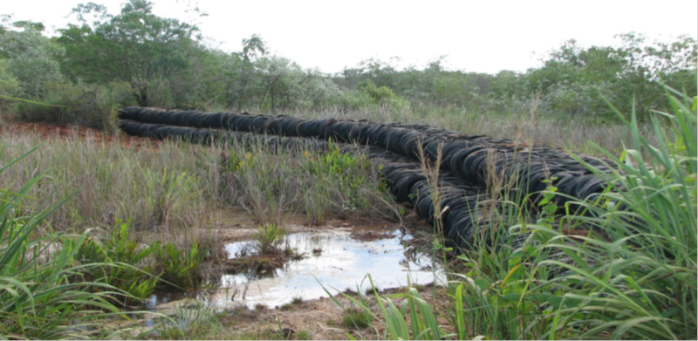

Figure 4 Transportable Transient Mixing Zone (Brett Fitzgerald, Australia)
Low Cost, environmentally sound Transferable Mixing Zone and Wetland Development System designed and successfully demonstrated environmentally and cost effectively utilising recycled tyres on mine sites in the Northern Territory, Australia.
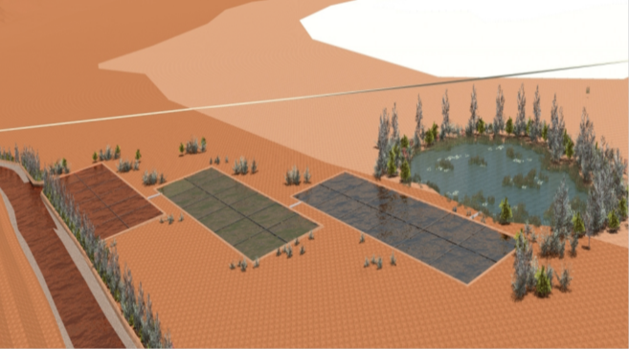
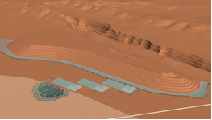

Figure 5 Figure 6

Diagrammatic representations of a 3-Stage Multiple (36) Cell SABR system designed to engage low to high flow waste rock dump effluent without the burden of completely capping a delinquent formation.

Additional applications including microbiological leaching advances remediation
The SABR system utilises key reactions mediated by multiple microbiological configurations as a part of a multiple microbiological manifolds solution to reduce sulfates and dissolved salts and precipitate metals contained within the water as metal sulfides. As a demonstration of a part of the sulfate reducing effect, the following can be considered:

Beginning with the reduction of sulfate (SO4₂-) via the donation of electrons from a specific carbon source, (CH3COO-) (in this case acetate, a non-involved SABR constituent as an example carbon source): CH₃COO- + SO4₂- + H+ » H₂S + 2HCO₃- (1). In this case, two moles of alkalinity (HCO₃-) are produced per mole of sulfate reduced; however, this varies depending upon the carbon source. (The ESS SABR carbon sources were developed through the distinct need of specificity of reaction elaboration and took completely different paths to other research). One mole of sulfide (H₂S) in this example will be produced per mole of sulfate reduced. The sulfide produced will precipitate heavy metals with low metal sulfide solubility products and be managed by the following reaction: Me₂+ + H₂S » MeS + 2H+ (2). In this case, Me₂+ is any divalent heavy metal (e.g. Zn₂+, Cd₂+, Cu₂+, Fe₂+, Ni₂+, etc.). Other metals such as arsenic (As) form complex sulfide minerals via alternative reactions. Metals such as Mn, Fe, nickel (Ni), copper (Cu), zinc (Zn), cadmium (Cd), mercury (Hg) and lead (Pb) can be further removed by co-precipitation with other metal sulfides. It is important to note the chemistry involved in the precipitation of certain heavy metals is far more complex than the simple reactions shown above as an example. The SABR system supported by a wetland settling and polishing system has proven to remove metals to levels compliant with up to 99% ANZECC (2000) guidelines for freshwater ecosystems. The increased alkalinity produced by initial reaction by the multiple microbiological manifolds creates an ideal environment for increased precipitation of metal sulfides. The increased alkalinity can also produce an ideal environment for the improved precipitation of metal hydroxides to occur. The specific substrates utilised are locally researched and piloted to develop the most effective microbiological environment based on the particular needs of the source site and receiving environment considering abundance, renewability, cost, and delivery ability. The choice of substrate within the bioreactor system may affect the lifespan of the bioreactor materials, however, correct management advances the ability of multiple microbiological colonies to grow, and their ability to effectively remediate the situation. Metals are also reduced within the bioreactor system via the bio-sorption to the substrate as well as to the microbiological components themselves. Bio-sorption to the substrate involves the divalent cations interacting with the net negative charge of the substrate in order to bind metals. The physiological characteristics of the bacterial cell wall represented by Gram-positive and Gram-negative bacteria, both represented within microbiological components, is the most important factor affecting the biosorbing properties. The ability for the SABR System to effectively manage incumbent Arsenic contaminated water with As(III) (Arsenite), & As(V) (Arsenate), at varying measurements up to greater than 850 micrograms/L to environmental flows of As(III) & As(V) at a maximum of 3 micrograms/L was delivered in the Northern Territory Australia, post the results in table one.

Sustainable Controlled Management of Microbiological Manifolds
Earth Sustaining Sciences created the understanding for microbiological manifolds to be safely developed and safely manipulated in order to confer resistance to high concentrations of specific metals, which may otherwise inhibit the action of microbiological components in removing high concentrations of metals, sulfates and dissolved salts from Acid Mine Drainage and other Process Affected Waters. Specific interactive microbiological components are critical in the reduction of sulfates to form sulfides, which precipitate most metals at a reasonably achievable pH, these components must also function at a high rate to maintain treatment at acceptable flow rates with a low residence time within the bioreactor system for expedience. Cultures of specific microbiological components can be maintained by the cloning and expression of genes encoding a higher-level resistance to toxic metals such as managnese, (Mn), cadminum (Cd), aluminium (Al), and copper (Cu). The increased resistance maintained by microbiological component cultures within the bioreactor allow the system to maintain the delivery of appropriate waters to the environment.

To avoid any significant environmental impacts AMD and PAW is collected and treated before being utilised on-site or discharged into the environment. SABR systems allow the use of relatively low cost, naturally occurring, recycled or waste materials to create the system to manage AMD in an immediately effective, long-term, sustainable method. SABR technology is one of the most economically efficient and environmentally expedient absolute minimal risk technologies developed to remediate polluted environments and restore degraded ecological systems. SABR is site specific and utilises specific microbiological components to reduce water and soil contaminant levels. For economic reasons and environmental sustainability, treatment options such as the SABR and SABR wetland systems are a practical solution. They are not only cost effective, but also environmentally beneficial in the long-term and can provide intergenerational learning, employment and business opportunities for local communities.

Preserving natural integrity of the landscape, traditional cultural values and sound economics is of utmost importance. Mining and processing are able to be managed in an economically, socially and environmentally sustainable manner, delivering enduring value to stakeholders and the environment in, which operations are conducted. According to the United Nations, the biggest risk to the global environment, next to climate change, is water management and contamination to surface water and groundwater from AMD and PAW.

The SABR system can provide effective, appropriate solutions to clean up mine water and prevent the continuing contamination of waterways and systems. Though expertise, applied technology and commitment to delivering outstanding performance, most appropriate industry practices and appropriately managed activities, environmental risk and damage can be minimised, the landscape rehabilitated and cultural, sociological and collective commercial values maintained, whilst maximising resource extraction and economic gain for all stakeholders.

Earth Sustaining Sciences have developed a series of SABR models to approach the effective remediation of a range of mine and process affected waters with the potential to reduce the metalliferous contaminants, sulfates and dissolved salts to levels that render the water suitable for on-site and associated uses or off-site environmental discharge as active or passive processes or a combination of both.

